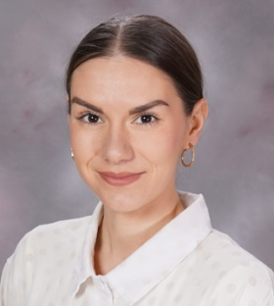



11th September, 2025

Dear Parents/Carers,

It is lovely to be able to introduce myself. My name is Mrs Buck and I am thrilled to be teaching your children in 2SB this year. We have had a lovely start to the year and it has been a pleasure getting to know 2SB – I am certain that we are going to have a great year learning together. Here’s a little about me: I enjoy running, reading and being outdoors. If you have anything at all that you would like to discuss with me please do not hesitate to request a call from the office and I would be happy to have a chat.

Indoor PE will be on Tuesday and outdoor PE will be on Thursday. Children can bring in PE kits on a Monday and take them home on Friday, if you wish. P.E kits should include pumps or trainers, black shorts or tracksuit bottoms for cold weather and a white t-shirt. **Please ensure that all PE kit and school uniform is clearly named.**

* Bottles for water can be brought into school for your child and taken home at the end of the day (only water may be brought in.)
* Homework will be sent out on Thursday and expected back by Tuesday.
* Please listen to your child read at home and sign their journal. Remind the children to bring their book into school every day. Please encourage your child to look after their reading book as they are costly to replace. There is a charge of £5.00 for lost books and £1.00 for lost journals. There is a charge of £5.00 for lost books and £1.00 for lost journals.

Can I take this opportunity to thank you for your continued support and co-operation and remind you that if you want to talk to me you can always catch me at the gate at the beginning or the end of the day.

Yours sincerely

Mrs Buck