Summer  Activities    What’s on during the summer? ☀️  You can access FREE multi-sport activity programme during the school Summer holidays at Bidston Sports and Activity Centre.  Four days of activities at Bidston Sports and Activity Centre  Monday 28th to Thursday 31st July  Monday 4th to Thursday 7th August  Monday 11th to Thursday 14th August  Monday 18th to Thursday 21st August 10:00am – 2:00pm  Badminton, Tag, Arts and Crafts, Football, Multi sports, Hockey, Dance & Dodgeball  Email 📧 - activewirral@wirral.gov.uk | HiveAbility 🥅  The Hive Youth Zone provide sessions tailored support for young people with through accessible activities, trained staff, and a nurturing environment that encourages confidence, independence, and meaningful social connections.    When: there are two Hiveability sessions: HiveAbility: Sundays 10am to 2pm (8-19 years)  Hiveability 13+: Tuesdays 5pm to 8pm  Where: Bright Street, Birkenhead, Wirral CH41 4EA  Cost 💳 : annual membership is £5 and then only 50p for each session attended.  Contact Details📱 : 0151 705 8000 |   The Positivitree Stay and Play Sessions 🌳  The Stay and Play sessions aim to provide a safe space for parents/carers to access peer support in a welcoming place, where the children can come along and play.  When and where:  Brassy Gardens Family Hub, 2 Brassey St, Birkenhead CH41 8DA - every Wednesday from 30 July to 27 August from 10am to 12pm  Seacombe Family Hub, St Paul's Rd, Wallasey, CH44 7AN - every Thursday from 31 July to 28 August from 10am to 12pm  Cost 💳 : Free

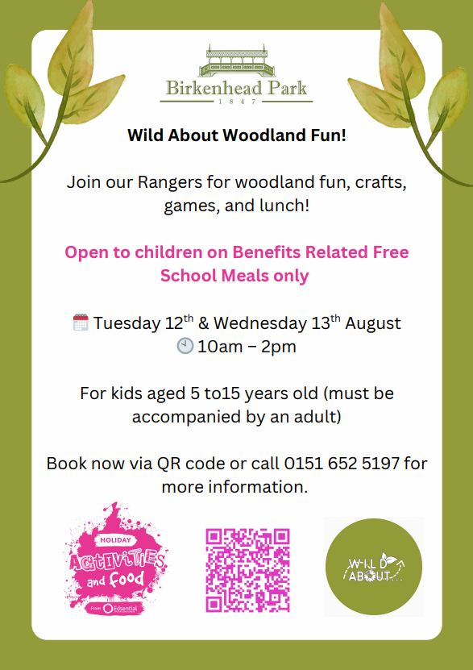  Woodland Fun Activity 🌳 | 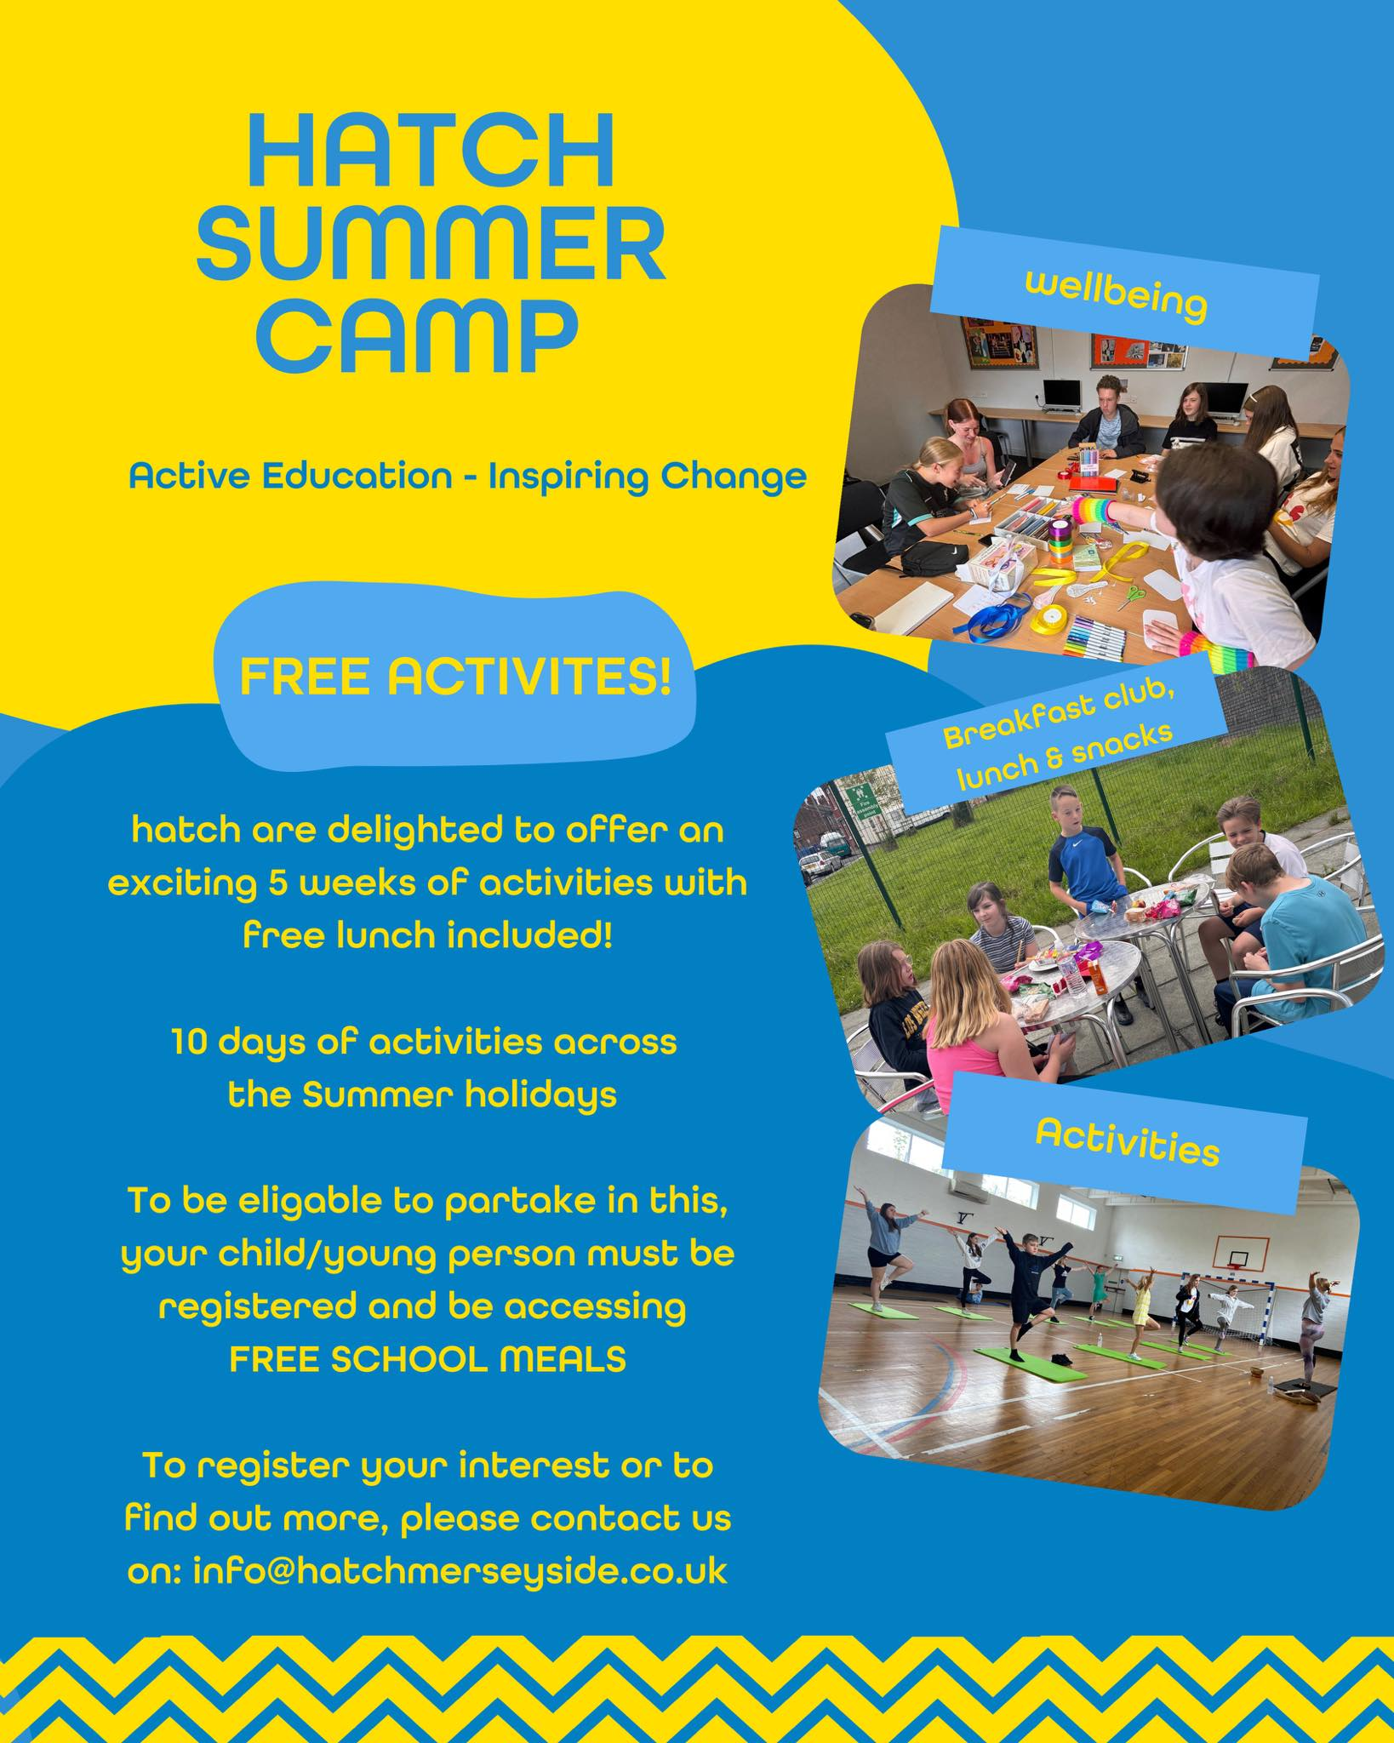  Hatch Summer Camp ☀️🎾 | 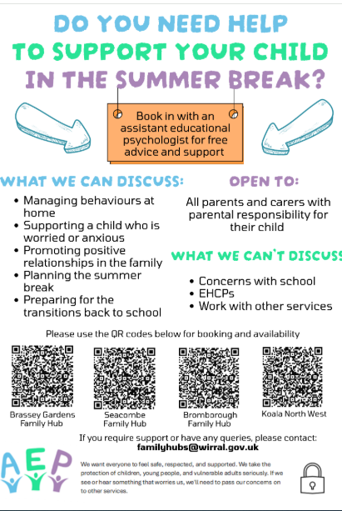  Support for Parents 👨‍👩‍👦

