17th March 2025
Letter for Parents / Guardians

Dear Parent / Guardian

Second wave of norovirus

The UK Health Security Agency (UKHSA) have reported an increase in norovirus. People who have already had the virus this winter could be at risk again, as new data shows that there are different circulating strains.

Symptoms can include diarrhoea and/or vomiting, slight fever, stomach cramps and headaches. The symptoms appear one to two days after you become infected and typically last for up to two or three days. Norovirus is most infectious from the start of symptoms until 48 hours after all symptoms have stopped.

It can spread very easily and quickly from person to person through hand to mouth contact and can be picked up from contaminated surfaces such as equipment, hands and toys. It can also spread through the air by sneezing and coughing, though this is less common.

Please encourage good hand hygiene and respiratory hygiene practices and clean and disinfect surfaces regularly to reduce the risk of infection. Washing hands frequently with soap and water is particularly important before eating and preparing food, after going to the toilet and after being in contact with someone who is ill with symptoms. Alcohol hand gels do not kill norovirus.
If your child has diarrhoea and/or vomiting:
  - Inform school (or nursery) and keep your child away from school (or nursery) and other people until they have not had symptoms for at least 48 hours and are well enough to return to school.
  - Avoid visiting your GP or hospital while symptomatic, unless advised otherwise.
  - Do not let your child handle or prepare food for other people until they have been free of symptoms for 48 hours.
Vomiting and diarrhoea can cause your child’s body to lose water and salts, which can lead to dehydration, so it is important that they drink plenty of fluids to prevent this.
If you are concerned, you can talk to your GP by phone, contact NHS 111 or visit the NHS UK norovirus webpage.

Thanks for your co-operation.

Yours faithfully,

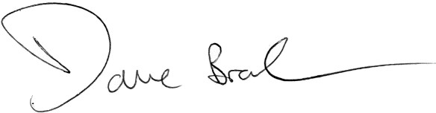

Dave Bradburn Elizabeth Hartley
Director of Public Health Director of Education
Wirral Council Wirral Council

