Careers Newsletter Year 9 - Term 2
Faye Rafferty Careers Advisor frafferty@wirralhs.co.uk
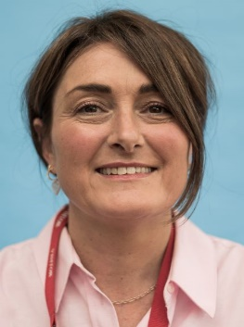
Faye delivers ‘Independent Advice and Guidance’ for our students and families. Please get in touch with Faye or your child’s House Team if you would like to discuss your child’s options at post-16 education.

As part of our careers programme, students have had a lesson this term with Faye to think about their Next Steps.
Faye visits our school for a number of days every half term. Students are given a 1:1 meeting to discuss ideas for their future plans regarding education and work. Our priority for 1:1 meetings is students in Year 11. However, other students are very welcome to talk to Faye at lunchtimes when she is in school.
Students will receive more careers and preparation for working life lessons in Years 10 and 11.

The list of colleges and schools below is not exhaustive and is an example of what is available in our area. Faye has more information about independent providers and apprenticeships.
You may also find the following websites useful.
https://amazingapprenticeships.com
https://www.gov.uk/apply-apprenticeship
https://successatschool.org

FE Colleges

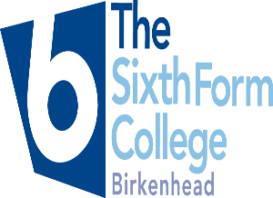
https://bsfc.ac.uk

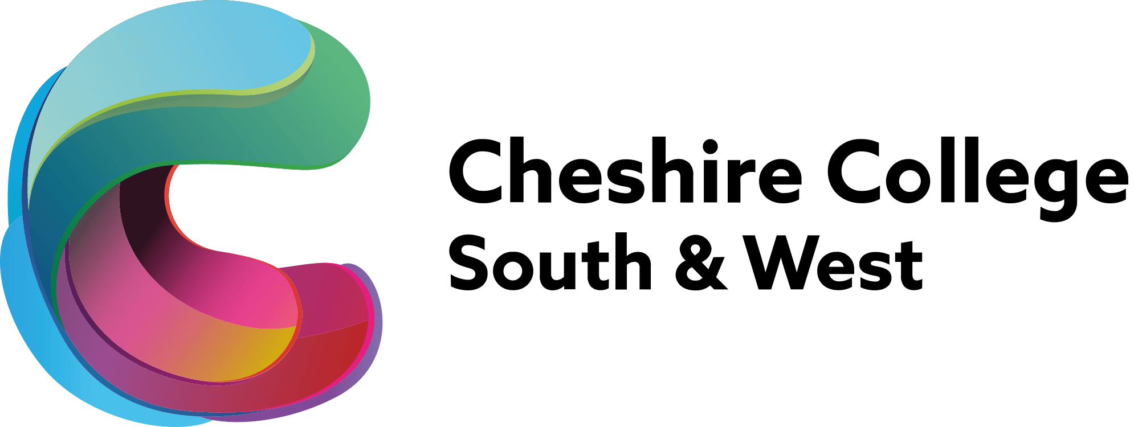
https://www.ccsw.ac.uk

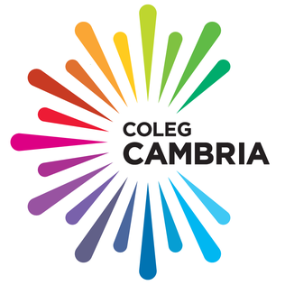

https://www.cambria.ac.uk
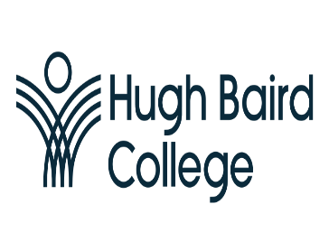
https://www.hughbaird.ac.uk
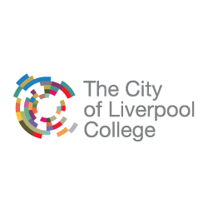

https://www.liv-coll.ac.uk/the-college

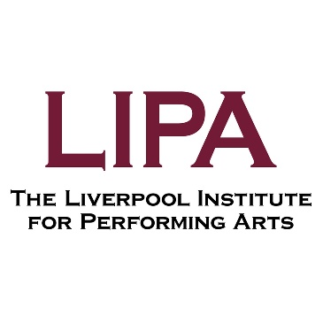

https://www.lipasixthformcollege.org



https://lma.ac.uk

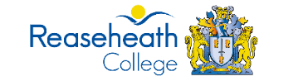
https://www.reaseheath.ac.uk

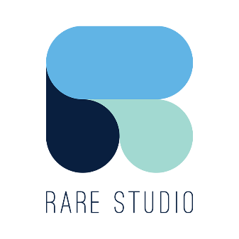

https://rarestudioliverpool.co.uk

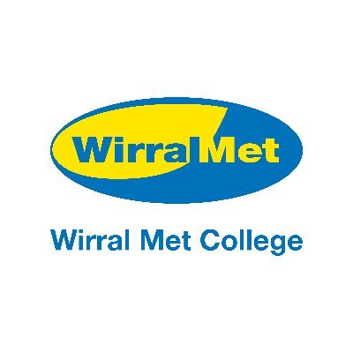

https://www.wmc.ac.uk

