Headteacher’s Report to Governors
Spring 2024

School Context + Admissions
There are currently 86 students on roll, broken down as follows:
Year 11 = 33 (out of 32 places)
Year 10 = 29 (out of 24) With an additional two students on a waiting list.
Year 9 = 18 (out of 16)
Year 8 = 3; Year 7 = 3 (out of 8 combined)
We have now completed three of our six admissions panels, and will have completed the fourth by the time governors receive this report. Sadly, we will have an increasing waiting list between now and the end of the year.
We are already oversubscribed and have been so since the start of 2024. Despite this, we continue to receive EHCP consultations from Wirral LA’s SEND team, even though we received clear guidance from a KC that they must not do so.
At this week’s admissions panel, we were unable to offer a placement to three Y9 children, all of whom fully met the admissions criteria and are suffering from an acute mental health condition. In one case, the young person is regularly self-harming, in the other two cases they are suffering from suicidal ideation. In this year group, we have three students who have been placed at JPC on a single-rolled basis by the Local Authority, contrary to our admissions process. Following a lengthy discussion, panel members unanimously agreed that we should not operate a waiting list for students, and that we should not continue to proceed with referrals for students in year groups where we are already full. The reasons for this are to not give false hope to families (given that we cannot guarantee that a space will ever become available due to the actions of Wirral LA) and to ensure that schools actively seek and promote alternatives when JPC is full and unable to offer a space.
Exclusions / Placements Ended
We have ended the placements of three students since the last governors report.
Two of the three students have been unable to sustain attendance to JPC and so, following meetings with the families and mainstream schools, we made the joint decision that it is in their best interests to try a different education provision at the present time. In both cases, we have recommended a referral to Home Education. Sadly, in one case, despite it being a long-term plan for her to move to Home Education, and despite the fact that her parent was initially supportive of it, the student’s parent is now challenging the decision and is likely to make a formal complaint. From what I can ascertain, it appears that she may have been given false information by our previous SENCO, which has led to the feelings of upset at the placement closure.
The third student was involved in a significant physical altercation with another student. This student had long-standing behavioural issues and very complex social needs. Following the incident, we imposed some restrictions upon this student in terms of where they needed to be during the school day, as well as some areas of school they were not allowed to attend. Sadly, this young person refused to accept these conditions and chose to leave. It is our understanding that she now attends a more behavioural-focused AP.
There have been two fixed term exclusions last term; none this term. The two fixed term exclusions were both for three days and were as a result of the above-mentioned physical altercation.

Attendance
Term | 2021-22 | 2022-23 | 2023-24
Autumn | 72% | 68.58% | 72.55%
Spring | 71.38% | 67.92% | 64.94%
Summer | 72.12% | 62.43%
Overall | 71.83% | 65.86% | 69.56%
Banding
We have now received the response from Simone White regarding the change of Banding for WHS from 1 down to 2, and Kate and me have met to discuss it. Whilst we still believe there are aspects that could be challenged, it is our view that Simone’s response does acknowledge the LA’s lack of understanding, as well as addressing some of the previous errors in communication from their part. Crucially, the focus of Simone’s response is to offer a meeting with James Backhouse, Assistant Director for Education, to review the school’s attendance procedures, see if there is anything the LA can, and will, do to support us, and to agree a way forward. Most importantly, Simone has agreed that if the outcome of this meeting is that the LA agree with us that our attendance is as good as we can reasonably expect it to be, then they will return us to Band 1. Kate has written back to Simone thanking her for the letter and taking up the offer of a meeting with James, whilst also formally challenging some of the responses and the LA’s actions in relation to placing students at JPC on a single roll basis – these students single-handedly account for much of the drop in attendance. At the time of writing, I am waiting for a response from James to arrange this meeting.
Wirral LA SEND team
Following on from the previous Governors report, where I had recently met with the latest interim SEND Strategic manager and felt we had agreed a way forward, I am sad to report that the situation has not improved in any way, in fact it has significantly worsened.
Wirral LA continue to send EHCP consultation requests in to JPC and, far worse, have even named JPC on an EHCP despite us meeting about the specific child just before Christmas and all agreeing not to do so. What makes this even worse is that nobody informed me of this decision until the parent herself contacted school to ask why we hadn’t arranged an induction meeting! I have formally challenged this due to the LA failing to afford me the statutory 15-day formal consultation timeframe. I have since sent in my formal response, outlining all of the reasons why the student cannot be placed at JPC. Despite my clear explanations, I was informed by the LA Solicitor last week that the student has been placed at JPC anyway! There was absolutely no explanation as to why! I have formally complained to the DfE about this and an am awaiting their response.
Even worse than the above is the separate situation whereby a parent has reported to me that the SEND manager was intending to name JPC on the EHCP of a student who we have never been sent a consultation request for…and whose parent herself was objecting to us being named! This is clearly against the SEND Code of Practice! I advised the parent of her rights to refuse this version of the EHCP and have since received a very grateful phone call from her thanking me for my advice and informing me that the LA have agreed to the package of education she had been requesting.
In addition to the specific cases above, in a recent meeting with Simone White and James Backhouse, Simone falsely claimed that the LA only name JPC on an EHCP as a result of SEND tribunals or when the DfE directly tell them that they should. This is patently false and so I challenged it. James then corrected Simone, adding that they also do so when parents request them to. This is also provably false, as can be evidenced from the case above! James then claimed that the reason they name students to JPC is to avoid costly tribunals that “we will lose”. Again, I challenged this, pointing out that I have never yet lost a tribunal. James’ response to this was to shrug his shoulders and roll his eyes. Governors may be interested to note that the attitude of Simone and James towards me was noted as being unacceptable and disrespectful by the CEO who accompanied me to this meeting.
Finally, the SEND Strategic manager confirmed that he would continue to name JPC on students’ EHCPs regardless of how oversubscribed we are, even if we already have a waiting list for that year group. This means two things: Firstly, I must stick firmly to our roll of 80 from now on, as we cannot afford to allow ourselves to be oversubscribed in any year group, given that we might still be forced to take in additional students. Secondly, I must end the placement of a hospital school student for each EHCP student placed at JPC over and above our roll number. I have informed secondary Headteachers of this situation at a recent WASH meeting, and I am seeking advice from governors about how, if, and when, we should warn parents that their child’s placements are at risk.
It is my strong view that I must keep insisting on these cases going to SEND tribunal. If they do so, and we win, then word will quickly spread and the situation will resolve itself. If, on the other hand, we lose at tribunal, then I feel we will need to seriously consider the direction of the school, especially in relation to Autism Accreditation Status. In short, if we can’t block these placements on principle, we will need to accept that I will continue to be consulted (which itself has workload implications on top of our six admissions panels a year!) and then aim to block them on our inability to meet needs. However, the LA are currently taking the stance that they will no longer allow these cases to go tribunal due to the low success rate nationally. Interestingly, they have only taken this stance since we receive the clear guidance from our KC! It is my view that it is time for us to take our concerns about Wirral LA’s actions in relation to EHCP placements to our local MPs.
Funding
In addition to the above difficulties, we are also in dispute with Wirral LA regarding several funding issues:
The first of these issues relates to unpaid funding for TA support for students with specific needs. In some cases, these are students who were placed here by Wirral LA against our admissions policy, and with significant support needs written into their EHCPs. Despite this, we are yet to receive any funds for the current financial year. Although it is by no means an excuse, it is possible that this is simply a delay due to Wirral LA running their finance department with just one staff member, who went off on long-term sickness absence. They have recently moved other staff into this department to try to catch up on their backlog. In addition, the new Interim SEND manager has apologised for the delay and promised to look into the matter for us.
The second relates to money owed for us carrying out the work of the LA for them. Due to the lack of capacity with the Educational Psychology (EP) team, Wirral LA have been asking all schools to source a private EP to help with EHCP requests, with the plan being that Wirral LA will refund the costs involved. Up to date, they have failed to do so, failed to respond to numerous repeated emails from us chasing this money up, and, when the matter is raised with various levels of management within Wirral LA, they simply advise us to get in touch the very person who is failing to respond to our emails! Thankfully, the new Interim SEND manager also promised to chase this up for us and I am pleased to inform governors that we have now received this money, less than a week since the new Interim manager agreed to look into the matter. Hopefully, this is a sign of things to come!
Finally, our school bursar recently informed us that Wirral LA had taken money from our budget for our previous contract with Wirral HR. Governors will remember that we moved to Cook Lawyers and cancelled our contract with immediate effect due to Wirral HR’s failure to deliver the service promised. Wirral HR disputed this and so I was told they would formally review our complaint, investigate the matter, and then respond. This was in October 2022! We have never received a response following that date, and yet they have taken the money from our budget, without permission, over 14 months later! I contacted James Backhouse and Simone White to complain about this and to threaten legal action. Astonishingly, both replied to me promising me that they would look into the situation and get back to me as soon as possible. I have since received an email from Catherine Kerr (Line manager for Wirral HR) to apologise for the situation and informing me that she has instructed Sue Blevins (HR manager) to issue a full and complete refund with immediate effect.
Whilst two of these have reached a satisfactory outcome in the last week, I believe it is wholly unacceptable that they ever arose, and they are examples of the unnecessary time we are having to waste in solving issues that relate to poor, unprofessional, unacceptable, and/or illegal practices within Wirral LA.
Wirral LA Communication
As groups of Headteachers, both WiSpHA (special Heads group) and WASH (secondary Heads group) have recently raised significant concerns over the culture of non-communication from Wirral LA staff at all levels. These concerns are being raised by the Chairs of both groups with Elizabeth Hartley (new DCS), but they are such a source of additional workload and stress for me that I feel it is important to share the level of difficulty with governors. It is my intention to report this each term, until and unless there is a significant improvement. To this end, please see the table below, which only includes those at manager level within the LA. Sadly, I could add dozens more lines to this if I included all LA staff that we try to deal with. However, given that it is incumbent on leaders to set the tone and culture, I feel it is the lack of response from LA leaders that I should report to governors.

LA Officer | Number of emails sent | Number of emails not responded to
Simone White, Director of Children’s Services | 5 | 3
James Backhouse, Assistant Director - Education | 12 | 10
Adrian Leach, Strategic SEND manager | 28 | 19

Staffing
As I write this report we are just at the start of some significant staffing changes at JPC. These are currently temporary, as a result of AOP’s absence and pending departure, but there will be a consultation process early next year to consider making them permanent. At present, and due to the delay in HCES amalgamation, it would be prudent for all staffing changes of this kind to be temporary until Summer 2025, by which point we will have carried out a formal review, including consultation process, of the staffing structure of both WHS and HCES.
The most significant change is the removal of the Head of House (HOH) roles. One of the drivers for this was the need to move P Hoey into the role of acting SENCO, with H O’Loughlin taking on the role of Acting Head of LFL Faculty, with a focus for this year on transition to Post-16 education for our current Y11 students. HOL’s new role will also lead to an increase in capacity for Sarah, who has previously led this faculty as part of her Deputy Headteacher role. I do wish governors to be aware that I already had concerns that these HOH roles were not working in the way they were intended and did not represent value for money. The intention of these roles was for them to be strategic, data-driven roles that resulted in a problem-solving approach to improving attendance, punctuality and student progress. Unfortunately, as is so often the case with pastoral work, they have become all-consuming student support roles, with no time for the strategic work – which in turn has led to a lack of capacity in Laura’s Assistant Headteacher role. Therefore, we have ‘swapped’ the role out for a specific House TA position, which will provide more time for the students’ pastoral needs, without the distraction of teaching and other responsibilities.
In addition to these new House TA positions, the rest of the TA team have been re-deployed amongst the two faculties in order to provide more specific, academic support to each subject area. This has proven to be enormously effective in recent years in both Food and Art, and so we have extended it to the rest of the subject areas. Again, this is a temporary change and we will be reviewing it at regular intervals over the coming months. However, it has so far been very much welcomed by both teachers and TAs, and we are hopeful that we will see a really positive impact on student progress as a result of these changes, as well as providing a clearer professional development route for our TAs.
One of the consequences of the aforementioned lack of strategic work from the Heads of House, and the subsequent removal of those positions, is that there is an even greater demand on our small leadership team to carry out this data analysis and strategic work. Therefore, and especially at a time of increased demand on my workload due to academy conversion, HCES amalgamation, and as a result of the ongoing EHCP consultations, the capacity within the Senior Leadership Team is limited to say the least. (As a reminder, when I joined the school, its SLT consisted of one Head, one Deputy, two Assistant Heads, and a Senior Teacher. We have spent the last six years operating with one Head, one Deputy, and a 0.9 Assistant Head.) Consequently, and whilst these temporary changes are in place, I am formally requesting a temporary increase in the school’s Senior Leadership Team. The intention is to increase the responsibilities of our two Heads of Faculty (HOF), with an additional, enhanced focus on analysis of data re. academic progress, as well as responsibility for reporting to governors for their faculty area. This will increase Laura’s capacity in relation to the other aspects of her role, allowing a greater focus at SLT level on attendance and punctuality data analysis and interventions. In order to accommodate the increased responsibility, I would be seeking to increase the HOF’s non-teaching time, as well as increasing the size of their TLR. I am requesting this to be in place temporarily until Summer 2025, by which time the HCES amalgamation will be completed and we will have completed a formal consultation process on the required, permanent leadership structure for both services.
Staff wellbeing
This continues to be an agenda item on every staff meeting. Some minor issues have been raised throughout the term in relation to staff wellbeing, which have all been easily and quickly resolved.
It is my intention to change the way we conduct staff wellbeing survey this year. We have carried out virtually the same survey for several years now and we can be confident in the repeated positive messages we have received from these. Therefore, I intend to ask a much more ‘open’ question this year:
“We want to have a school where every staff member feels valued, supported, and part of a community that is all pulling in the same direction for the benefit of our students. To what extent do you feel we have reached this goal? What changes do we need to make in order to achieve it? Please comment on anything we should stop doing, anything we should introduce, and anything we should tweak, in order to ensure the best possible school community for all.”
On a separate note, Joe Dutfield, Food teacher, has asked me to formally thank the governing body for the incredible support she has received since joining the school and her husband falling seriously ill. It was truly incredible to see him at our recent Enterprise Week event, looking so healthy and independent. For governor’s information, Joe attended the event without pay, despite it being her day off, as a way of thanking the school for the support she has received. On a personal level, I do think it’s good to be reminded that the vast majority of staff really are very grateful for the moral way in which we run the school and for the support we give them in times of need. Joe is a shining example of the benefits of treating staff with compassion and understanding.
Health and Safety
There haven't been any reportable Health and Safety injuries since the last report.

There have been two accident reports completed for staff, both for minor injuries. The first when the automatic front door swung open and hit the member of staff on the hand, resulting in bruising and swelling. The second during the icy weather when the staff member slipped when getting out of a vehicle. Safe paths into school had been prepared by gritting. The recorded injury was a pulled hamstring.

The building work is underway for the new Home Education service area, and this has resulted in some health and safety challenges regarding access to water for the rear part of the building and the impact of the building work on our intruder and fire alarm systems. We are in contact with the LA to reinstall the water connection for this part of the JPC site, and, in relation to the fire and intruder alarms, the LA have made the decision to isolate this area temporarily from both automatic systems.

Number of accidents/incidents reported to LA: 0
Number of minor accidents/incidents staff: 2
Number of minor accidents/incidents students: 4
GDPR
Number of GDPR incidents/breaches reported outgoing from WHS: 0*
Number of GDPR incidents/breaches reported incoming to WHS: 0
*This does not include the recent email situation with an ex-member of staff. Despite the seriousness of this situation, there was no proof of a GDPR breach that we could report to the ICO.
Academy Status and HCES amalgamation
Jim Bowyer and me finally got the opportunity to meet with Simone White and James Backhouse to discuss their concerns about our application to join Skylark academy. The meeting was a largely positive one (at least in terms of the agreed plan of action, if not in terms of their conduct towards me) and we were able to challenge many of their misconceptions and misunderstandings in relation to hospital education. An example of this is that Simone claimed that Wirral LA are paying for in-patient education for students at Ancora House. Quite apart from how irrelevant that is to our academy conversion application, we were able to explain to her that it is against the DfE funding agreement for this to be happening, and so, if it is, then Wirral LA have been negligent in allowing it to continue for so long.
The result of the meeting was that we agreed to produce an action plan and proposed timeline for both the academy conversion and the amalgamation of HCES and WHS. Please see Appendix 1 for the document we produced. The next step now is to produce a paper for Schools Forum in order to inform the wider school community, and general public, of the changes to come; changes which also include the introduction of a charge to schools for students attending JPC.

SEND – PH
Changes
We are really sad to have lost Annette as our SENCo. Her extensive knowledge and informed decision making will be really missed. Annette has been at the school for many years and, through the time she gave to students and their families and to other staff members, she has touched many lives and changed students’ life experiences for the better. I have been fortunate to have worked with Annette for many years and have learned a lot from her, both in terms of factual knowledge and the importance of giving people time and consideration to think a challenging situation through.
I am looking forward to the challenge and grateful for the support of colleagues as I try to work out how to manage the many different tasks within this role. I am particularly fortunate to have Anna Kirby, our admin support working alongside me!

SALT
I know Annette wrote in our last report about the work Kirstie is doing with our TAs. We are looking at her running some training for them on a regular basis through the school’s CPD programme.

Teaching Assistants
There has been a lot of change as we have returned from our half term break. For some time, in our WLT meetings, we have been considering different ways of managing our TAs. Due to the nature of our school, any plan put in place frequently requires adaptations due to the ever-changing circumstances students bring to us! It was felt that asking our Faculty Leads to assign TAs, based on discussion with the teachers in their faculty, would enable us to develop a plan that ensured we were making the best use of the excellent support we have available.
We also now have two TAs working as Pastoral TAs to support the House Teams. Louise Bell is supporting Carol in the Blue House and Anthony Thompson is supporting Helen in the Green House. Both of these staff have excellent skills for these roles and it is great that they have the opportunity to gain new experience.
It is early days to see how our new systems work out but once again our TAs have demonstrated their adaptability and preparedness to rise to new challenges!
This part of the report may be shorter than usual as it is my first week in the job!

Safeguarding – J McArdle
Safeguarding and Attendance remains a major focus for our students at JPC. We have adopted a systematic and proactive approach of support for students and families who are struggling. We achieve this by regular meetings with families in school and home visits. Having an overview of what services are available on Wirral ensures our families are sign posted to services and charities that can help them.
We currently have:
4 Students CLAC.
0 Students Child Protection.
0 Students CiN
7 Students TAF
5 Students supported through regular Multi Agency Meetings.
6 Students supported by CAMHS Eating Disorder Team.
9 Students on our Risk List, including 2 for health.
1 student assessment from Social Care.
We have introduced a more formal, structured approach for students who need a short-term reduced timetable. Families now meet with pastoral staff and complete a ‘Reduced timetable pro forma’, which includes SMART targets to work back towards full time. This can then be shared with Phill and WLT to monitor and track progress.
We continue to work with outside agencies including CAMHS, HSIS, Family Matters, Response and Safer School Police Officer. Our current Early Help Advisor is Kristina Ryan, she has taken over the role from Christine Meek and we look forward to working with her in the future. Recently CAMHS have held their sessions with students in school, this is working particularly well as they are in a safe environment, away from the clinical aspect of Birch Centre.
In response to the concerns surrounding Emotionally Based School Avoidance (EBSA), Wirral has initiated a comprehensive strategy aimed at supporting children, families, and schools grappling with this issue. EBSA, a phenomenon where children experience significant anxiety or worry about attending school, has become increasingly prevalent, necessitating a coordinated effort to address its root causes and provide necessary support systems. Sarah and I are attending a course at the end of March which we will feed back to all staff and governors.
As part of my CPD, I have attended Smoothwall training for Web Filtering and Monitoring, as recommended by DFE & KCSIE, ensuring the effectiveness of our provision to filter and monitor alerts on our computer systems. In addition to attending a Safer School Conference led by Merseyside Police, all of which continues to ensure safeguarding of our students and staff.

Curriculum and Extra-Curricular News and Celebrations

Technology – J Dutfield
Year 11
This term in food technology, year 11 students are having to complete their final practical exam. Their task this year is to cook a 3-course meal whilst increasing the dietary fibre in each dish. So, they have been practising by making some wholemeal pastry for their meat and potato pies, some wholemeal pasta for a vegetable lasagne and a mixed berry compote for a panna cotta. Their exams are coming up over the next few weeks so they are all ready to go and they have chosen some delicious dishes to cook.
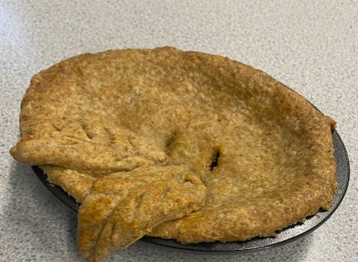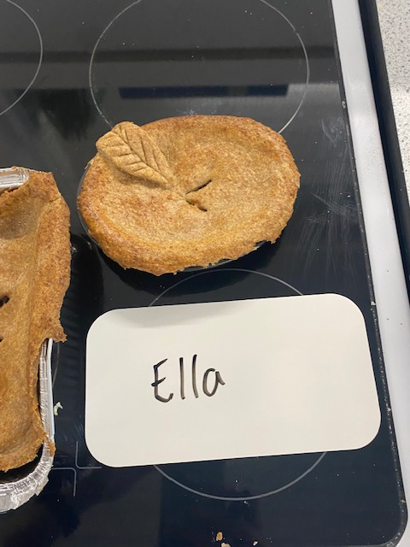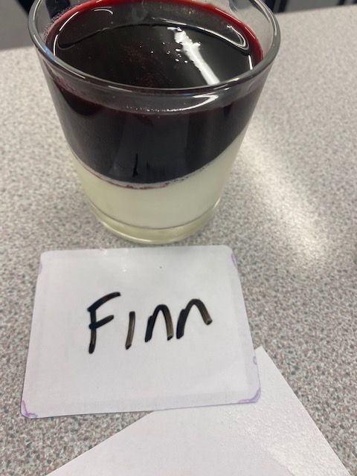
Year 10
Year 10 absolutely love their cooking lessons and they have been studying diets for different age groups, medical diets and ethical diets this term. They have been cooking, amongst other things, sushi and an apple tarte tatin.
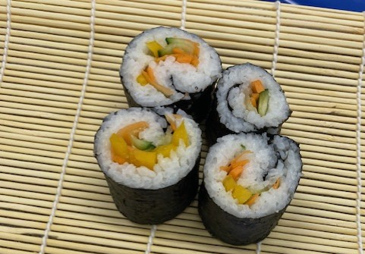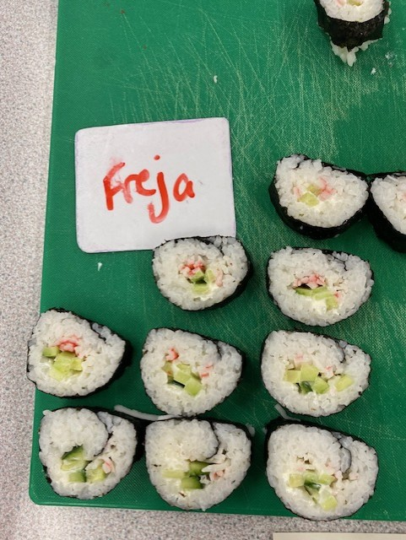

KS3, student voice, snow day and enterprise week
KS3 have been busy in lessons learning how to ‘eat well for less’. They have been cooking mini pizzas, scones and cheese and onion pasties. They have all completed an independent cooking assessment and proving they can independently follow a recipe and method.
All students have also been taking part in student voice activities within Food technology and helping to design student friendly recipe sheets to use in class. This has been really successful and has meant that more students are taking recipes with them to cook at home.
On the snow day the students who were in all came down to the food room and cooked as a team. They made a delicious spaghetti bolognaise and homemade garlic bread. They then served it at lunch time to staff and students. It was like an Italian restaurant and certainly warmed everyone up.
For enterprise week the students in the catering team created ‘Nan’s Scrans’ where they revamped some old fashioned recipes such as Beef cobbler, Manchester tart and pineapple upside down cake. They served these to the judges who all seemed to enjoy the food.
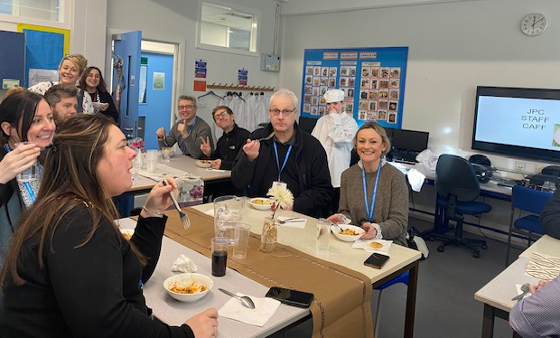

Music and Performing Arts – S Steff
We have recently had enterprise week where some of our Music and Performing Arts students performed at the local old age home, Nazareth House. The students played fantastically and the residents loved having our students play. We even had one of the residents then play the piano for us.
In the final event of Enterprise week, we had students perform the songs to all of the guests in the hall.
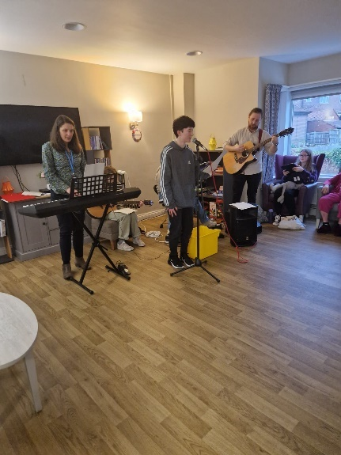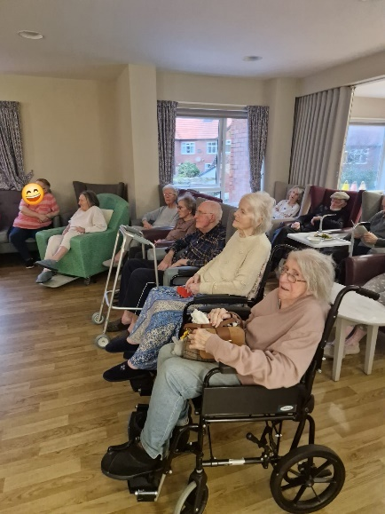

Our Y11 students are working hard to complete their coursework for their Performing Arts course.

Next Thursday we will be taking students from KS3 & 4 to see the Royal Liverpool Philharmonic Orchestra perform, one of our annual music trips.
Here are some photos from Nazareth House.

STEM – S Little
This term, we are celebrating British Science Week. The science department are delivering lessons to KS3 and yr10 classes on this year’s theme ‘Time’.
Biology lessons are looking at the digestion system and the length of time it takes food to pass through the body. KS4 classes will dissect organs from the digestive system including, stomach, liver and kidneys. KS3 classes will dissect owl pellets to see what has and hasn’t been digested.
Chemistry lessons are learning about the formation of rocks and fossils over time. Students will explore how fossils form, how they help us discover the past and have a go at making their own fossils.
Physics lessons will look at the possibility of time travel. Students will design their own balloon propelled time machines, we will calculate the speed of these vehicles and hope that one reaches the 88mph needed in the Back to the Future films.

Science week will culminate with a whole school event celebrating the successes of students during the activities. Students and visitors will take part in a ‘Time’ themed science and the event will finish off with our stage demonstration ‘The Fast and Slow Science Show’.

All resources were fully funded for following a successful bid for a £350 grant from the British Science Association.

Art – R McMillan
Liverpool Biennial workshop.
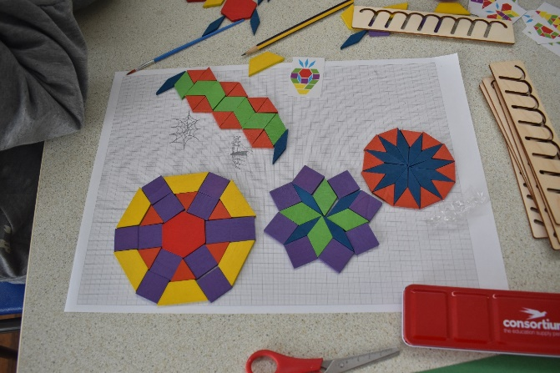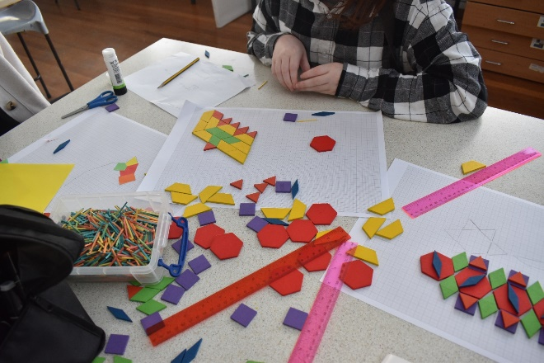
Students across both Key Stages were involved in a workshop delivered by Klaire Doyle from the Liverpool Biennial designing ideas for one of the Liverpool Totemy to be recycled into. The students have been involved in the process of the meanings (climate change) of the Totemy since 2021. The recycled object will then be presented to the school. Klaire is visiting the school later in March to deliver a presentation on the reasons for the Totemy design and how it links to climate change.
Our Totemy, by the artist Alicja Biala was delivered to us over the February half term. It was originally one of 3 that were on display outside the Liver building.
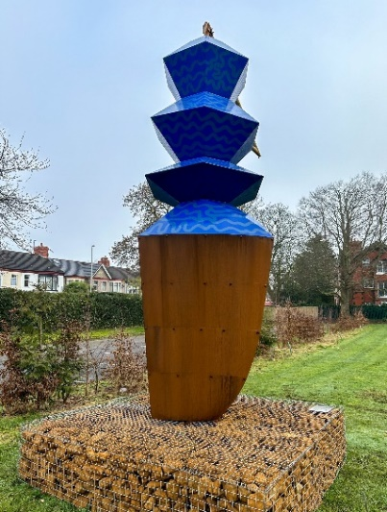


Y10 new Brighton trip.
Year 10 Photography students enjoyed a visit to New Brighton to take part in a photo walk to capture images of the town and it’s surrounds. The work completed in the project will go towards their final GCSE grade.


Y11 exams.
Y11 students are well underway with work for their examination module for their GCSE’s. They will sit their exams at the end of march and during April. We wish everyone of them best of luck!


Library and Reading intervention – A Rimmer
FH, Y10, received a reply from King Charles' office in response to her letter that she wrote to the King a while back, explaining about how well she is doing and our library etc. She has it framed, alongside the envelope, on her bedroom wall.

That Reading Thing phonics intervention - JDS, Y10, has made brilliant progress and passed the foundation stages so is now completing the advanced levels. She has grown in confidence so much and has been brilliant in the sessions.

The student librarians looked at the book suggestions from all students and we ordered some new books for the library which some students have been reading.

We have applied to Siobhan Dowd Trust to take part in an Independent Bookseller Book Spree. MM, Y11, wrote the following supporting statement: 'Hello! I am Maria, one of the student librarians at Wirral Hospitals' School and I truly love reading. We heard about the incredibly generous opportunity of going on a book spree. We have created a 'Recommended Reads' shelf where I put books I have read and enjoyed to try and encourage others to read. It would be an honour if you could consider our appeal. Thank you so much!'

We now 75 students who have completed their GL Reading tests and have been set personalised Reading Strategies (based on the GL reports) to be used by teachers across the curriculum.

Animal Care – H Rice
Visit from Otis the Dog to Animal Care Lessons
As part of the BTEC Animal Care course students have to show evidence of restraining two different animals. The Y11’s have already had a visit to West Wirral Riding stables to handle Trixie, the pony, and Y10’s will have this visit later on this year.
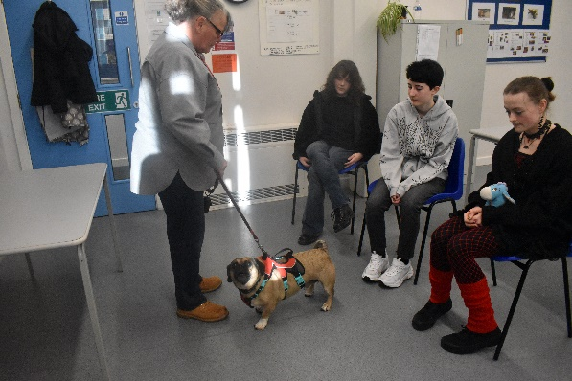
So, to fulfil the BTEC criteria I invited Kathy Jones, my twin sister, into school with her rescue dog, Otis. Otis is a pug and was rescued by Kath as his owner couldn’t look after his welfare needs properly. Kathy explained to the students that when she got him he was very overweight. She explained plans that she has put in place to reduce Otis’s weight to a healthier one.
The students had the opportunity to put on his harness and lead, lift him correctly and walk him through an obstacle course in the hall.
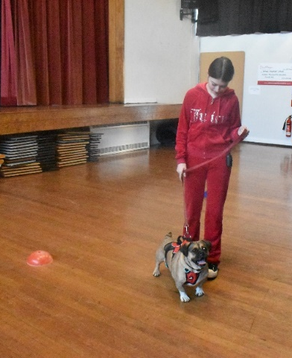
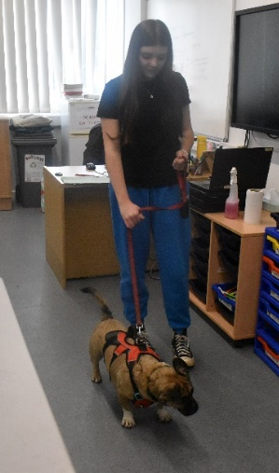
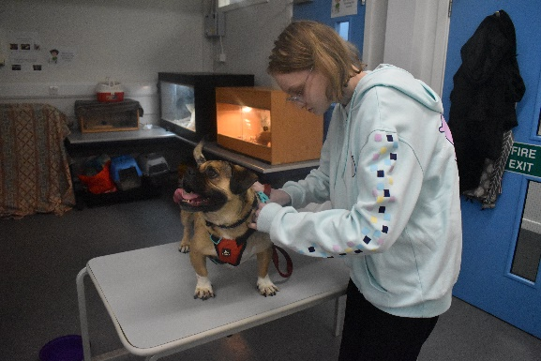

Business Studies – P Tam
Local entrepreneur, Matt Tomlinson, visited our Year 10 and 11 Business Studies classes at the start of February.

Matt delivered a talk discussing the financial and non-financial motives of starting a business and related this to his own personal journey. He described how he went from being a sole trader to a private limited company partnership that is in its tenth year of trading. He explained the challenges he encountered from the pandemic and the need to constantly evolve to meet the demands of an ever-changing market. Matt also gave inspiration to our students on how his business mottos PUSH (Push Until Success Happens), FAIL (First Attempt In Learning) and CHAMP (Confidence, Happiness, Attitude, Mindset and People) can always be applied to our everyday lives.

Quotes from students:
"Really motivating and very encouraging, which has really inspired me with his story"
"He showed you could be in one of your worst places but still improve and change your way of life"
"I learnt that to make a successful business, you need a lot of patience and hard work. It doesn't happen overnight"
"Made me realise being awful at Maths means I'm not horrifically done for or stupid"
"He put everything into his business, like time and effort"
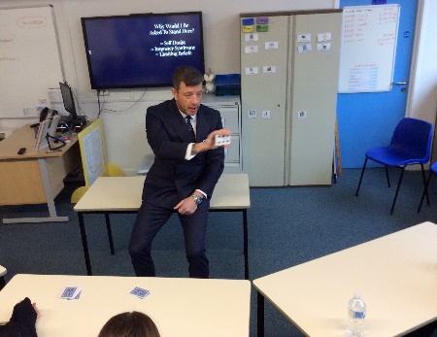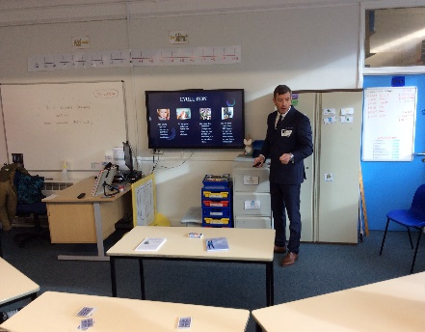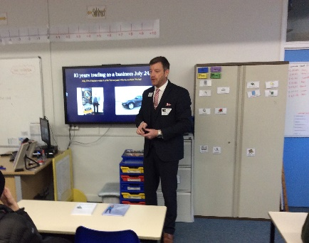

Science Technician News – J Hale
Connections from my Salters Institute Science technicians award are still ongoing. Having already received a science trolley from Gratnells - manufacturer of innovative storage solutions worth £567 we have now been offered three large storage units from them. These are worth £2850 and will be a welcome solution to storage problems in some areas of the building. We have also been asked to supply a wish lish of smaller science equipment to take us up to a full class set to secure the next few years of successful experiments. Fingers crossed for what we will receive in the future.
Careers – H O’Loughlin
Virtual Reality Work Experience
As part of the government’s careers strategy to support secondary schools in implementing a world-class standard of careers guidance, the ‘Let’s Explore’ programme is designed to allow SEND students to engage with employers wherever they are. As part of National Careers Week 2024, all students had the opportunity to undertake this VR work experience. Built by the team at Growth Platform-Liverpool City Region Growth Company, state-of-the-art virtual reality headsets transported students directly into a working environment, all from the comfort of their classroom. Students had the opportunity to familiarise themselves with employers, what they would see on their first day and who they might be working with. There were three different categories of work and work places that students had the opportunity to immerse themselves in:
- The Visitor Economy – Knowlsey Safari Park
- The Housing Sector – Regenta Living
- The Engineering Sector – Shawton Engineering
Following the experience, students were invited to complete some questions to evaluate what they thought about it. All feedback was extremely positive.

PE and Sports Leaders – C Leach
SLA trip to Heswall primary school
As a requirement for the sports leaders’ award, students need to showcase their skills by teaching groups a sport or activity. This year our students completed this by attending Heswall Primary School, where they had to deliver a session they had developed themselves, to year 6 students. Our students were in charge of roughly 16 students per group, over 30 overall.
Firstly, I would like to express how well SE did on the day. He was clear with his words and instructions, as well as using a desired amount of humour to get on a good level with the primary aged kids. He showed confidence the entire afternoon from the get go. Dividing the kids into separate groups ready for them to be taught, using verbal and no-verbal cues throughout the sessions.
AA and SJ teamed up to deliver two sessions of tennis. They got off to a shaky start as their nerves were clearly showing, but grew in confidence as the sessions went on. Both clearly showed progress in the second session as they became more comfortable and learnt how to deliver the lesson more effectively by realising what had not been too successful in their previous one.
After the session two of the Heswall pupils came up to me and said "your students did very well, we enjoyed all of the lessons, you should pass all of them."
Each of the three students have now completed the course, and each one has done brilliantly throughout the course. To see how far they have come, witnessed their journey, and watch them perform how they did, in a difficult situation for all three of these students was very special.

LFC Festival
11 Students took part in a festival prepared by the LFC foundation, who have been working with our students for the last two academic year. The festival took place at the Hive, where the students participated in four separate sporting activities.
The students were coached in a new and growing sport, Kin ball, as well as Basketball, Football and a multi sports session. There was a total of 11 students that took part. The students represented the school well and showed willingness to learn and resilience throughout the day.
LFC foundation continue to work with us and we have been invited back to other festivals in the near future.
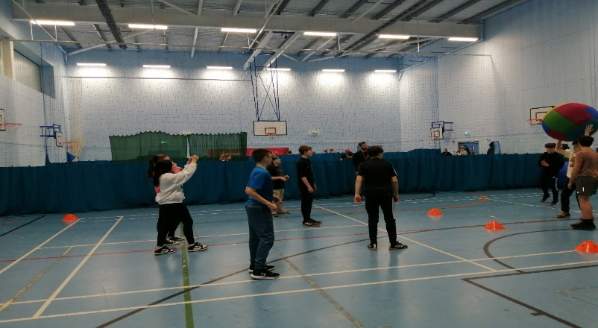
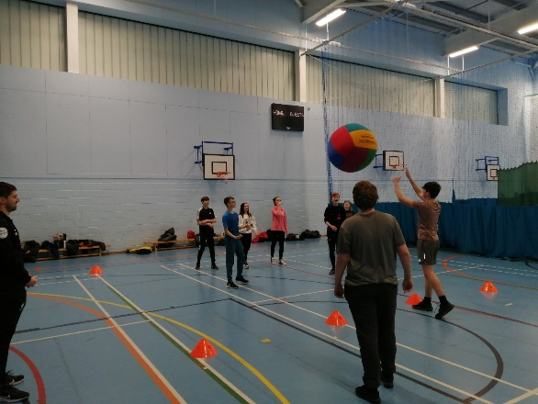

And finally…
Never work with children or animals they say! So, I did both!
Lochy, our new school puppy is, let’s just say, ‘Going through a phase’! This phase being that he wants to chew anything and everything…apart from his chew toys! This is usually okay, and the office team have been incredible in their support for keeping him entertained when I am busy, but sometimes it can prove to be tricky! For example, in a recent, very difficult, parent meeting about the need to close a student’s placement through non-attendance, Lochy proceeded to shred his puppy pad into a thousand pieces…and then pee on the carpet! What fun!
More positively, however, he is brilliant with the children and is already having a positive impact on their wellbeing. We all look forward (i.e. we’re really desparate!) until he is fully trained and ready to work closely with those who need him. He is going to be an incredibly positive addition to our team here at JPC!

P Arrowsmith Date: March 2024

Appendix 1
Proposal to reorganise the Management of Wirral Home and Continuing Education Service.
Background
Prior to Sep 2016 Wirral Home and Continuing Education Service was managed by the Headteacher and governing body of Wirral Hospitals School. This situation altered in time for the academic year 2016-17 when the management responsibilities of Wirral Home and Continuing Education Service moved to the Local Authority, and was run by the Head of Service. The rationale for this move is unknown however it has resulted in:
- An absence of the quality assurance and safeguarding structures that are expected to be present in the management of alternative provision to meet section 19 duties.
- A greater potential for uncoordinated provision for children whose chronic health condition prevents them attending their school. Arranging education for children who cannot attend school because of health needs - GOV.UK
Proposal
To address both of these points we propose to create a new Medical Needs Education Service for the Wirral, which will not only return HCES to the pre-2016 situation, with regards to its management, but further coordinate the service by running it as one holistic service alongside WHS, with the management responsibilities being fully undertaken by the governing body and Headteacher of WHS.
This move will also:
- Provide significant development opportunities to improve the quality of education provided by HCES, as its staff will access opportunities available to staff at WHS and the hospital education sector nationally, with whom WHS has strong and productive links.
- Prepare for future provision of AP in the LA by increasing the capacity of WHS to offer the 3-tier intervention model outlined in the 2022 SEND and AP Green Paper.
In addition, the LA supports the conversion request made by WHS who have applied to join The Skylark Partnership. This conversion will move WHS into a specialist Hospital Education/Medical Needs Multi Academy Trust, securing access to the knowledge and expertise that is present in the trust and the guarantee of provision development and support that Skylark provides.
This will result in the following Coordinated provision delivery by the newly titled Wirral Medical Needs Education Service, WMNES

Proposed Structure of support for pupils with medical needs
In addition to bedside teaching at Arrowe Park Hospital, which will continue as previously (working around the nursing team’s requirements to provide medical care), and as part of the LA’s Section 19 Duty to provide education for children who are too unwell to attend their main-rolled school, Wirral will have a five-stage offer of support:
Stage 1 – Housebound pupils who, for reasons of physical health and/or social anxiety, are not yet ready or able to work within a community setting.
Education will be provided by teachers and/or tutors in the CYP’s home. This will be provided for a minimum of 5 hours per week, as per historical statutory guidelines. Due to the intensity of 1:1 teaching, and as per statutory guidance, this offer will be limited to less than 25 hours a week.

Stage 2 – Students displaying social anxiety and/or immunosuppression to the point where they are unable to be educated in a group setting with other CYP.
Education will be provided by teachers and/or tutors in a community setting near to the CYP’s home. This will be provided for a minimum of 5 hours per week, as per historic statutory guidelines. Due to the intensity of 1:1 teaching, and as per statutory guidance, this offer will be limited to less than 25 hours a week.

Stage 3 – Students whose illness and/or social anxiety prevents them from attending full time education in a group setting.
Education will be provided by teachers and/or tutors in the HCES base. This will be provided for a minimum of 5 hours per week, with a view to building as quickly as possible towards full-time attendance.

Stage 4 – Students whose illness and/or social anxiety prevents them from attending full time education in a mainstream school, but are able to manage a small, low-arousal environment in groups of 8-12.
Education will be provided by teachers and/or tutors in the JPC site. Students will be offered a flexible integration package lasting approx. 6-8 weeks (health dependent), with a view to building as quickly as possible towards full-time attendance. If students are unable to sustain full-time attendance due to their health needs, they will be temporarily returned to Stage 3 until they are well enough to try full-time education again.

Stage 5 – Return to mainstream.
Ideally, and if funding allows, the return to mainstream would be facilitated by specialist WMNES staff as part of a reintegration package/outreach service.
Note: Students may proceed directly to stage 5 from any of the previous four stages, depending on the improvement in their health and readiness to return.

The intention of the service is that CYP will move up and down the stages of support as their health allows. All students must be referred on medical grounds, with supporting evidence from specialist medical practitioners. In line with recent guidelines, students on a waiting list for specialist medical intervention may be admitted on the strength of a GP letter, but only to Stages 1-3. All students admitted to Stage 4 must have supporting evidence from specialist medical professionals, i.e. CAMHS and/or paediatrician.
Students will be admitted following a multi-agency admissions panel process, including partners from health, the LA, and the EP service, and will be placed by the admissions panel on the stage that best suits their health needs. Admissions panels will take place each half term. In order to meet the statutory guidance of providing education to CYP within 15 days of them not attending school, some students may be offered support at Stages 1 or 2 in between panels, with their cases formally reviewed at the next available admissions panel.

WHS Academy Conversion - Proposed Timeline
Spring Term 2 2024 – Paper to be written for Schools Forum. Documentation to be shared with LA regarding proposed new service and providing information relating to JPC cohort. LA to confirm to Regional directors office that they support WHS application to join The Skylark Partnership.
Summer Term 1 2024 – Financial review of WHS and HCES, involving all key partners from LA and WHS. Proposed new staffing structure for HCES to be agreed. Formal consultation process for new staffing structure to begin.
Summer Term 2 2024 – Staffing restructure for HCES based on jointly-agreed plan. New staffing structure to be in place for September 2024. Paper to be presented to Schools Forum outlining the structure and charging plans for the new service.
Autumn Term 1 2024 – Formal application for academisation to proceed supported by LA based on new structure and integrated service plan.
Spring Term 1 2025 – HCES to formally relocate to JPC site.
Spring Term 2 2025 – Dependent on RSC timeframes and agreement, academy conversion to finalise and full amalgamation to complete in time for summer term 1 2025.

