Wirral Hospitals’ School

Safeguarding Policy and
Procedure
September 2020

Adopted Autumn 2020 Ref G53.20
Mid year review – Spring 2021

Key Contacts:
Role: | Name/ Details: | Contact:
Designated Safeguarding Lead | Vicki Tranter | 0151 488 7680
Deputy Designated Safeguarding Lead | Jackie McArdle | 0151 488 7680
Nominated governor for Safeguarding and CP | Maureen Bowsley | 0151 488 7680
Chair of Governors | Maureen Bowsley | 0151 488 7680
Local Authority Designated Officer (LADO) | Anne King | 0151 6664442/5525  kerryWilliams@wirral.gov.uk  anneking1@wirral.gov.uk
Head of Service Quality & Safeguarding Children | Joe Banham | 0151 666 4371
Prevent Co-ordinator | Alison Burnett | Alison.Burnett@Liverpool.gov.uk  07394559106  Alison.Burnett@liverpool.gov.u
Prevent Team Merseyside Police | Prevent Team | 0151 777 8125
Director of Children’s Services | Paul Boyce | 0151 606 2000
Integrated Front Door | Mon-Fri, 9:00am – 5.00pm  Outside of these hours | Tel: 0151 606 2008  ifd@wirral.gov.uk  Tel: 0151 677 6557
Police | In an emergency  For non-emergency but possible crime | 999  101

School Record of Safeguarding Training:
Type of Training: | Date completed: | Next due date:
Whole School Safeguarding Training  (Due every three years) | 10th January 2019 | 10th January 2022
Senior Designated Safeguarding Lead (DSL)  (Due every 2 years) | Vicki Tranter  November 2019 | November 2021
Deputy Senior Designated Safeguarding Lead (DSL)(Due every 2 years) | Jackie McArdle  30th November 2018 | November 2020
Whole School Staff Refresher/updates  (Annual) | September 2018 | September 2019
Safer Recruitment Training  Name & Date of training  (Due every 5 years) | Phill Arrowsmith 2016  Sharon Jones 2014  Jenny Macdonald – December 2017 | Phill Arrowsmith 2021  Sharon Jones 2019  Jenny Macdonald December 2022
Governor Training  Safer Recruitment Training  Whole School Safeguarding Training  (Due every three years)  Whole School Staff Refresher/updates  (Annual) | Maureen Bowsley 2018  Whole Governing Body  January 2019  Whole Governing Body  2018 | Maureen Bowsley 2023  Whole Governing Body  January 2022  Whole Governing Body  2019
Contents:
Safeguarding Policy: |  | Pg.
1 | Introduction | 4
2 | Our Ethos | 4
3 | Scope | 4
4 | Legal Framework | 5
5 | COVID 19 / Roles and Responsibilities | 5
6 | Supporting Children | 7
7 | Safeguarding Procedure | 8
8 | Dealing with a Disclosure / Record Keeping | 9
9 | Discussing Concerns with the Family | 9
10 | Safer Workforce and Managing Allegations | 10
11 | Staff induction, training and development | 11
12 | Confidentiality, consent and information sharing | 12
13 | Inter-agency working | 12
14 | Contractors, Service and Activity Providers and Work Placement Providers | 12
15 | Whistleblowing and complaints | 13
16 | Site Security | 13
17 | Quality Assurance | 13
18 | Policy Review | 14

Safeguarding Policy:
INTRODUCTION:

  - Safeguarding children is everyone’s responsibility. Everyone who comes into contact with children and families has a role to play ensuring children and young people are safe from abuse, exploitation and harm. Our school is committed to safeguarding children and aims to create a culture of vigilance.

  - Our pupils’ welfare is our paramount concern. The governing body will ensure that our school will safeguard and promote the welfare of pupils and work together with agencies to ensure that our school has adequate arrangements to identify, assess and support those children who are suffering or likely to suffer harm.

  - Our school is a community and all those directly connected, staff members, governors, parents, families and pupils, have an essential role to play in making it safe and secure for all.

  - This procedure document provides the basis for good practice within the school for Safeguarding work. It should be read in conjunction with the Wirral Safeguarding Partnership safeguarding Policies and Procedures. These are in keeping with relevant national procedures and reflect what the partnership considers to be safe and professional practice in this context.

2 OUR ETHOS:

2.1 We believe that this school should provide a caring, positive, safe and stimulating environment that promotes the social, physical, spiritual and moral development of the individual child; enabling all children to thrive.

2.2 We recognise the importance of providing an environment within our school that will help children feel safe and respected. We recognise that both mental and physical health are relevant to safeguarding and the welfare of children.

2.3 We recognise that all adults within the school, including permanent, supply staff, temporary staff, volunteers, parents and governors, have a full and active part to play in protecting our pupils from harm.

2.4 We will work with parents to build a solid understanding of the school’s responsibilities to ensure the welfare of all children, including the need for referrals to other agencies in some situations.

3 SCOPE

3.1 In line with the law, this policy defines a child as anyone under the age of 18 years but in the case of SEN it is up to 25 years of age.

3.2 This policy applies to all members of staff in our school, including all permanent, temporary and support staff, governors, volunteers, contractors and external service or activity providers.

3.3 This policy applies to all learners in this school.

4 THE LEGAL FRAMEWORK

4.1 Section 175 of the Education Act 2002 places a duty on governing bodies of maintained schools and further education institutions (including sixth-form colleges) to make arrangements for ensuring that their functions relating to the conduct of the school are exercised with a view to safeguarding and promoting the welfare of children who are pupils at the school. Section 157 of the same Act places a similar duty on non-maintained and independent schools, including free schools and academies.

4.2 Under section 10 of the Children Act 2004, all maintained schools, further education colleges and independent schools, including free schools and academies, are required to co-operate with the local authority to improve the well-being of children in the local authority area.

4.3 Under section 14B of the Children Act 2004, the Local Safeguarding Children Board can require a school or further education institution to supply information in order to perform its functions. This must be complied with.

4.4 This policy and the accompanying procedure have been developed in accordance with the following statutory guidance and local safeguarding procedures:

Working Together to Safeguard Children: A Guide to Inter-Agency Working to Safeguard and Promote the Welfare of Children, July 2018:

https://www.gov.uk/government/publications/working-together-to-safeguard-children--2

Keeping Children Safe in Education: Statutory Guidance for Schools and Colleges, September 2020

https://www.gov.uk/government/publications/keeping-children-safe-in-education--2

All procedures can be found on the Wirral Safeguarding Children Partnership website:

https://www.wirralsafeguarding.co.uk/procedures/

5 COVID-19 ROLES AND RESPONSIBILITIES (SEE PAGES 48 and 49 OF THIS POLICY)

5.1 Keeping Children Safe in Education (KCSIE) remains in force throughout the response to coronavirus (COVID-19).

The department has issued non-statutory interim guidance on safeguarding in schools, colleges and other providers during the coronavirus outbreak. This guidance supports governing bodies, proprietors, senior leadership teams and designated safeguarding leads to continue to have appropriate regard to KCSIE and keep their children safe. It suggests where schools and colleges might consider safeguarding policy and process differently when compared to business as usual.

School have implemented a Remote Learning Policy due to Covid 19 lockdown restrictions. The school are to make weekly well-being calls during this time and staff are to report any safeguarding concerns to the DSLs. All contact with families and students is recorded as per policy guidance (see Remote Learning Policy). Where school is aware of multi-agency involvement phone calls will be made by the relevant staff as per the Safeguarding Pastoral System. Any specific concerns about e safety and/or the welfare of a child not being seen by professionals during this will be follow-up by DSLs and a home visit maybe then be undertaken by school or a MARF completed for additional multi-agent support.

5.1 The school’s lead person with overall designated responsibility for safeguarding is Vicki Tranter. We have a deputy safeguarding lead, Jackie McArdle to ensure there is appropriate cover for this role at all times. The responsibilities of the Designated Safeguarding Lead are described in Appendix A.

The Designated Safeguarding Lead will be on our school’s leadership team and their role of Designated Safeguarding Lead will be explicit in their job description. This person should have the appropriate authority and be given the time, funding, training, resources and support to provide advice and support to other staff on child welfare and Safeguarding matters, to take part in strategy discussions and inter-agency meetings – and/or to support other staff to do so – and to contribute to the assessment of children (KCSIE: P40).

5.2 The school has a nominated governor Maureen Bowsley responsible for safeguarding to champion good practice, to liaise with the head teacher and to provide information and reports to the governing body.

5.3 The case manager for dealing with allegations of abuse made against school staff members is the head teacher. The case manager for dealing with allegations against the head teacher is the chair of governors Maureen Bowsley. The procedure for managing allegations is detailed in Appendix C.

5.4 The head teacher or proprietor will ensure that the policies and procedures adopted by the governing body are fully implemented and sufficient resources and time are allocated to enable staff members to discharge their safeguarding responsibilities.

5.5 The governing body is collectively responsible for ensuring that safeguarding arrangements are fully embedded within the school’s ethos and reflected in the school’s day-to-day practice.

5.6 All staff members, governors, volunteers and external providers know how to recognise signs and symptoms of abuse, how to respond to pupils who disclose abuse and what to do if they are concerned about a child. They are aware that behaviours and physical signs linked to behaviours that put children in danger. All staff should know what to do if a child tells them he/she is being abused or neglected. Staff should know how to manage the requirement to maintain an appropriate level of confidentiality. This means only involving those who need to be involved, such as the designated safeguarding lead (or a deputy) and children’s social care. Staff should never promise a child that they will not tell anyone about a report of abuse, as this may ultimately not be in the best interests of the child. Safeguarding issues can manifest themselves via peer on peer abuse. This may include, but not limited to: bullying (including cyber bullying), gender based violence/sexual assaults, harmful sexual behaviour and sexting. Staff should recognise that children are capable of abusing their peers.

Staff must challenge any form of derogatory and sexualised language or behaviour. Staff should be vigilant to sexualised/aggressive touching/grabbing Recent DfE guidance situates sexual violence, sexual harassment and harmful sexual behaviour in the context of developing a whole-school safeguarding culture, where sexual misconduct is seen as unacceptable, and not 'banter' or an inevitable part of growing up. It should be recognised that these issues are likely to occur, and so schools should have procedures in place to deal with them. Groups at particular risk include girls, students who identify as Lesbian, Gay, Bisexual, Transgender+ (LGBT+), or are perceived by peers to be LGBT+, and pupils with SEND.

It is important that schools record incidents across the whole spectrum of sexual violence, sexual harassment, and harmful sexualised behaviours so that they can understand the scale of the problem in their own schools and make appropriate plans to reduce it.

https://www.gov.uk/government/publications/sexual-violence-and-sexual-harassment-between-children-in-schools-and-colleges (May 2018)

Concerns should be referred to senior staff who may need to consult with the Designated Safeguarding Lead. Victims of peer on peer harm should be supported by the school’s pastoral system.

5.7 There is a policy regarding the use of mobile phones, cameras and other digital recording devices e.g. i-Pads. For online safety, there is within the policy support about children accessing the internet whilst they’re at school using data on their phones (3G or 4G networks). (The IT policy is located Refresher Document Folder located in the Main School Office)

6 SUPPORTING CHILDREN

6.1 We recognise that children who are abused or witness violence are likely to have low self-esteem and may find it difficult to develop a sense of self-worth. They may feel helpless, humiliated and some sense of blame. Our school may be the only stable, secure and predictable element in their lives.

6.2 We accept that the behaviour of a child in these circumstances may range from that which is perceived to be normal to aggressive or withdrawn.

6.3 Our school will support all pupils by:

- ensuring the content of the curriculum includes social and emotional aspects of learning; Through PSHE and other curriculum contexts, pupils are encouraged to talk about feelings and deal assertively with pressures, are listened to, and know to whom they can turn to for help and advice;

- providing pupils with a range of appropriate adults to approach if they are in difficulties; and ensuring that pupils are taught about safeguarding so that they ‘recognise when they are at risk and how to get help when they need it’ (KCSIE 2020)

- supporting the child’s development in ways that will foster security, confidence and independence and encourage the development of self-esteem and self-assertiveness while not condoning aggression or bullying; (The anti-bullying policy is located on the school website)

- ensuring a comprehensive curriculum response to online safety, enabling children and parents to learn about the risks of new technologies and social media and to use these responsibly; plus Relationship and Sexual Education (RSE) requirements.

- liaising and working together with other support services and those agencies involved in safeguarding children;

- ensuring that the curriculum will help children stay safe, recognise when they do not feel safe and identify who they might or can talk to and will support young people to become more resilient to inappropriate behaviours towards them, risk taking behaviours and behaviours that children may be coerced into including ‘sexting’ and ‘Harmful Sexualised Behaviour’;

- having a behaviour policy that is aimed at supporting vulnerable pupils in the school. The school will ensure that each pupil knows that some behaviour is unacceptable but that they are valued and not to be blamed for any abuse which has occurred;

- ensuring repeated hate incidents, e.g. racist, homophobic or gender- or disability-based bullying, are considered under Safeguarding procedures and monitoring children who have been identified as having welfare or protection concerns and providing appropriate support;

- acknowledging the importance of ‘contextual safeguarding’, which considers wider environmental factors in a pupils life that may be a threat to their safety and/or welfare (Working together to safeguard children July 2018 and KCSIE 2020).

- liaising with a range of agencies that support the pupil such as Health Services, Wirral Social Care, Child and Adolescent Mental Health Services, Education Welfare Services, Special Educational Support Services, Youth Services and the Educational Psychology Service.

- ensuring that, when a pupil who is the subject of a Child Protection Plan leaves, their information is transferred to the new school within two weeks and that the child's Social Worker is informed that the child has moved;

- After 20 days absence if a child has moved and the new school is unknown the school will post details on the ‘Pupil to Pupil’ register;

- alert the authority if it is aware of any child being looked after under a Private Fostering arrangement. On admission to school, and at other times, the school will be vigilant in identifying any private fostering arrangement. (See Appendix C)

- acknowledging that a child that is looked after (CLA) or has been previously looked after by the Local Authority potentially remains vulnerable and all staff should have the skills, knowledge and understanding to keep CLA and previously looked after children safe. It is important that all agencies work together and prompt action is taken on concerns to safeguard these children, who are a particularly vulnerable group;

- applying disciplinary measures such as restraint or isolation in response to incidents involving children with SEN and disabilities, by considering the risks carefully, given the additional vulnerability of the group;

- recognising that to safeguard a pupil, it may be necessary to use restraint and yet restraint is likely to impact on the well-being of the child. By planning positive and proactive behaviour support, schools and colleges can reduce the occurrence of risky behaviour and the need to use restraint. Guidance is available here:

https://www.gov.uk/government/publications/use-of-reasonable-force-in-schools

7 SAFEGUARDING PROCEDURE

7.1 We have developed a structured procedure in line with Wirral Safeguarding Children Partnership which will be followed by all members of the school community in cases of suspected abuse. This is detailed in Appendix B.

7.2 In line with the procedures, the Integrated Front Door will be contacted as soon as there is a significant concern (0151 606 2008 / ifd@wirral.gov.uk)

7.3 The name of the Designated Safeguarding Lead will be clearly advertised in the school and on the website, with a statement explaining the school’s role in referring and monitoring cases of suspected abuse.

7.4 We will ensure all parents and carers are aware of the responsibilities of staff members to safeguard and promote the welfare of children by publishing the policy and procedures on our website and by referring to them in our introductory school materials. We will use the NPCC- When to call the police to help designated safeguarding leads understand when they should consider calling the police and what to expect when they do.

8 DEALING WITH A DISCLOSURE MADE BY A CHILD – ADVICE FOR ALL MEMBERS OF STAFF

8.1 If a child discloses that he or she has been abused in some way, the member of staff or volunteer should follow this guidance:

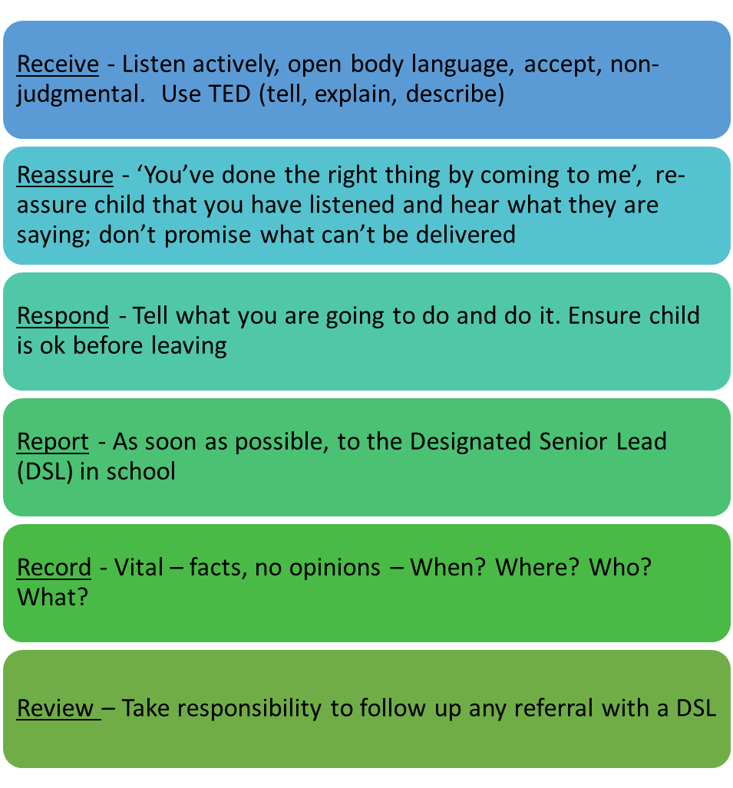

Record – Is Vital – facts, no opinions – When? Where? Who? What?

- Inform the Designated Safeguarding Lead without delay and follow safeguarding process.

- Complete the Safeguarding incident/welfare concern form and pass it to the DSL.

Dealing with a disclosure from a child and safeguarding issues can be stressful. Consider seeking support for yourself and discuss this with the DSL.

Further information about what to do if you are worried that a child is being abused is available here in advice for practitioners:

https://www.gov.uk/government/publications/what-to-do-if-youre-worried-a-child-is-being-abused--2

RECORD KEEPING

8.2 All concerns, discussions and decisions made and the reasons for those decisions must be recorded in writing (signed and dated). Supporting Families, Enhancing Future model (SFEF) to be used to capture the child’s voice (appendix C)

8.3 We will continue to support any pupil leaving the school about whom there have been concerns by ensuring that all appropriate information, including Safeguarding and welfare concerns, is forwarded under confidential cover to the pupil’s new school as a matter of priority.

8.4 Schools should have at least two emergency contacts for every child in the school in case of emergencies, and in case there are welfare concerns at the home in order to reduce the risk of not making contact with family members where welfare and/or safeguarding concerns are identified. (Keeping Children Safe in Education 2020)

DISCUSSING CONCERNS WITH THE FAMILY AND THE CHILD – ADVICE FOR THE DESIGNATED SAFEGUARDING LEAD (DSL)

9.1 In general, you should always discuss any concerns the school may have with the child’s parents. They need to know that you are worried about their child. However, you should not discuss your concerns if you believe that this would place the child at greater risk or lead to loss of evidence for a police investigation.

9.2 If you make a decision not to discuss your concerns with the child’s parents or carers, this must be recorded in the child’s Safeguarding file with a full explanation for your decision.

9.3 It is important to record and consider the child’s wishes and feelings, as part of planning what action to take in relation to concerns about their welfare. Capturing the lived experience of the child is paramount to ensure that actions remain child-centred (See Appendix C (Supporting Families Enhancing Futures - SFEF) model to capture the child’s lived experience.

9.4 When talking to children, you should take account of their age, understanding and preferred language, which may not be English. It is also important to consider how a SEND child may need support in communicating.

9.5 How you talk to a child will also depend on the substance and seriousness of the concerns. You may need to seek advice from the Integrated Front Door or the police to ensure that neither the safety of the child nor any subsequent investigation is jeopardised.

9.6 If concerns have arisen as a result of information given by a child, it is important to reassure the child but not to promise confidentiality.

9.7 It is expected that you discuss your concerns with the parents and seek their agreement to making a referral to the Integrated Front Door, unless you consider that this would place the child at increased risk of significant harm.

9.8 You do not need the parents’ consent to make a referral if you consider the child is in need of protection, although parents will ultimately be made aware of which organisation made the referral. If parents refuse to give consent to a referral but you decide to continue, you need to make this clear to the Integrated Front Door (0151 606 2008).

9.9 If you decide to refer the child without the parents’ consent, make sure to record this with a full explanation of your decision.

9.10 When you make your referral, you should agree with the Integrated Front Door what the child and parents will be told, by whom and when.

MAKING A REFERRAL

If a child or young person is at risk of harm, abuse or neglect please report it to the Integrated Front Door

Mon-Fri, 9:00am – 5.00pm Tel: 0151 606 2008

Outside of these hours Tel: 0151 677 6557

Email: IFD@wirral.gov.uk

In an emergency always call police on 999.
If you think there has been a crime but it is not an emergency call 101.

The new online Request for Services referral form can be accessed here:

https://wirral-self.achieveservice.com/service/Children_and_families_request_for_support_form

10 SAFER WORKFORCE AND MANAGING ALLEGATIONS AGAINST STAFF AND VOLUNTEERS (This procedure is detailed in Appendix C, Section 4)

10.1 We will prevent people who pose risks to children from working in our school by ensuring that all individuals working in any capacity at our school have been subjected to safeguarding checks in line with Keeping Children Safe in Education: Statutory Guidance for Schools and Colleges, September 2020. In addition to obtaining the DBS certificate described, anyone who is appointed to carry out teaching work will require an additional check to ensure they are not prohibited from teaching. See Appendix C.

A check of any prohibition can be carried out using the Teacher Services’ system that may be found here: https://teacherservices.education.gov.uk/ (January 2018)

Prohibition orders are described in the National College for Teaching and Leadership’s (NCTL) publication Teacher misconduct: the prohibition of teachers. It can be found here:

https://www.gov.uk/government/publications/teacher-misconduct-the-prohibition-of-teachers--3

10.2 We will ensure that agencies and third parties supplying staff provide us evidence that they have made the appropriate level of safeguarding checks on individuals working in our school. See Appendix C, for information on Single Central Record (SCR). The Single Central Record is located On-line via secure access and maintained by Headteacher and Headteachers PA (APCS). The single central record must cover the following people: all staff, including teacher trainees on salaried routes, agency and third-party and supply staff who work at the school. The Single Central Record is located via an online portal.

10.3 Every job description and person specification will have a clear statement about the safeguarding responsibilities of the post holder.

10.4 We will ensure that at least one member of every interview panel has completed safer recruitment training within the last 5 years.

10.5 We have a procedure in place to manage allegations against members of staff, supply staff and volunteers in line with WSCP procedures.
10.6 Supply teachers – we will consider all allegations against an individual not directly employed by, where disciplinary procedures do not fully apply, (for example, supply teachers provided by an employment agency) and ensure allegations are dealt with properly.
10.7 There is an agreed staff behaviour policy (sometimes called the code of conduct) which is compliant with ‘Safer Working Practices’, and includes - acceptable use of technologies, staff/pupil relationships and communications including the use of social media.
10.8. For agency and third party supply staff, schools and colleges must also include whether written confirmation has been received that the employment business supplying the member of supply staff has carried out the relevant checks and obtained the appropriate certificates, and the date that confirmation was received and whether any enhanced DBS certificate check has been provided in respect of the member of staff.

Guidance can be accessed:
http://www.rrrecruitment.com/wp-content/uploads/2016/04/Guidance-for-Safer-Working-Practice-October-2015.pdf

11 STAFF INDUCTION, TRAINING AND DEVELOPMENT

11.1 All new members of staff, including newly-qualified teachers and teaching assistants, will be given induction that includes basic safeguarding training on how to recognise signs of abuse, how to respond to any concerns, e-safety and familiarisation with the safeguarding policy, staff code of conduct, Keeping Children Safe in Education: Statutory Guidance for Schools and Colleges, Part One, September 2020 and other related policies. There are mechanisms in place, such as safeguarding updates, to assist staff to understand and discharge their role and responsibilities as set out in Part one of Keeping Children Safe in Education. Staff should also read, “Working Together to Safeguard Children.” September 2020

11.2 The induction will be proportionate to staff members’ roles and responsibilities

11.3 All Designated Safeguarding Leads (DSLs) will undergo updated Safeguarding training every two years. DSL’s should undertake PREVENT Awareness Training

11.4 All staff members of the school will undergo face to face training (whole-school training) which is regularly updated and at least every three years. All governors must undergo governor specific awareness training at least every two years – this is to be decided by the school / setting. All staff will have access to WSCB multi-agency safeguarding training and e-learning.

11.5 Staff members who miss the whole-school training will be required to undertake other relevant training to make up for it, e.g. by joining another school’s whole-school training, booking onto whole-school training mop-up sessions. To book mop up sessions visit safeguarding partnership website: www.wirralsafeguarding.co.uk/safeguarding-training for schools

11.6 The nominated governor for safeguarding will undergo training prior to or soon after appointment to the role; this training will be updated every three years.

11.7 We will ensure that staff members provided by other agencies and third parties, e.g. supply teachers and contractors, have received appropriate safeguarding training commensurate with their roles before starting work. They will be given the opportunity to take part in whole-school training if it takes place during their period of work for the school.

11.8 The Designated Safeguarding Lead will provide briefings to the school on any changes to safeguarding legislation and procedures and relevant learning from local and national serious case reviews. These will occur annually or more frequently when necessary.

https://www.wirralsafeguarding.co.uk/professionals/serious-case-reviews/

11.9 The school will maintain accurate records of staff induction and training.

12 CONFIDENTIALITY, CONSENT AND INFORMATION SHARING

12.1 We recognise that all matters relating to Safeguarding are confidential.

12.2 The head teacher or the Designated Safeguarding Lead will disclose any information about a pupil to other members of staff on a need-to-know basis only

12.3 All staff members must be aware that they cannot promise a child to keep key information a secret or to themselves which might compromise the child’s safety or well-being.

12.4 All staff members have a professional responsibility to share information with other agencies in order to safeguard children.

12.5 All staff members who come into contact with children will be given appropriate training to understand the purpose of information sharing in order to safeguard and promote children’s welfare.

12.6 We will ensure that staff members are confident about what they can and should do under the law, including how to obtain consent to share information and when information can be shared without consent.

12.7 Staff should not assume a colleague or another professional will take action and share information that might be critical in keeping children safe. They should be mindful that early information sharing is vital for effective identification, assessment and allocation of appropriate service provision. Information Sharing: Advice for Practitioners Providing Safeguarding Services to Children, Young People, Parents and Carers supports staff who have to make decisions about sharing information. This advice includes the seven golden rules for sharing information and considerations with regard to the Data Protection Act 2018 and General Data Protection Regulation (GDPR). If in any doubt about sharing information, staff should speak to the designated safeguarding lead or a deputy. Fears about sharing information must not be allowed to stand in the way of the need to promote the welfare, and protect the safety of children. (KCSIE 2020)

https://assets.publishing.service.gov.uk/government/uploads/system/uploads/attachment_data/file/721581/Information_sharing_advice_practitioners_safeguarding_services.pdf (July 2018)

13 INTER-AGENCY WORKING

13.1 We will develop and promote effective working relationships with other agencies, including agencies providing early help services to children, the police and Children’s Social Care. Early help means providing support as soon as a problem emerges at any point in a child’s life, from the foundation years through to the teenage years. For more information on Early Help click below:

https://www.wirralsafeguarding.co.uk/professionals/what-is-early-help/

13.2 We will ensure that relevant staff members participate in multi-agency meetings and forums, including child protection conferences and core groups, to consider individual children.
13.3 We will participate in serious case reviews, other reviews and file audits as and when required to do so by the Wirral Safeguarding Children Partnership. We will ensure that we have a clear process for gathering the evidence required for reviews and audits, and embed recommendations into practice and compile required actions within agreed timescales.

14 CONTRACTORS, SERVICE AND ACTIVITY PROVIDERS AND WORK PLACEMENT PROVIDERS

14.1 We will ensure that contractors and providers are aware of our school’s safeguarding policy and procedures. We will require that employees and volunteers provided by these organisations use our procedure to report concerns.

14.2 We will seek assurance that employees and volunteers provided by these organisations and working with our children have been subjected to the appropriate level of safeguarding check in line with Keeping Children Safe in Education: Statutory Guidance for Schools and Colleges, 2018. If assurance is not obtained, permission to work with our children or use our school premises may be refused.

14.3 When we commission services from other organisations, we will ensure that compliance with our policy and procedures is a contractual requirement.

15 WHISTLE-BLOWING AND COMPLAINTS

15.1 We recognise that children cannot be expected to raise concerns in an environment where staff members fail to do so.

The school / College Whistle Blowing policy is located on the school website and signs are located in staff toilets for information purposes.

Whistleblowing: guidance and code of practice for employers is located: https://assets.publishing.service.gov.uk/government/uploads/system/uploads/attachment_data/file/415175/bis-15-200-whistleblowing-guidance-for-employers-and-code-of-practice.pdf (March 2015)

Whistleblowing Advice Line is available for all worker - 0800 028 0285
- Email help@nspcc.org.uk

15.2 We will ensure that all staff members are aware of their duty to raise concerns, where they exist, about the management of Safeguarding, which may include the attitude or actions of colleagues. If necessary, they will speak with the head teacher, the chair of the governing body or with the Local Authority Designated Officer (LADO).

15.3 We have a clear reporting procedure for children, parents and other people to report concerns or complaints, including abusive or poor practice.

15.4 We will actively seek the views of children, parents and carers and staff members on our Safeguarding arrangements through surveys, questionnaires and other means.

16 SITE SECURITY

16.1 All staff members have a responsibility to ensure our buildings and grounds are secure and for reporting concerns that may come to light.

16.2 We check the identity of all visitors and volunteers coming into school. Visitors are expected to sign in and out in the office visitors’ log and to display a visitor’s badge while on the school site. Any individual who is not known or identifiable will be challenged for clarification and reassurance.

16.3 The school will not accept the behaviour of any individual, parent or anyone else, that threatens school security or leads others, child or adult, to feel unsafe. Such behaviour will be treated as a serious concern and may result in a decision to refuse the person access to the school site.

17 QUALITY ASSURANCE

17.1 We will ensure that systems are in place to monitor the implementation of and compliance with this policy and accompanying procedures.

17.2 We will complete an audit of the school’s safeguarding arrangements at frequencies specified by the Wirral Safeguarding Children Partnership and using the Section 175 online audit tool provided by them for this purpose. More information including how to register for the audit can be found below

https://www.wirralsafeguarding.co.uk/professionals/section-11-175-audit/

17.3 The school’s senior management and the governing body will ensure that action is taken to remedy any deficiencies and weaknesses identified in child protection arrangements without delay.

18 POLICY REVIEW

18.1 This policy and the procedures will be reviewed every academic year. All other linked policies will be reviewed in line with the policy review cycle.

18.2 The Designated Safeguarding Lead will ensure that staff members, including volunteers and sessional workers are made aware of any amendments to policies and procedures.

Updated Policy Date: | Scheduled review
07/07/2019 | 07/06/2021

JOSEPH PAXTON CAMPUS
SECTION 47 FLOWCHART – safeguarding concerns

Allegation – from another

Verbal or in writing
Disclosure from the child either verbally or in writing
Suspicion - observation of injury marks or inappropriate behaviour
Concerns – a build up of concerns about the child, e.g. behaviour, language, absences

R

E

C

O

R

D

Date

Time

Place
JOSEPH PAXTON CAMPUS
Designated Safeguarding Person
Vicki Tranter – JPC
488-7680 (School No.)
488-7686 (direct line)
07766-780308 (mobile) - or in absence
Phill Arrowsmith – JPC Headteacher
488-7680 (school No.)
488-7685 (direct line)
07976- 027161 (mobile)
IFD/MASH by phone – 606-2008 followed by a written referral
File all papers referring to Safeguarding matters securely and SEPARATE from the child’s school file

R

E

P

O

R

T
All Staff
Unless there is reason to believe that the child will suffer additional harm the DSL should ensure the parent/carer is informed
All referrals should go through the named DSL (Designated Safeguarding Person) UNLESS:
- the matter is urgent and the DSL is unavailable
- the DSL will not refer
- staff must then refer themselves but seek advice from senior member of staff of LEA. Lead Officer for Safeguarding (606-2008)
 | APPENDIX A: The role of the Designated Safeguarding Lead
1 | MANAGING REFERRALS / RECORD KEEPING /
2 | INTER-AGENCY WORKING & INFORMATION SHARING / TRAINING
3 | AWARENESS RAISING / QUALITY ASSURANCE
5 | SUPERVISION AND REFLECTION
APPENDIX B: Safeguarding Procedure
1 | DEFINITIONS & EARLY HELP
2 | CATEGORIES OF ABUSE
3 | MENTAL HEALTH
 | APPENDIX C: Further Information
1 | Female Genital Mutilation
2 | Fabricated Illness
3 | Gang and Youth Violence
4 | Faith Based Abuse
5 | Risk to Trafficking
6 | Risks Associated with Parent/Carer Mental Health
7 | Drugs and Alcohol
8 | Honour Based Violence and Forced Marriages
9 | Managing Allegations Against School Staff
10 | Preventing Radicalisation (Prevent & Channel)
11 | Child Missing from Education
12 | Child Sexual Exploitation, Child Exploitation (CE) & County Lines
13 | Online Safety
14 | Pre-Appointment Checks
15 | Single Central Record
 | Flow chart: Actions where there are concerns about a child
 | Flow chart: Disclosure and Barring Service criminal record checks and barred list checks
 | 7 Minute Briefing: NEW Social Media and Mental Health
 | 7 Minute Briefing: NEW Safeguarding Children
 | 7 Minute Briefing: NEW Children Missing
 | 7 Minute Briefing: NEW Sexting
 | 7 Minute Briefing: NEW Adverse Childhood Experiences (ACES)
 | 7 Minute Briefing: Anderson Children
 | 7 Minute Briefing: Supporting Families, Enhancing Futures (SFEF) Voice of the child
 | 7 Minute Briefing: County Lines / Contextual Safeguarding
 | 7 Minute Briefing: Professional disagreement and escalation
 | 7 Minute Briefing: Neglect / Child Sexual Exploitation (CSE) / Harmful Sexual Behaviour
 | 7 Minute Briefing: Private Fostering / Domestic Violence
 | Early Help and Prevention Offer

APPENDIX A:
The role of the Designated Safeguarding Lead

1 MANAGING REFERRALS:

1.1 Refer all safeguarding cases, including Early Help, to the Integrated Front Door (IFD) and to the Police if a crime may have been committed. (IFD@wirral.gov.uk)

1.2 Identify any safeguarding issues relating to individual children, especially ongoing enquiries under section 47 of the Children Act 1989.

1.3 Act as a source of support, advice and expertise to staff members on matters of child protection and safeguarding.

1.4 Escalate inter-agency concerns and disagreements about a child’s wellbeing. Further information can be found here: https://www.wirralsafeguarding.co.uk/procedures/10-2-multi-agency-escalation-procedure/

1.5 Have responsibility to ensure there is at least one key adult for ‘Operation Encompass*’ and the point of contact for Child Exploitation. *Guiding principles of the scheme are here https://www.operationencompass.org/school-participation. An annual information letter to be sent to parents. All downloadable documents are here: https://www.operationencompass.org/school-participation/school-downloads.

1.6 To ensure that the Local Authority are notified if children are persistently absent or missing from education

2 RECORD KEEPING:

2.1 Keep written records of Safeguarding and welfare concerns and ensure a stand-alone file is created as necessary for children with safeguarding concerns

2.2 Schools should have at least two emergency contacts for every child in the school in case of emergencies, and in case there are welfare concerns at the home (KCSIE 2020)

2.3 Maintain a chronology of significant incidents for each child with safeguarding concerns

2.4 Ensure such records are kept confidentially and securely and separate from the child’s educational record.

2.5 When a child leaves our school, the Designated Safeguarding Lead will make contact with the Designated Safeguarding Lead at the new school and will ensure that the safeguarding file is forwarded to the receiving school within two weeks. We will retain evidence to demonstrate how the file has been transferred; this may be in the form of a written confirmation of receipt from the receiving school and/or evidence of recorded delivery. Where a parent elects to remove their child from the school roll to home educate, the school will make arrangements to pass any safeguarding records to the Education Social Welfare Service.

3 INTER-AGENCY WORKING AND INFORMATION SHARING:

3.1 Co-operate and comply with Children’s Social Care for enquiries under section 47 of the Children Act 1989.

3.2 Advocate that the Data Protection Act 2018 and GDPR do not prevent, or limit, the sharing of information for the purposes of keeping children safe; and this includes allowing practitioners to share information without consent (Keeping Children Safe in Education 2020).

3.3 Complete reports and attend, or ensure other relevant staff members attend, child protection conferences, core group meetings and other multi-agency meetings, as required.

3.4 Liaise with other agencies working with the child, share information as appropriate and contribute to assessments.

3.5 The school’s information sharing policy is located on the school website refers to confidentiality in line with ‘Information sharing: advice for practitioners providing safeguarding services’ (DfE, 2018).

https://assets.publishing.service.gov.uk/government/uploads/system/uploads/attachment_data/file/721581/Information_sharing_advice_practitioners_safeguarding_services.pdf

4 TRAINING:

4.1 Undertake appropriate training, updated every two years, in order to
- be able to recognise signs of abuse and how to respond to them, including special circumstances such as child sexual exploitation, female genital mutilation, fabricated or induced illness
- understand the assessment process for providing early help and intervention, e.g. WSCP thresholds of need
- have a working knowledge of how the local authority conducts initial and review child protection case conferences and contribute effectively to these; and
- be alert to the specific needs of children in need (as specified in section 17 of the Children Act 1989), those with special educational needs, pregnant teenagers and young carers.

4.2 Ensure each member of staff has read and understands the school’s safeguarding policy and procedures, including providing induction on these matters to new staff members. Induction training, must include the school’s behaviour policy and the school’s procedures for managing children who are missing education, as well as the staff code of conduct, and the child protection policy.

4.3 Organise face-to-face whole-school Safeguarding training for all staff members at least every three years. Ensure staff members who miss the training receive it by other means, e.g. by joining another school’s training. The DSL must provide all staff members with safeguarding updates (for example, via email, e-bulletins and staff meetings), as required, but at least annually, to provide them with relevant skills and knowledge to safeguard children effectively. Link to access safeguarding training via Wirral Safeguarding Children Partnership (WSCP) is: https://www.wirralsafeguarding.co.uk/safeguarding-training-for-schools/

4.4 All staff should be aware of systems within their school or college which support safeguarding, and these should be explained to them as part of staff induction. This should include the:
- child protection policy
- behaviour policy
- staff behaviour policy (sometimes called a code of conduct)
- safeguarding response to children who go missing from education; and
- role of the designated safeguarding lead (including the identity of the designated safeguarding lead and any deputies).

Copies of policies and a copy of Part one of this document should be provided to staff at induction (Keeping Children Safe in Education 2020: 6)

Best practice would also see staff and leaders reading - 'What to do if you're worried a child is being abused', as it contains examples of the different types of safeguarding issues.

4.5 Ensure the school allocates time and resources every year for relevant staff members to attend training and receive continuous professional development opportunities.

4.6 Encourage a culture of listening to children and taking account of their wishes and feelings in any action the school takes to protect them.

4.7 Maintain accurate records of staff recruitment, induction and training.

WSCP School / College / Educational establishment training courses can be found here:

https://www.wirralsafeguarding.co.uk/schools/

5 AWARENESS RAISING:

5.1 Ensure the school’s or college’s child protection policies are known, understood and used appropriately;

5.2 Ensure the school’s or college’s safeguarding policy is reviewed annually (as a minimum) and the procedures and implementation are updated and reviewed regularly, and work with governing bodies or proprietors regarding this;

5.3 Ensure the safeguarding policy is available publicly and parents are aware of the fact that referrals about suspected abuse or neglect may be made and the role of the school or college in this; and

5.4 Link with the safeguarding partner arrangements to make sure staff are aware of any training opportunities and the latest local policies on local safeguarding arrangements. (KCSIE 2020:100)

6 QUALITY ASSURANCE:

6.1 Monitor the implementation of and compliance with policy and procedures, including periodic audits of Safeguarding and welfare concerns files (at a minimum once a year).

6.2 Complete an audit of the school’s safeguarding arrangements at frequencies specified by the Wirral Safeguarding Children Partnership.

6.3 Provide regular reports, to the governing body detailing changes and reviews to policy, training undertaken by staff members and the number of children with child protection plans and other relevant data.

6.4 Take lead responsibility for remedying any deficiencies and weaknesses identified in Safeguarding arrangements.

7 SUPERVISION AND REFLECTION:

7.1 Working to ensure children and young people are protected from harm requires sound professionals judgements to be made. It is demanding work that can be distressing and stressful. It is therefore essential that staff involved in this work have access to advice and a robust process of reflection/ supervision to help them reflect upon and review their work.
7.2 The school will have a framework for providing an opportunity to staff who are working directly with vulnerable young people, particularly those who are being managed on a child protection, child in need or team around the family plan, to have regular access to an appropriate manager to talk through and reflect on their involvement with the child’s case. A guidance document published by the Wirral Safeguarding Children Partnership for undertaking safeguarding reflection is published on the WSCP website and can be accessed here:
https://www.wirralsafeguarding.co.uk/procedures/
APPENDIX B:
Safeguarding Procedure
1 DEFINITIONS:

1.1 Abuse: a form of maltreatment of a child. Somebody may abuse or neglect a child by inflicting harm or by failing to act to prevent harm. Children may be abused in a family or in an institutional or community setting by those known to them or, more rarely, by others (e.g. via the internet). They may be abused by an adult or adults or another child or children.

1.2 Children are any people who have not yet reached their 18th birthday; a 16-year-old, whether living independently, in further education, in the armed forces or in hospital, is a child and is entitled to the same protection and services as anyone younger.

1.3 Child protection is part of safeguarding and promoting the welfare of children and refers to activity undertaken to protect specific children who are suffering, or likely to suffer, significant harm.

1.4 Early help means providing support as soon as a problem emerges, at any point in a child’s life, from the foundation years to teenage years.

1.5 Harm is ill treatment or impairment of health and development, including impairment suffered from seeing or hearing the ill treatment of another.

1.6 Safeguarding children is the action we take to promote the welfare of children and protect them from harm. Safeguarding and promoting the welfare of children is defined as:
- protecting children from maltreatment;
- preventing impairment of children’s health and development;
- ensuring that children grow up in circumstances consistent with the provision of safe and effective care; and
- taking action to enable all children to have the best outcomes.

All staff must have an awareness of safeguarding issues. Staff should be aware that behaviours linked to the likes of drug taking, alcohol abuse, truanting and sexting put children in danger.

All staff must be aware safeguarding issues can manifest themselves via peer on peer abuse. This is most likely to include, but not limited to: bullying (including cyber bullying), gender based violence/sexual assaults and sexting. Staff should be clear as to the school or college’s policy and procedures with regards to peer on peer abuse; and on how the risk of peer-on-peer abuse is being minimised, how suspected abuse will be recorded and investigated; as well as how the victims and perpetrators will be supported. More support can be found:

https://assets.publishing.service.gov.uk/government/uploads/system/uploads/attachment_data/file/609874/6_2939_SP_NCA_Sexting_In_Schools_FINAL_Update_Jan17.pdf

1.7 Significant harm is the threshold that justifies compulsory intervention in the family in the best interests of the child. Section 47 of the Children Act 1989 states ‘where the question of whether harm suffered by a child is significant turns on the child’s health or development, his health or development shall be compared with that which could reasonably be expected of a similar child.’

1.8 Any child may benefit from early help, but all school and college staff should be particularly alert to the potential need for early help for a child who:

• is disabled and has specific additional needs;
• has special educational needs (whether or not they have a statutory Education, Health and Care Plan);
• is a young carer;
• is showing signs of being drawn in to anti-social or criminal behaviour, including gang involvement and association with organised crime groups;
• is frequently missing/goes missing from care or from home;
• is at risk of modern slavery, trafficking or exploitation;
• is at risk of being radicalised or exploited;
• is in a family circumstance presenting challenges for the child, such as drug and alcohol misuse, adult mental health issues and domestic abuse;
• is misusing drugs or alcohol themselves;
• has returned home to their family from care; and
• is a privately fostered child.

2 CATEGORIES OF ABUSE:

2.1 Emotional abuse is the persistent emotional maltreatment of a child such that it causes severe and persistent adverse effects on the child’s emotional development and conveying that they are worthless or unloved, inadequate, or valued only insofar as they meet the needs of another person. It may include

  - not giving the child opportunities to express their views,
  - deliberately silencing them or ‘making fun’ of what they say or how they communicate
It may feature:
- age or developmentally inappropriate expectations being imposed on children
- interactions that are beyond a child’s developmental capability
- overprotection and limitation of exploration and learning,
- preventing the child from participating in normal social interaction.
- seeing or hearing the ill-treatment of another
- serious bullying (including cyberbullying)
- causing children frequently to feel frightened or in danger, or the exploitation or corruption of children

Some level of emotional abuse is involved in all types of maltreatment of a child, although it may occur alone.

2.2 Neglect is the persistent failure to meet a child’s basic physical or psychological needs, likely to result in the serious impairment of the child’s health or development. Neglect may occur during pregnancy as a result of maternal substance misuse. Once a child is born, it may involve a parent failing to:
  - provide adequate food, clothing and shelter, including exclusion from home or abandonment
  - protect a child from physical and emotional harm or danger
  - ensure adequate supervision, including the use of inadequate care givers
  - ensure access to appropriate medical care or treatment

It may also include neglect of, or unresponsiveness to, a child’s basic emotional needs.

2.3 Physical abuse may involve hitting, shaking, throwing, poisoning, burning, scalding, drowning, suffocating, or otherwise causing physical harm to a child. Physical harm may also be caused when a parent or carer fabricates the symptoms of, or deliberately induces, illness in a child.

2.4 Sexual abuse: involves forcing or enticing a child or young person to take part in
sexual activities, not necessarily involving a high level of violence, whether or not the
child is aware of what is happening. The activities may involve physical contact, including
assault by penetration (for example rape or oral sex) or non-penetrative acts such as
masturbation, kissing, rubbing and touching outside of clothing.
They may also include non-contact activities, such as involving children in looking at, or in the production of, sexual images, watching sexual activities, encouraging children to behave in sexually inappropriate ways, or grooming a child in preparation for abuse.
Sexual abuse can take place online, and technology can be used to facilitate offline abuse. Sexual abuse is not solely perpetrated by adult males. Women can also commit acts of sexual abuse, as can other children. The sexual abuse of children by other children is a specific safeguarding issue in education (KCSIE 2020).
3. Mental Health:

  - All staff should also be aware that mental health problems can, in some cases, be an indicator that a child has suffered or is at risk of suffering abuse, neglect or exploitation

  - Only appropriately trained professionals should attempt to make a diagnosis of a mental health problem. Staff however, are well placed to observe children day-to-day and identify those whose behaviour suggests that they may be experiencing a mental health problem or be at risk of developing one

  - Where children have suffered abuse and neglect, or other potentially traumatic adverse childhood experiences, this can have a lasting impact throughout childhood, adolescence and into adulthood. It is key that staff are aware of how these children’s experiences, can impact on their mental health, behaviour and education

  - If staff have a mental health concern about a child that is also a safeguarding concern, immediate action should be taken, following their child protection policy and speaking to the designated safeguarding lead or a deputy.

The department has published advice and guidance on Preventing and Tackling Bullying, and Mental Health and Behaviour in Schools (which may also be useful for colleges). In addition, Public Health England has produced a range of resources to support secondary school teachers to promote positive health, wellbeing and resilience among young people including its guidance Promoting children and young people’s emotional health and wellbeing. Its resources include social media, forming positive relationships, smoking and alcohol. See Rise Above for links to all materials and lesson plans.

There are three thresholds for and types of referral that need to be considered:

Is this a child with additional needs; where their health, development or achievement may be adversely affected?

- Age appropriate progress is not being made and the causes are unclear or
- The support of more than one agency is needed to meet the child or young person’s needs.

If this is a child with additional needs discuss the issues with the Early Help Assessment (EHAT) trained practitioner in your school, the child and parents. You will need to obtain parental consent for an EHAT to be completed.

Is this a child in need matter? Section 17 of the Children Act 1989 says:

- they are unlikely to achieve or maintain, or to have opportunity to achieve or maintain a reasonable standard of health or development, without the provision of services by a local authority.
- their health or development is likely to be impaired, or further impaired without the provision of such services.
- they are SEND (and as such can face additional safeguarding challenges).

If this is a child in need, discuss the issues with the Designated Safeguarding Lead and parents. Obtain their consent for referral.

Is this a child protection matter? Section 47 of the Children Act 1989 says:

- children at risk or who are suffering significant harm.
- children suffering the effects of significant harm
- serious health problems.

More on the thresholds can be found here:
https://www.wirralsafeguarding.co.uk/multi-agency-thresholds/

If this is a child protection matter, this should be discussed with the Designated Safeguarding Lead and will need to be referred to the Integrated Front Door by the school as soon as possible.

https://www.wirralsafeguarding.co.uk/public/concerned-about-a-child/

APPENDIX C: FURTHER INFORMATION

A series of ‘7-minute briefings’ have been designed to inform and engage staff in understanding a wide range of safeguarding concerns. A selection can be found at the end of this document. There are new briefing being added, so to access the full range of briefings click here: https://www.wirralsafeguarding.co.uk/7-minute-briefings/

1 Female Genital Mutilation - Female Genital Mutilation (FGM) comprises all procedures involving partial or total removal of the external female genitalia or other injury to the female genital organs. It is illegal in the UK and a form of child abuse with long-lasting harmful consequences. Professionals in all agencies, and individuals and groups in relevant communities, need to be alert to the possibility of a girl being at risk of FGM, or already having suffered FGM.

1.1 Indicators - There is a range of potential indicators that a girl may be at risk of FGM. Warning signs that FGM may be about to take place, or may have already taken place, can be found on pages 16-17 of the Multi-Agency Practice Guidelines , and Chapter 9 of those Guidelines (pp42-44) focuses on the role of schools and colleges.

Section 5C of the Female Genital Mutilation Act 2003 (as inserted by section 75 of the Serious Crime Act 2015) gives the Government powers to issue statutory guidance on FGM to relevant persons. Once the government issues any statutory multi-agency guidance this will apply to schools and colleges.

1.2 Actions - If staff have a concern they should activate local safeguarding procedures, using existing national and local protocols for multi-agency liaison with police and children’s social care. Mandatory reporting commenced in October 2015. These procedures remain when dealing with concerns regarding the potential for FGM to take place. Where a teacher discovers that an act of FGM appears to have been carried out on a girl who is aged under 18, there will be a statutory duty upon that individual to report it to the police.

1.3 Mandatory Reporting Duty

Section 5B of the Female Genital Mutilation Act 2003 (as inserted by section 74 of the Serious Crime Act 2015) will place a statutory duty upon teachers, along with social workers and healthcare professionals, to report to the police where they discover (either through disclosure by the victim or visual evidence) that FGM appears to have been carried out on a girl under 18. Those failing to report such cases will face disciplinary sanctions. It will be rare for teachers to see visual evidence, and they should not be examining pupils, but the same definition of what is meant by “to discover that an act of FGM appears to have been carried out” is used for all professionals to whom this mandatory reporting duty applies.

The Mandatory reporting duty commenced in October 2015. Teachers must report to the police cases where they discover that an act of FGM appears to have been carried out. Unless the teacher has a good reason not to, they should still consider and discuss any such case with the school’s designated safeguarding lead and involve the Integrated Front Door as appropriate.

2 Fabricated Illness:

2.1 Staff must be aware of the risk of children being abused through fabricated illness. There are three main ways of the carer fabricating or inducing illness in a child. These are not mutually exclusive and include:
• fabrication of signs and symptoms. This may include fabrication of past medical history;
• fabrication of signs and symptoms and falsification of hospital charts and records, and specimens of bodily fluids. This may also include falsification of letters and documents;
• induction of illness by a variety of means.

2.2 Where this is identified and considered a risk a referral will be made to The Integrated Front Door (IFD) for support and guidance. School may involve other agencies in making their assessments. That could include school nurse, community paediatrician, occupational therapists etc.

3 Gang and Youth Violence:

3.1 Children and Young People who become involved in Gangs are at risk of violent crime and as a result of this involvement are deemed vulnerable. Agencies and professionals have a responsibility to safeguard these children and young people and to prevent further harm both to the young person and their potential victims. Risks associated with Gang activity include access to weapons (including firearms), retaliatory violence and territorial violence with other gangs, knife crime, sexual violence and substance misuse

3.2 Indicators may be (age in brackets):
• Troublesome (7-9; 10-12) / High daring (10-12) / Positive attitude towards delinquency (10-12) / Previously committed offences (7-9) / Involved in anti-social behaviour (10-12)
• Substance use (7-9) / Aggression (7-9) / Running away and truancy (7-9; 10-12) / Marijuana use (10- 12) / Marijuana availability (10-12) / Disrupted family (7- 9; 10-12) / Poor supervision (10-12)
• Low academic achievement in primary school (10- 12) / Learning disability (10-12) / Peers involved in crime and/or anti-social behaviour (7-9; 10-12)
• Children and young people in the neighbourhood involved in crime and/or anti-social behaviour (10-12)
(Preventing Youth Violence and gang Involvement for Schools and Colleges – Home Office)
4 Faith Based Abuse:

4.1 Our policy recognises the ‘National Action Plan to Tackle Abuse linked to faith or belief’ which describes this abuse as:

‘not about challenging people’s beliefs, but where beliefs lead to abuse that must not be tolerated. This includes belief in witchcraft, spirit possession, demons or the devil, the evil eye or djinns, dakini, kindoki, ritual or muti murders and use of fear of the supernatural to make children comply with being trafficked for domestic slavery or sexual exploitation. The beliefs which are not confined to one faith, nationality or ethnic community.’

4.2 When this type of abuse is suspected staff will make a referral will make a referral to Wirral MASH for support and guidance. School may request the advice and support of MEAS service in making their assessments.

https://www.gov.uk/government/publications/national-action-plan-to-tackle-child-abuse-linked-to-faith-or-belief

5 Risk to Trafficking:

5.1 Article 3 of the Palermo Protocol to Prevent, Suppress And Punish Trafficking In Persons, Especially Women And Children, Supplementing the United Nations Convention Against Transnational Organised Crime to the UN Convention (2000) (ratified by the UK on 6 February 2006) defines trafficking as:

(a) “Trafficking of persons” shall mean the recruitment, transportation, transfer, harbouring or receipt of persons, by means of the threat of or use of force or other forms of coercion, of abduction, of fraud, of deception, of the abuse of power or of a position of vulnerability or of the giving or receiving of payments or benefits to achieve the consent of a person having control over another person, for the purpose of exploitation. Exploitation shall include, at a minimum, the exploitation of the prostitution of others or other forms of sexual exploitation, forced labour or services, slavery or practices similar to slavery, servitude or the removal of organs.
(b) The consent of a victim of trafficking in persons to the intended exploitation set forth in sub-paragraph (a) of this article shall be irrelevant where any of the means set forth in subparagraph (a) have been used.
(c) The recruitment, transportation, transfer, harbouring or receipt of a child for the purpose of exploitation shall be considered “trafficking in persons” even if this does not involve any of the means set forth in sub-paragraph (a) of this article
(d) “Child” shall mean any person under eighteen years of age.

5.2 Children trafficked into the country may be registered at a school for a term or longer, before being moved to another part of the UK or abroad. This pattern of registration and de-registration may be an indicator that a child has been trafficked. It has been identified as a particular concern in schools which are situated near ports of entry, but practitioners should be alert to this possibility in all schools. However, practitioners should always bear in mind that not all children who go missing from education have been victims of trafficking. For example, there may be instances of children from communities that move around – Gypsy, Roma, traveller or migrant families – who collectively go missing from school.

5.3 If a member of the school staff suspects that a child may have been trafficked they should act immediately to inform the senior member of staff with designated responsibility for child protection and ensure that police or local authority children’s social care are contacted immediately.

6 Risks Associated with Parent/Carer Mental Health:

6.1 The majority of Parents who suffer mental ill-health are able to care for and safeguard their children and/or unborn child. Some parents, however, will be unable to meet the needs and ensure the safety of their children. The school will follow the guidance outlined in ‘working with parents with mental health problems and their children (Think child, think parent, think family: a guide to parental mental health and child welfare).

6.2 Our approach is to recognise; seek support; instil preventive factors and monitor. The Integrated Front Door can provide links and support with Wirral Adult Social Care if required. Designated teacher should seek support through TAF with family support but escalate to the Integrated Front Door if they are concerned that the child involved is being placed at immediate risk of harm. The CAMHS and Early Help Resource-and-Information-Pack details the Early Help services available to children, young people and their families. The offer includes mental health support services: https://www.wirralsafeguarding.co.uk/professionals/what-is-early-help/

7 Drugs and Alcohol: Children can be at risk of drugs and alcohol directly and indirectly.
They may be at direct risk of having access to these substances (see guidance on gangs) or indirectly because they affect family life at home through use by parents/carers, siblings, child-minders etc. Risks associated with drugs and alcohol and built into the year 5-6 curriculum. We work with our partners and Wirral LA to provide curriculum advice and guidance in this area. To access the most up to date Wirral School Drugs Policy click - https://www.wirralsafeguarding.co.uk/school-drug-policy/

More details can be found at: https://www.wirralsafeguarding.co.uk/substance-misuse/

8 Honour Based Violence and Forced Marriages:

8.1 Honour Based Violence and Forced Marriage refers to a collection of practices used to control behaviour within families to protect perceived cultural or religious beliefs and honour. Violence can occur when offenders perceive that a relative has shamed the family or community by breaking their ‘code of honour’. Honour Based Violence cuts across all cultures and communities: Turkish, Kurdish, Afghani, South Asian, African, Middle Eastern, South and Eastern European for example. This is not an exhaustive list. Where a culture is heavily male dominated, HBV may exist.

8.2 ‘A forced marriage is a marriage in which one or both spouses do not (or, in the case of some vulnerable adults, cannot) consent to the marriage and duress is involved. Duress can include physical, psychological, financial, sexual and emotional pressure.’ For more information see;

http://www.fco.gov.uk/en/travel-and-living-abroad/when-things-go-wrong/forced-marriage/

http://www.fco.gov.uk/en/travel-and-living-abroad/when-things-go-wrong/forced-marriage/case-studies/safer-schools-partnership

9 Managing Allegations against staff:

9.1 The Local Authority Designated Officer for Allegations (LADO) must be told of allegations against adults working with children and young people within 24 hours. Chairs of Governors should refer to this guidance if there is an allegation against the headteacher. This includes all cases where a person is alleged to have:

- behaved in a way that has harmed, or may have harmed a child
- possibly committed a criminal offence against, or related to, a child
- behaved towards a child or children in a way that indicates they may pose a risk of harm to children

9.2 The Local Authority Designated Officer for Allegations (LADO) in Wirral is:
Anne King:

- call 0151 666 4442 / 5525
- email all referrals to: anneking1@wirral.gov.uk and kerrywilliams@wirral.gov.uk

If judged appropriate during the initial contact with the LADO, an Allegations Referral Form must be completed by the senior manager in full and forwarded to the LADO via email within 24 hours. LADO referral form, flowcharts and information can be accessed here:

https://www.wirralsafeguarding.co.uk/professionals/lado-allegations

The LADO procedure does not replace safeguarding procedures and the Integrated Front Door (IFD@wirral.gov.uk) must be contacted if you have a safeguarding concern about a child. If you require advice about your agency’s response to an allegation, please contact your HR provider.
The LADO can only provide advice and guidance regarding allegations in relation to a person in a position of trust. Any general safeguarding enquiries or concerns should be reported to Wirral Children’s Services on 0151 606 2008 or 0151 677 6557 out of hours. The LADO cannot provide advice to professionals subject to allegations, support and investigation updates should be sought directly from the investigating agency or employer.

10 Preventing Radicalisation:

Protecting children from the risk of radicalisation should be seen as part of schools’ wider safeguarding duties and is similar in nature to protecting children from other forms of harm and abuse. During the process of radicalisation, it is possible to intervene to prevent vulnerable people being radicalised.

Radicalisation refers to the process by which a person comes to support terrorism and forms of extremism. There is no single way of identifying an individual who is likely to be susceptible to an extremist ideology. Specific background factors may contribute to vulnerability which are often combined with specific influences such as family, friends or online, and with specific needs for which an extremist or terrorist group may appear to provide an answer. The internet and the use of social media in particular has become a major factor in the radicalisation of young people. As with managing other safeguarding risks, staff should be alert to changes in children’s behaviour which could indicate that they may be in need of help or protection. School staff should use their professional judgement in identifying children who might be at risk of radicalisation and act proportionately which may include making a referral to the Channel programme

10.1 Prevent - From 1 July 2015 all schools are subject to a duty under section 26 of the Counter-Terrorism and Security Act 2015 (‘The CTSA 2015’) Schools must have regard to statutory PREVENT GUIDANCE issued under section 29 of the CTSA 2015. Paragraphs 57-76 of the Prevent guidance are concerned specifically with schools’ responsibility to the need to prevent people from being drawn into terrorism.”
This duty is known as the Prevent duty. It applies to a wide range of public-facing bodies.

The statutory Prevent guidance summarises the requirements on schools in terms of four general themes:
- risk assessment
- working in partnership
- staff training
- IT policies

Schools are expected to assess the risk of children being drawn into terrorism, including support for extremist ideas that are part of terrorist ideology. This means being able to demonstrate both a general understanding of the risks affecting children and young people in the area and a specific understanding of how to identify individual children who may be at risk of radicalisation and what to do to support them. Schools and colleges should have clear procedures in place for protecting children at risk of radicalisation. These procedures may be set out in existing safeguarding policies. It is not necessary for schools and colleges to have distinct policies on implementing the Prevent duty. The Prevent duty builds on existing local partnership arrangements. For example, governing bodies and proprietors of all schools should ensure that their safeguarding arrangements take into account the policies and procedures of Local Safeguarding Children Partnerships (LSCPs).

Designated safeguarding leads and other senior leaders should familiarise themselves with the revised Prevent duty guidance: for England and Wales.

The Prevent guidance refers to the importance of Prevent awareness training to equip staff to identify children at risk of being drawn into terrorism and to challenge extremist ideas. Individual schools are best placed to assess the training needs of staff in the light of their assessment of the risk to pupils at the school of being drawn into terrorism. As a minimum, however, schools should ensure that the designated safeguarding lead undertakes Prevent awareness training and is able to provide advice and support to other members of staff on protecting children from the risk of radicalisation.

Schools must ensure that children are safe from terrorist and extremist material when accessing the internet in schools. Schools should ensure that suitable filtering is in place. It is also important that schools teach pupils about online safety more generally. Further information and guidance is available on the WSCP website:

https://www.wirralsafeguarding.co.uk/radicalisation-and-extremism/

The Department for Education has also published advice for schools on the Prevent duty and is intended to complement the Prevent guidance and signposts other sources of advice and support.

https://www.gov.uk/government/publications/protecting-children-from-radicalisation-the-prevent-duty

10.2 Channel

School staff should understand when it is appropriate to make a referral to the Channel team. Channel is a programme which focuses on providing support at an early stage to people who are identified as being vulnerable to being drawn into terrorism. It provides a mechanism for schools to make referrals if they are concerned that an individual might be vulnerable to radicalisation. An individual’s engagement with the programme is entirely voluntary at all stages.

Section 36 of the CTSA 2015 places a duty on local authorities to ensure Channel panels are in place. The panel must be chaired by the local authority and include the police for the relevant local authority area. Following a referral the panel will assess the extent to which identified individuals are vulnerable to being drawn into terrorism, and, where considered appropriate and necessary consent is obtained, arrange for support to be provided to those individuals. Section 38 of the CTSA 2015 requires partners of Channel panels to co-operate with the panel in the carrying out of its functions and with the police in providing information about a referred individual. Schools and colleges are required to have regard to Keeping Children Safe in Education and, as partners, are required to cooperate with local Channel panels.

11 Child Missing Education: All children, regardless of their circumstances, are entitled to a full time education which is suitable to their age, ability, aptitude and any special educational needs they may have. Local authorities have a duty to establish, as far as it is possible to do so, the identity of children of compulsory school age who are missing education in their area.

11.1 A child going missing from education is a potential indicator of abuse or neglect. School and college staff should follow the school’s or college’s procedures for dealing with children that go missing from education, particularly on repeat occasions, to help identify the risk of abuse and neglect, including sexual exploitation, and to help prevent the risks of their going missing in future.

11.2 Schools should put in place appropriate safeguarding policies, procedures and responses for children who go missing from education, particularly on repeat occasions. It is essential that all staff are alert to signs to look out for and the individual triggers to be aware of when considering the risks of potential safeguarding concerns such as travelling to conflict zones, FGM and forced marriage.

The law requires all schools to have an admission register and, with the exception of schools where all pupils are boarders, an attendance register. All pupils must be placed on both registers. An appropriated response is needed when a child has poor attendance or is regularly missing education. https://www.gov.uk/government/publications/children-missing-education

11.3 All schools must inform their local authority of any pupil who is going to be deleted from the admission register where they:

- have been taken out of school by their parents and are being educated outside the school system e.g. home education;
- have ceased to attend school and no longer live within reasonable distance of the school at which they are registered;
- have been certified by an appropriate medical practitioner as unlikely to be in a fit state of health to attend school before ceasing to be of compulsory school age, and neither he/she nor his/her parent has indicated the intention to continue to attend the school after ceasing to be of compulsory school age;
- are in custody for a period of more than four months due to a final court order and the proprietor does not reasonably believe they will be returning to the school at the end of that period; or,
- have been permanently excluded.

11.4 The local authority must be notified when a school is to delete a pupil from its register under the above circumstances. Schools should contact the Admissions section: Tel: 0151 666 4600. This should be done as soon as the grounds for deletion are met, but no later than deleting the pupil’s name from the register. It is essential that schools comply with this duty, so that local authorities can, as part of their duty to identify children of compulsory school age who are missing education, follow up with any child who might be in danger of not receiving an education and who might be at risk of abuse or neglect.

All schools must inform the local authority of any pupil who fails to attend school regularly, or has been absent without the school’s permission for a continuous period of 10 school days or more, at such intervals as are agreed between the school and the local authority (or in default of such agreement, at intervals determined by the Secretary of State).

12 Child Sexual Exploitation & Child Exploitation (CE):

12.1 Child Sexual Exploitation (CSE) - CSE occurs where an individual or group takes advantage of an imbalance of power to coerce, manipulate or deceive a child into sexual activity (a) in exchange for something the victim needs or wants, and/or (b) for the financial advantage or increased status of the perpetrator or facilitator. The victim may have been sexually exploited even if the sexual activity appears consensual. CSE does not always involve physical contact; it can also occur through the use of technology. CSE can affect any child or young person (male or female) under the age of 18 years, including 16 and 17 year olds who can legally consent to have sex. It can include both contact (penetrative and non-penetrative acts) and non-contact sexual activity and may occur without the child or young person’s immediate knowledge (e.g. through others copying videos or images they have created and posted on social media). The above CCE indicators can also be indicators of CSE, as can:

• children who have older boyfriends or girlfriends; and
• children who suffer from sexually transmitted infections or become pregnant.

The department provide: Child sexual exploitation: guide for practitioners

12.2 Child Criminal Exploitation: While there is still no legal definition of ‘Child Criminal Exploitation’ or CCE, it is increasingly being recognised as a major factor behind crime in communities across Merseyside and the UK, while also simultaneously victimising vulnerable young people and leaving them at risk of harm. A simple definition of CCE is:

CCE often occurs without the victim being aware that they are being exploited and involves young people being encouraged, cajoled or threatened to carry out crime for the benefit of others. In return they are offered friendship or peer acceptance, but also cigarettes , drugs (especially cannabis), alcohol or even food and accommodation.

12.3 County lines is a term used to describe gangs, groups or drug networks that supply drugs from urban to suburban areas across the country, including market and coastal towns, using dedicated mobile phone lines or ‘deal lines’. They exploit children and vulnerable adults to move the drugs and money to and from the urban area, and to store the drugs in local markets. They will often use intimidation, violence and weapons, including knives, corrosives and firearms. County lines is a major, cross-cutting issue involving drugs, violence, gangs, safeguarding, criminal and sexual exploitation, modern slavery, and missing persons; and the response to tackle it involves the police, the National Crime Agency, a wide range of Government departments, local government agencies and voluntary and community sector organisations. County lines activity and the associated violence, drug dealing and exploitation has a devastating impact on young people, vulnerable adults and local communities. Further information and PAN Merseyside CE / CCE Documentation can be found here:
https://www.wirralsafeguarding.co.uk/child-criminal-exploitation-and-county-lines/

12.4 Child Sexual Exploitation & Child Criminal Exploitation: Both CSE and CCE are forms of abuse and both occur where an individual or group takes advantage of an imbalance in power to coerce, manipulate or deceive a child into sexual or criminal activity. Whilst age may be the most obvious, this power imbalance can also be due to a range of other factors including gender, sexual identity, cognitive ability, physical strength, status, and access to economic or other resources. In some cases, the abuse will be in exchange for something the victim needs or wants and/or will be to the financial benefit or other advantage (such as increased status) of the perpetrator or facilitator. The abuse can be perpetrated by individuals or groups, males or females and children or adults.

The abuse can be a one-off occurrence or a series of incidents over time, and range from opportunistic to complex organised abuse. It can involve force and/or enticement-based methods of compliance and may, or may not, be accompanied by violence or threats of violence. Victims can be exploited even when activity appears consensual and it should be noted exploitation as well as being physical can be facilitated and/or take place online.

Further information and documentation can be found here: https://www.wirralsafeguarding.co.uk/child-sexual-exploitation-cse/

13 Online Safety:

The use of technology has become a significant component of many safeguarding issues. Child sexual exploitation; radicalisation; sexual predation- technology often provides the platform that facilitates harm. An effective approach to online safety empowers a school or college to protect and educate the whole school or college community in their use of technology and establishes mechanisms to identify, intervene and escalate any incident where appropriate.
The breadth of issues classified within online safety is considerable, but can be categorised into three areas of risk:
- content: being exposed to illegal, inappropriate or harmful material
- contact: being subjected to harmful online interaction with other users
- conduct: personal online behaviour that increases the likelihood of, or causes, harm
For online safety, there is recognition in this guidance that most children are using data on their phones, on the 3G or the 4G network. In schools, this means that not only must staff think about filtering and monitoring within the school’s infrastructure, they also need to have a policy about children accessing the internet whilst they’re at school.
13.1 Filters and monitoring
Governing bodies and proprietors should be doing all that they reasonably can to limit children’s exposure to the above risks from the school’s or college’s IT system. As part of this process, governing bodies and proprietors should ensure their school or college has appropriate filters and monitoring systems in place.
Whilst considering their responsibility to safeguard and promote the welfare of children, and provide them with a safe environment in which to learn, governing bodies and proprietors should consider the age range of their pupils, the number of pupils, how often they access the IT system and the proportionality of costs vs risks.
The appropriateness of any filters and monitoring systems are a matter for individual schools and colleges and will be informed in part, by the risk assessment required by the Prevent Duty.119 The UK Safer Internet Centre has published guidance as to what “appropriate” filtering and monitoring might look like: UK Safer Internet Centre: appropriate filtering and monitoring. There is guidance below designed to help parents and carers to keep their children as safe as possible when online: https://www.wirralsafeguarding.co.uk/online-safety-guidance-parents/
14 Pre-Appointment Checks:

14.1 Any offer of appointment made to a successful candidate, including one who has lived or worked abroad, must be conditional on satisfactory completion of the necessary pre-employment checks.
14.2 When appointing new staff, schools and colleges must
- Verify a candidate’s identity. Identification checking guidelines can be found on the GOV.UK website;
- obtain (via the applicant) an enhanced DBS certificate (including barred list information, for those who will be engaging in regulated activity);
- obtain a separate barred list check if an individual will start work in regulated activity before the DBS certificate is available;
- schools that work with children between 8 and 18 years old must recognise that the ‘relationships and associations’ that staff have in school and outside (including online), may have an implication for the safeguarding of children in the school. Where this is the case, the member of staff must speak to the school (Childcare Act 2006 – as amended).
- verify the candidate’s mental and physical fitness to carry out their work responsibilities. A job applicant can be asked relevant questions about disability and health in order to establish whether they have the physical and mental capacity for the specific role;
- verify the person’s right to work in the UK. If there is uncertainty about whether an individual needs permission to work in the UK, follow advice on the GOV.UK website;
- if the person has lived or worked outside the UK, make any further checks the school or college consider appropriate and
- verify professional qualifications, as appropriate.
- carry out prohibition check for all staff with QTS
- complete a risk assessment for each volunteers to decide whether they need to do an enhanced DBS check or not. (Please note:, even if it is decided an enhanced DBS is to be requested, if the volunteer is not in regulated activity, then you’re not legally allowed to do a barred list check).

Further guidance can be found in Keeping Children Safe in Education (2020)

15 Single Central Record:
15.1 Schools and colleges must keep a single central record. The single central record must cover the following people:
- all staff (including supply staff, and teacher trainees on salaried routes) who work at the school: in colleges, this means those providing education to children; and
- The information that must be recorded in respect of staff members (including teacher trainees on salaried route) is whether the following checks have been carried out or certificates obtained, and the date on which each check was completed/certificate obtained:
- an identity check / a barred list check / an enhanced DBS check/certificate / a prohibition from teaching check;
- further checks on people who have lived or worked outside the UK; this would include recording checks for those EEA teacher sanctions and restrictions
- a check of professional qualifications; and a check to establish the person’s right to work in the United Kingdom.

15.2 For supply staff, schools should also include whether written confirmation that the employment business supplying the member of supply staff has carried out the relevant checks and obtained the appropriate certificates, whether any enhanced DBS check certificate has been provided in respect of the member of supply staff, and the date that confirmation was received.
15.3 A record of staff leavers must be maintained on the Single Central record.
15.4 Maintained school governors - Governors in maintained schools are required to have an enhanced criminal records certificate from the DBS. It is the responsibility of the governing body to apply for the certificate for any of their governors who does not already have one. Governance is not a regulated activity and so they do not need a barred list check unless, in addition to their governance duties, they also engage in regulated activity.
15.5 The SCR shall be updated in the light of any further legislation.

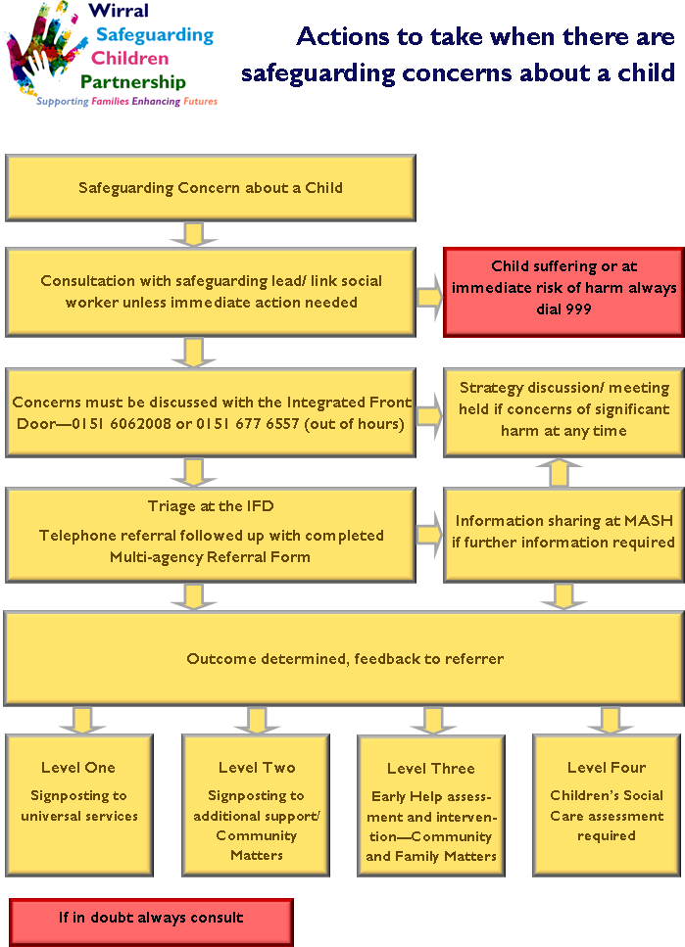

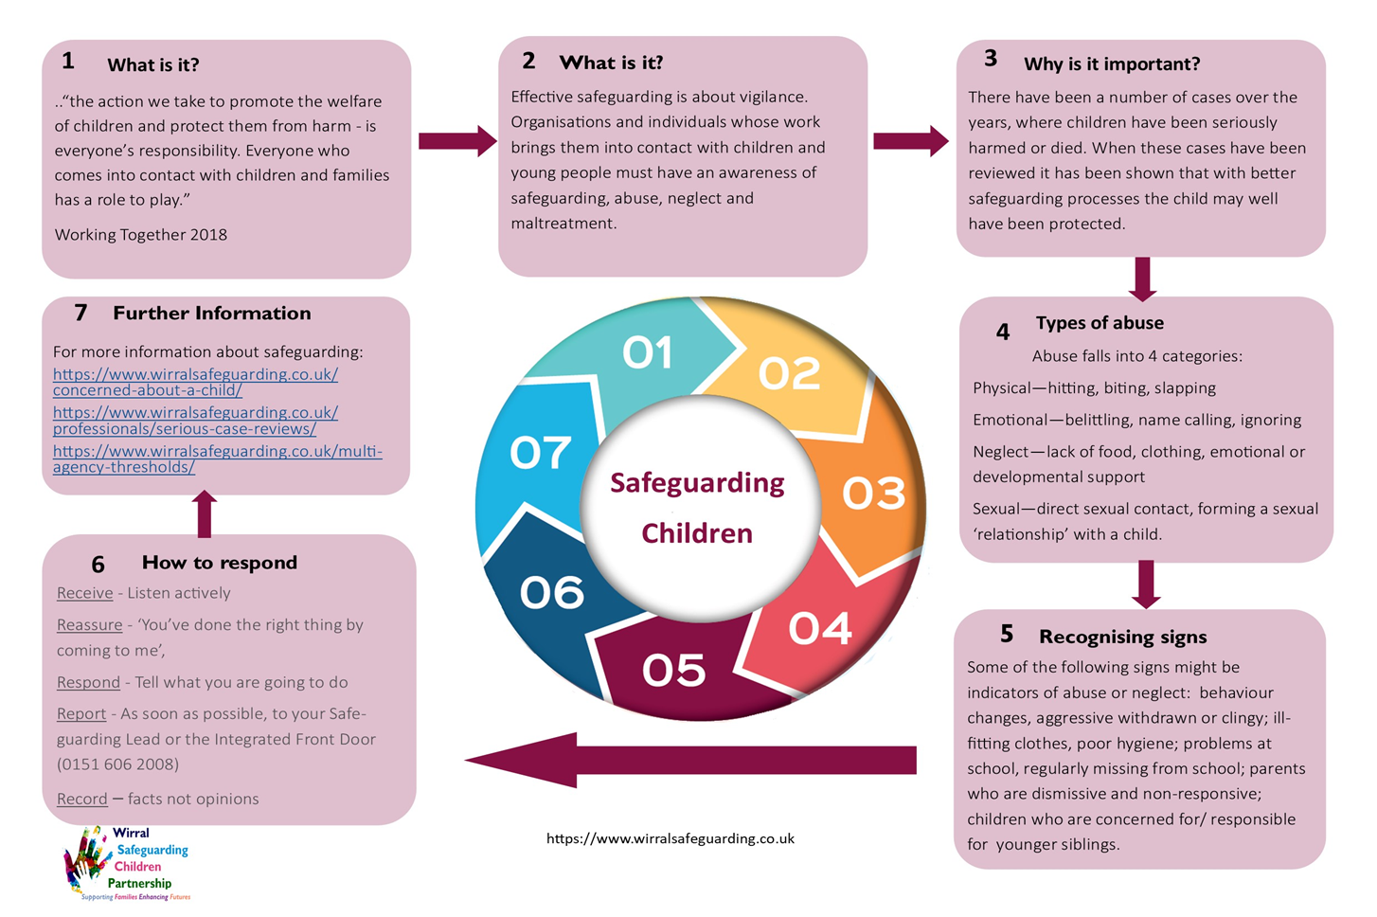

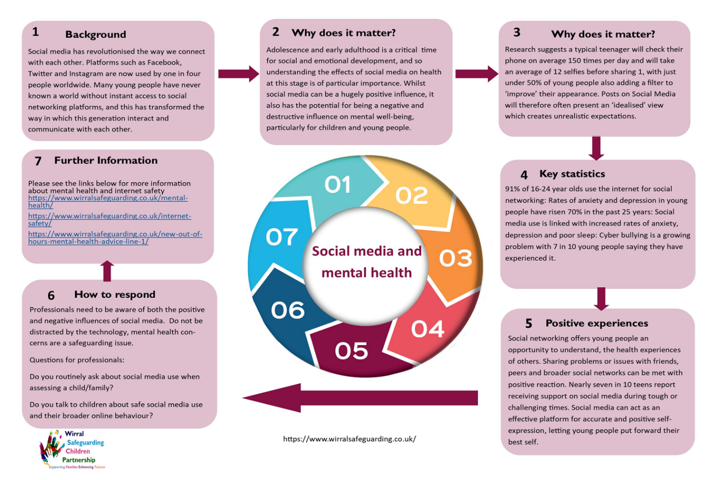
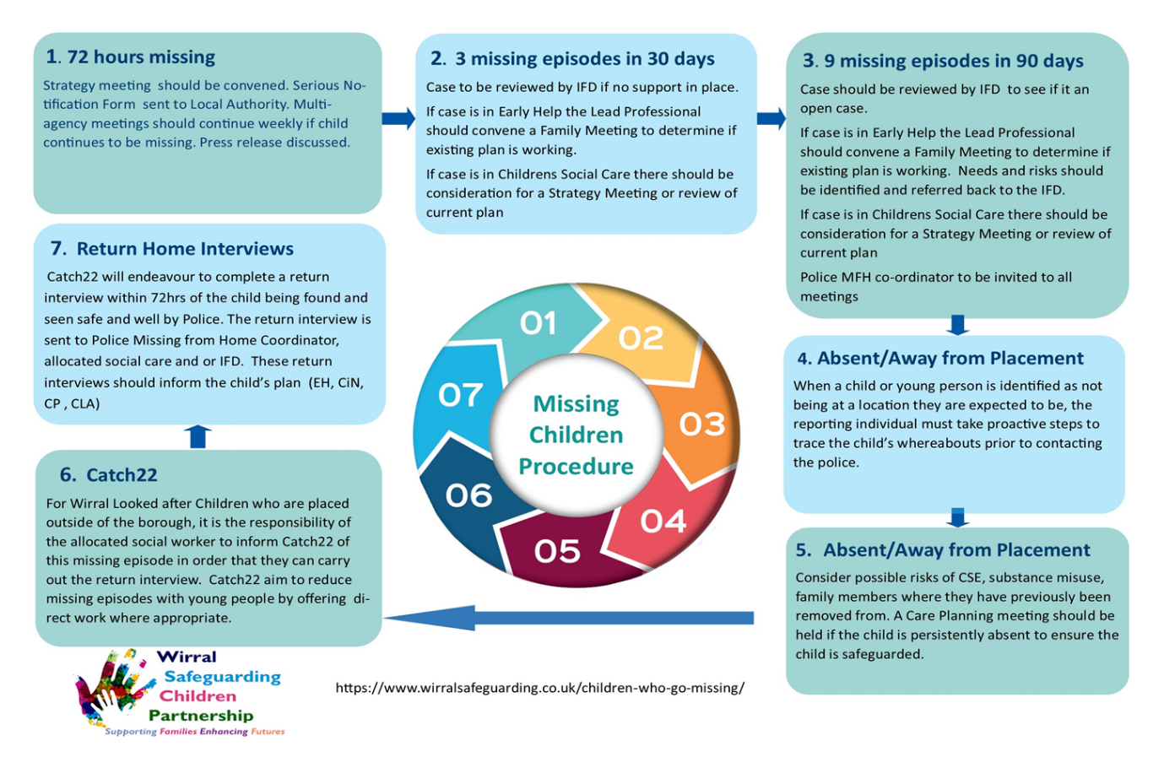

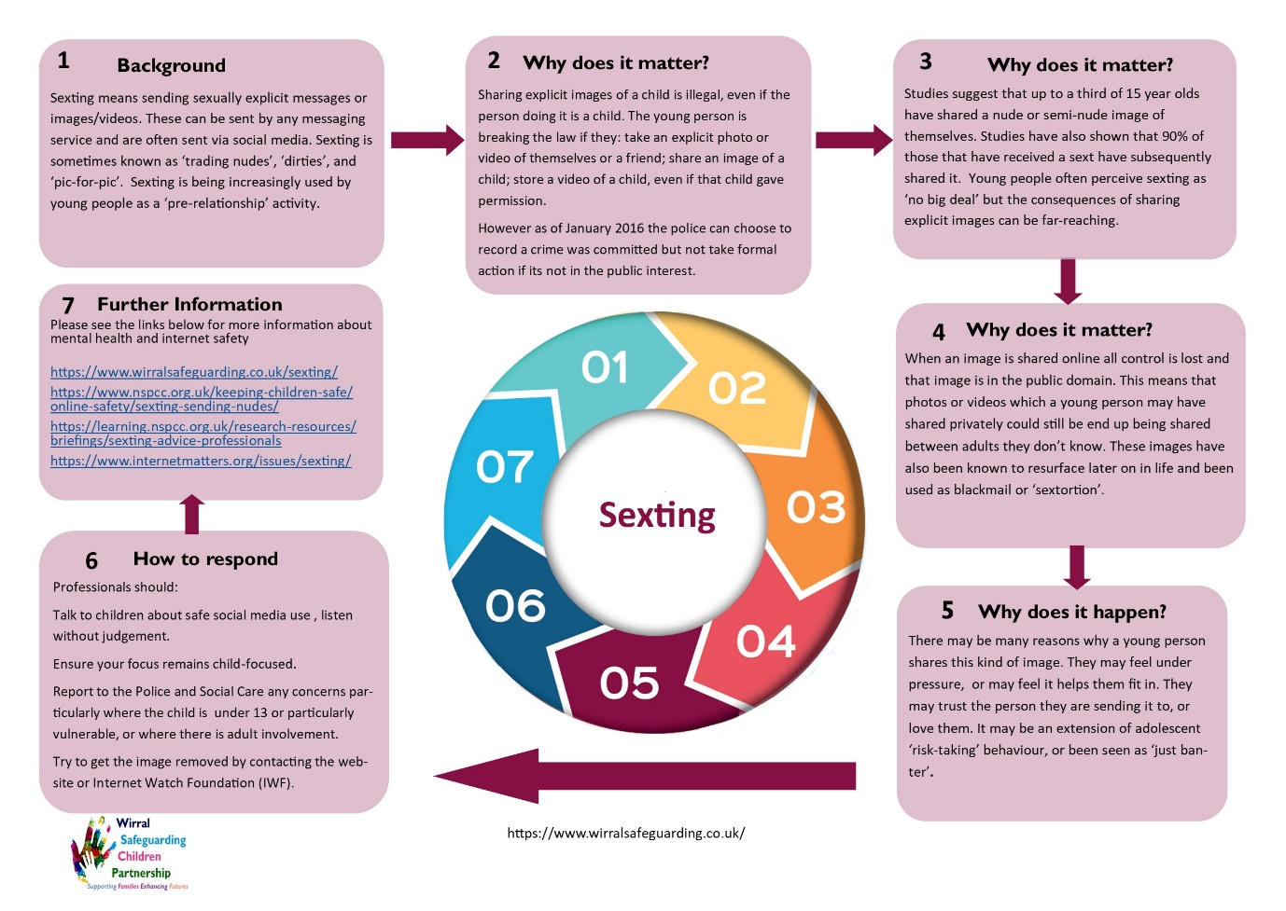

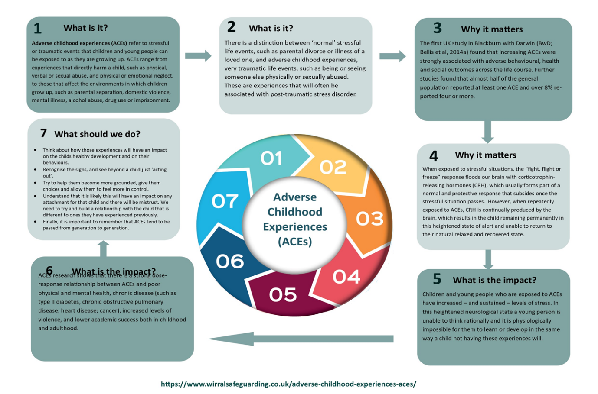

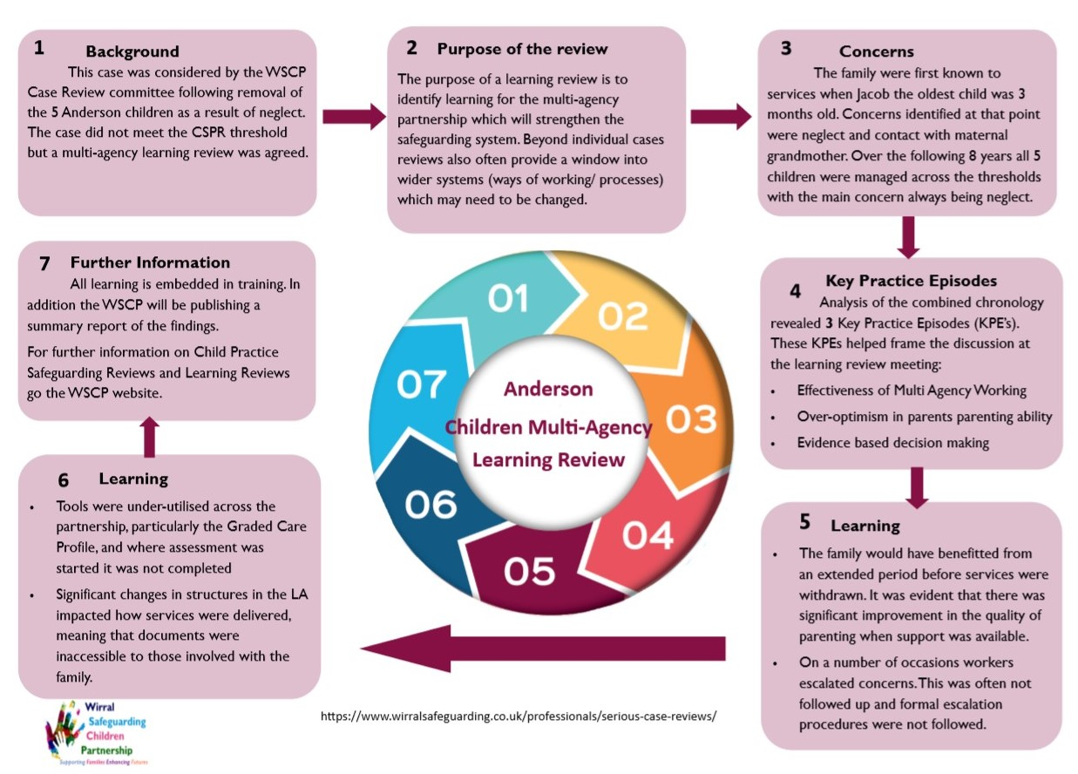

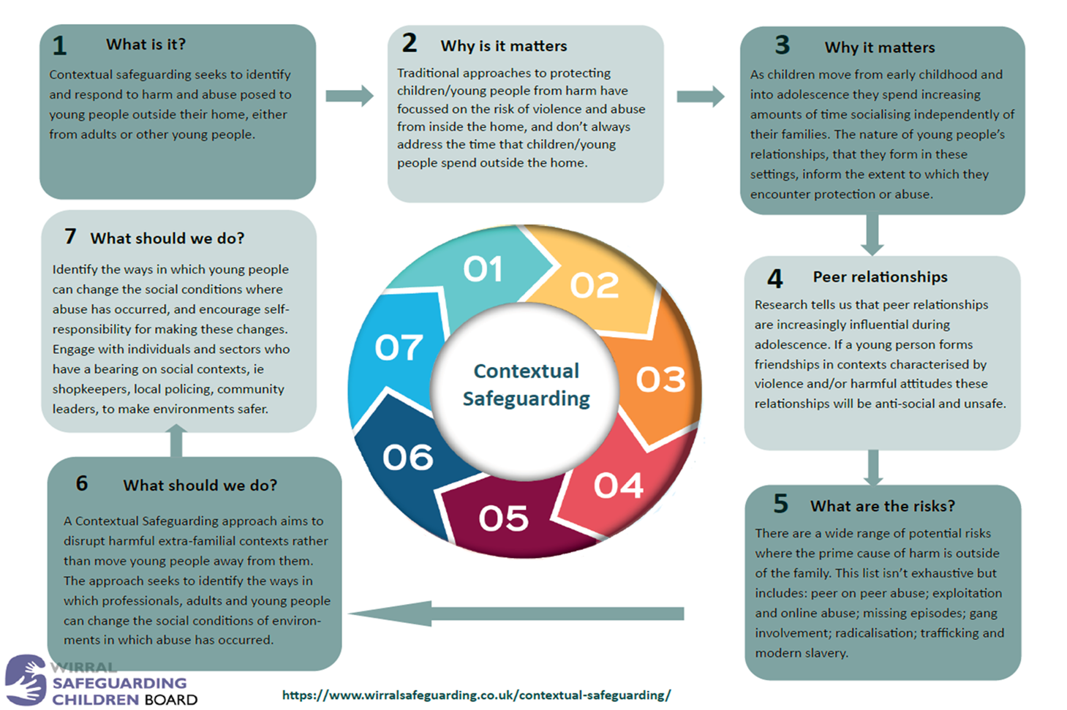

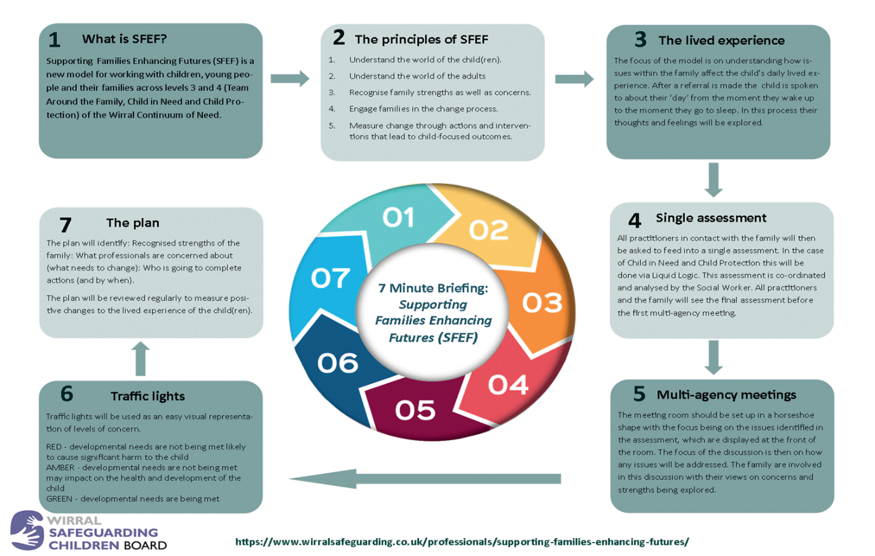

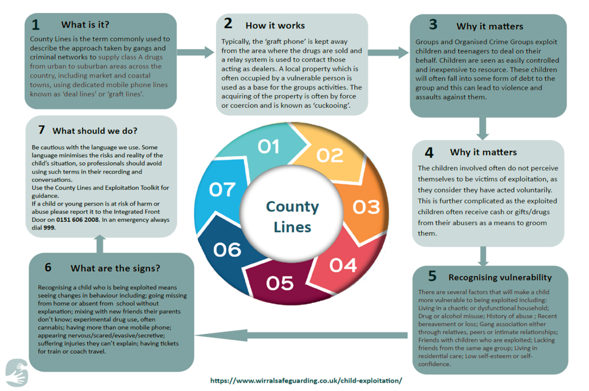

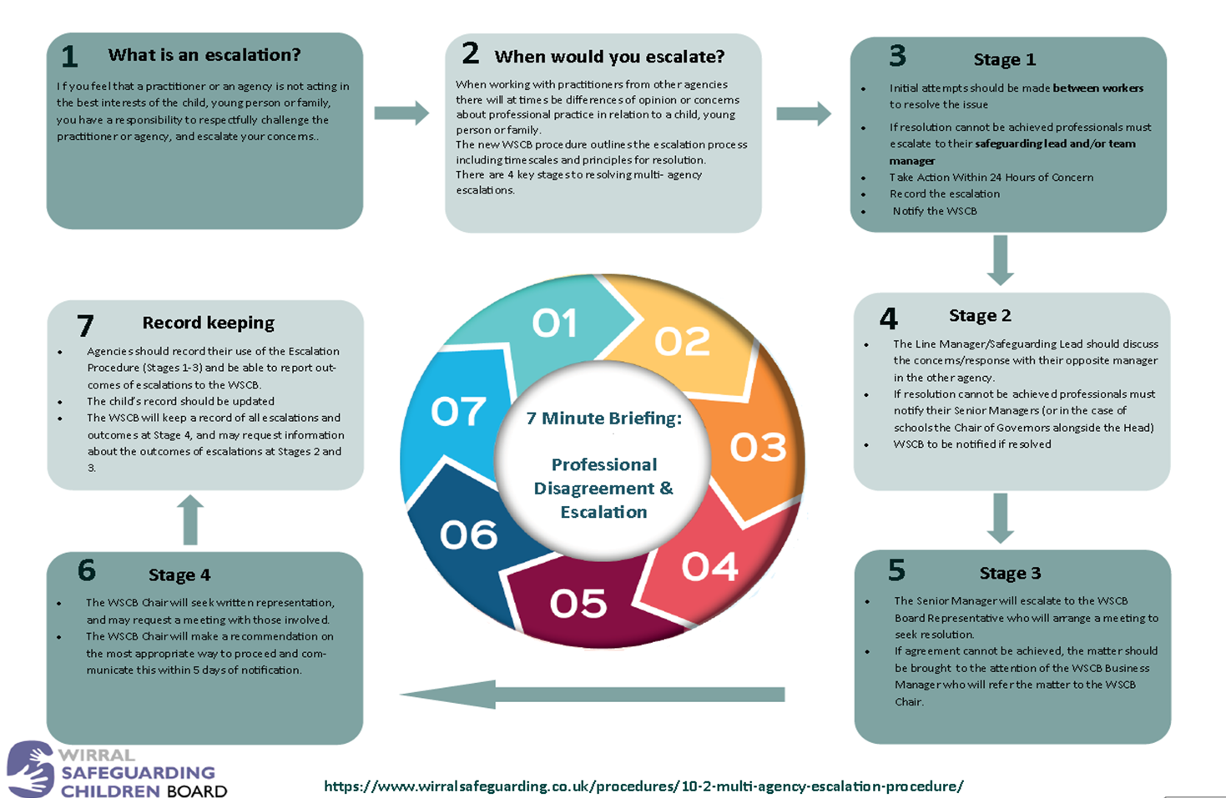

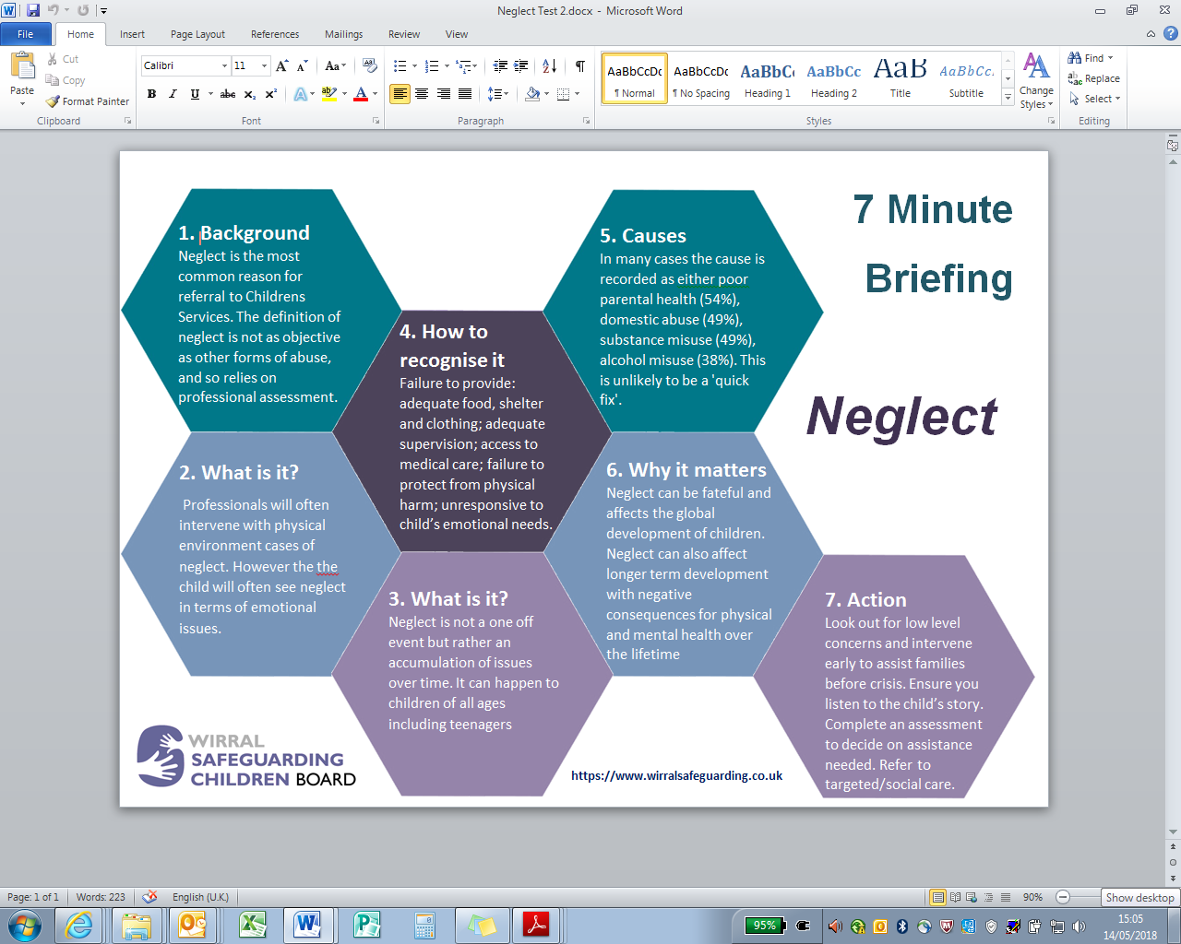

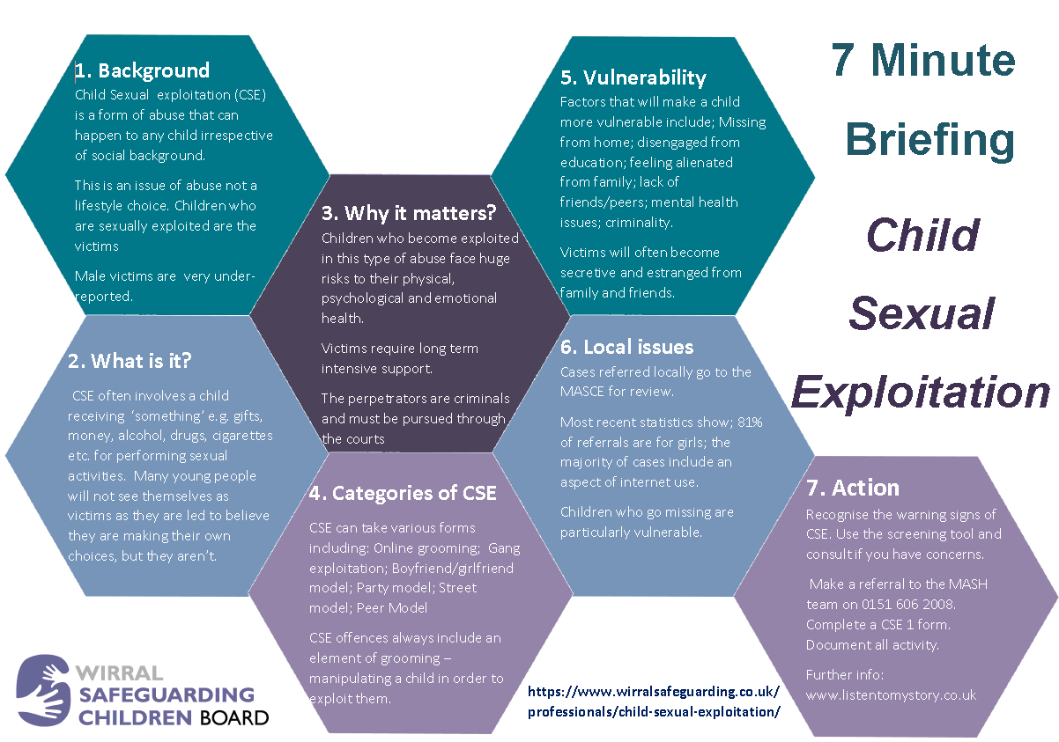

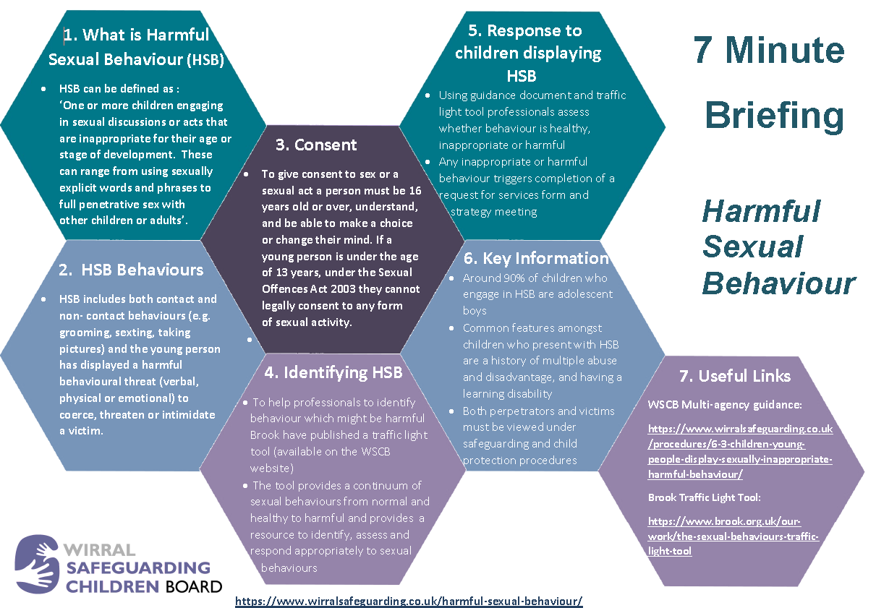

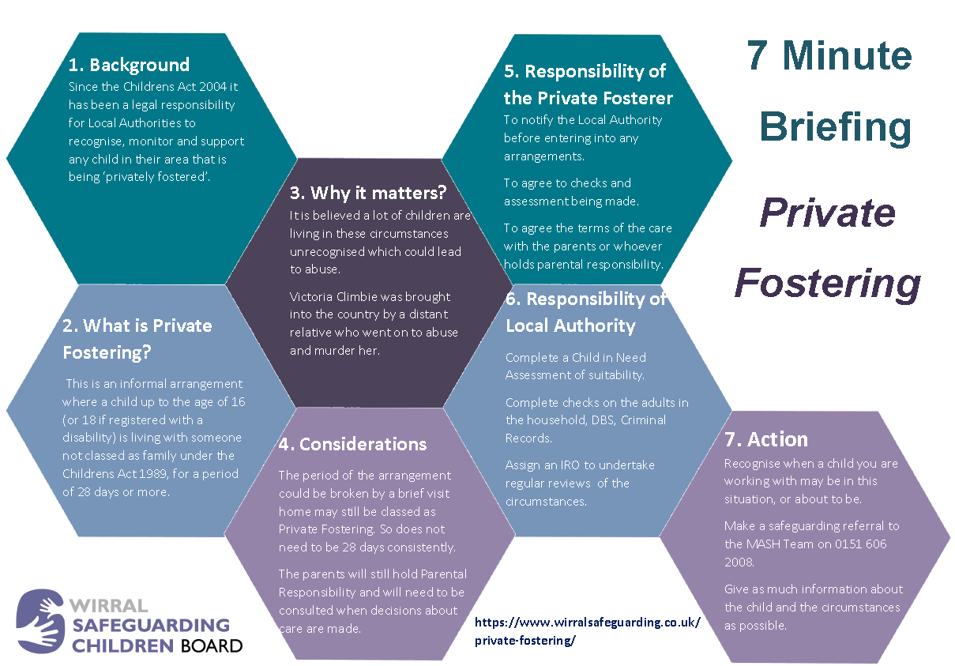

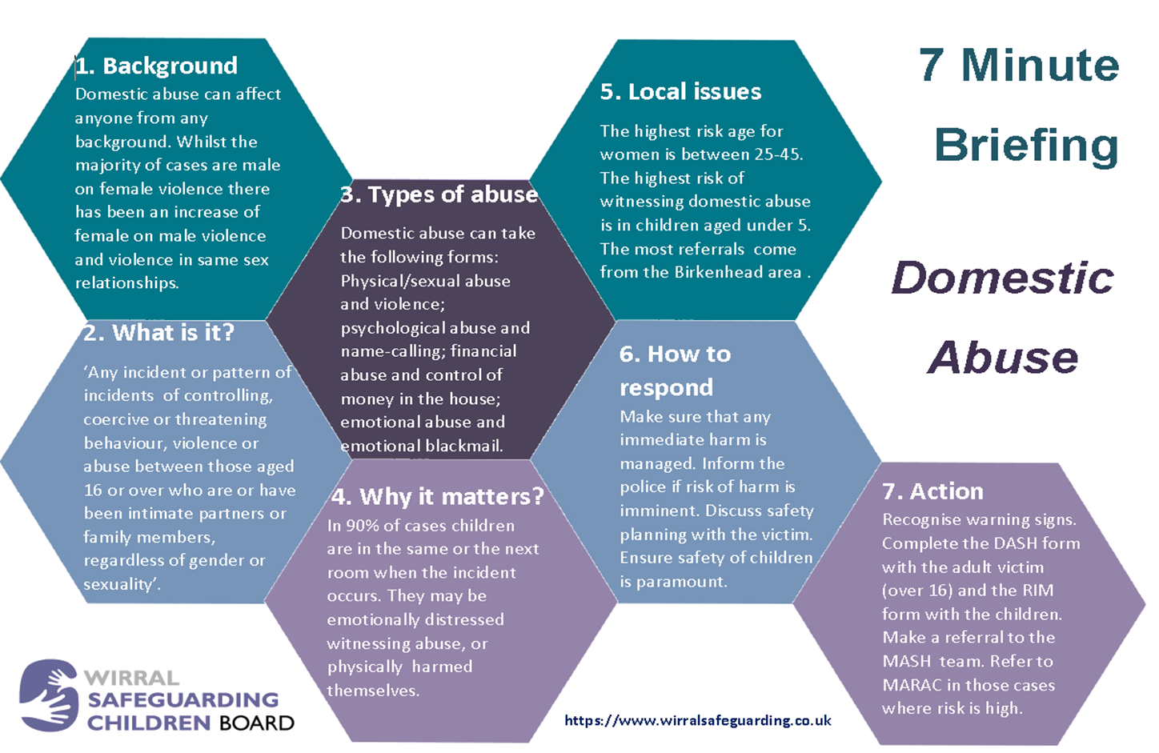

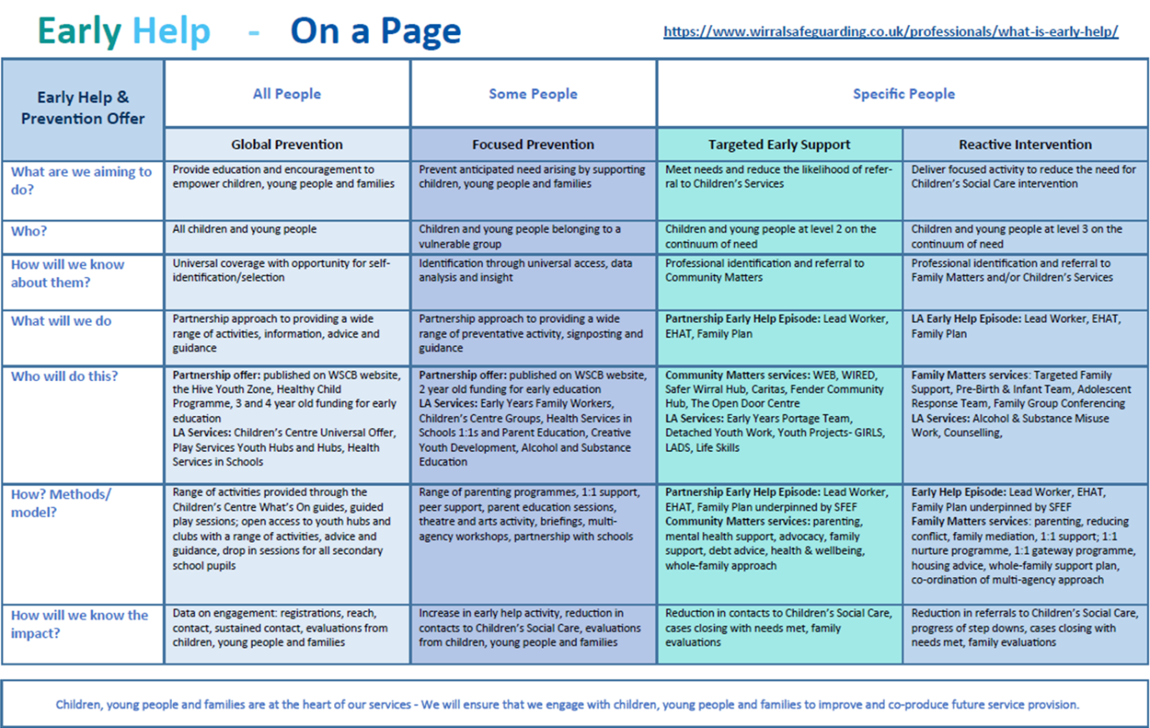

Wirral Hospitals’ School Safeguarding Policy
Coronavirus Addendum 31st March 2020
This addendum to our Safeguarding policy has been written to cater for the extraordinary circumstances surrounding the coronavirus pandemic and its impact on our children and families. It will be reviewed weekly as a minimum, but will be changed and distributed the next working day, should the national guidance change.
LA advice
All new advice coming into school from the LA is shared with all relevant staff by the Headteacher on a daily basis. Usually, this is via the school’s email system.
Updated advice regarding LA systems for social care and reporting procedures are shared with the DSL and Deputy DSL.
Reporting Concerns within our setting
Any concerns of a child protection nature MUST be reported to the DSL or Headteacher by telephone on the same working day and followed up with an email. The relevant phone numbers are:
Headteacher, Phill Arrowsmith – 07976 027 161
DSL, Vicki Tranter – 07976 027 137
Any concerns of a wellbeing nature should be emailed to the DSL, Headteacher and, where known, Head of House, on the same working day that they arise.
Reporting Concerns to Wirral LA
As the corporate parent, Wirral Social Care remain responsible for safeguarding procedures for all children who are not attending school on a daily basis.
It is our responsibility to ensure that all children who subject to CP plans or at CIN are able to access school each day. If they are not present, either on a given day or as part of their social distancing plan during the current ‘lockdown’ procedures, we MUST ensure that the child’s social worker is contacted without delay. Where a child in this category is expected in school and does not arrive, we MUST try to establish the reasons. If we cannot, or are not satisfied, the SW MUST be contacted the same day and without delay.
Wirral LA have published new guidance for reporting concerns for children who do not currently have an allocated SW, but who we have concerns about. This guidance has been shared with the DSL and Deputy DSL, as well as all members of SLT.
Safeguarding Lead
The school’s DSL is Vicki Tranter and our Deputy DSL is Jackie McArdle. In addition, the Headteacher has completed DSL training. On most occasions, one of those three members of staff are on site at all times. On all other occasions, the school’s Deputy Headteacher, Sarah Marrion, is on site. During normal working hours, the Headteacher and DSL can be contacted by email or telephone.

Children Looked After
Laura Birch remains responsible for the coordination of education provision for all CLA’s. In her absence, please discuss any concerns with the Headteacher or DSL.
Peer-on-peer abuse
As we are not using an electronic platform for our off-site education provision, there is no change to the guidance for peer-on-peer abuse. The only caveat to this is that our students will be spending more time online during this period and so we must be available to offer support as quickly as possible where students report incidents of peer-on-peer abuse. Concerns must be reported through the normal channels, i.e. shared with DSL, Deputy DSL or Headteacher the same working day.
Vulnerable Students
Although our students are not specifically identified in government documents as being in the vulnerable category, we have taken the decision to identify ALL students as being vulnerable, due to their health needs. Therefore, the guidance in this document and all other information shared with staff, applies to all students.
Safeguarding arrangements for children out of school
All JPC students have the right to attend school. However, most are following government guidelines and staying at home. This puts our cohort at increasing risk of mental health problems. Therefore, in order to ensure their safety and check on their wellbeing, we have implemented a process whereby every child who does not attend school receives a weekly phone call from a member of SLT. Any concerns raised during this phone call MUST be shared on the same working day with the DSL and Headteacher.
If we are unable to make contact with the child or family, we must try again the following working day, using all numbers we hold for the child’s family. If we are still unable to make contact, this MUST be reported to the DSL and Headteacher, who will arrange for a home visit to be made.
Arrangements for Hubs/Volunteers
As we are staying open throughout the duration of the outbreak, there will not be a need for any JPC student to attend a hub or other school. In addition, as there is so much good will amongst our staff, there will not be a need for us to recruit volunteers, and we will not proceed with any offers of volunteers until the school has returned to normal operation.
Online communication
Where possible, all communication with a child should be via their parent’s email address. However, all children have a school email address and this can be used to communicate with them. Please note the following:
- Communication must only be about setting and/or marking work
- Any communication outside of this MUST be immediately reported to the DSL and Headteacher
- Communication MUST NOT come from a member of staff’s private email account or go to a student’s private email account under any circumstances
- If it is necessary to use the student’s email account for communication, we MUST copy in our line manager to all communications

