Daily tasks
Reading  Read your reading book, or any other book, magazine etc. AFTER reading, write 3 quiz questions about the book. See if your family member can answer them.  Log onto Bug Club and read some new books too! |  | Spelling  Write sentences with your spelling words. Pick 4 different words from your year group list to practise daily.  There are also spelling activities for you to complete on Bug Club, Education City and Purple Mash. |  | Times tables  Practise your 2, 5 and 10 times tables. You can chant them, write them down or get a family member to quiz you!  White Rose Maths Hub also have some helpful home learning resources.  https://whiterosemaths.com/homelearning/year-2/
Tasks that I can select each day
We are all scientists!  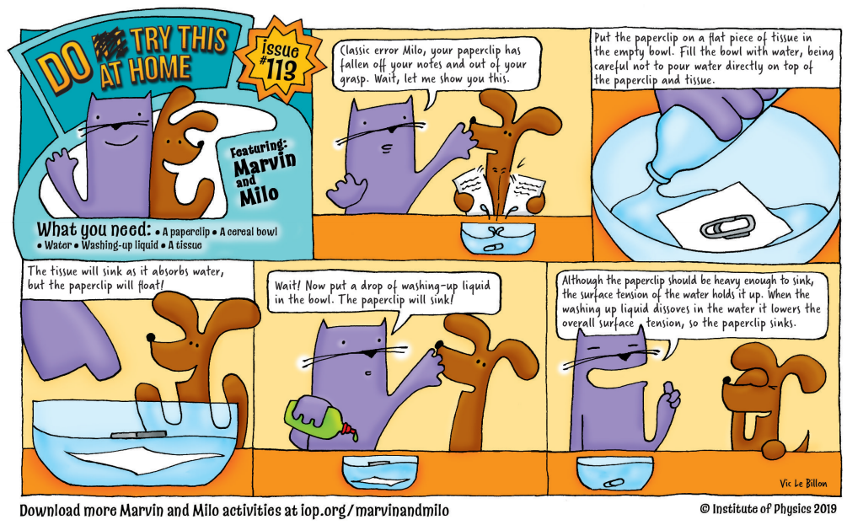  Join Marvin and Milo in completing some scientific experiments at home! http://www.physics.org/marvinandmilo.asp | Physical activity  Get your hearts racing by doing at least 10minutes of exercise every day.  Can you try and make up a 5 minute exercise routine of your own like Joe Wicks? |  | Art  Make some wild art using sticks, leaves, flowers and anything else that you can find outdoors. |  | Write all about it!  Create a comic strip about an animal that turns into a super hero!  What adventures could it go on? Will it have a super power? Don’t forget to include some cool drawings to match.
Family time  Could you make a family kindness jar? Every time that somebody does something kind at home write it on a piece of paper and put it in the jar. When the jar is full everyone deserves a treat! | Independence  If you go on a daily walk, take note of all of the things that you can see in your local area. Make a scavenger hunt for somebody to complete. Can they spot all of the things on your list?  Make a den at home or find an unusual place to read and book. Take a picture and email it to me!

