Daily tasks
Reading  Read your reading book, or any other book, magazine etc. AFTER reading, write 3 quiz questions about the book. See if your family member can answer them. |  | Spelling  Write sentences with your spelling words. Pick 4 different words from your year group list to practise daily. |  | Times tables  Practise your 2, 5 and 10 times tables. You can chant them, write them down or get a family member to quiz you!
Tasks that I can select each day
We are all scientists!  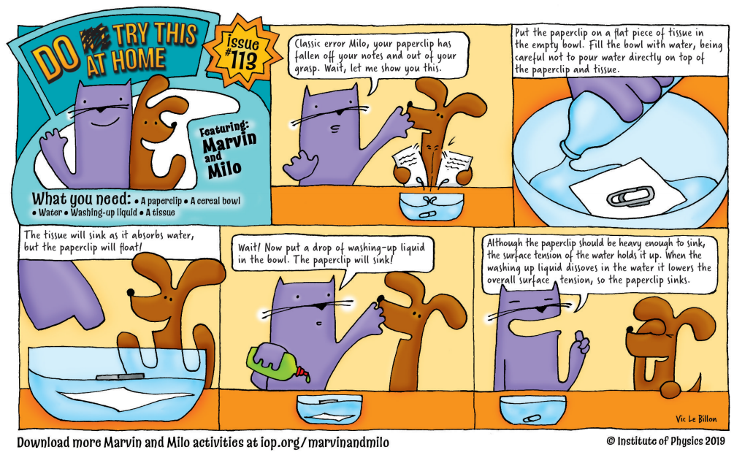  Join Marvin and Milo in completing some scientific experiments at home! http://www.physics.org/marvinandmilo.asp | Physical activity  Get your hearts racing by doing at least 10minutes of exercise every day.  Can you try and make up a dance routine to one of your favourite songs? |  | DT  Collect and recycle materials from around your home like yoghurt pots, toilet rolls and boxes and see what you can create a with them! |  | Write all about it!  Describe the most disgusting meal ever. Maybe something that Mr Twit might eat!  You can draw a picture, write a recipe or write a description. You could even do all 3!
Family time  Could you Face Time or call somebody that you haven’t seen for a while and read them a book or part of a book? | Independence  Ask your grown up to assign you a new chore to do around the house that can be your responsibility each day this week.  Play alphabet bingo! Can you find something in your house or garden that starts with each letter of the alphabet?

