

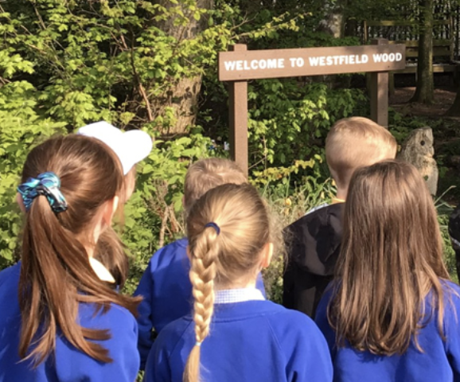

REMINDER

All pupils need to bring water bottles and sun hats with them to school, and have sun cream applied before coming into school each day

Dates for your Diary

Tuesday, 13th June
Cherry Class go to the Fire Station Community Garden

Wednesday, 14th June
Gifted & Talented at the Heath School

Friday, 16th June
Year 6 – First Aid
Other Awards
Tidiest Classroom – Oak Class
Ms Powell – Lexi, Larch Class
Headteacher Award – Annie, Willow Class

h
Star of the Week
Willow – George
Cherry – Freddie
Larch – Daisy
Oak – Lillie

Attendance
Willow – 88.1%
Cherry – 93.4%
Larch – 93.9%
Oak – 93.9%
Whole school – 92.8%

PuntualityAward
Willow Class

Any questions or comments? Please send us an email.
School: sec.westfield@haltonlearning.net
Headteacher – Miss S. Pope: head.westfield@haltonlearningnet

  - Promoting independence, individuality and an inquisitive mind.

Westfield Primary School
9th June 2023

