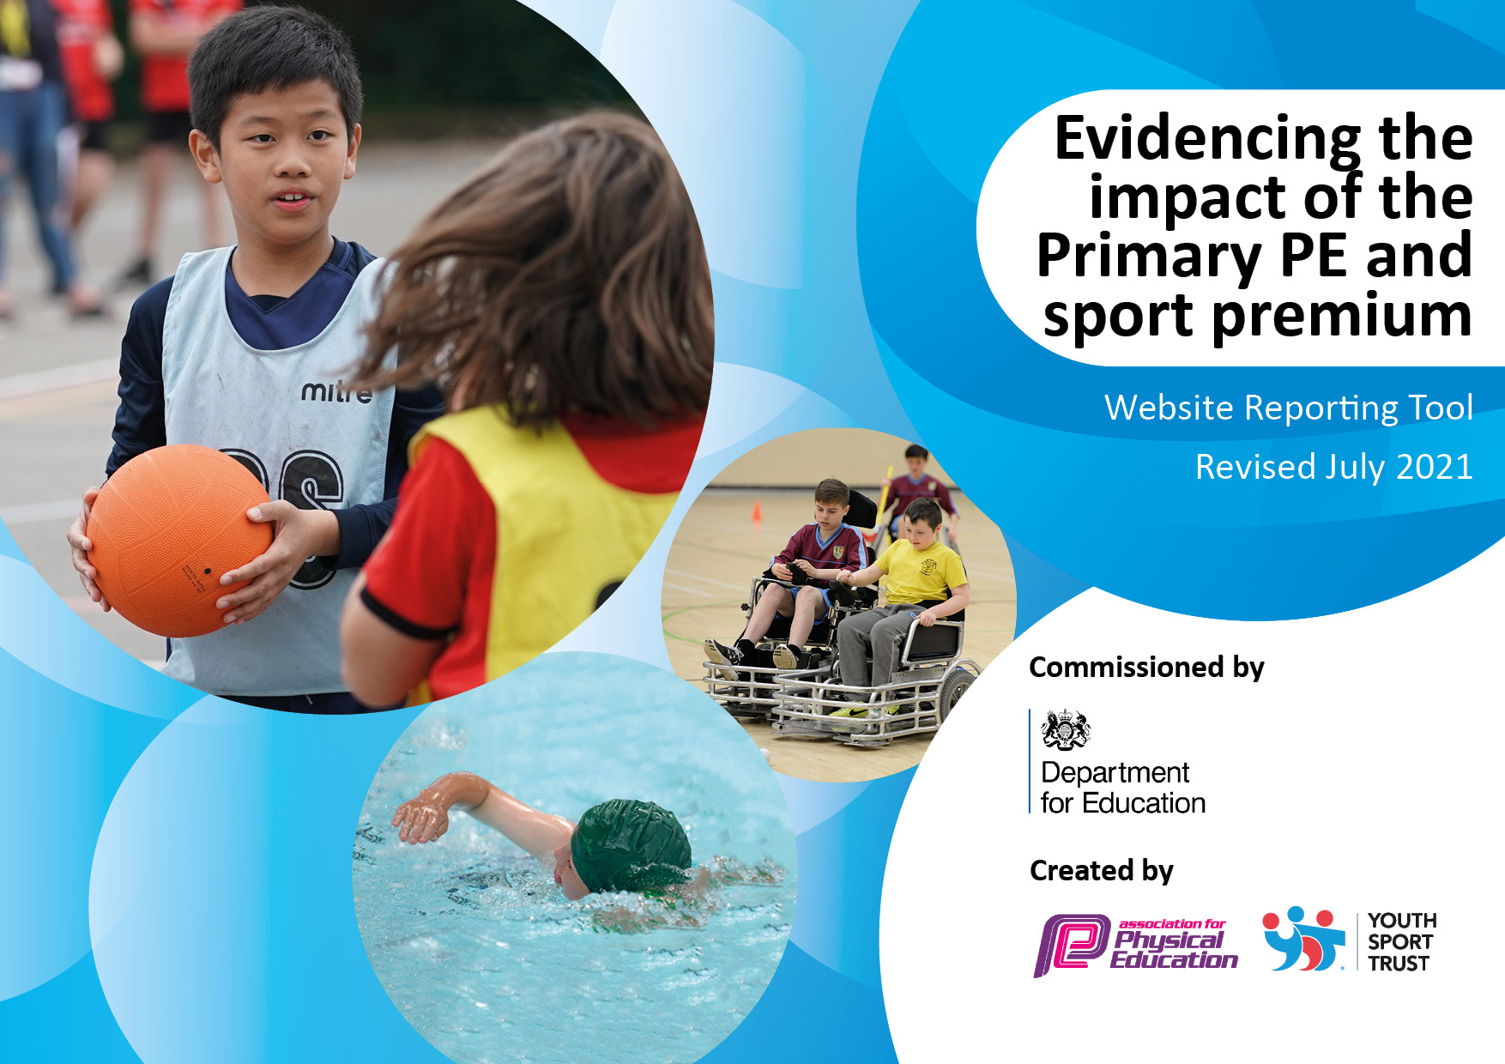
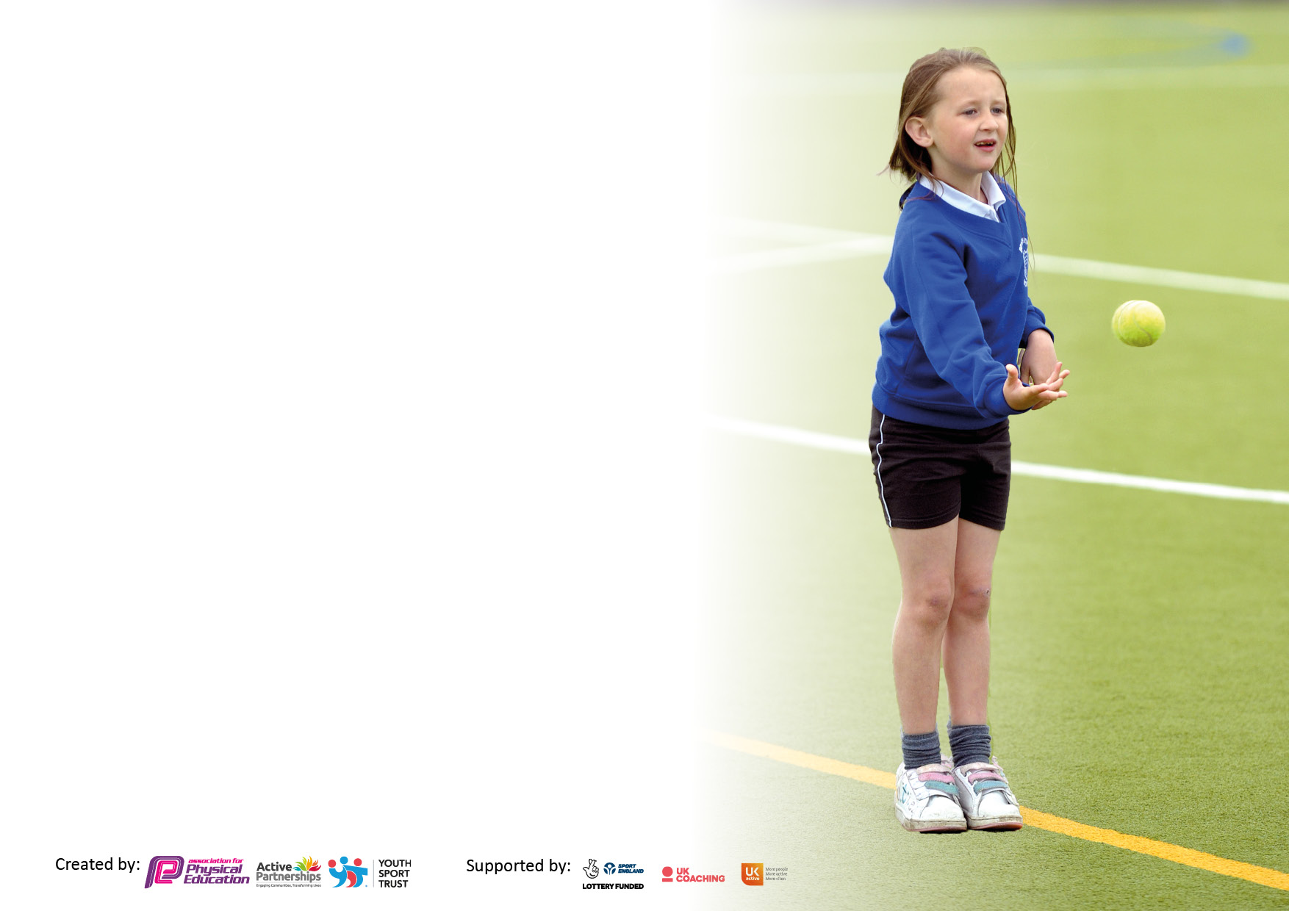

It is important that your grant is used effectively and based on school need. The Education Inspection Framework makes clear there will be a focus on ‘whether leaders and those responsible for governors all understand their respective roles and perform these in a way that enhances the effectiveness of the school’.

Under the Quality of Education Ofsted inspectors consider:
Intent - Curriculum design, coverage and appropriateness
Implementation - Curriculum delivery, Teaching (pedagogy) and Assessment
Impact - Attainment and progress

To assist schools with common transferable language this template has been developed to utilise the same three headings which should make your plans easily transferable between working documents.

Schools must use the funding to make additional and sustainable improvements to the quality of Physical Education, School Sport and Physical Activity (PESSPA) they offer. This means that you should use the Primary PE and sport premium to:

- Develop or add to the PESSPA activities that your school already offer
- Build capacity and capability within the school to ensure that improvements made now will benefit pupils joining the school in future years
- The Primary PE and sport premium should not be used to fund capital spend projects; the school’s budget should fund these.

Pleasevisitgov.ukfortherevisedDfEguidanceincludingthe5keyindicatorsacrosswhichschoolsshoulddemonstrate animprovement.Thisdocumentwillhelpyoutoreviewyourprovisionandtoreportyourspend.DfEencouragesschools to use this template as an effective way of meeting the reporting requirements of the Primary PE and sport premium.

We recommend you start by reflecting on the impact of current provision and reviewing the previous spend.

Schools are required to publish details of how they spend this funding, including any under-spend from 2019/2020, as well as on the impact it has on pupils’ PE and sport participation and attainment. All funding must be spent by 31st July 2022.

We recommend regularly updating the table and publishing it on your website throughout the year. This evidences your ongoing self-evaluation of how you are using the funding to secure maximum, sustainable impact. Final copy must be posted on your website by the end of the academic year and no later than the 31st July 2021. To see an example of how to complete the table please click HERE.


Created by: Supported by:

Details with regard to funding
Please complete the table below.

Total amount carried over from 2020/21 | £ 7,609.52
Total amount allocated for 2021/22 | £ 18,350.00
How much (if any) do you intend to carry over from this total fund into 2022/23? | £ 0
Total amount allocated for 2021/22 | £ 25959.52
Total amount of funding for 2021/22. To be spent and reported on by 31st July 2022. | £ 25959.52
Swimming Data
Please report on your Swimming Data below.

Meeting national curriculum requirements for swimming and water safety.

N.B. Complete this section to your best ability. For example you might have practised safe self-rescue techniques on dry land which you can then transfer to the pool when school swimming restarts.
Due to exceptional circumstances priority should be given to ensuring that pupils can perform safe self rescue even if they do not fully meet the first two requirements of the NC programme of study
What percentage of your current Year 6 cohort swim competently, confidently and proficiently over a distance of at least 25 metres?  N.B. Even though your pupils may swim in another year please report on their attainment on leaving primary school at the end of the summer term 2021.  Please see note above | 22%
What percentage of your current Year 6 cohort use a range of strokes effectively [for example, front crawl, backstroke and breaststroke]?  Please see note above | 22%
What percentage of your current Year 6 cohort perform safe self-rescue in different water-based situations? | 22%
Schools can choose to use the Primary PE and sport premium to provide additional provision for swimming but this must be for activity over and above the national curriculum requirements. Have you used it in this way? | No

Action Plan and Budget Tracking
Capture your intended annual spend against the 5 key indicators. Clarify the success criteria and evidence of impact that you intend to measure to evaluate for pupils today and for the future.

Academic Year: 2020/21 | Total fund allocated: | Date Updated:
Key indicator 1: The engagement of all pupils in regular physical activity – Chief Medical Officers guidelines recommend that primary school pupils undertake at least 30 minutes of physical activity a day in school |  |  |  | Percentage of total allocation:
 |  |  |  | %
Intent | Implementation |  | Impact
Your school focus should be clear what you want the pupils to know and be able to do and about  what they need to learn and to  consolidate through practice: | Make sure your actions to achieve are linked to your intentions: | Funding allocated: | Evidence of impact: what do pupils now know and what can they now do? What has changed?: | Sustainability and suggested next steps:
A qualified Sports Development Sports Coach is employed for 2 afternoons per week to plan and deliver high quality curricular PE provision for the children across the school in –  - Games both indoor and outdoor  - Net games  - Gymnastics  Provide opportunities for all children to access high quality extracurricular sports provision and competitions.  Additional equipment to provide opportunities for children to remain active during lunchtimes and playtimes  New playground markings across all playgrounds. | Coaches timetables to work with all classes throughout the year, providing a broad experience of a wide range of sports and activities which develop key skills and ensure that all children are physically active and enjoying their activity  Sports coach provides an extra- curricular clubs each Tuesday and Friday. The additional activities are there to encourage children to attend an activity which they enjoy.  Playground markings were designed and installed with the intent of focussing on the daily mile, long jump and other fitness activities. Other markings related to typical playground games. | £11,015.00  £1411.92  £387.55  £5884.00 | All children are more physically active and have been provided with a broad range of experiences in sports.  The sports coach has engaged all children, including some children who do not particularly like participating in sports.  All children have been taught by qualified sports coaches who have delivered a curriculum that has developed children’s skills and techniques through a multi sports approach.  Various sports both traditional and alternative sports are encouraging children’s interest in a more sport and healthy lifestyle.  New bark has been laid to recommission a piece of trim trail that was previously not used. Encouraging active playtime.  New equipment for playtime provides opportunity to learn new skills and greater confidence and participation in sports.  Enhanced engagement in a range of physical activities at break and dinner times, particularly of an athletics nature. | With continued funding, the quality provision provided will be able to continue.  Upskill staff through observing and team teaching with qualified sports coaches to ensure continuity of provision.  To increase the uptake of children taking extracurricular sports.  To reintroduce play leaders to support activities for KS1 and EYFS at lunchtimes.
Key indicator 2: The profile of PESSPA being raised across the school as a tool for whole school improvement |  |  |  | Percentage of total allocation:
 |  |  |  | %
Intent | Implementation |  | Impact
Your school focus should be clear what you want the pupils to know and be able to do and about  what they need to learn and to  consolidate through practice: | Make sure your actions to achieve are linked to your intentions: | Funding allocated: | Evidence of impact: what do pupils now know and what can they now do? What has changed?: | Sustainability and suggested next steps:
Ensure all children develop a positive attitude towards health and fitness  School sports display in school celebrating successes and achievements. Friday assembly children are able to share their sporting achievements, from their home activities.  Sports week held in school annually.  Active Angels Classroom Yoga  Druhmz Aloud | Freddy fit to visit school to deliver fun fitness to all our children  Celebrating our children’s achievements both in and out of school.  Children are able to access different sports activities during this week, such as a climbing wall, golf, archery, street dance. They also take part in traditional sports days’ competitions.  To enable children to try a new fitness activity.  A fun fitness and music activity to for all children. | £2340.00  £259.58  £2012.88  £300.00  £657.50 | Children enjoy sharing and seeing their achievements and it acts as a great motivator for them.  Children are motivated to do and be their best. Children enjoy taking part and acknowledging that sport is fun. | Investigate alternative new sporting activities to introduce to pupils to develop a wider range of skills and sustained engagement.  To look at new health themes to promote across school and link in with Freddy Fit.

Key indicator 3: Increased confidence, knowledge and skills of all staff in teaching PE and sport |  |  |  | Percentage of total allocation:
 |  |  |  | %
Intent | Implementation |  | Impact
Your school focus should be clear | Make sure your actions to | Funding | Evidence of impact: what do | Sustainability and suggested
what you want the pupils to know | achieve are linked to your | allocated: | pupils now know and what | next steps:
and be able to do and about | intentions: |  | can they now do? What has
what they need to learn and to |  |  | changed?:
consolidate through practice:
CPD opportunities are being explored by the whole staff by observing the trained coaches deliver specific lessons. | Observations and staff to work alongside external sports providers to gain additional knowledge and skills. | £0 | As a result, all staff have an increased subject knowledge to develop further effectiveness of the delivery of this subject. | PE Lead to access SSP networks and lead internal training and model lessons.
Key indicator 4: Broader experience of a range of sports and activities offered to all pupils |  |  |  | Percentage of total allocation:
Intent | Implementation |  | Impact
Your school focus should be clear | Make sure your actions to | Funding | Evidence of impact: what do | Sustainability and suggested
what you want the pupils to know | achieve are linked to your | allocated: | pupils now know and what | next steps:
and be able to do and about | intentions: |  | can they now do? What has
what they need to learn and to |  |  | changed?:
consolidate through practice:
To encourage wider participation of the children of said physical activities by introducing a wider range of extracurricular activities. | Introduction of Little Rockies and Little Biker programmes throughout school. | £1078.00 | Children enjoy sharing and seeing their achievements and it acts as a great motivator for them.  Developing cycling skills through balance bikes.  Children are motivated to do and be their best. Children enjoy taking part and acknowledging that sport is fun. | Later on in school children will be provided with the opportunity to take part in the Bike Ability Level 1&2 awards.

Key indicator 5: Increased participation in competitive sport |  |  |  | Percentage of total allocation:
 |  |  |  | %
Intent | Implementation |  | Impact
Your school focus should be clear | Make sure your actions to | Funding | Evidence of impact: what do | Sustainability and suggested
what you want the pupils to know | achieve are linked to your | allocated: | pupils now know and what | next steps:
and be able to do and about | intentions: |  | can they now do? What has
what they need to learn and to |  |  | changed?:
consolidate through practice:
Through membership of the school sports partnership to increase wider participation in competitive sport  To re-engage with inter-school sporting competition. | Membership of school sports partnership  New football Kit | £583.00  £219.00 | For the children to experience competitive sport with other schools. | Wider involvement in other competitive sports, other than football.

Signed off by
Head Teacher: | Simon Wright
Date: | 20.07.2022
Subject Leader: | Liam Browne
Date: | 20.07.2022
Governor: | Jackie Yates
Date: | 20.07.2022

