 | Autumn 1 | Autumn 2 | Spring 1 | Spring 2 | Summer 1 | Summer 2
ENGLISH | GREEK MYTHS  by Marcia Williams  Theseus and the Minotaur/Pandora’s Box  - Narrative  - Instructions  - Persuasion | LEON AND THE PLACE BETWEEN  by Graham Baker-Smith.  - Explanation  - Persuasion  - Narrative | EXPLORERS  How to be an Explorer  By Henry Hardcastle  - Non-chronological reports  - Persuasion  - Narrative Unit | SPIES  Alex Rider by Anthony Horowitz  - Explanation  - Biography  - Description | LOST HAPPY ENDINGS  by Carol Anne Duffy  - Narrative  - Non-chronological reports  - Instructions  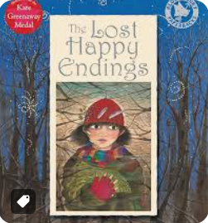 | THE BOY AT THE BACK OF THE CLASS  by Onjali Q.Rauf  - Narrative  - Information Text  - Discussion  - Newspaper  (Literacy Shed+ Unit)
READING SPINE | 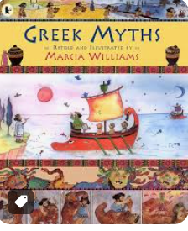  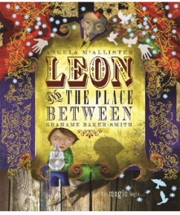  Who Let the Gods out by Maz Evans |  | 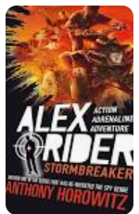  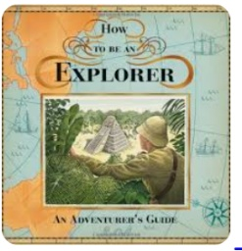  Kensuke’s kingdom By Michael Morpurgo. |  | 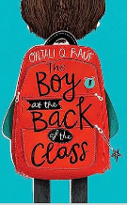  The Boy at the Back of the Class by Onjali Rauf  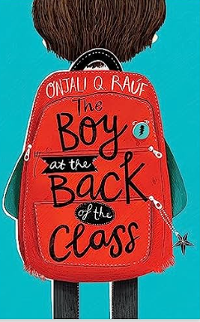
HISTORY/ GEOGRAPHY | 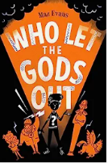  Ancient Greece – in depth study |  | UK compared to North America | 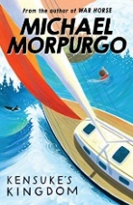  Vikings | Local area study | Enough for everyone
SCIENCE | Forces | Properties of Materials | Space | British Science Week | Living Things and their habitats | Animals including humans
ART/DT | Art of Sculpture  Clay vases | Construction Technoloy  Steady Hand Game | Art of Printing  Lino Printing | Food Technology  Cous Cous Salad | Sewing Technology  Puppets | Art of Painting  Still Life
COMPUTING | Quizzing  Databases | Game creator | Spreadsheets | Coding | Concept maps  Word processing | Coding external devices  Micro:bits
PE | Football | Dance | Swimming  Gymnastics | Swimming  Volleyball | Swimming  Cricket | Swimming  Athletics
RE | Tameside Unit UKS2.1 Why do some people believe God exists?  Can incorporate UC Unit KS2b1 God | Understanding Christianity Unit KS2b4 Incarnation | Tameside Unit UKS2.2 What would Jesus do? Can we live by the values of Jesus in the twenty-first century? | Understanding Christianity Unit KS2b6 Salvation | TU: Is it better to express your beliefs in art and architecture or in charity and generosity? | Understanding Christianity KS2b2 Creation
PSHE | Get HEARTSMART | Don’t Forget To Let Love In | Too Much Selfie Isn’t Healthy! | Don’t Rub It In, Rub It Out | Fake Is A Mistake | No Way Through’, Isn’t True
FRENCH | Pleased to meet you | All about Ourselves | That’s Tasty | Family and Friends | School Life | Time Travelling
MUSIC | Fresh Prince of Bel Air  OLD-SCHOOL HIP-HOP | Y5 Ukulele Tuition | Y5 Ukulele tuition | Living on a Prayer  ROCK | Reflect, Rewind and Replay CLASSICAL | End of Year Play

