
Billinge St Aidan’s CE Primary School

Positive Relationships Policy

“Let your light shine.” Matthew 5:16
Name of Reviewer | Rachel Fisher
Date of Approval of Governing Body | December 2021
Signature of Chair | Alison Corkill
Signature of Head | Rachel Fisher
Date Due for Review | November 2022

HOPE LOVE FRIENDSHIP FORGIVENESS TRUTH PERSEVERANCE

St Aidan’s CE School’s vision for our children is rooted in Christian belief and principles for developing the mind, body and spirit. It is a primary aim of our school that every member of the school community feels valued and respected for their own uniqueness, and that each person is treated fairly and well. We are a caring community, whose values are built on mutual trust, compassion, forgiveness and friendship. At St Aidan’s CE School, we want our behaviour policy to ensure that our children grow into ethically conscious, considerate and independent learners who acquire skills and knowledge through the development of confidence and positive self-esteem. We want them to act upon a personal set of well-founded values and attitudes with an increasing sense of personal responsibility towards, and as members of, the community.
Our Positive Relationships and Behaviour policy is not primarily concerned with rule enforcement, but is a tool used to promote positive relationships with peers and adults with the common purpose of helping everyone learn in a nurturing, empathetic and respectful environment. Consistency, and clear, calm adult behaviour underpins this.

Aims:
We aim to:
• Provide a calm, safe, purposeful and happy atmosphere within school, where everyone feels safe, welcome and secure.
• Have a consistent and positive approach to behaviour throughout the school by providing clear boundaries and modelling appropriate behaviour.
• Encourage self-discipline so that each child learns to accept responsibility for their own behaviour.
• Ensure that every member of the school community behaves in a considerate, co-operative way towards others reflecting the ethos of our Christian values.
• Help our children develop into caring and thoughtful people who respect and value the feelings, opinions, beliefs, property and differences of others.
• Encourage our children to co-operate with one another and with adults in the school.
• Create a positive climate with realistic expectation.
• Provide additional and different behaviour support and guidance for pupils with specific needs.
• Work alongside parents to encourage our children to develop their mind, body and spirit in preparation for living life in all its fullness.

How we will achieve our aims:
• We will provide a caring community whose values are built upon mutual trust and respect for all, where children and adults have access to support and advice where needed.
• We will establish clear rules and boundaries. We will have a clear set of rights, expectations and routines for all members of the school community. Additionally, each class will agree and display its own rules. Playground rules will be agreed.
• We will ensure that all children understand the rewards and consequences. Wherever possible, a problem solving and restorative approach will be adopted by children and adults to resolve differences. Consequences may still need to be enforced but the decision is shared and explained.
• The adults in school have an important responsibility to model high standards of behaviour in their dealings with children and with each other as their example has an important influence on the children.
• Adults will encourage the reflection of the ‘Golden Rule’ when dealing with incidents of negative behaviour:

“So in everything, do to others what you would have them do to you, for this sums up the Law and the Prophets.”
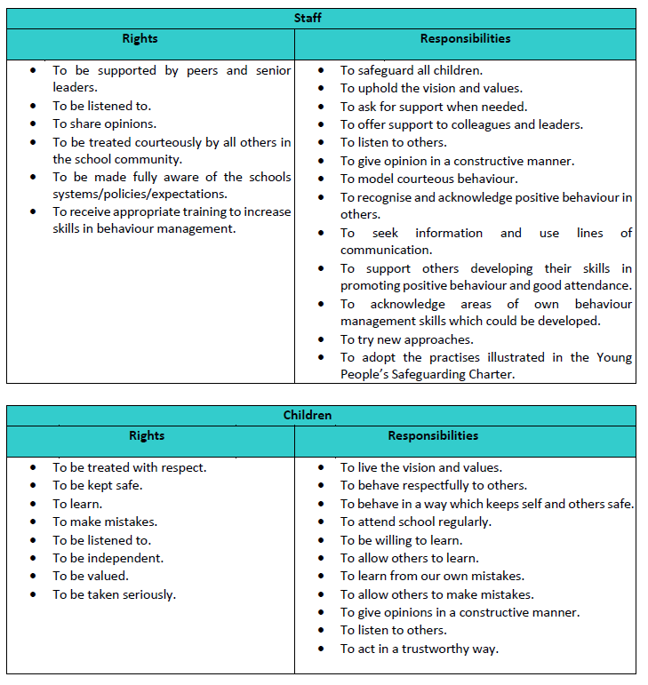
Rights and Responsibilities

Roles:

Governors are responsible for:

• Supporting the school to provide a calm, safe, purposeful and happy atmosphere, where everyone feels safe and secure.
• Ensuring that the school has a policy, which is implemented, communicated, published, monitored, evaluated and reviewed.
• Making appropriate resources available for the policy to be fully implemented.
• The headteacher has the day-to-day authority to implement the school’s policy on behaviour and discipline, but governors may support the headteacher on particular disciplinary issues.

It is the responsibility of the headteacher, under the School Standard and Framework Act 1998, to implement the school Behaviour Policy consistently throughout the school, and to report to governors, when requested, on the effectiveness of the policy.
All staff are responsible for:

• Upholding the school’s vision and values.
• Providing a calm, safe, purposeful and happy atmosphere within school, where everyone feels safe and secure.
• Discussing and consistently reinforcing school expectations.
• Ensuring that they are aware of the Behaviour Policy and that they have the necessary skills to deal with situations as they arise.
• Implementing, communicating, publishing, monitoring, evaluating and reviewing the school policy.
• Ensuring that every opportunity is made to resolve conflicts, should they arise, in a manner that maintains positive relationships and conforms to restorative practices.
• Acting as good role models.
• Managing challenging behaviour in accordance with the school policy.
• Keeping parents/carers informed of behaviour issues as they arise.
• Keeping records of all reported serious incidents of misbehaviour.
• The headteacher has the responsibility for giving fixed-term exclusions to individual children for serious acts of misbehaviour. For repeated or very serious acts of anti-social behaviour, the headteacher may permanently exclude a child. These actions are taken only after the school governors have been notified.

Senior Leaders will:

1. Meet and greet learners at the beginning of the day
2. Be a visible presence across the school and especially at transition times
3. Celebrate staff, leaders and learners whose effort goes above and beyond expectations
4. Regularly share good practice
5. Support staff in managing learners with more complex or entrenched negative behaviours
6. Monitor school wide behaviour policy and teacher practice
7. Regularly review provision for learners who may need additional support.

Parents/carers are responsible for:

• Ensuring that they support the creation of a safe and secure school.
• Supporting the school policies.
• Working with the school to encourage children to maintain school expectations.
• Acting as good, positive role models.
• Supporting their child’s learning, and to cooperate with the school, as set out in the home-school agreement.
• Supporting the actions of the school. If parents have any concerns about the way that their child has been treated, they should initially contact the class teacher. If the concern remains, they should contact the headteacher. If these discussions cannot resolve the problem, a formal grievance or appeal process can be implemented.

Role of the Pupils:

We wish to work closely with the Junior Leadership Team and to hear their views and opinions as we acknowledge and support Article 12 of the United Nations Convention on the Rights of the Child that children should be encouraged to form and to express their views. The Junior Leadership Team will be involved in:
• determining this policy with the Governing Body.
• discussing improvements to this policy during the school year.
• devising school rules and sanctions.
• reviewing the effectiveness of this policy with the Governing Body.

As adults, we have a vital part to play as role models.
We do this through:

• demonstrating good manners,
• modelling positive behaviour in relationships with adults and children including our Christian Values,
• teaching appropriate behaviour and giving positive feedback when pupils are behaving well,
• showing respect for every child as an individual,
• making every child feel valued,
• not accepting bullying or anti-social behaviour in school, on any level, at any time,
• being aware of vulnerable children,
• being seen to be fair and consistent,
• responding quietly, calmly, consistently and positively,
criticising the behaviour not the child,
• avoiding labelling,
• listening with empathy and tact,
• handling confidential information with sensitivity,
• having regular liaison and update meetings internally and with relevant outside agencies to make our policy effective,
• having an awareness of our appearance and demeanour and the messages they give.

We have produced a home school agreement in order to formalise this agreement between all parties.

Behaviour Systems – Rewards and Consequences.

We will manage behaviour through the consistent application of rules, rewards and consequences. As a school we firmly believe that everyone has the following rights:
• A right to learn.
• A right to feel safe.
• A right to respect.

Consistency of Approach

In implementing this Positive Relationships and Behaviour Policy St Aidan’s CE Primary acknowledges the need for consistency.
• Consistent language and consistent response: simple and clear expectations reflected in all conversations about behaviour.
• Consistent follow up: ensuring “certainty” at the classroom and Senior Leadership level. Teachers taking responsibility for behaviour interventions, seeking support only where needed.
• Consistent positive reinforcement: routine procedures for reinforcing, encouraging and celebrating.
• Consistent consequences: defined, agreed and applied at the classroom level as well as established structures for more serious behaviours.
• Consistent expectations referencing promoting appropriate behaviour.
• Consistent respect from the adults: even in the face of disrespectful learners.
• Consistent models of emotional control: emotional restraint that is modelled and not just taught, teachers as role models for learning.
• Consistently reinforced rituals and routines for behaviour: in classrooms, and at the school reception.

Getting the Basics Right

Visible Consistency makes everyone feel safe. These simple consistencies are key to the success of the policy and need to be adhered to by all staff.

Welcoming children | At the start of the day, children should be welcomed into school and into the classroom. This includes the SLT being visible in the playground and staff standing at their classroom door.
Playtimes/ end of lunchtimes | Teachers need to be out promptly at the end of playtimes/lunchtimes and be proactive in ensuring children are ready to go into school
Collective Worship | Children need to come into Collective Worship in silence. It is the Class teacher’s responsibility to ensure this. Children should remain silent throughout the worship as appropriate
In the corridors | Children are expected to walk in silence in the corridors
In the playground | Children should not climb on furniture or walls
At lunchtimes | Children should not climb on furniture or walls. There are zoned areas for varied activities. Playground leaders support activities
Dining room | Children should enter silently and remain silent whilst queuing. Pupils should use quiet voices to talk to pupils in immediate vicinity only once sat down.
After School | No unsupervised games. Children who are not with parents and are walking home should do so immediately.
In church | Once children have entered the church building and remain so whilst sitting down  and waiting for worship to begin.

EYFS

Children in Foundation and Key Stage 1 are expected to follow the Class Rules, which are discussed frequently and prominently displayed in the classroom.

Throughout EYFS and KS1 we have a ‘Rainbow’ system in place which is used to reward positive attitudes and discourage poor learning behaviour in class.

All children begin each day with a fresh start.

Children who consistently demonstrate positive attitudes and behaviour will be moved up the behaviour system until they reach ‘cool at school’ where they will be given a reward card to take home. Five ‘Cool at School’ cards equals a Headteacher’s Award.

Children who demonstrate poor learning behaviour will be first given a verbal warning then, if the negative behaviour continues, they are moved to the cloud.

If behaviour improves, they may be moved back into the sunshine. If negative behaviour continues, then they are moved into the rain cloud and will spend the next morning playtime in the Headteacher’s office.

(EYFS children may be sent to the Headteacher for 5 minutes or spend part of playtime with the teacher on duty at the discretion of the teacher).

In EYFS and KS1 there is also a Star of the Day system to reward children who have demonstrated consistent positive learning behaviour.

Consistent negative behaviour is recorded through the school’s CPOMS system and follow up is scheduled with the HeadTeacher or Deputy where appropriate.

Key Stage One and Two:
In key stage 1 and 2 we use a rainbow reward and sanction system. All children start the day on ‘Ready to Learn / Starting point’. Good behaviour and attitudes to learning are rewarded by moving up the ladder.
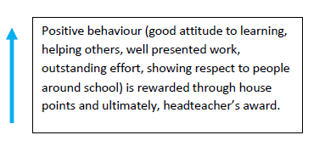
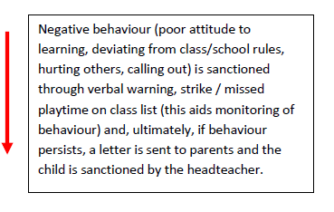
SUPER STUDENT
HEADTEACHER’S AWARD
EXCELLENT BEHAVIOUR
2 EXCELLENT CARDS
GOOD BEHAVIOUR
1 EXCELLENT CARD
START
PRE- WARNING

WARNING 1

WARNING 2
MISS PLAYTIME
WARNING 3
HEADTEACHER OR DEPUTY

Staff will always deliver sanctions calmly and with care. It is in nobody’s interest to confront poor behaviour with anger.

Rewards:
We encourage good patterns of behaviour by using:

• non-verbal signals,
• positive verbal comments and praise,
• team points rewards in books
• giving children responsibility,
• sharing positive aspects with others,
• awarding headteacher award stickers for children to wear, in order to motivate / reward,
- recognition in assembly/worship by awarding certificates,
- SHINE Awards
• displayed work,
- children invited to have lunch with the Headteacher,
- Occasional Headteacher Awards with afternoon tea.

Consistent negative behaviour is recorded through the school’s CPOMS system and follow up is scheduled with the Head or Deputy where appropriate.

TEAM POINTS

Our reward system is based around children gaining Team points. Team points are:
• Allocated to the children’s designated house team.
• Points awarded for positive behaviour etc.
• Each week points are collected by house captains with a ribbon awarded to the winning team.
• Each term the champions will achieve a non-uniform day.

Midday supervisors are made aware of and understand the reward and consequences system. Concerns regarding children’s behaviour at lunchtime will be recorded through the school’s internal monitoring system – CPOMS and actions followed up with the appropriate assigned person. Midday supervisors are also able to use rewards and consequences from those detailed throughout the policy. Midday supervisors also have their own to stickers to award pupils during lunchtime.

CLASS COUNTERS
Class counters can be awarded as a whole class reward for lining up, excellent lessons etc. Children will be rewarded with a Golden Time Hour for 100 counters and a non-uniform day for 200 counters.

Persistent Challenging Behaviour

Sometimes there is need to devise specific responses to inappropriate, persistent or challenging behaviours in the classroom which has led to a loss of learning or the playground which may have been unsafe. This may require teaching and/or support staff to consider additional, alternative or specialised approaches. Teachers are encouraged to approach more experienced senior members of staff, Phase Leaders or SLT, for help to manage behaviour challenges.

Pupils with SEMH concerns/behavioural difficulties

For some pupils, the above ‘Steps to Success’ may not be fully appropriate. In fact, for some pupils, this strategy further upset and cause emotional harm. In these cases a trauma-informed approach will be used.

Regulate (Brainstem) | Relate (Feeling Brain) | Reason (Thinking Brain)
Co-regulator gives time, space & safety  Repetitive & rhythmic activity (rocking, throwing & catching, drumming, dancing, reading, swinging)  Use large muscles (wall push ups, plank, walking, hockey & puck, obstacle course yoga ball)  Environmental support –what does the space offer the child? | Repair& restore connection (I’m here, I care, it’s ok to be mad, when you’re ready)  US vs Problem (we will get through this)  Do together  Solve problem, not punish | Reflect and learn  Remember and articulate  Rehearse for next time  Solve a problem  Learn a new skill –teach explicitly  Rehearse

Fixed-term and permanent exclusions
We do not wish to exclude any child from school, but sometimes this may be necessary. The school has therefore adopted the standard national list of reasons for exclusion, and the standard guidance, Exclusion from maintained schools, academies and pupil referral units in England(DfES, September 2017). We refer to this guidance in any decision to exclude a child from school. The relevant Internet address is:
https://assets.publishing.service.gov.uk/government/uploads/system/uploads/attachment_data/file/921405/20170831_Exclusion_Stat_guidance_Web_version.pdf

Use of Restrictive Physical Intervention – Team Teach
At St Aidan’s the use of restrictive physical intervention is seen as a last resort when all other options have been exhausted and will be used with the minimum degree of intrusion required to resolve the situation. Where possible the use of restrictive physical intervention will be carefully planned and involve staff who have received awareness training on de-escalation techniques and approaches and the Team Teach approach to the use of restrictive intervention. At St Aidan’s CE school, alongside Team Teach, we follow the law and guidance as set out in the DfE document ‘Use of reasonable force.’ The duty of care for all who work in school includes the protection of children from harming themselves or others and in certain circumstances; reasonable force would need to be used to achieve this.

Reasonable force is:

• The term ‘reasonable force’ covers the broad range of actions used by most teachers at some point in their career that involve a degree of physical contact with pupils.
• Force is usually used either to control or restrain. This can range from guiding a pupil to safety by the arm through to more extreme circumstances such as breaking up a fight or where a student needs to be restrained to prevent violence or injury.
• ‘Reasonable in the circumstances’ means using no more force than is needed.
• As mentioned above, schools generally use force to control pupils and to restrain them. Control means either passive physical contact, such as standing between pupils or blocking a pupil's path, or active physical contact such as leading a pupil by the arm out of a classroom.
• Restraint means to hold back physically or to bring a pupil under control. It is typically used in more extreme circumstances, for example when two pupils are fighting and refuse to separate without physical intervention.
• School staff should always try to avoid acting in a way that might cause injury, but in extreme cases it may not always be possible to avoid injuring the pupil.

When reasonable force might be used:

Reasonable force can be used to prevent pupils from hurting themselves or others, from damaging property, or from causing disorder. It is used for two main purposes – to control pupils or to restrain them. The decision on whether or not to physically intervene is down to the professional judgement of the staff member concerned and should always depend on the individual circumstances.
• to remove disruptive children from the classroom where they have refused to follow an instruction to do so;
• to prevent a pupil behaving in a way that disrupts a school event or a school trip or visit;
• to prevent a pupil leaving the classroom where allowing the pupil to leave would risk their safety or lead to behaviour that disrupts the behaviour of others;
• to prevent a pupil from attacking a member of staff or another pupil, or to stop a fight in the playground; and
• to prevent a pupil at risk of harming themselves through physical outbursts.

SEND

Where a teacher, in discussion with the SENDCo and Senior Leaders feels that reasonable adjustment must be made to the provision provided to a child who is unable to work within the general school policy, a personal behaviour plan will be drawn up by the SENDCo, with support of the class teacher. Risk assessments will accompany this if necessary. The plan will be shared with parents and then a copy will be kept in school.

Incidents of Inappropriate Behaviour Outside of School and on Media Sites

The law states that teachers have a statutory power to discipline pupils for misbehaving outside of the school premises. Headteachers have a specific statutory power to regulate pupil’s behaviour in these circumstances “to such extent as is reasonable.”
School is aware that teachers may discipline a pupil for:

Any inappropriate behaviour when the child is:
- Taking part in any school-organised or school related activity,
- Travelling to or from school
- Wearing school uniform
- In some other way identifiable as a pupil at our school.

Or inappropriate behaviour at any time, whether or not the conditions above apply, that:
- Could have repercussions for the orderly running of the school,
- Poses a threat to another pupil or member of the public
- Could adversely affect the reputation of the school.

In response to all non-criminal inappropriate behaviour and bullying which occurs anywhere off the school premises and which is witnessed by a staff member or reported to the school, school will respond in the following way:
- The child will be spoken to regarding the incident.
- Any other children involved in the incident will be spoken to.
- Parents will be contacted regarding the incident.
- If it is felt that there will be repercussions in school the child(ren) involved will be monitored by school staff.
- If follow up incidents do occur then the schools procedures will be adhered to.
- If the incident witnessed raises child protection concerns then the schools Child Protection Policy and procedures will be adhered to.
- If the incident witnessed involves breaking the law then the police will be contacted.

The above procedures also apply to incidents of inappropriate behaviour involving media sites. School has an E-Safeguarding Policy which can also be referred to.

Unprecedented and Exceptional Circumstances
As a school we acknowledge we will need to make some alterations to the behaviour policy in times of exceptional change in order to keep our children and school community safe. These adaptations to the behaviour policy will be highlighted and shared with all stakeholders.

Monitoring and review
This policy is reviewed annually to ensure it reflects current practice.
Review date: September 2022

