School closure work:

Welcome to the month of June!
We hope you are all okay and managed to have some rest over the half term. We have been so lucky with the weather which we hope has made things a little easier at home for you. Thank you so much to those who were involved in making the gorgeous video for all the staff. It was so lovely to see the children’s faces after such a long time and it brought tears to our eyes!
Below are some ideas for activities to do at home but please do what suits you and your child and please do not feel under pressure to complete everything. If you have any questions or concerns, remember you can contact us via Class Dojo during school hours and we will happily help.

RE
Over the half term, the church celebrated the feast of Pentecost. Please read the bible story below or watch the video: https://www.youtube.com/watch?v=KwJJJoSGw84

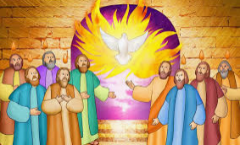
John 20:19-23
It was late that Sunday evening, and the disciples were gathered together behind locked doors, because they were afraid of the Jewish authorities. Then Jesus came and stood among them. “Peace be with you,” he said. After saying this, he showed them his hands and his side. The disciples were filled with joy at seeing the Lord. Jesus said to them again, “Peace be with you. As the Father sent me, so I send you.” Then he breathed on them and said, “Receive the Holy Spirit. If you forgive people's sins, they are forgiven; if you do not forgive them, they are not forgiven.”

Questions to consider:
- How did the disciples feel when Jesus appeared to them?
- What did Jesus do to the disciples?
- What are sins? Is it easy to forgive someone if they have upset you?
- Can you remember a time when you had to say sorry for doing wrong? Did the other person forgive you? How did that make you feel?

Our topic for this half term is ‘Our Church Family’. In this topic, the children need to be aware that we all belong to our Church family and anyone can belong in this family. Sunday is a special day when we can go to church and pray for those in need. We know at this time it is not possible to visit church as most are shut due to Covid 19 but if you get the opportunity, it would be great for the children to see different church buildings from the outside and be aware of what sort of things they would find inside.
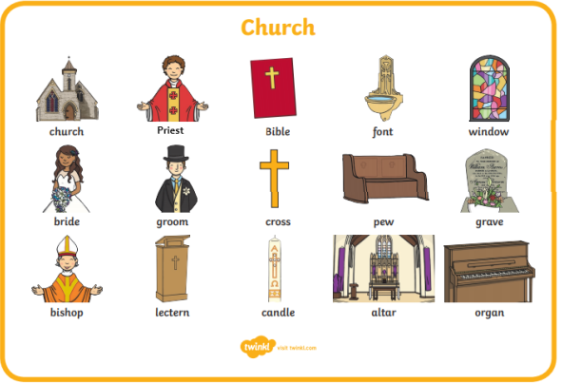
We have found this short video on YouTube that gives children a little insight into the Church and what can be found inside. There are 4 episodes in all with some differences to a Catholic church but in the main, they are very similar:
https://www.youtube.com/watch?v=KxLir3p9z8U

Can you draw a picture of inside a church and label it to show what you would find inside? (It is fine for the children to spell the words phonetically, we would encourage this – for example, they may spell priest ‘preest’ or candle ‘candul’. If your child finds it tricky to spell any words, see if they can write the first sounds of each word instead). Please add any finished work to Tapestry so that we can view what the children have done.

Literacy
On 21st June, we will celebrate Father’s Day in the UK. We would like the children to think about their daddies or any male role models they have in their lives (this could be an uncle/grandad/family friend) and write a list of all the things that are special about them. Please explain the meaning of a list to your child and give examples of when we might write a list e.g. to go shopping. Once they have finished this, can they create a card for Father’s Day and add their list to the inside of the card so that their daddies/grandads/uncles know how special they are?
You can make the card as simple or as challenging as you like according to your child’s ability. As a challenge, for example, the children may like to write their own message and try to use a capital letter, fingers spaces and a full stop.
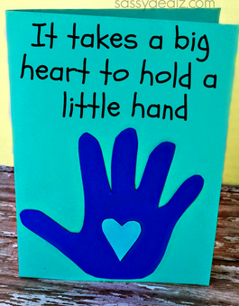
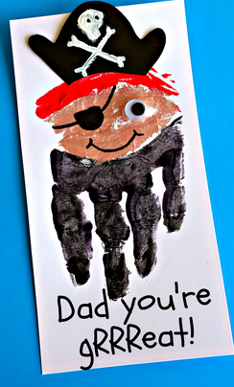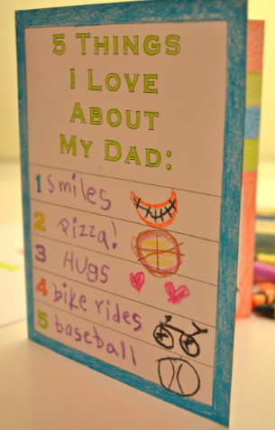

Phonics
Please continue to practise reading and writing the set 1/2 sounds daily – please use the sounds we sent home on the treasury tags or the orange phonics book. Also, practise reading the tricky words.
A really useful website called Oxford Owl is offering free activities during lockdown and has a wealth of information regarding the Ruth Miskin scheme for phonics. We would strongly recommend using this as a ‘go to’ when helping your child learn the sounds. There is advice for parents/carers, resources you can print out and activities to try at home: https://home.oxfordowl.co.uk/reading/learn-to-read-phonics/
Remember that Ruth Miskin has a daily phonics lesson on YouTube and follows the same format of teaching as we do in class: https://www.ruthmiskin.com/en/find-out-more/help-during-school-closure/
Fun phonics games can be found here:
https://www.phonicsplay.co.uk/
https://www.topmarks.co.uk/english-games/5-7-years/letters-and-sounds
https://www.bbc.co.uk/cbeebies/shows/alphablocks
Remember to practise reading every day. We have noticed that some of you have logged on to MyOn and taking advantage of the amazing breadth of books for your child to read. If you haven’t yet been on this website, please do so as soon as possible.
Here are some reading strategies to help the children learn how to read:

- Use Freddie fingers and your blending hand to sound out/decode words.
- Look at the first sound of the word.
- Use pictures for clues.
- Read the whole sentence and think what would make sense.
- Chop longer words up and sound blend both parts then put it back together. E.g playing – p-l-ay is ‘play’… i-ng is ‘ing’ so play and ing makes ‘playing’.

Maths
There are some lovely maths activities based on the story The Snail and The Whale here:
https://whiterosemaths.com/homelearning/early-years/
(see Summer term, week 6 – June 1st)
You could watch a video each day and try one of the activities.
If you don’t have the book you can find an online reading of it here:
https://www.youtube.com/watch?v=G_8QS_nyzM8

Or watch the brilliant BBC animated version of the story here:
https://www.bbc.co.uk/iplayer/episode/m000cslw/the-snail-and-the-whale

The activities focus on patterns.
There are more activities on pattern suitable for Reception children here:
https://www.twinkl.co.uk/resource/eyfs-maths-summer-term-activity-mats-t-m-31642

Topic

Our Reception topic for this half term is Adventures!
The Snail and the Whale certainly go on an adventure, let’s hope it’s not too long before we can all go on some adventures again! For now we can enjoy some stories about adventures, such as:

The Naughty Bus by Jan Oke https://www.youtube.com/watch?v=sqQ1BAEj1oE
The Night Pirates by Peter Harris https://www.youtube.com/watch?v=mdWxBn-xvrQ
Little Monkey by Marta Altes https://www.youtube.com/watch?v=TeNlaVJVCF0

Activities you could try at home:
Think about an adventure you have been on – a trip to the seaside, a holiday, a stomp around the park or forest, or one you would like to go on – into space, on a boat or up a mountain. Where did you go, or where would you like to go?
What did you/would you do there? Can you draw or paint a picture? Can you write a sentence about your adventure?

You could talk about what you would need to pack or take with you depending on where you are going. Some resources for this are linked here:
https://www.twinkl.co.uk/resource/t-t-8706-pack-a-suitcase-cut-and-stick-activity

PE
Have you tried P.E with Joe Wicks at 9am every week day? This is a fun workout and something the whole family can join in with.
Cosmic kids yoga on You Tube is also really good. There are lots of fun videos to practice stretching, balancing, and relaxation. Give them a go on the following link:
https://www.youtube.com/user/CosmicKidsYoga

Useful Links:
www.twinkl.co.uk/offer and enter the code UKTWINKLHELPS
www.purplemash.com
https://www.educationcity.com/

(Remember your child’s log in details were sent home on the last week)

We wish you all well and please send our love to all the children. Give them a huge hug from us and tell them how much we miss them.

Take care,
Mrs Bolton and Mrs Locker

