
Spring Egg Decorating Competition 2026!

For our holiday homework we will be holding a whole school egg decorating competition!
There will be one per class and each winner will receive a chocolate egg.

Please make sure that you boil the egg and leave it to cool before decorating it.

Here are some ideas…
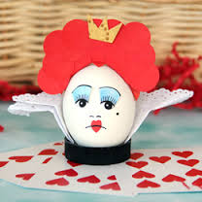
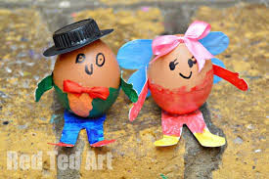
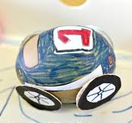
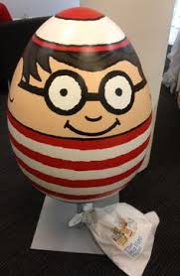
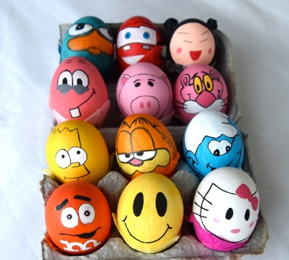
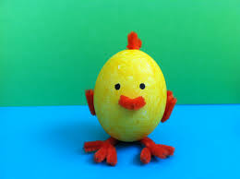

To enter please bring your decorated egg into school by Wednesday 15th April at 9am. All entries will be displayed in school and the winner will be announced in assembly on Friday 17th April.

