  
  
  
  Dinner Provided
  Free of Charge
  6-12 Years
  9:30am-2:30pm
  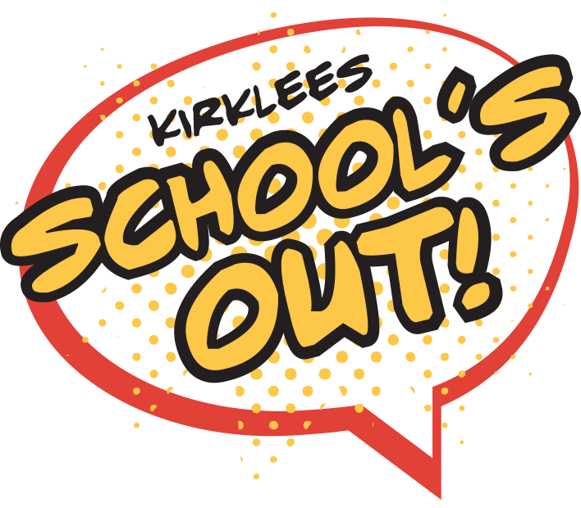
  
  
  THORNHILL WINTER CAMP
  WINTER HOLIDAY CAMP
  THORNHILL J&I SCHOOL
  Edge Lane, Thornhill, Dewsbury, WF12 0QT
  9:30am-2:30pm
  January | Tues 2nd | Weds 3rd | Thurs 4th | Fri 5th
  PLEASE CIRCLE DATES YOU ARE REQUESTING TO ATTEND
  Our action packed holiday camps are funded by kirklees! So there will be no charge to parents. However we do require children to bring indoor and outdoor clothing appropriate for sport. Dinner will be provided and children will be offered a menu each day to select from.
  …………………………………………………………………………………………………………………….
  Childs Name:
  Childs DOB:
  Medical Issues:
  Any additional support required:
  Any Allergies:
  Permission to be photographed at the event:
  Does your child receive benefit related free school meals? YES / NO
  Parents Name:
  Contact Details:
  Address:
  RETURN THIS PERMISSION SLIP TO SCHOOL RECEPTION
  D.B.S CHECKED
  FIRST AID TRAINED
  FA LEVEL 2
  EXPERIENCED
  PREPARED
  FUN
  RELIABLE
  PROFESSIONAL
  - Football
  - Dodgeball
  - Hockey
  - Netball
  - Rounders
  - Ball Games
  - MultiSports
  - Rugby
  - Basketball
  - Cricket
  - Social Skills
  - Boxing
  - Dance
  - Archery
  These Holiday camps are FREE of charge for families who receive benefits related FSM.
  Children must bring Indoor & Outdoor clothing (Dinner provided). Please sign up using the permission slip below and return to reception and send confirmation of your booking to the email below.
  Contact Details
  Matt Gardham
  07539116686
  
  provisionsportsandcoaching@hotmail.com
  @ProVisionSports

