
Elworth CE Primary School
LKS2 Calculation Policy

KEY STAGE 2
In Years 3 and 4, children develop the basis of written methods by building their skills alongside a deep understanding of place value. They should use known addition/subtraction and multiplication/division facts to calculate efficiently and accurately, rather than relying on counting. Children use place value equipment to support their understanding, but not as a substitute for thinking.
Key language: partition, place value, tens, hundreds, thousands, column method, whole, part, equal groups, sharing, grouping, bar model
Addition and subtraction: In Year 3 especially, the column methods are built up gradually. Children will develop their understanding of how each stage of the calculation, including any exchanges, relates to place value. The example calculations chosen to introduce the stages of each method may often be more suited to a mental method. However, the examples and the progression of the steps have been chosen to help children develop their fluency in the process, alongside a deep understanding of the concepts and the numbers involved, so that they can apply these skills accurately and efficiently to later calculations. The class should be encouraged to compare mental and written methods for specific calculations, and children should be encouraged at every stage to make choices about which methods to apply.  In Year 4, the steps are shown without such fine detail, although children should continue to build their understanding with a secure basis in place value. In subtraction, children will need to develop their understanding of exchange as they may need to exchange across one or two columns.  By the end of Year 4, children should have developed fluency in column methods alongside a deep understanding, which will allow them to progress confidently in upper Key Stage 2. | Multiplication and division: Children build a solid grounding in times-tables, understanding the multiplication and division facts in tandem. As such, they should be as confident knowing that 35 divided by 7 is 5 as knowing that 5 times 7 is 35.  Children develop key skills to support multiplication methods: unitising, commutativity, and how to use partitioning effectively.  Unitising allows children to use known facts to multiply and divide multiples of 10 and 100 efficiently. Commutativity gives children flexibility in applying known facts to calculations and problem solving. An understanding of partitioning allows children to extend their skills to multiplying and dividing 2- and 3-digit numbers by a single digit.  Children develop column methods to support multiplications in these cases.  For successful division, children will need to make choices about how to partition. For example, to divide 423 by 3, it is effective to partition 423 into 300, 120 and 3, as these can be divided by 3 using known facts.  Children will also need to understand the concept of remainder, in terms of a given calculation and in terms of the context of the problem. | Fractions: Children develop the key concept of equivalent fractions, and link this with multiplying and dividing the numerators and denominators, as well as exploring the visual concept through fractions of shapes. Children learn how to find a fraction of an amount and develop this with the aid of a bar model and other representations alongside.  in Year 3, children develop an understanding of how to add and subtract fractions with the same denominator and find complements to the whole. This is developed alongside an understanding of fractions as numbers, including fractions greater than 1. In Year 4, children begin to work with fractions greater than 1.  Decimals are introduced, as tenths in Year 3 and then as hundredths in Year 4. Children develop an understanding of decimals in terms of the relationship with fractions, with dividing by 10 and 100, and also with place value.

Year 3
 | Concrete | Pictorial | Abstract
Year 3
Addition
Understanding 100s | Understand the cardinality of 100, and the link with 10 tens.  Use cubes to place into groups of 10 tens.  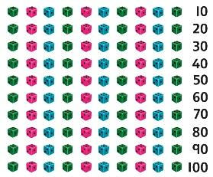 | Unitise 100 and count in steps of 100.  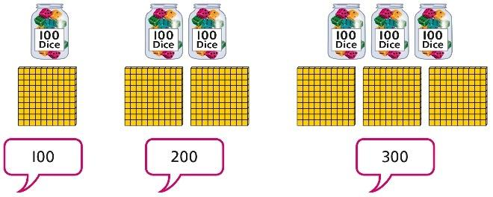 | Represent steps of 100 on a number line and a number track and count up to 1,000 and back to 0.  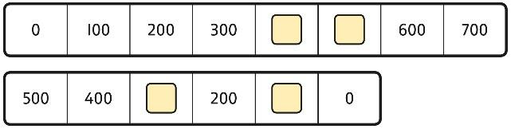
Understanding place value to 1,000 | Unitise 100s, 10s and 1s to build 3-digit numbers.  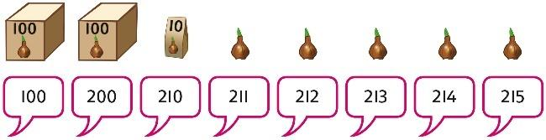 | Use equipment to represent numbers to 1,000.  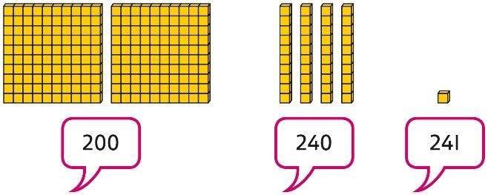  Use a place value grid to support the structure of numbers to 1,000.  Place value counters are used alongside other equipment. Children should understand how each counter represents a different unitised amount. | Represent the parts of numbers to 1,000 using a part-whole model.  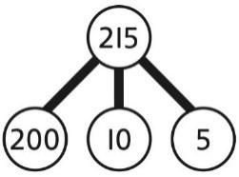  215 = 200 + 10 + 5  Recognise numbers to 1,000 represented on a number line, including those between intervals.
Adding 100s | Use known facts and unitising to add multiples of 100.  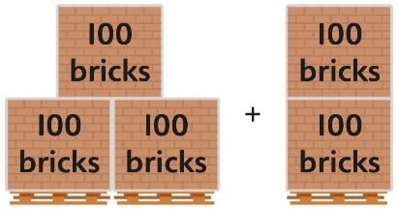  3 + 2 = 5  3 hundreds + 2 hundreds = 5 hundreds  300 + 200 = 500 | Use known facts and unitising to add multiples of 100.  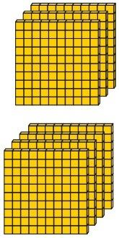  3 + 4 = 7  3 hundreds + 4 hundreds = 7 hundreds  300 + 400 = 700 | Use known facts and unitising to add multiples of 100.  Represent the addition on a number line.  Use a part-whole model to support unitising.  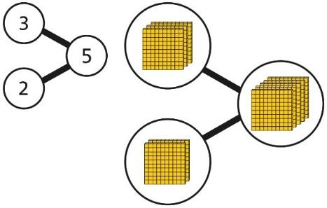  3 + 2 = 5  300 + 200 = 500
3-digit number + 1s, no exchange or bridging | Use number bonds to add the 1s.  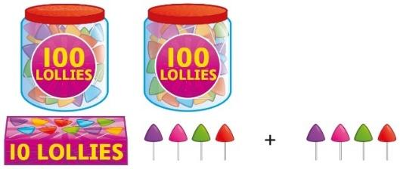  214 + 4 = ?  Now there are 4 + 4 ones in total.  4 + 4 = 8  214 + 4 = 218 | Use number bonds to add the 1s.  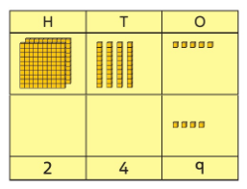  245 + 4  5 + 4 = 9  245 + 4 = 249 | Understand the link with counting on.  245 + 4  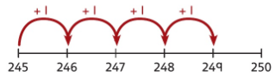  Use number bonds to add the 1s and understand that this is more efficient and less prone to error.  245 + 4 = ?  I will add the 1s.  5 + 4 = 9  So, 245 + 4 = 249
3-digit number + 10s, no exchange | Calculate mentally by forming the number bond for the 10s.  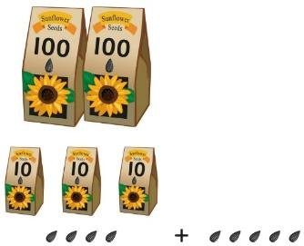  234 + 50  There are 3 tens and 5 tens altogether.  3 + 5 = 8  In total there are 8 tens.  234 + 50 = 284 | Calculate mentally by forming the number bond for the 10s.  351 + 30 = ?  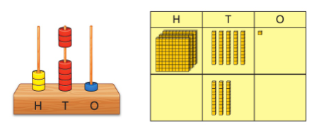  5 tens + 3 tens = 8 tens  351 + 30 = 381 | Calculate mentally by forming the number bond for the 10s.  753 + 40  I know that 5 + 4 = 9  So, 50 + 40 = 90  753 + 40 = 793
3-digit number + 1s with exchange | Understand that when the 1s sum to 10 or more, this requires an exchange of 10 ones for 1 ten.  Children should explore this using unitised objects or physical apparatus. | Exchange 10 ones for 1 ten where needed. Use a place value grid to support the understanding.  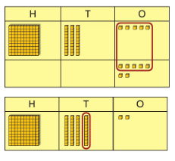  135 + 7 = 142 | Understand how to bridge by partitioning to the 1s to make the next 10.  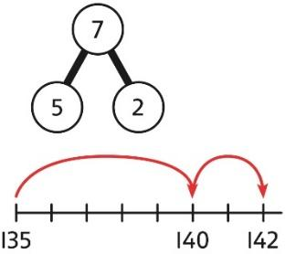  135 + 7 = ?  135 + 5 + 2 = 142  Ensure that children understand how to add 1s bridging a 100.  198 + 5 = ?  198 + 2 + 3 = 203
3-digit number + 10s, with exchange | Understand the exchange of 10 tens for 1 hundred.  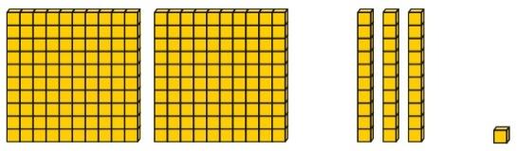 | Add by exchanging 10 tens for 1 hundred.  184 + 20 = ?  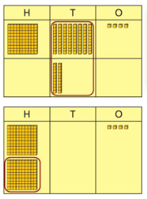  184 + 20 = 204 | Understand how the addition relates to counting on in 10s across 100.  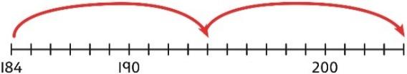  184 + 20 = ?  I can count in 10s … 194 … 204  184 + 20 = 204  Use number bonds within 20 to support efficient mental calculations.  385 + 50  There are 8 tens and 5 tens.  That is 13 tens.  385 + 50 = 300 + 130 + 5  385 + 50 = 435
3-digit number + 3-digit number, no exchange | Use place value equipment to make a representation of a calculation. This may or may not be structured in a place value grid.  326 + 541 is represented as:  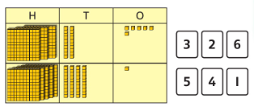 | Represent the place value grid with equipment to model the stages of column addition.  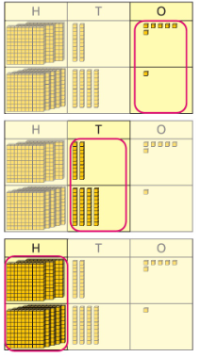 | Use a column method to solve efficiently, using known bonds. Children must understand how this relates to place value at every stage of the calculation.  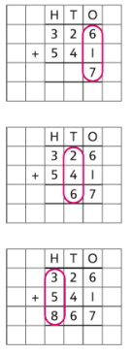
3-digit number + 3-digit number, exchange required | Use place value equipment to enact the exchange required.  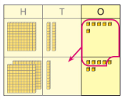  There are 13 ones.  I will exchange 10 ones for 1 ten. | Model the stages of column addition using place value equipment on a place value grid.  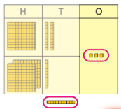  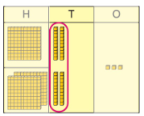  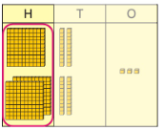 | Use column addition, ensuring understanding of place value at every stage of the calculation.  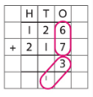  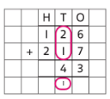  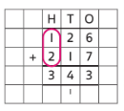  126 + 217 = 343  Note: Children should also study examples where exchange is required in more than one column, for example 185 + 318 = ?
3-digit number + 2-digit number | Use place value equipment to make and combine groups to model addition.  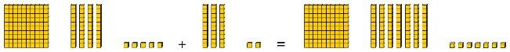 | Use a place value grid to organise thinking and adding of 1s, then 10s. | Use the vertical column method to represent the addition. Children must understand how this relates to place value at each stage of the calculation.
3-digit number + 2-digit number, exchange required | Use place value equipment to model addition and understand where exchange is required.  Use place value counters to represent  154 + 72.  Use this to decide if any exchange is required.  There are 5 tens and 7 tens. That is 12 tens so I will exchange. | Represent the required exchange on a place value grid using equipment.  275 + 16 = ?  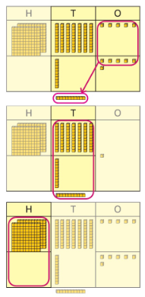  275 + 16 = 291  Note: In this example, a mental method may be more efficient. The numbers for the example calculation have been chosen to allow children to visualise the concept and see how the method relates to place value.  Children should be encouraged at every stage to select methods that are accurate and efficient. | Use a column method with exchange. Children must understand how the method relates to place value at each stage of the calculation.  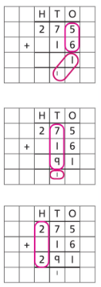  275 + 16 = 291
Representing addition problems, and selecting appropriate methods | Encourage children to use their own drawings and choices of place value equipment to represent problems with one or more steps.  These representations will help them to select appropriate methods. | Children understand and create bar models to represent addition problems.  275 + 99 = ?  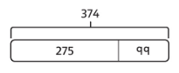  275 + 99 = 374 | Use representations to support choices of appropriate methods.  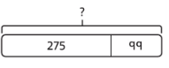  I will add 100, then subtract 1 to find the solution.  128 + 105 + 83 = ?  I need to add three numbers.  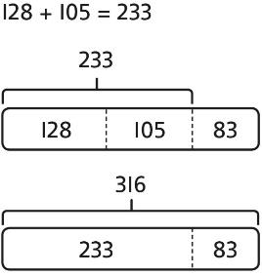
Year 3
Subtraction
Subtracting 100s | Use known facts and unitising to subtract multiples of 100.  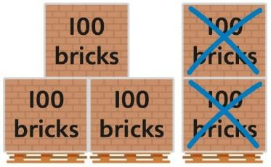  5 − 2 = 3  500 − 200 = 300 | Use known facts and unitising to subtract multiples of 100.  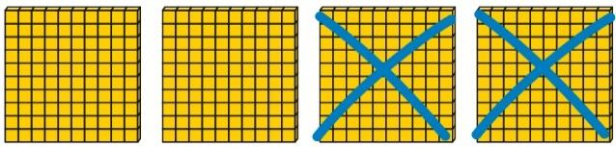  4 − 2 = 2  400 − 200 = 200 | Understand the link with counting back in 100s.  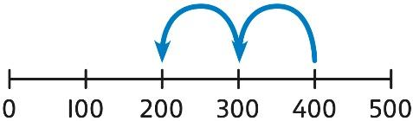  400 − 200 = 200  Use known facts and unitising as efficient and accurate methods.  I know that 7 − 4 = 3. Therefore, I know that 700 − 400 = 300.
3-digit number − 1s, no exchange | Use number bonds to subtract the 1s.  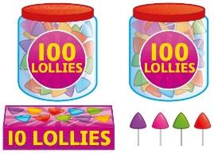  214 − 3 = ?  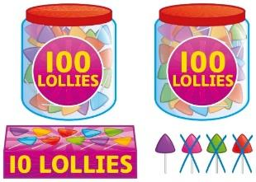  4 − 3 = 1  214 − 3 = 211 | Use number bonds to subtract the 1s.  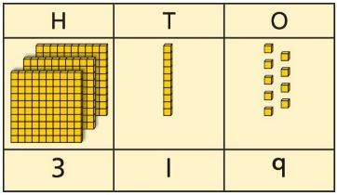  319 − 4 = ?  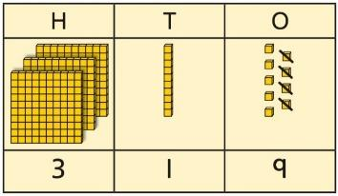  9 − 4 = 5  319 − 4 = 315 | Understand the link with counting back using a number line.  Use known number bonds to calculate mentally.  476 − 4 = ?  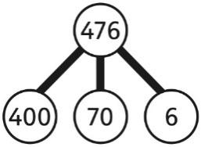  6 − 4 = 2  476 − 4 = 472
3-digit number − 1s, exchange or bridging required | Understand why an exchange is necessary by exploring why 1 ten must be exchanged.  Use place value equipment. | Represent the required exchange on a place value grid.  151 − 7 = ?  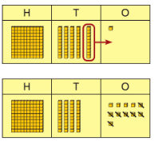 | Calculate mentally by using known bonds.  151 − 7 = ?  151 − 1 − 6 = 144
3-digit number − 10s, no exchange | Subtract the 10s using known bonds.  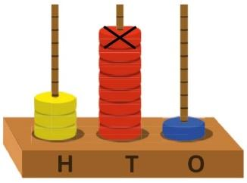  381 − 10 = ?  8 tens with 1 removed is 7 tens.  381 − 10 = 371 | Subtract the 10s using known bonds.  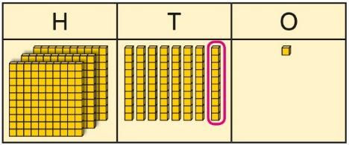  8 tens − 1 ten = 7 tens  381 − 10 = 371 | Use known bonds to subtract the 10s mentally.  372 − 50 = ?  70 − 50 = 20  So, 372 − 50 = 322
3-digit number − 10s, exchange or bridging required | Use equipment to understand the exchange of 1 hundred for 10 tens.  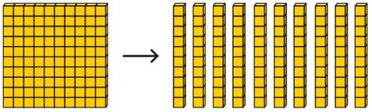 | Represent the exchange on a place value grid using equipment.  210 − 20 = ?  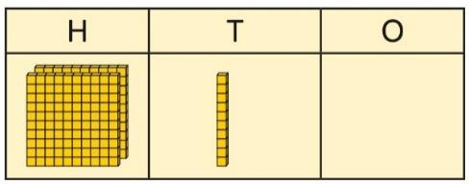  I need to exchange 1 hundred for 10 tens, to help subtract 2 tens.  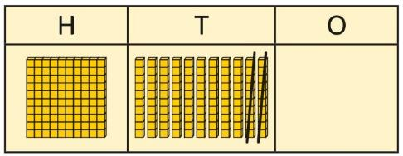  210 − 20 = 190 | Understand the link with counting back on a number line.  Use flexible partitioning to support the calculation.  235 − 60 = ?  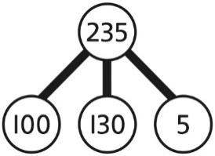  235 = 100 + 130 + 5  235 − 60 = 100 + 70 + 5  = 175
3-digit number − up to 3-digit number | Use place value equipment to explore the effect of splitting a whole into two parts, and understand the link with taking away.  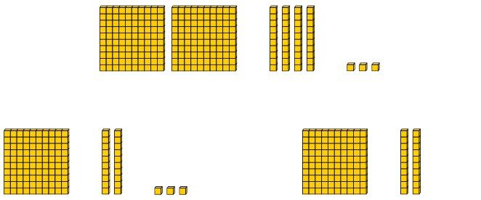 | Represent the calculation on a place value grid.  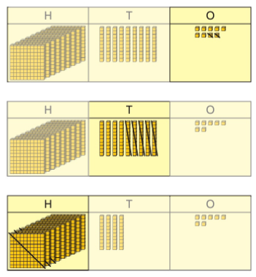 | Use column subtraction to calculate accurately and efficiently.  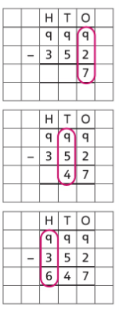
3-digit number − up to 3-digit number, exchange required | Use base 10 equipment to enact the exchange of 1 hundred for 10 tens, and 1 ten for 10 ones.  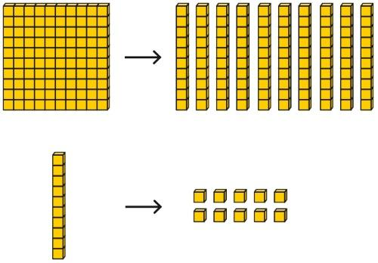 | Model the required exchange on a place value grid.  175 − 38 = ?  I need to subtract 8 ones, so I will exchange a ten for 10 ones.  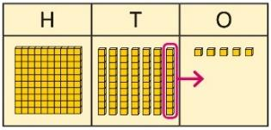  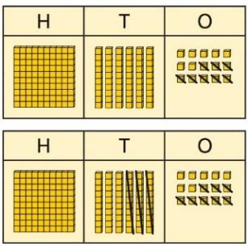 | Use column subtraction to work accurately and efficiently.  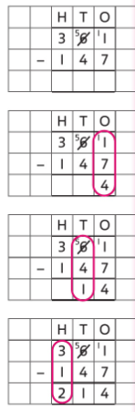  If the subtraction is a 3-digit number subtract a 2-digit number, children should understand how the recording relates to the place value, and so how to line up the digits correctly.  Children should also understand how to exchange in calculations where there is a zero in the 10s column.
Representing subtraction problems |  | Use bar models to represent subtractions.  ‘Find the difference’ is represented as two bars for comparison.  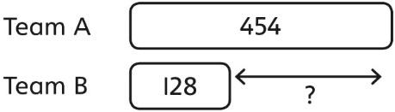  Bar models can also be used to show that a part must be taken away from the whole. | Children use alternative representations to check calculations and choose efficient methods.  Children use inverse operations to check additions and subtractions.  The part-whole model supports understanding.  I have completed this subtraction.  525 − 270 = 255  I will check using addition.  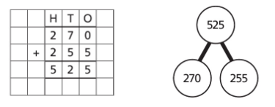
Year 3
Multiplication
Understanding equal grouping and repeated addition | Children continue to build understanding of equal groups and the relationship with repeated addition.  They recognise both examples and non-examples using objects.  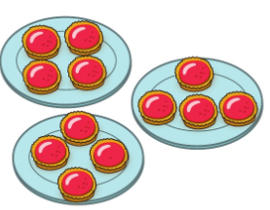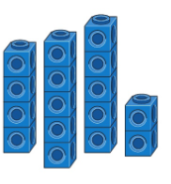  Children recognise that arrays can be used to model commutative multiplications.  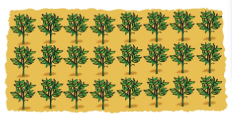  I can see 3 groups of 8.  I can see 8 groups of 3. | Children recognise that arrays demonstrate commutativity.  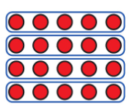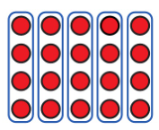  This is 3 groups of 4.  This is 4 groups of 3. | Children understand the link between repeated addition and multiplication.  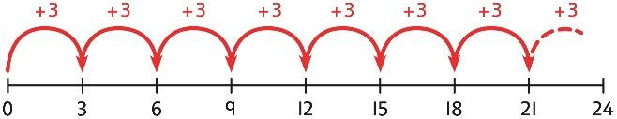  8 groups of 3 is 24.  3 + 3 + 3 + 3 + 3 + 3 + 3 + 3 = 24  8 × 3 = 24  A bar model may represent multiplications as equal groups.  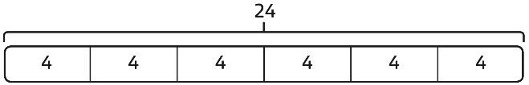  6 × 4 = 24
Using commutativity to support understanding of the times-tables | Understand how to use times-tables facts flexibly.  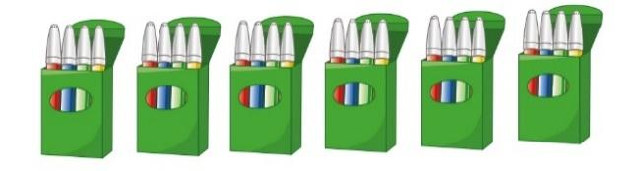  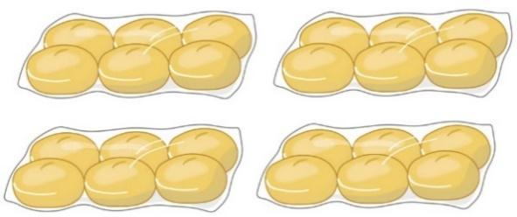  There are 6 groups of 4 pens.  There are 4 groups of 6 bread rolls.  I can use 6 × 4 = 24 to work out both totals. | Understand how times-table facts relate to commutativity.  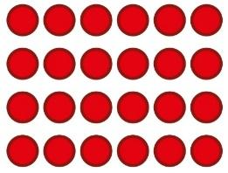  6 × 4 = 24  4 × 6 = 24 | Understand how times-table facts relate to commutativity.  I need to work out 4 groups of 7.  I know that 7 × 4 = 28  so, I know that  4 groups of 7 = 28  and  7 groups of 4 = 28.
Understanding and using ×3, ×2, ×4 and ×8 tables. | Children learn the times-tables as ‘groups of’ but apply their knowledge of commutativity.  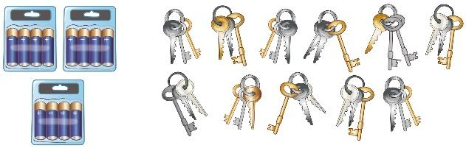  I can use the ×3 table to work out how many keys.  I can also use the ×3 table to work out how many batteries. | Children understand how the ×2, ×4 and ×8 tables are related through repeated doubling.  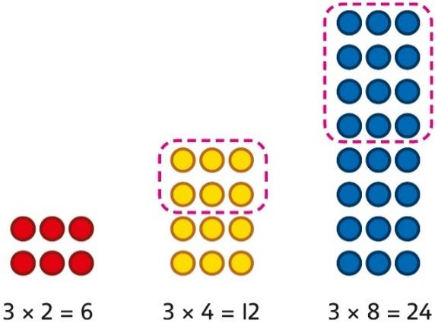 | Children understand the relationship between related multiplication and division facts in known times-tables.  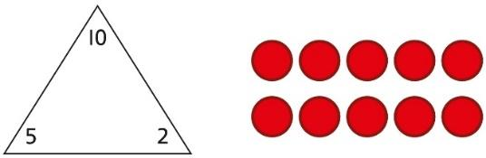  2 × 5 = 10  5 × 2 = 10  10 ÷ 5 = 2  10 ÷ 2 = 5
Using known facts to multiply 10s, for example  3 × 40 | Explore the relationship between known times-tables and multiples of 10 using place value equipment.  Make 4 groups of 3 ones.  Make 4 groups of 3 tens.  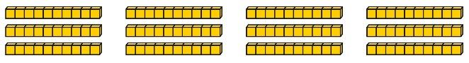  What is the same?  What is different? | Understand how unitising 10s supports multiplying by multiples of 10.  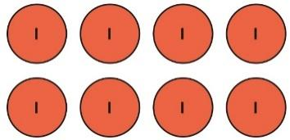  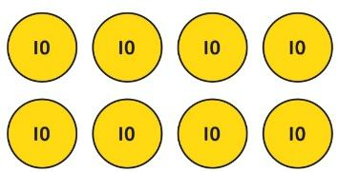  4 groups of 2 ones is 8 ones.  4 groups of 2 tens is 8 tens.  4 × 2 = 8  4 × 20 = 80 | Understand how to use known times-tables to multiply multiples of 10.  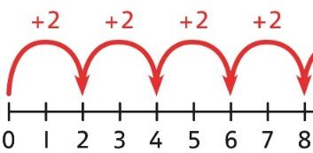  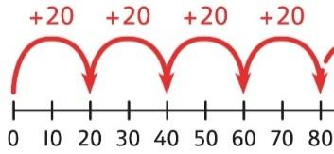  4 × 2 = 8  4 × 20 = 80
Multiplying a  2-digit number by a 1-digit number | Understand how to link partitioning a 2-digit number with multiplying.  Each person has 23 flowers.  Each person has 2 tens and 3 ones.  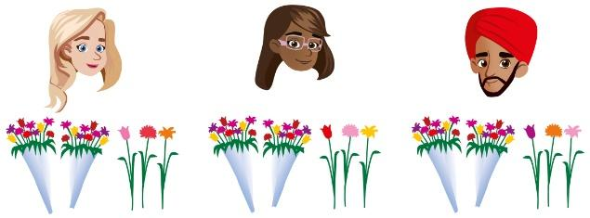  There are 3 groups of 2 tens.  There are 3 groups of 3 ones.  Use place value equipment to model the multiplication context.  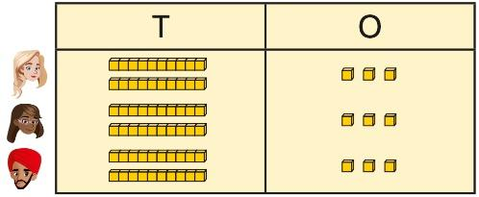  There are 3 groups of 3 ones.  There are 3 groups of 2 tens. | Use place value to support how partitioning is linked with multiplying by a 2-digit number.  3 × 24 = ?  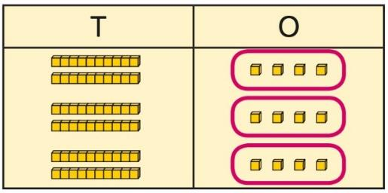  3 × 4 = 12  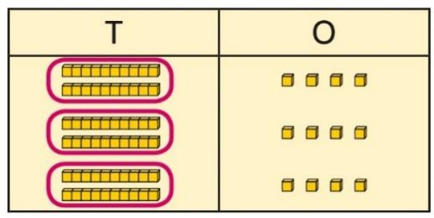  3 × 20 = 60  60 + 12 = 72  3 × 24 = 72 | Use addition to complete multiplications of 2-digit numbers by a 1-digit number.  4 × 13 = ?  4 × 3 = 12 4 × 10 = 40  12 + 40 = 52  4 × 13 = 52
Multiplying a  2-digit number by a 1-digit number, expanded column method | Use place value equipment to model how 10 ones are exchanged for a 10 in some multiplications.  3 × 24 = ?  3 × 20 = 60  3 × 4 = 12  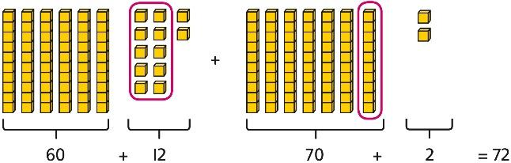  3 × 24 = 60 + 12  3 × 24 = 70 + 2  3 × 24 = 72 | Understand that multiplications may require an exchange of 1s for 10s, and also 10s for 100s.  4 × 23 = ?  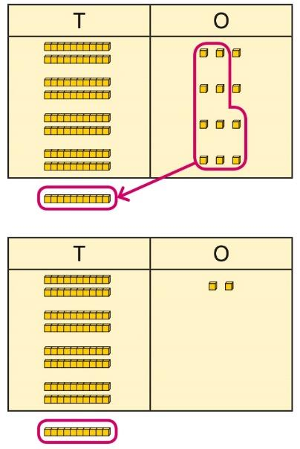  4 × 23 = 92  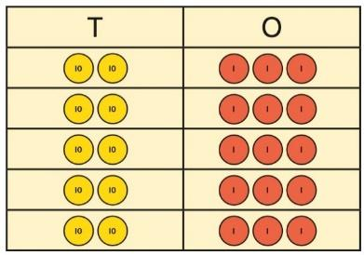  5 × 23 = ?  5 × 3 = 15  5 × 20 = 100  5 × 23 = 115 | Children may write calculations in expanded column form, but must understand the link with place value and exchange.  Children are encouraged to write the expanded parts of the calculation separately.  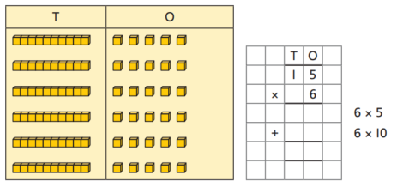  23 × 5 = ?  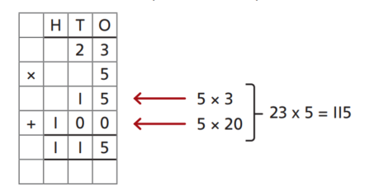
Year 3
Division
Using times-tables knowledge to divide | Use knowledge of known times-tables to calculate divisions.  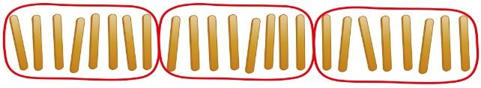  24 divided into groups of 8.  There are 3 groups of 8. | Use knowledge of known times-tables to calculate divisions.  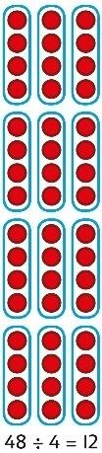  48 divided into groups of 4.  There are 12 groups.  4 × 12 = 48  48 ÷ 4 = 12 | Use knowledge of known times-tables to calculate divisions.  I need to work out 30 shared between 5.  I know that 6 × 5 = 30  so I know that 30 ÷ 5 = 6.  A bar model may represent the relationship between sharing and grouping.  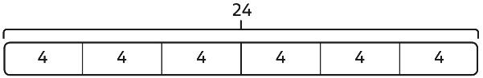  24 ÷ 4 = 6  24 ÷ 6 = 4  Children understand how division is related to both repeated subtraction and repeated addition.  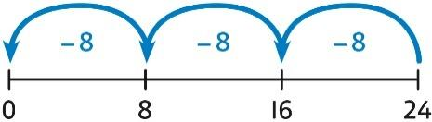  24 ÷ 8 = 3  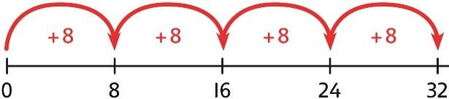  32 ÷ 8 = 4
Understanding remainders | Use equipment to understand that a remainder occurs when a set of objects cannot be divided equally any further.  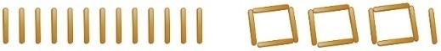  There are 13 sticks in total.  There are 3 groups of 4, with 1 remainder. | Use images to explain remainders.  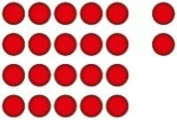  22 ÷ 5 = 4 remainder 2 | Understand that the remainder is what cannot be shared equally from a set.  22 ÷ 5 = ?  3 × 5 = 15  4 × 5 = 20  5 × 5 = 25 … this is larger than 22  So, 22 ÷ 5 = 4 remainder 2
Using known facts to divide multiples of 10 | Use place value equipment to understand how to divide by unitising.  Make 6 ones divided by 3.  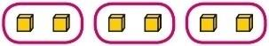  Now make 6 tens divided by 3.  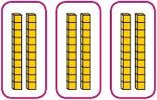  What is the same? What is different? | Divide multiples of 10 by unitising.  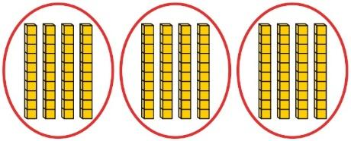  12 tens shared into 3 equal groups.  4 tens in each group. | Divide multiples of 10 by a single digit using known times-tables.  180 ÷ 3 = ?  180 is 18 tens.  18 divided by 3 is 6.  18 tens divided by 3 is 6 tens.  18 ÷ 3 = 6  180 ÷ 3 = 60
2-digit number divided by  1-digit number, no remainders | Children explore dividing 2-digit numbers by using place value equipment.  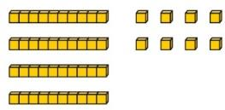  48 ÷ 2 = ?  First divide the 10s.  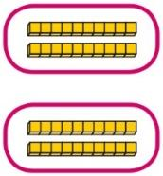  Then divide the 1s.  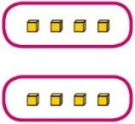 | Children explore which partitions support particular divisions.  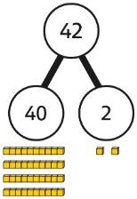  I need to partition 42 differently to divide by 3.  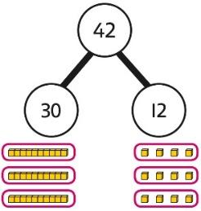  42 = 30 + 12  42 ÷ 3 = 14 | Children partition a number into 10s and 1s to divide where appropriate.  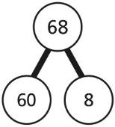  60 ÷ 2 = 30  8 ÷ 2 = 4  68 ÷ 2 = 34  Children partition flexibly to divide where appropriate.  42 ÷ 3 = ?  42 = 40 + 2  I need to partition 42 differently to divide  by 3.  42 = 30 + 12  30 ÷ 3 = 10  12 ÷ 3 = 4  10 + 4 = 14  42 ÷ 3 = 14
2-digit number divided by  1-digit number, with remainders | Use place value equipment to understand the concept of remainder.  Make 29 from place value equipment.  Share it into 2 equal groups.  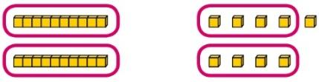  There are two groups of 14 and  1 remainder. | Use place value equipment to understand the concept of remainder in division.  29 ÷ 2 = ?  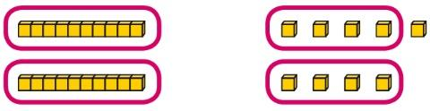  29 ÷ 2 = 14 remainder 1 | Partition to divide, understanding the remainder in context.  67 children try to make 5 equal lines.  67 = 50 + 17  50 ÷ 5 = 10  17 ÷ 5 = 3 remainder 2  67 ÷ 5 = 13 remainder 2  There are 13 children in each line and  2 children left out.
Year 4
 | Concrete | Pictorial | Abstract
Year 4
Addition
Understanding numbers to 10,000 | Use place value equipment to understand the place value of 4-digit numbers.  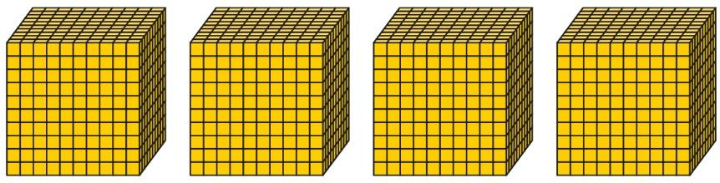  4 thousands equal 4,000.  1 thousand is 10 hundreds. | Represent numbers using place value counters once children understand the relationship between 1,000s and 100s.  2,000 + 500 + 40 + 2 = 2,542 | Understand partitioning of 4-digit numbers, including numbers with digits of 0.  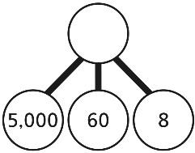  5,000 + 60 + 8 = 5,068  Understand and read 4-digit numbers on a number line.  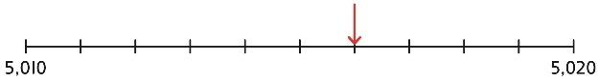
Choosing mental methods where appropriate | Use unitising and known facts to support mental calculations.  Make 1,405 from place value equipment.  Add 2,000.  Now add the 1,000s.  1 thousand + 2 thousands = 3 thousands  1,405 + 2,000 = 3,405 | Use unitising and known facts to support mental calculations.  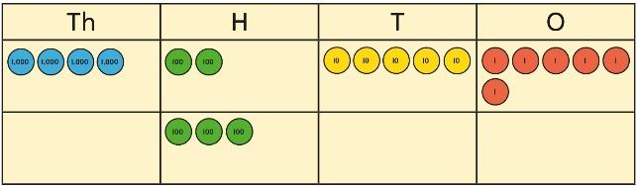  I can add the 100s mentally.  200 + 300 = 500  So, 4,256 + 300 = 4,556 | Use unitising and known facts to support mental calculations.  4,256 + 300 = ?  2 + 3 = 5 200 + 300 = 500  4,256 + 300 = 4,556
Column addition | Use place value equipment on a place value grid to organise thinking.  Ensure that children understand how the columns relate to place value and what to do if the numbers are not all 4-digit numbers.  Use equipment.to show 1,905 + 775.  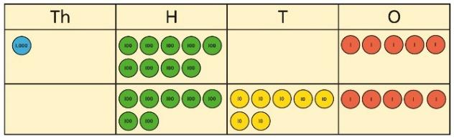  Why have only three columns been used for the second row? Why is the Thousands box empty?  Which columns will total 10 or more? | Use place value equipment to model required exchanges.  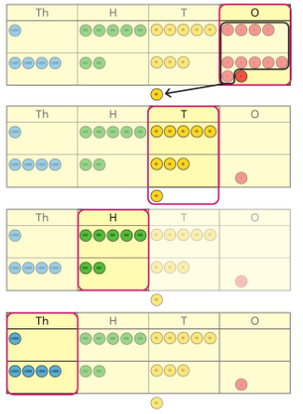  Include examples that exchange in more than one column. | Use a column method to add, including exchanges.  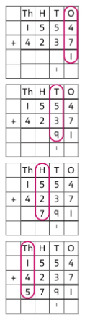  Include examples that exchange in more than one column.
Representing additions and checking strategies |  | Bar models may be used to represent additions in problem contexts, and to justify mental methods where appropriate.  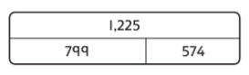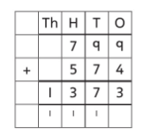  I chose to work out 574 + 800,  then subtract 1.  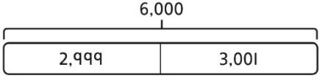  This is equivalent to 3,000 + 3,000. | Use rounding and estimating on a number line to check the reasonableness of an addition.  912 + 6,149 = ?  I used rounding to work out that the  answer should be approximately  1,000 + 6,000 = 7,000.
Year 4
Subtraction
Choosing mental methods where appropriate | Use place value equipment to justify mental methods.  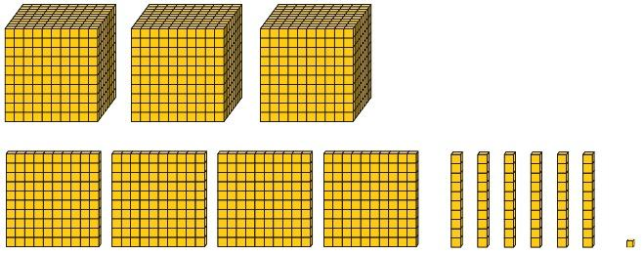  What number will be left if we take away 300? | Use place value grids to support mental methods where appropriate.  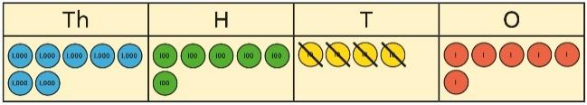  7,646 − 40 = 7,606 | Use knowledge of place value and unitising to subtract mentally where appropriate.  3,501 − 2,000  3 thousands − 2 thousands = 1 thousand  3,501 − 2,000 = 1,501
Column subtraction | Understand why exchange of a 1,000 for 100s, a 100 for 10s, or a 10 for 1s may be necessary.  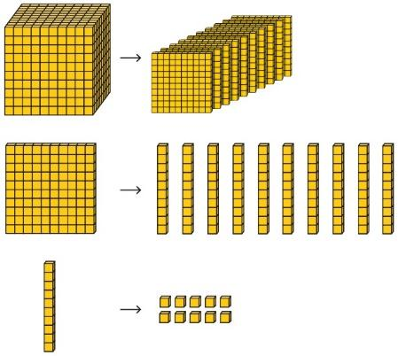 | Represent place value equipment on a place value grid to subtract, including exchanges where needed.  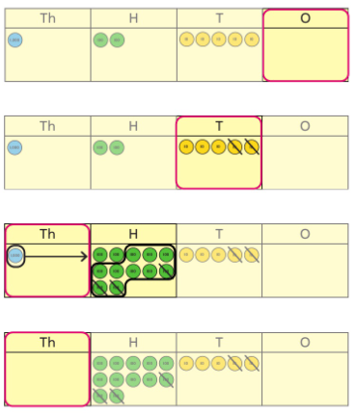 | Use column subtraction, with understanding of the place value of any exchange required.  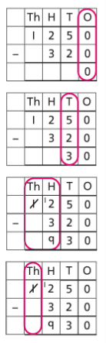
Column subtraction with exchange across more than one column | Understand why two exchanges may be necessary.  2,502 − 243 = ?  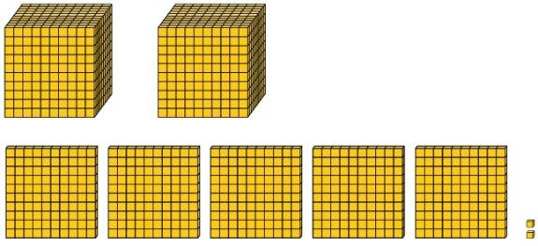  I need to exchange a 10 for some 1s, but there are not any 10s here.  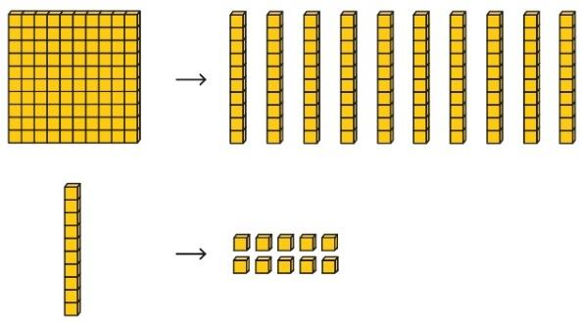 | Make exchanges across more than one column where there is a zero as a place holder.  2,502 − 243 = ?  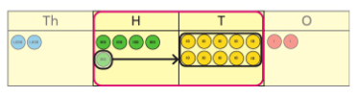  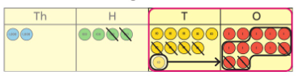 | Make exchanges across more than one column where there is a zero as a place holder.  2,502 − 243 = ?  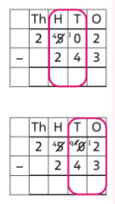  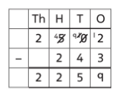
Representing subtractions and checking strategies |  | Use bar models to represent subtractions where a part needs to be calculated.  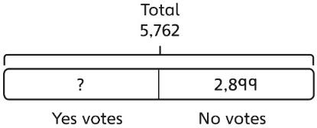  I can work out the total number of Yes votes using 5,762 − 2,899.  Bar models can also represent ‘find the difference’ as a subtraction problem.  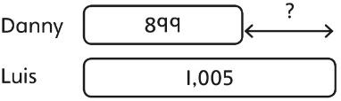 | Use inverse operations to check subtractions.  I calculated 1,225 − 799 = 574.  I will check by adding the parts.  The parts do not add to make 1,225.  I must have made a mistake.
Year 4
Multiplication
Multiplying by multiples of 10 and 100 | Use unitising and place value equipment to understand how to multiply by multiples of 1, 10 and 100.  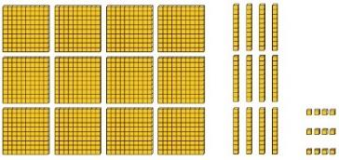  3 groups of 4 ones is 12 ones.  3 groups of 4 tens is 12 tens.  3 groups of 4 hundreds is 12 hundreds. | Use unitising and place value equipment to understand how to multiply by multiples of 1, 10 and 100.  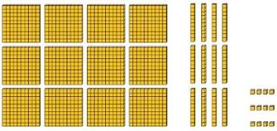  3 × 4 = 12  3 × 40 = 120  3 × 400 = 1,200 | Use known facts and understanding of place value and commutativity to multiply mentally.  4 × 7 = 28  4 × 70 = 280  40 × 7 = 280  4 × 700 = 2,800  400 × 7 = 2,800
Understanding times-tables up to 12 × 12 | Understand the special cases of multiplying by 1 and 0.  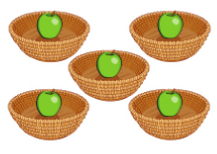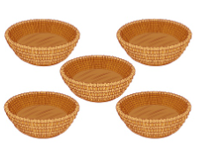  5 × 1 = 5 5 × 0 = 0 | Represent the relationship between the ×9 table and the ×10 table.  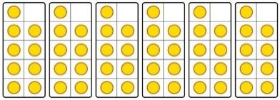  Represent the ×11 table and ×12 tables in relation to the ×10 table.  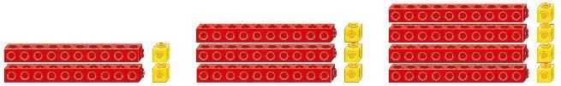  2 × 11 = 20 + 2  3 × 11 = 30 + 3  4 × 11 = 40 + 4  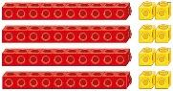  4 × 12 = 40 + 8 | Understand how times-tables relate to counting patterns.  Understand links between the  ×3 table, ×6 table and ×9 table  5 × 6 is double 5 × 3  ×5 table and ×6 table  I know that 7 × 5 = 35  so I know that 7 × 6 = 35 + 7.  ×5 table and ×7 table  3 × 7 = 3 × 5 + 3 × 2  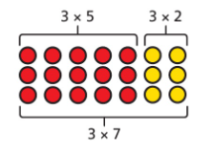  ×9 table and ×10 table  6 × 10 = 60  6 × 9 = 60 − 6
Understanding and using partitioning in multiplication | Make multiplications by partitioning.  4 × 12 is 4 groups of 10 and 4 groups of 2.  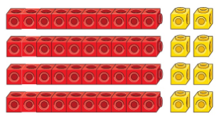  4 × 12 = 40 + 8 | Understand how multiplication and partitioning are related through addition.  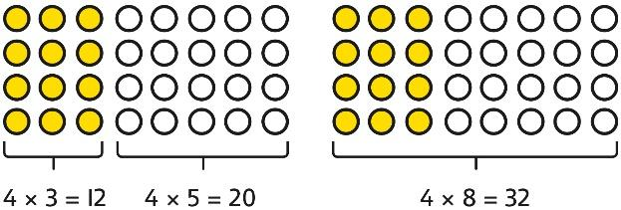  4 × 3 = 12  4 × 5 = 20  12 + 20 = 32  4 × 8 = 32 | Use partitioning to multiply 2-digit numbers by a single digit.  18 × 6 = ?  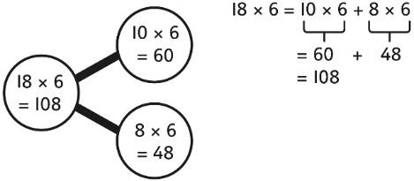  18 × 6 = 10 × 6 + 8 × 6  = 60 + 48  = 108
Column multiplication for 2- and  3-digit numbers multiplied by a single digit | Use place value equipment to make multiplications.  Make 4 × 136 using equipment.  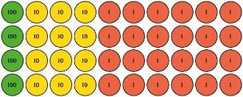  I can work out how many 1s, 10s and 100s.  There are 4 × 6 ones… 24 ones  There are 4 × 3 tens … 12 tens  There are 4 × 1 hundreds … 4 hundreds  24 + 120 + 400 = 544 | Use place value equipment alongside a column method for multiplication of up to  3-digit numbers by a single digit.  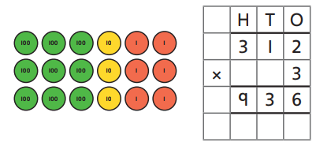 | Use the formal column method for up to  3-digit numbers multiplied by a single digit.  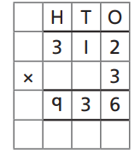  Understand how the expanded column method is related to the formal column method and understand how any exchanges are related to place value at each stage of the calculation.  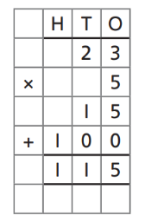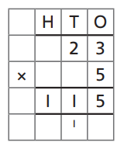
Multiplying more than two numbers | Represent situations by multiplying three numbers together.  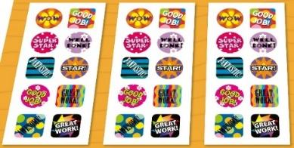  Each sheet has 2 × 5 stickers.  There are 3 sheets.  There are 5 × 2 × 3 stickers in total.  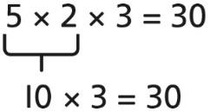 | Understand that commutativity can be used to multiply in different orders.  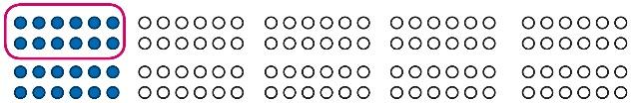  2 × 6 × 10 = 120  12 × 10 = 120  10 × 6 × 2 = 120  60 × 2 = 120 | Use knowledge of factors to simplify some multiplications.  24 × 5 = 12 × 2 × 5  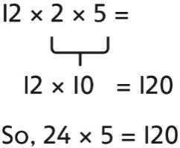
Year 4
Division
Understanding the relationship between multiplication and division, including times-tables | Use objects to explore families of multiplication and division facts.  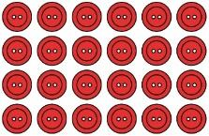  4 × 6 = 24  24 is 6 groups of 4.  24 is 4 groups of 6.  24 divided by 6 is 4.  24 divided by 4 is 6. | Represent divisions using an array.  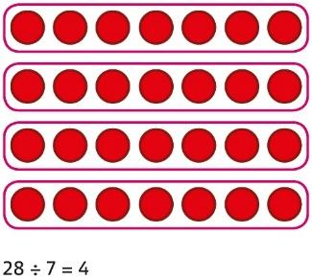 | Understand families of related multiplication and division facts.  I know that 5 × 7 = 35  so I know all these facts:  5 × 7 = 35  7 × 5 = 35  35 = 5 × 7  35 = 7 × 5  35 ÷ 5 = 7  35 ÷ 7 = 5  7 = 35 ÷ 5  5 = 35 ÷ 7
Dividing multiples of 10 and 100 by a single digit | Use place value equipment to understand how to use unitising to divide.  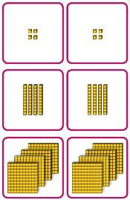  8 ones divided into 2 equal groups  4 ones in each group  8 tens divided into 2 equal groups  4 tens in each group  8 hundreds divided into 2 equal groups  4 hundreds in each group | Represent divisions using place value equipment.  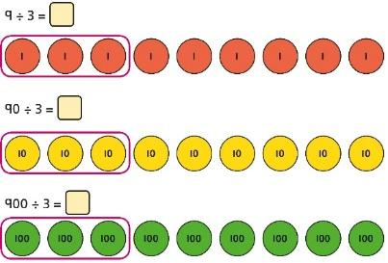  9 ÷ 3 = 3  9 tens divided by 3 is 3 tens.  9 hundreds divided by 3 is 3 hundreds. | Use known facts to divide 10s and 100s by a single digit.  15 ÷ 3 = 5  150 ÷ 3 = 50  1500 ÷ 3 = 500
Divide by sharing | Share using place value equipment  36 shared equally between 3 groups  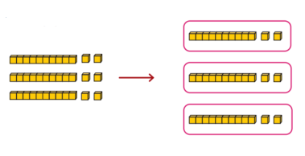  36 ÷ 3 = 12 | Share by exchanging  56 shared equally between 4 groups  First share the 10s.  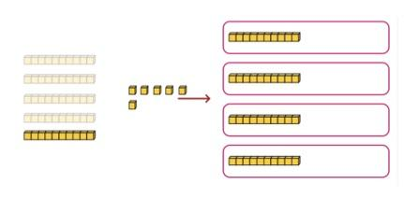  Exchange 1 ten for 1s, then share all the 1s.  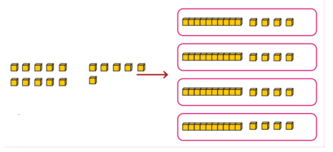  56 ÷ 4 = 14 | Share using known facts and partitioning where appropriate  142 ÷ 2 = ?  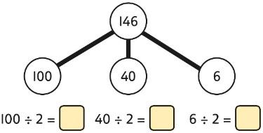  100 ÷ 2 = 50  40 ÷ 2 = 20  6 ÷ 2 = 3  50 + 20 + 3 = 73  142 ÷ 2 = 73
Understanding remainders | Use place value equipment to find remainders.  85 shared into 4 equal groups  There are 24, and 1 that cannot be shared.  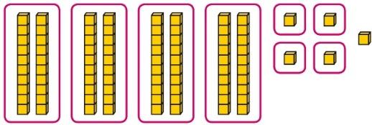 | Represent the remainder as the part that cannot be shared equally.  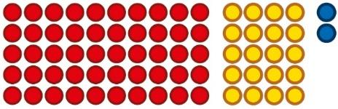  72 ÷ 5 = 14 remainder 2 | Understand how partitioning can reveal remainders of divisions.  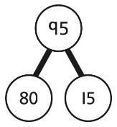  80 ÷ 4 = 20  12 ÷ 4 = 3  95 ÷ 4 = 23 remainder 3

