 | ELWORTH C.E. PRIMARY SCHOOL  School Lane, Elworth, Sandbach  Cheshire CW11 3HU  Telephone: 01270 698914  Headteacher: Neil Garratt  E-mail: head@elworthce.cheshire.sch.uk  Website: www.elworthce.cheshire.sch.uk

Year 4 Autumn Term Letter 2026
Welcome back! We hope you all enjoyed a lovely summer holiday. We are looking forward to welcoming the children back into school on Thursday.

Staffing
Teachers
Kingfishers - Mrs Garratt and Mrs Astley
Robins - Mrs Morgan

Mrs Garratt teaches Monday - Wednesday. Mrs Astley will teach Kingfishers alternating Wednesdays and every Thurs - Friday.
This week Mrs Garratt will teach Thurs 3rd and Mrs Astley will teach Fri 4th.

Teaching Assistants
Mrs Copnall, Mrs Visan and Mrs Owen are our teaching assistants who will be supporting the classes.

Phase Leaders
Mrs Garratt is the Y3/4 Phase Leader.

Start and End of the School Day
We are hoping a lot of the children will take part in our Wake up Shake up mornings - the gates will open at 8:25am for this. If your child is not wanting to attend, they can come through the gates as normal at 8:35am for registration at 8:40am. KS2 children can enter one of the external gates (Randell Bennett or the Co-op gate) and make their way to the main playground at the start of school where their teacher will meet them. Teachers will be available on the playground if they are not sure where to go. We are asking parents to leave their child at the gate.

The school day ends at 3:20pm. At pick up, parents must meet their child on the KS2 tarmac school playground. It is our policy in year 4 that all children are collected by a person over the age of 16.

Topic
Our year 4 topic is a geography based topic called ‘Splash! Where does all the water go?’ and will focus on mountains and rivers. The children will be developing their map skills, fieldwork skills and asking and answering geographical questions to find out more about mountains and rivers. We have an exciting visit planned to Macclesfield Forest as part of our topic. During this visit, we will be taking part in a river study which will include measuring different aspects of the river, including depth, width and speed of flow. We will also be visiting different river features and learning how they are formed.

Equipment
All children in KS2 need to bring their own pencil cases with a supply of items listed below.
- Pencil
- Rubber
- Pencil Sharpener

- Colouring pencils
- Ruler
- Glue Stick
- Drywipe marker, black
- 4 colour Bic biro
- Black handwriting pen (Not biro)
- Blue handwriting pen (Not biro)
- Simple headphones with jack cable

Water bottles/ Snacks
Children must have a water bottle with them every day. Children must bring their own healthy snack for morning break.

Spelling/ Phonics
Children will have spelling lessons within their spelling/phonics groups, and National Curriculum spelling lists will be given out at the start of the year for the children to learn for a spelling test every half-term. Year 4 children will be expected to learn one column of spellings per half term and will require help and support at home to ensure they are confident and achieve well. We realise that some of these spellings may appear quite demanding, but every child in the country has to be proficient in the spelling of the relevant age-related words.

Reading
We love to foster a love of reading at Elworth. It is crucial to children’s development that they are reading regularly therefore all children are expected to read for 20-30 minutes three times per week as part of their homework and have their reading diary signed by an adult. These will be checked weekly. Children are responsible for telling their teacher when they need to change their book, to promote independent learning. All children in Year 4, when reaching a suitable standard, will have access to Accelerated Reader, where children read their choice of book and complete a comprehension quiz online at the end. These results are tracked by teachers and the children achieve dojo points for good test results.

PE
PE sessions take place once a week. Year 4 will have their PE day on a Wednesday. Mr Darby and the PE team will run these sessions. Children need to come to school wearing their full PE Kit on Wednesdays (and also on Fitness Friday). As they will have to wear their PE kit throughout the whole school day, the children will need to be suitably dressed and prepared for indoors, outdoors and all weather conditions. It is essential that all children have a waterproof coat/jacket with them.
No jewellery is to be worn during PE sessions and long hair must be tied back for health and safety reasons.
Their first PE lesson will be on Wednesday 9th September. There will be no PE this first week back. Children will need to wear normal school uniform on Thursday and Friday this week.

Uniform
For your reference, our school uniform is listed below. Summer uniform can continue to be worn until October half term. Please ensure all uniform is named.

Boys | Girls
Grey trousers  School specific sweatshirt  White shirt  School tie  Grey socks  Black shoes  *Summer alternative = formal school shorts in charcoal grey. | Grey pinafore/skirt/ trousers  School specific sweatshirt or cardigan  White shirt  School tie  White or grey socks/ tights  Black shoes  *Summer alternative = pale blue checked summer dress or formal school shorts in charcoal grey.

The children must have clean trainers for going on the MUGA at playtimes.

Our whole school PE Kit is listed below:

Boys | Girls
Royal Blue Elworth Printed Logo Tech shirt  Plain Black shorts (unbranded)  Plain Black Jogging Bottoms (unbranded)  School specific fleece  Waterproof coat  Trainers and Sports socks | Royal Blue Elworth Printed Logo Tech shirt  Plains Black shorts/ fitness pants/ skort (unbranded)  Plain Black Jogging Bottoms (unbranded)  School Specific Fleece  Waterproof coat  Trainers and Sports socks

Homework
All of the homework will be set on Google Classroom. Your child will be given their logins for the learning programs we use at the start of term, when they will be stuck in their reading records.

Subject | Activity | Day Set | Completed by
Maths | Edshed (online) | Monday | Following Monday
Multiplication | Times Tables Rock Stars (TTRS) | Daily | Checked every Monday
Reading | 20-30 minutes at least 3 times a week | Daily | Daily
Spelling | Edshed (online) | Monday | Following Monday
Spelling | Half termly spelling list of y3/4 National Curriculum spelling list | Start of half term | End of half term
SPAG (spelling, punctuation and grammar) CGP book | SPAG CGP book | Monday | Following Monday

Rewards
We love to celebrate the children’s achievements in Year 4! This year the children have so much to look forward to and to work towards. Our Hot Chocolate Club will be attended by our Good Samaritan Award winners each week. A daily Star of the Day will continue to be awarded; on Wednesdays this will be a PE certificate! Achievement Assemblies will celebrate our Class Merit winners. Children will accumulate Dojo points and certificates sent home at the end of each half term. There will be a whole school achievement assembly once a half term to celebrate the achievements and awards the children achieve outside of school.

Music
All children in Year 4 will benefit from weekly whole class instrument lessons! New for this year, Year 4 will have tuition in Clarinet or Saxophone. These instruments will come home later in the term for the children to practise their pieces.

Example Weekly Timetable

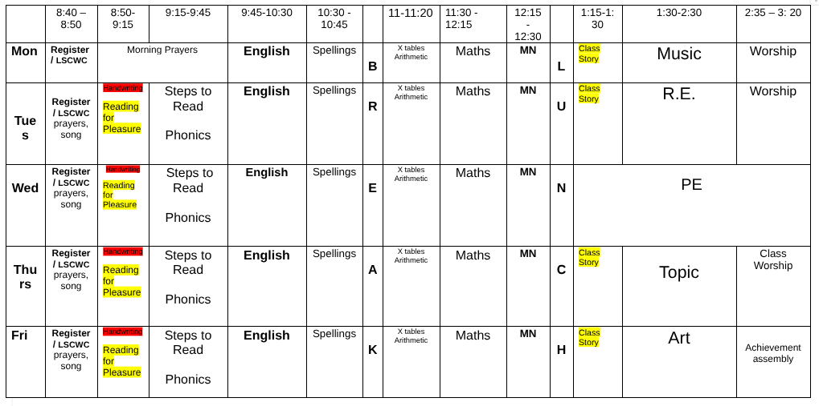

Educational Experiences
We plan educational visits to enrich and enhance our curriculum. We try our best to keep costs to a minimum. Information regarding our Autumn term visit to Macclesfield Forest has already been sent out. Just a reminder that we do have our residential in Year 4 which takes place during the Spring term. The cost of the residential will be £265. More information regarding our Residential will be sent out later this term.

Below is an overview of visits across the year with approximate costs to help with budgeting.

Visit | Term | Approximate cost
Macclesfield forest | Autumn 1 | £14
New Vic theatre | Autumn 2 | £25
Big Sing
Y4 Residential | Spring 2 | £265
Chester - Roman experience | Summer | £23
Halle (Music) | Summer | £15

If you have any further questions or queries, please contact your child’s class teacher.

Thank you for your continued support,
Mrs Garratt, Mrs Astley and Mrs Morgan

