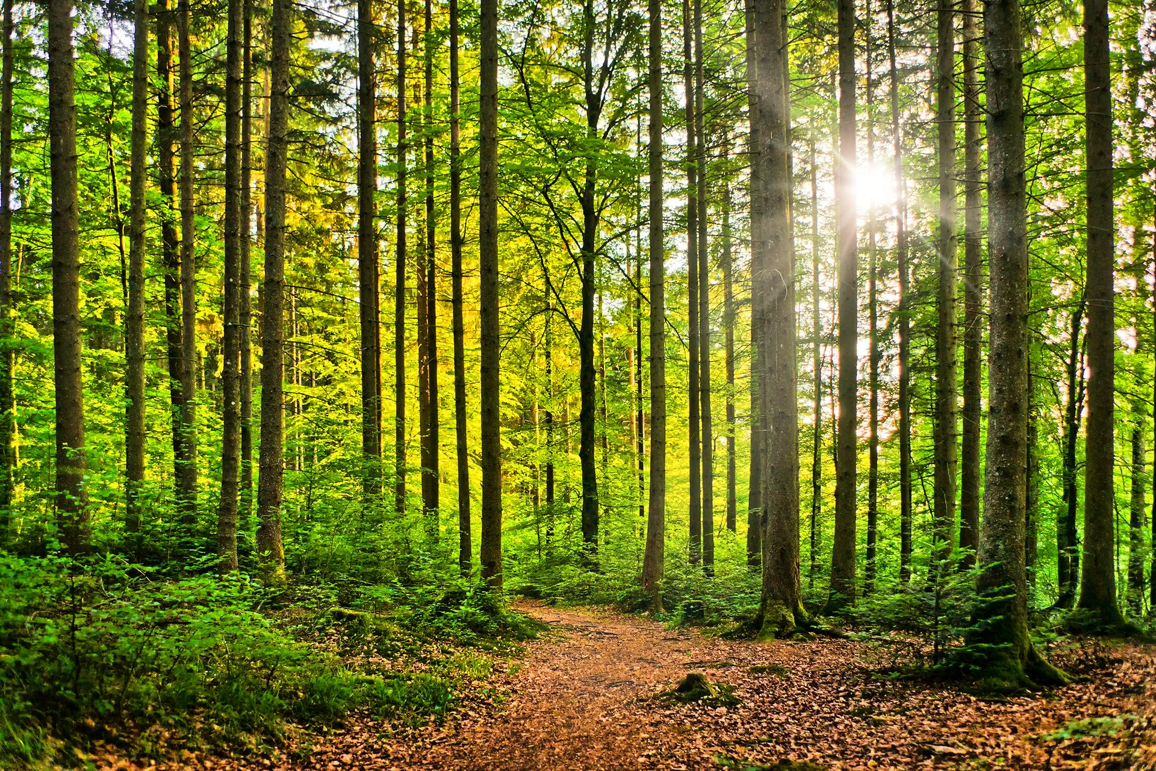

Lost in the forest 2026
Geography
I can create a forest word bank
I can devise a simple map.
I can use simple compass directions and locational language.
I can use aerial photographs to recognise landmarks and basic human and physical features.
I can draw a map of our route around Delamere Forest
I can find out about Daintree Forest
I can compare a forest to a rainforest.
I can understand geographical similarities and differences.
I can raise awareness of deforestation

Design and Technology
Link to Science
Food for picnics
Healthy foods and choices.
Make a fruit salad
Make a healthy sandwich
Make a bag to carry your healthy lunch in.
Punch and Judy theatre and puppets
Beach mobiles
Mosaic tiles of sea creatures
Design and make a lighthouse with a working light.
Maths

I can recognise and use symbols for pounds and pence and combine amounts to make a particular value
I can recognise and know the value of different denominations of coins and notes
I can find different combinations of coins that equal the same amounts of money.
I can solve simple problems in a practical context involving addition and subtraction of money of the same unit, including giving change.
I can solve problems involving multiplication and division.
I can solve one-step problems involving multiplication and division.
I can calculate mathematical statements for multiplication and division.
I can recall and use multiplication and division facts for the 2, 5 and 10 multiplication tables.
I can use appropriate standards of measurement to measure length, capacity, height, mass and temperature.

Science
Identify, name, draw and label the basic parts of the human body and say which part of the body is associated with each sense.
Observe and describe weather associated with the seasons and how day length varies.

Materials

Literacy
I can write for a variety of purposes including return narrative, information text , twisted narrative and persuasive letter.
I can use a variety of punctuation including capital letters, full stops, commas in lists, question marks and exclamation marks and apostrophes for possession.
I can use a range of conjunction including or/and/but/because/when/if/that.
I can add suffixes including er, est, ly, ful and less to make new words.
I can use description in my writing.
Music
Love Music Trust
Year 1 Unit 5: Under the Sea
Year 2 Unit 4: Whatever the Weather

Oh I do like to be beside the seaside

Computing

Word processing - I can use word processing.
P.E
I can take part in invasion games such as football and hockey.
I can perform simple gymnastic movements.
I can use striking and fielding skills.

R.E.

I can explain the place where Jesus lived is different to where and how we live today.

I can explain how symbols help us to understand the Easter story.

Trip to Delamere Forest
Science
I can observe and describe how seeds and bulbs grow into mature plants.
I can find out and describe how plants need water, light and a suitable temperature to grow and stay healthy.
Music

Charanga- To know five songs off by heart. To know some songs have a chorus or a response/answer part. To know that songs have a musical style.
DT
I can name different fruits and vegetables.
I can explain where some food grows and where different fruit comes from.
I can say which fruit I liked the most and why.
I can explain why it is important to eat fruit and vegetables.
I can explain that fruit and vegetables contain lots of vitamins and minerals.
LO: I can prepare a tasty fruit salad.

Art
I can develop a range of mark-making techniques.
I can develop observation skills.
I can develop illustrations to tell a story.
I can discuss my work and the work of others.

