
St. Peter’s Church meeting in Brigade Hall, Bryn Road
Our Local Missional Leader is Eth Yates
Romans 15:13 May the God of hope fill you with all joy and peace as you trust in him, so that you may overflow with hope by the power of the Holy Spirit.
Our Services for May

Sunday 3rd May – Morning Prayer 10.30 a.m.
Sunday 10th May – Hub Service 10 a.m. at St. Thomas’ (Communion)
followed by APCM and ‘bring and share’ lunch
Monday 11th May – Communion Service in Garswood House 11 a.m.
Thursday 14th May – Ascension Day at Holy Trinity 7 p.m.
Sunday 17th May – Holy Communion 10.30 a.m.
. Sunday 24th May – Whit Sunday (Pentecost) Morning Prayer 10.30 a.m.
Sunday 31st May – Trinity Sunday Morning Prayer 10.30 a.m.

Our Organisations (All in Brigade Hall – termtime only)
Mondays Girls’ Brigade – 6.30 p.m.
Tuesdays Boys’ Brigade – 6 p.m.
Wednesdays Knit and Chat – 1-3 p.m. Women’s Fellowship – 7.30-9 p.m.

Our Hub Communion Service this month takes place on the second Sunday (10th) at St. Thomas’. It will be a 10 a.m. start, followed by our APCM (Annual Parochial Church Meeting) and a faith lunch (bring and share). Neil Cook will be preaching.

Garswood House Communion will be a week later than usual because of the May Bank Holiday.

Our own Communion Service will be, as usual, on the third Sunday when we welcome Kelvin to share a reflection. The 5th Sunday (31st May) will be Morning Prayer here at St. Peter’s.

There are ‘Seven Sundays of Easter’ so we remain in ‘Eastertide’ until Whit Sunday. Following on from the joy of the Resurrection on Easter Sunday, in May we celebrate three other important days in the Church’s calendar – Ascension Day, Pentecost (Whit Sunday) and Trinity Sunday.

Last month Sue Fulford led us to the tomb with Mary Magdalene who found that Jesus had risen and was alive; Eth took us to the Upper Room where Jesus appeared to his frightened disciples and a week later showed himself alive to doubting Thomas; then Sue walked with us along the road to Emmaus with Cleopas and another disciple when they were joined by our risen Lord and went to eat with Him. He is risen indeed!

On the Church’s calendar this month we remember Jesus’ Ascension to heaven (40 days after his resurrection and after preparing his disciples for their mission), the coming of the Holy Spirit at Pentecost, and the unity of God – the Father, Son and Holy Spirit – the Trinity.

While we celebrate and commemorate these events each year, as Christians led by the Holy Spirit we hold these things in our hearts every day – in our lives, our prayers and our worship, and as we say our Lord’s Prayer, the Creed and read our Bibles.

Women’s Fellowship

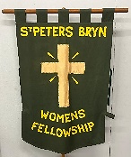
It is good to have Christine back with us this month, thankful that she has made such a good recovery. We pray that all continues to go well for you Christine.
Meeting on Wednesdays at 7.30 p.m. Brigade Hall.
6th May – Jean Reynard will speak about HMD/RHS Garden at Stubshaw Cross 13th May – all are welcome to our Bible Study
20th May – Elaine Tyrrell will speak on Soroptimism
27th May – Bank holiday so there will be no meeting

Knit and Chat

We are a friendly group who love to knit or chat and all are welcome to come along. Bring your own knitting or crochet to work on or help to knit small items needed by our charities. Can’t knit? – we can teach you, or why not just come along for a chat and a brew with us – Wednesdays 1-3 p.m. in Brigade Hall.

Easter morning – Early Communion at The Three Sisters
Eth writes: “I am not a morning person, my family will tell you that speaking to me first thing in the morning is a tricky thing to do! So a few years ago when Jeremy asked St. Peter’s to host the early morning service on Easter Day I was very unsure !! When Sandra came I thought it may not happen or perhaps be later, but no it continued.

However, having said all that, when I get to the service it is a lovely time. It is so peaceful at that time in the day around the pond at The Three Sisters. There is little chatter, as we are possibly all still waking up, and the fact we are outside brings something to this simple but so meaningful service.

We gather to celebrate the resurrection of our Lord, and being so early you can begin to imagine how the women felt when they saw that empty tomb. That simple empty tomb was so very meaningful for all who believe. It is the realisation that all that Jesus said was true and that we now have eternal life because of Him. The grief and sadness of Good Friday doesn't go away but now we have a risen Lord; a Lord who lives and dwells with all who believe and trust in this amazing event, and what it means to Christians.

So we come away from the service with a sense of warmth and fellowship, we share Communion with each other and there is something very powerful in that simple act. To give someone Communion is one of those things in our church that is so special and such a privilege to do.

The fact that we saw beautiful swans and heard the ducks, and this year got absolutely soaked, all adds to the glory of the time there. Also the fact that we can return to our church and share a warm drink and hot cross buns also adds to the wonder of Easter Day.”

He is risen Alleluia !! Eth x


Brigade
Thank you to our Girls’ and Boys’ Brigades for the beautiful artwork they furnished us with for Easter. Their work around Brigade Hall brings us joy to see each month.
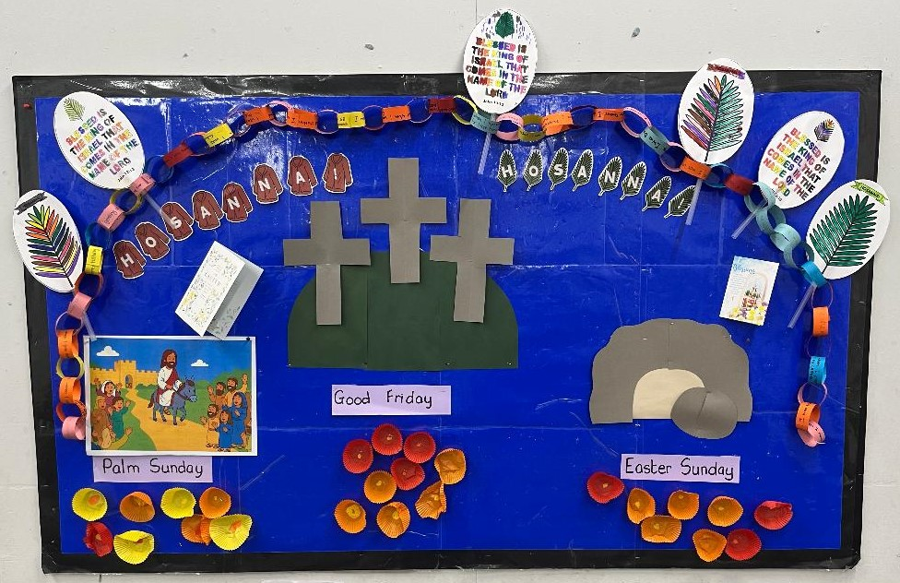

We wait to see what they come up with for the 50th anniversary of GB later this year!

Wigan South APCM (Annual Parochial Church Meeting)
The APCM for Wigan South will be held after the Hub Communion Service at St. Thomas’ on Sunday 10th May. This is an important meeting for our parish so please stay if you can; it will be followed by a Faith Lunch. This year we have vacancies for a Hub Warden and Deputy Warden, and places on the PCC and for a Deanery Synod member.

The APCM provides an opportunity for members of the congregation to engage with the leadership and contribute to the direction of the church. Various reports are presented to help us review the past year, plan for the future and make decisions about aspects of church life, finances, and mission, and some new PCC members are elected. Everyone is welcome to attend and comment but only those on the Electoral Roll can vote and stand for election to help shape the future of the ministry and mission of our Hub Churches.

Our PCC (Parochial Church Council) is the governing body of our Hub Churches. Our vicar, Sandra Jones serves as the chairperson, our churchwardens oversee the maintenance and operation of the church and elected lay members represent the congregations. The Deanery Synod member represents the church to connect with the wider Diocese of Liverpool.

The PCC meets about six times a year. Please have a think and pray if there is anyone in church who might be willing to take on one of these roles. Have a chat with Tony or Sandra to find out more. You don’t need to be an expert in anything—just come with a willingness to pray together, share your thoughts, and work as part of a team. Nomination forms for the election of PCC members are available from our church leaders and wardens.

Our primary school leavers

Please help us to buy Bibles to present to our Y6 leavers at St. Peter’s School this summer. As from previous years we know that these Bibles are well appreciated and we pray that the Good News of Jesus will go with our young people as they move on to their new schools. Kath is now collecting donations towards the cost. We will need 31 Bibles at about £16 each.
In June we will be working with Y6 pupils at St. Peter’s as they prepare for their transition to High School in September. It can be a daunting time for some so we hope to ease any worries and help them to know what to expect. If you would like to help with this work have a chat with Eth.
Bible Study

This month’s Bible Study will be held in Brigade Hall on Wednesday May 13th. Last month we completed our study of the Beatitudes in Matthew’s Gospel, so we will continue in Matthew and begin to look into Jesus’ teachings in the Sermon on the Mount and the challenges they present in our Christian lives. We look forward to seeing you there, all are welcome.
Confirmation classes
A reminder that confirmation classes are starting at St. Thomas’ Vestry this month on Tuesday 12th May, and on each of the following five Tuesdays, in preparation for the Confirmation Service on Wednesday 1st July at St. Thomas’ Church. It is not too late to sign up for these – see Eth, Sue or Sandra for more information.
Grave Talk
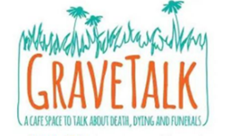
If you missed out on ‘Grave Talk’ at St. Peter’s in March (or loved it so much you want to join in again), the next opportunity will be at St. Andrew’s on Tuesday May 5th 10 – 11.30 a.m. Led by Dave Hamlett and Sandra Jones, come along and enjoy an informative and light hearted discussion among friends – ‘because it’s part of life and affects us all and talking about death and funerals doesn’t have to be deadly serious’. Ask Eth or any of the dozen or so from our church who have already participated if you want to know more.
The Prayer Course
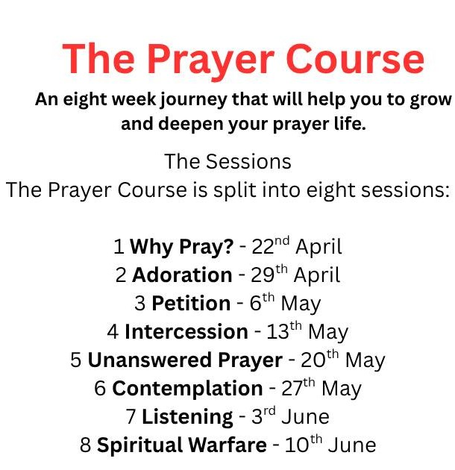
We can also recommend ‘The Prayer Course’ which has started up again, this time at St. Thomas’ on Wednesdays at 7 p.m. There are 8 sessions that will help you to grow and deepen your prayer life. It’s not too late to join in – come to all the sessions, or just the ones you can make. Everyone is welcome.

From last month
Kath and Carol visit Llandudno
Carol writes: “On Tuesday the 31st of March, Betty, Kath and Carol boarded a coach with lots of other travellers to Llandudno for the day. The weather was good and it didn't rain. Llandudno was busy and lots of families were enjoying the day. We had a really nice day and came home with lots of shopping, lol !

The trip was organised by the Methodist Church in Queens Road, who run about three trips a year. We always have a really good time and meet some lovely people. Bakewell and Matlock was discussed for our next trip possibly. Why not give it a try?”



Which was best, ladies, the view or the shopping? That bag looks heavy Kath!

Our Prayers
This month sees the beginning of tests and examinations for young people in our schools and colleges, especially our Y6 and Y11 pupils. Many will be studying hard to achieve their best, some may be worried or fearful knowing that their results might determine their future paths into further education or work places. Pray for them, also for the families and teachers who support them. Summer holidays will soon be round the corner!

May Birthdays



We wish you all every blessing on your special day

5th Alan Slater 11th Sue Fulford 12th Rebecca Hobson

‘The joy of the Lord is your strength.’ Nehemiah 8 v.10

