St. Peter’s Church meeting in Brigade Hall, Bryn Road
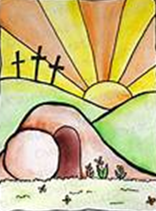
Our Local Missional Leader is Eth Yates

John 11: 25 Jesus said, ‘I am the resurrection and the life. The one who believes in me will live, even though they die.’
John 14: 6 Jesus said “I am the way and the truth and the life. No one comes to the Father except through me.’

Our Services for April (Holy Week and Easter)

Maundy Thursday 2nd April Hub Service here at St. Peter’s 7 p.m.
(with washing of feet or hands if you wish)
Good Friday 3rd April – Our service of readings and reflections 9.30 a.m.
Easter Sunday 5th April – Sunrise Service by the lake at the Three Sisters 6.30 a.m.
– Our Easter Day Holy Communion 10.30 a.m.
Sunday 12th April – Morning Prayer 10.30 a.m.
Monday 13th April – Communion Service in Garswood House 11 a.m.
Sunday 19th April – Holy Communion 10.30 a.m.
Sunday 26th April – Café Church 10.30 a.m.


Happy Easter and a warm welcome to all our services this month.
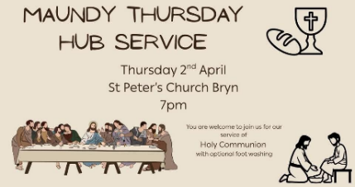
On Maundy Thursday, the fifth day of Holy week, we commemorate Jesus washing the feet of his disciples and we remember the Last Supper. At the Last Supper, Jesus, blessed the bread and the wine, sharing them with his disciples. The word ‘Maundy’ comes from the Latin, ‘mandatum’, or command, which refers to the instructions Jesus gave his disciples at the Last Supper. Jesus commanded that people should love one another and encouraged his disciples to eat bread and wine after his death. He then washed the feet of his disciples as an act of kindness.

On Good Friday we commemorate the crucifixion of Jesus. So why is it called Good Friday? Jesus, the Son of God ,was flogged, ordered to carry the cross on which he would be crucified and then put to death; it's difficult to see what is ‘good’ about it. Different liturgical traditions suggest various reasons for this, but for us it could be just ‘good’ because by his death Jesus showed his great love for us, by the price he paid for our salvation.

The Sunrise Service with Communion beside the lake at the Three Sisters is a very special way to celebrate the Resurrection on Easter Sunday, welcoming folk from churches around Bryn and Ashton. It will be followed by tea and coffee and hot cross buns in Brigade Hall, a reward for the 6.30 a.m. start to the day!

We have our own Easter Sunday Communion service here at Brigade Hall at 10.30 a.m. for later risers.

(N.B. Monday Communion at Garswood House takes place a week later than usual on 13th April)

Don’t forget Café Church on the 26th, a very informal service with bacon or sausage balms and hot drinks before we begin our worship, and a short reflection, prayers and an activity to follow.

Our Organisations (All in Brigade Hall – termtime only)
Mondays Girls’ Brigade – 6.30 p.m.
Tuesdays Boys’ Brigade – 6 p.m.
Wednesdays Knit and Chat – 1-3 p.m. Women’s Fellowship – 7.30-9 p.m.

Women’s Fellowship Knit and Chat
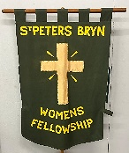

These groups will close for the two Wednesdays of the Easter holiday (8th and 15th April) and reopen on Wednesday 22nd of April for their usual activities.
Women’s Fellowship will host our Next Bible Study on the 22nd April at 7.30 when all are welcome to join us.
Christine will not be with us at Women’s Fellowship for a while as she recovers from an operation; we send her our love and prayers and wish her a speedy recovery. In the meantime Eth will ‘hold the fort’ in her absence.
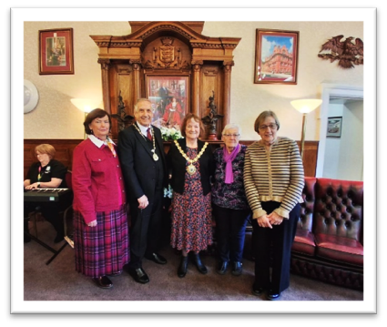
Mayor’s Charity Event

Last month three members of Women’s Fellowship attended a Charity Lunch at the Mayor’s Parlour in Wigan Town Hall, an event to raise funds for the Mayor’s chosen charities for 2025-26, ‘Curious Minds’ and ‘All Ears Mental Health Awareness’, both supporting children and young people in the Borough. Very nice it was too! There they met the Mayor, Councillor Jenny Bullen, and were given a guided tour of the Council Chambers and learned of its workings. Jenny is a former member of St. Peter’s, now worshipping at St. Lukes, so it was great to meet up with her again.


Our Brigades

At the moment we in the Brigades are looking towards Camp and all the things we will need to do before we go. The Camp list has gone up and so the excitement will begin. It is without doubt the highlight of most of our year.

Every week we meet and share fellowship with the young people we serve as leaders. We share their happiest times and we are there for them when times are tough. Those eagle eyed among you will notice some of the things we do with them around the hall.

At GB we finish most weeks off by playing a form of cricket, it truly is hilarious; we are practising for camp but need to work so hard because we do more laughing than playing cricket.

We know that soon many of our young people will be sitting assessments and exams and that is a stressful time for them and their families, and the schools they go to.

As leaders we are there to offer support to our young people, to show them God's love by the way we treat them and by the way we live our lives. It's such a privilege to work with them and to see them grow into the fine young people they are.

Please pray for them all as they move into exam season, and pray for us we begin our preparation for Camp 2026 !! Eth

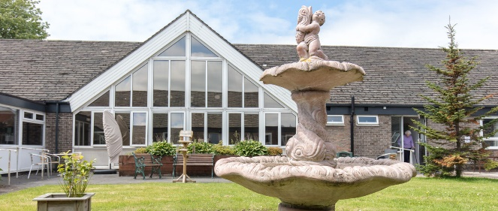
Home Communions and Garswood House

Never in a million years did I ever think that I would be part of this kind of ministry. I have always thought that teaching a class of very young children was where I feel in my “comfort zone” but God has proved me wrong.

When we were first invited into Garswood House I wondered what on earth we could offer the residents. But I had it the wrong way round, they give us so much. Communion in there is much simpler and more relaxed, the residents are so glad to see us and we are always made welcome. We have a few family members who occasionally join us and there is always a member of staff with us. So our ministry in there is slightly wider than we first thought.

We have always to be mindful that we are guests in their home and as such we need to be flexible. Sometimes we need to move rooms or the residents need to do other things and sometimes the tea trolly comes in, but these are all parts of life in a care home and we always need to remember that this is a home. We meet up with friends in there and that is a privilege.


Home Communions are the same, we are sharing communion with friends who can no longer make it to church but still want to be connected to God by sharing Communion with us. I think I have said before that it was when Sue Fulford and I went out to do communions a few Christmases ago that I realised that some of the people we visited hadn't had Communion for years. It was at that point that I realised that this was something God was calling our church to do, and we could easily do it. Yes, we had to do safeguarding training and safer recruiting of all the visitors, but that went well and people did it willingly.

We are a team of 5 and we go out in twos. We go out the first week of the month and we now visit 5 homes and serve 6 people with the promise of another person who we are trying to get to. We are made so very welcome and we realise just how much our friends appreciate us sharing communion with them.

I know I speak for all the 'team' when I say God has blessed us just as much as those we visit. It is a chance to share communion in a less formal quiet way, to listen to prayer we may take for granted and to hear the Bible read in that peaceful quiet way. We always come away feeling blessed, plus we get to chat and laugh and catch up.

If you feel you would like to join this ministry then please contact me, there is a process to go through; you would need to do safeguarding training but if you feel you want to minister in this way that is the key thing to focus on, the rest we can cope with!! I always think of that passage of scripture where our Lord talks about serving others and by doing that we are serving Him

“They also will answer, ‘Lord, when did we see you hungry or thirsty or a stranger or needing clothes or sick or in prison, and did not help you?’
“He will reply, ‘Truly I tell you, whatever you did not do for one of the least of these you did it for me.’ Matthew Ch.25 v.37
Please pray for all involved at Garswood House and Home communions, your prayers are an important part of this ministry.
Thank you, Eth x

Bible Study

We have just had our monthly Bible Study where we have begun to look at The Beatitudes in Matthew Chapter 5. These are the teachings of Our Lord where he makes a statement that gives us encouragement. e.g. ‘Blest are the poor in spirit, for theirs is the kingdom of God’.

I wondered if we ever think how blessed we are to be able to meet and study God's word as we do. There are still many areas of the world where we could not meet, we are truly blessed with freedom.

The world at the moment is a worrying place for us, but for those poor souls in the middle of the conflicts that rage it must be truly awful and I for one cannot begin to imagine their fear.

This is the prayer I began a service with recently, perhaps we could use it to pray for our world and all God's children in it.

Almighty God, our refuge and our strength, we turn to you as we once again witness the rising of conflict and the fear laid upon ordinary lives.

Trusting in your never ending love, we hold before you our friends and partners across the Middle East, in communities already stretched beyond endurance.

Surround them with your protection. Be a fortress for those who cannot flee and a shield for those whose work is to heal and to hope.

Do not let the innocent be swept away by the decisions of the powerful. Open paths for wisdom, restraint, and justice where none seem possible.

Give courage to peacemakers and clarity to those who speak truth. Let your peace take root in scorched and fearful places.
Keep our hearts from despair and teach us to stand with those who suffer, to pray without ceasing and to hope, even now, in your redeeming love.
Amen.
During our next Bible Study, on Wednesday 22nd April, we will continue our study of the Beatitudes and begin to look deeper into the Sermon on the Mount which follows with more of Jesus teachings. Thank you to Eth and Women’s Fellowship for hosting this for us all.


Confirmation Service in July

If you have ever thought about Confirmation or know someone who has, then speak to Eth, or our clergy (Rev. Sandra Jones or Rev. Sue Fulford) to learn more.

Rev. Sandra writes, ‘Confirmation marks the point in the Christian journey at which you affirm for yourself the faith into which you were baptised and your intention to live by faith. If you have never been baptised, no worries, just have a chat with us and we can arrange for you to also be baptised at your confirmation’.

The Confirmation Service this year will held at St. Thomas’ on Wednesday 1st July at 7 p.m. Joining us will be folk from North-West and West Hub, as the Bishop only plans to do two confirmation services in Wigan this year. Preparation classes will take place on Tuesdays, 12th, 19th and 26th May and 2nd, 9th and 16th of June at St. Thomas’ Vestry. (You would need to have been to at least 4 of these sessions.)

From last month
Mothering Sunday
Sheila writes: “On Mothering Sunday we welcomed Rev. Sue Fulford (and Mike) to lead our Communion service. Sue’s message related to all mothers and the Mother Church. The ladies of the congregation were presented with flowers and a card to pass on to their mums; these were distributed by the young people of our church family. It was lovely to see the smile on the face of our youngest member when he gave his mum her flowers.
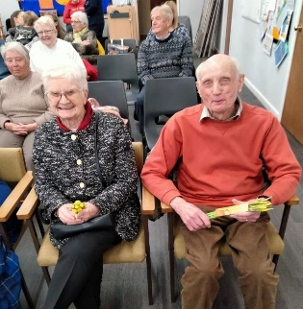
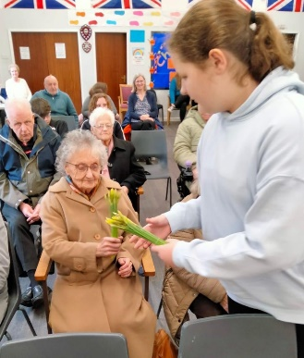
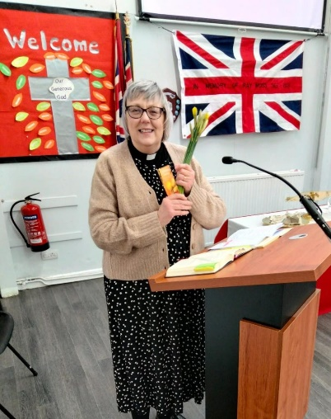
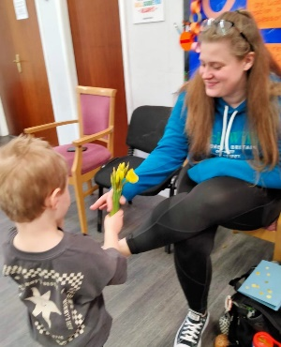
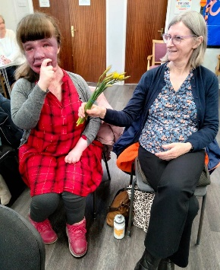
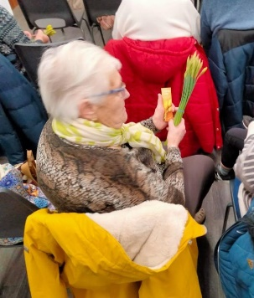
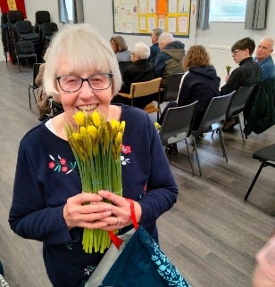
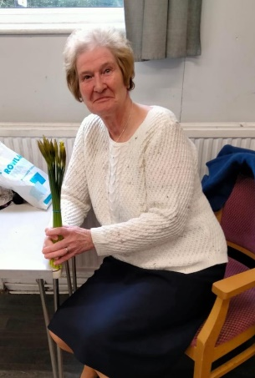
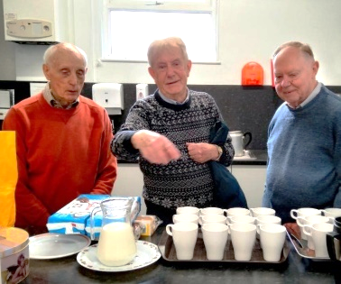
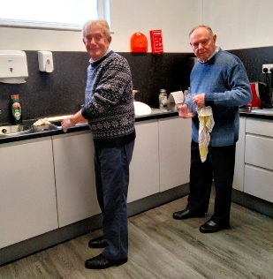
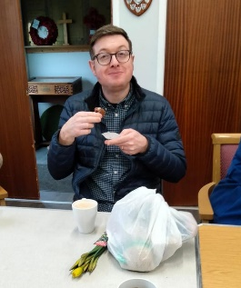
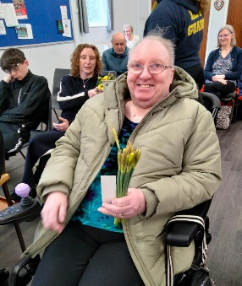
The men of the congregation were the ‘tea-makers’ and ‘dish-washers’ for the day. The day was enjoyed by all. Our thanks to Mike for taking the photos.”

Songs of Praise
At the beginning of March we had a joyful service of praise and worship, and sharing of stories, with a wide variety of hymns and songs, chosen by our congregation, 17 in all! We celebrated the greatness of God, his creation and Jesus our Saviour, recounted the special moments of our faith journeys, shared memories of family favourites and church occasions, and thanks to Lauren songs that just make us feel happy (and we all need those!)

Thanks to Lesley for arranging and leading this special service. We must do this again next year! For all of us it was spiritually uplifting, brought us closer together and gave us much joy.

Our Prayers
Let us continue to pray for our troubled world – it might be useful to use the prayer that Eth has shared with us this month as it covers so many of the aspects of the situations where our prayers are needed at this time.
Nearer to home we pray for the young people in our schools, Brigades and families facing tests or exams next term. Be with them as they study hard, take away their fears and anxieties and help them to do their best.
Pray for our Brigade leaders as they plan for camp at Caerwys again this year – it will be tinged with sadness as they will be missing their friend Nerys who had looked after them so well. Pray that their preparations go well and also for Nerys’ family as they plan for their future without her.
Pray for our friends at Garswood House and our church family confined to their homes. Thank God for all they mean to us and for the love and dedication of those who visit who take and share Communion with them. Pray for another helper for our Home Communion ministry.
Remember Christine as she recovers from her operation, and pray that she makes a good recovery.

April Birthdays
Happy Birthday to

9th John Boon 17th Catherine Cloake 23rd Wendy Draper




‘The Lord bless you and keep you; the Lord make his face to shine upon you and be gracious to you; the Lord turn his face towards you and give you peace.’ Numbers 6 v.24-26

