
St. Peter’s Church meeting in Brigade Hall, Bryn Road
Our Local Missional Leader is Eth Yates
‘The people who walked in darkness have seen a great light; those who dwelt in the land of deep darkness, on them has light shined.’ Isaiah 9:2
Jesus – the light of the World has come

Our Services for December 2025 – Advent and Christmas
Christmas Blessings to you all
Sunday 7th December – Service at Holy Trinity 11 a.m. (see below)
Monday 8th December – Communion Service in Garswood House 11 a.m.
Sunday 14th December – Carol Service 10.30 a.m.
Sunday 21st December – Holy Communion 10.30 a.m.
Thursday 25th December – Christmas Day Communion 10.30 a.m.
Sunday 28th December – Said Morning prayer (possibly - TBA) 10.30 a.m.

On Sunday 7th December we will be worshipping at Holy Trinity Church, Downall Green, at 11 a.m. in support of the commissioning of our friend Stuart Ainsworth Barton as their Local Missional Leader (LML). Please be there! There will be no service in Brigade Hall on this Sunday.
(Eth tells us about the LML ministry on the next page)

Our Organisations (All in Brigade Hall – termtime only)
Mondays Girls’ Brigade – 6.30 p.m.
Tuesdays Boys’ Brigade – 6 p.m.
Wednesdays Knit and Chat – 1-3 p.m. Women’s Fellowship – 7.30-9.p.m.

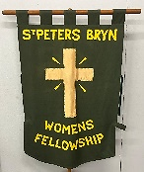

Women’s Fellowship and Knit and Chat
These groups will close for the Christmas holiday on Wednesday 10th December and restart on Wednesday 7th January.

Women’s Fellowship will have a Communion Service on Wednesday 3rd December at 7.30 p.m. to which all are welcome.

To mark the end of this term’s sessions Fellowship and Knitter and Chat are having a Joint Christmas party in Brigade Hall on Wednesday 10th December from 1 p.m. to 3 p.m.

Brigades

On Saturday 6th December our Boys’ and Girls’ Brigades host their annual Over 60s Christmas Dinner and Entertainment, come at 2.30 p.pm for 3 p.m. start. Make sure your name is down.

The afternoon will be followed by the Brigade Christmas Bingo night at 5.50 p.m. so stay on and join in the fun! Books of tickets are £5 (6 pages with 6 games per page). There will be prizes for winners and a raffle (50p per ticket with a hamper for the winner) so plenty of fun to be had.

Trinity Girls’ Brass Band Christmas Concert and Carols
If you don’t qualify for a seat at the Over 60s Christmas Dinner then why not get into the spirit of Christmas and go along to Holy Trinity Church 1 p.m. Saturday 6th December to hear the Trinity Girls’ Brass Band Concert and join in the carols. You’ll need a ticket £7 (going fast). Tel. 07864 917591 or 07712 235259 to get yours.
St. Peter’s School
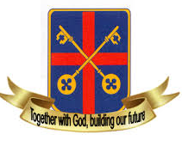
We will be saying a fond farewell to our outgoing Head Teacher Julie Alcock at the end of this term, as she leaves for a well-deserved retirement and, we trust, some long happy days ahead. Governors and staff have prepared well for the changeover so we hope that Julie will be able enjoy her last few weeks with us. We are thankful for all that that she has done for our school over the years.

Be ready to welcome Andrew McConnell our new Head Teacher who will be joining us in January.

The celebrations for the 150th Anniversary of our school have continued this term with tree planting and signing banners to be used by the children to make a video on the field, bringing back happy memories for us, and making new ones for the future.

Local Missional Leader (LML) Ministry – Eth writes:
As I write this we are planning to go to Holy Trinity to support Stuart Ainswoth-Barton as he becomes an LML. I thought you may like to know the process he will have gone thought to get to this stage in his Christian life.
Firstly, and most important, he must have felt that God is calling him to this role. That is often backed up by those around the prospective LML recognising something in them that they may not have recognised themselves.
Then working with the minister, the vicar, they identify an area in church life that the LML can develop. That area must have four components: it must provide the LML with leadership opportunities; there needs to be a missional element; then a worship element; and finally a way that the LML can develop discipleship within the area identified.
Once that has been done the LML needs two references, one from the Vicar and one from someone else who knows them and their Christian life well. The LML needs to write a statement to say how they have arrived at the point they are at, and then they need to go and speak to Sam Stanford who co-ordinates all the LMLs in the diocese.
One of the last things is have an interview with members of the parish and the Vicar and then the PCC needs to agree that the person is OK to become an LML.
So it's a calling and a process. We wish Stuart all the very best as he begins the work he knows God has called him too. Oh, and finally after three years he will have a review, I’ve just done mine!!!
By the time you read this we will all be in the throes of Christmas, thank you all for your love and support this year. Thank you for your encouragement.
Harry and I wish you all a very happy and blessed Christmas,

and all the very best for the New Year.
God Bless,
Eth X

Barry has shared this lovely verse with us. Enjoy! Let’s make sure these gifts are on our list too!

HEAVEN’S GROCERY STORE


I was walking down Life’s Highway a long time ago.
One day I saw a sign that read: ‘Heaven’s Grocery Store’.
As I got a little closer, the door came open wide,
And when I came to myself, I was standing there inside.
I saw a host of ANGELS, they were standing everywhere.
One handed me a basket and said: ‘My child, shop with care.’
Everything a Christian needed was in the grocery store,
And all you couldn’t carry you could come back next day for more.

First I got some PATIENCE, LOVE was in the same row,
Further down was UNDERSTANDING, you need that everywhere you go.
I got a bag or two of WISDOM, a bag or two of FAITH,
And I couldn’t miss the HOLY GHOST for it was all over the place.
I stopped to get some STRENGTH and COURAGE to help me run this race,
By then my basket was full, but then I remembered some GRACE.
I didn’t forget SALVATION for SALVATION is free,
So I tried to get enough of that to save for you and me.

Then I started up to the counter to pay my grocery bill,
For I thought I had everything to do my MASTER’s will.
As I went up the aisle I saw PRAYER, and I just had to put that in,
For I know when I stepped outside, I would run into sin.
PEACE and JOY were plentiful, they were on the last shelf,
SONGS and PRAISE were hanging near so I just helped myself.

Then I said to the angel, “Now how much do I owe?”
He just smiled at me and said, “Just take them all everywhere you go.”
So again I said, “How much do I really owe?”
He smiled and said:
“MY CHILD, JESUS PAID YOUR BILL A LONG, LONG TIME AGO.”

Our Prayers
At the year’s end we pray for Julie as she leaves us for retirement, for Andrew who will be joining us in January, and for the staff, the young people in our school and their families, as they all prepare for change. We pray for our Hub and ourselves as we look to the future to see our part in growing God’s Kingdom. We pray that God will bless our communities with love, joy and peace this Christmas and into the New Year.


December Birthdays
HAPPY BIRTHDAY to:
6th Hannah Hobson, 13th Margaret Smith, 15th Archie Ashall
28th Chloe Sudworth
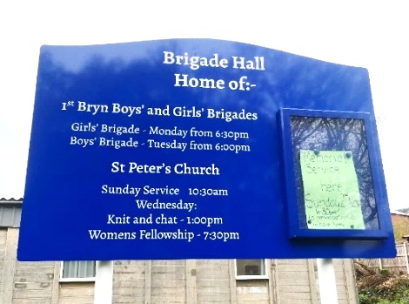
From last month
For those who haven’t spotted it yet, we have a new signboard outside Brigade Hall facing onto Bryn Road.

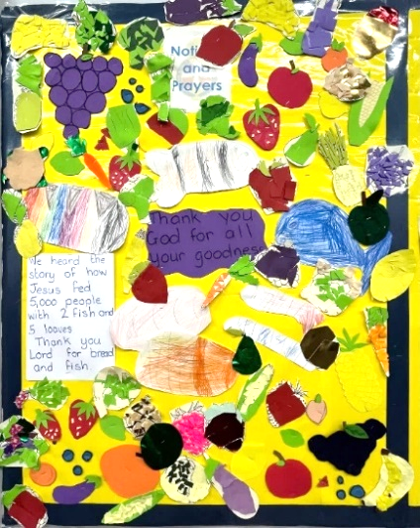

We also have some lovely new artwork from Girls’ Brigade on display in response to the story of the Feeding of the 5000, and thanking God for all His goodness. It’s lovely, thank you girls!

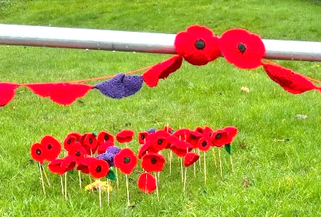
Knit and Chat Knitted these poppies to stand outside the Brigade Hall for Remembrance in November, whilst Brigade created a display at the back of church which featured all the soldiers named on our War memorials.
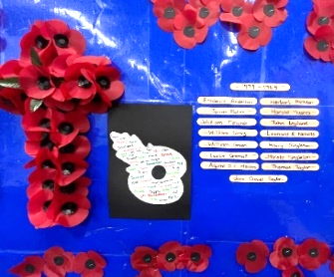
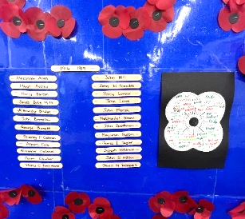

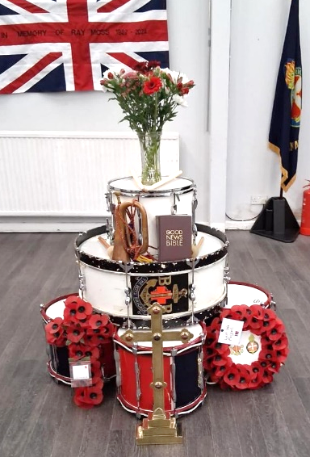

Boys’ Brigade set up a Drumhead Altar at the front of church on Remembrance Sunday. These would have been make-shift altars used in the field for religious services and remembrance during wartime. A fitting symbol for us to use on this occasion. Thanks lads!



HAPPY CHRISTMAS EVERYONE!

