Je m’appelle …………………………….. Les vêtements (clothes) Cover Work
TASK 1 – Match the French (1-14) with the pictures (A-N) by writing the letters in the boxes.
TASK 2 – Colour in the clothing with the correct colours from the description.
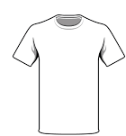
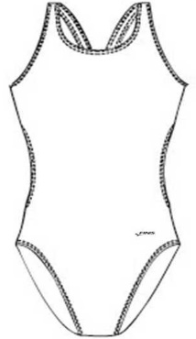
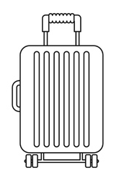
TASK 3 – Write 6+ sentences about what you are going to wear for different activites on holiday, using the near future tense. (eg: Pour jouer au foot, je vais porter un short et un tee-shirt. – To play football, I’m going to wear shorts and a t-shirt.) SILVER = Add colours to your sentences, GOLD = Then do 3 past tense sentences saying activities you did in the past and what you wore – you will need to turn porter (to wear) into the past tense (I wore).
c
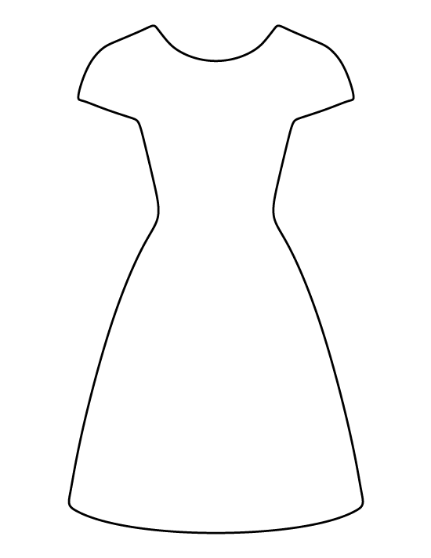
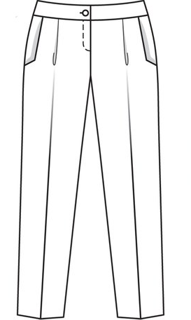
- une chemise blanche
e
b
a
- un tee-shirt rouge
d
- un blouson gris
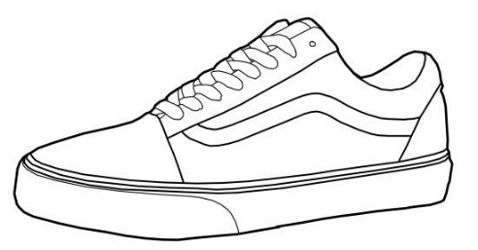
- une jupe bleue
- une robe rouge
h
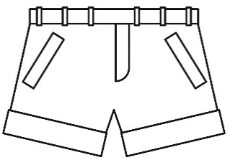
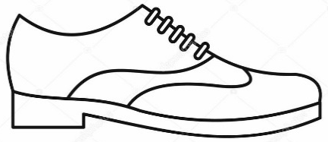
- un pantalon noir
g
f
- un jean bleu
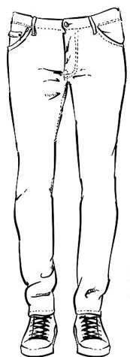
- un short jaune
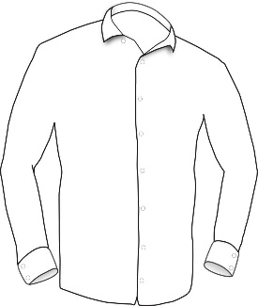
- un sweat vert
j
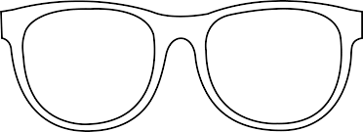
- des chaussures brunes
k
- des baskets bleus
i
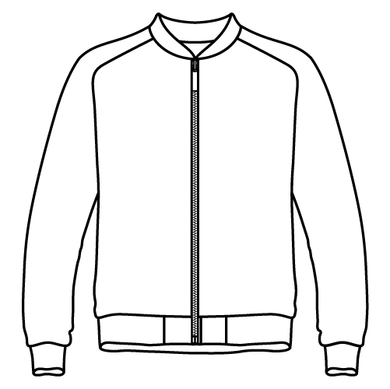
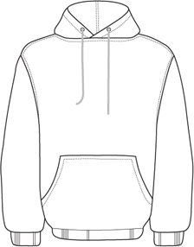
- un maillot de bain jaune
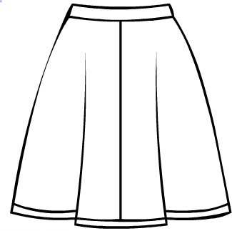
- des lunettes de soleil rose
l
- une valise violette
m
n

