Activity: Identify the type of seed dispersal:

Name | Characteristics | Type of Seed Dispersal
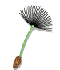Dandelion | Parachute like structures
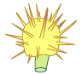thistle | Has hooks to cling to animal fur
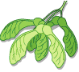 Maple | Fruits have wings to move with wind
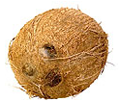Coconut | Has air spaces within
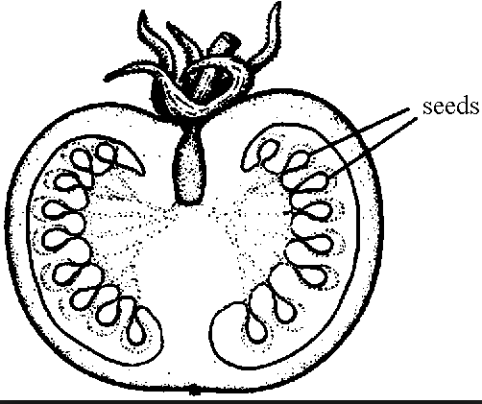 Tomato

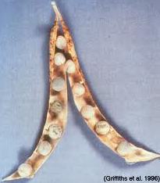 Peas | Pod splits open and seeds are thrown out

