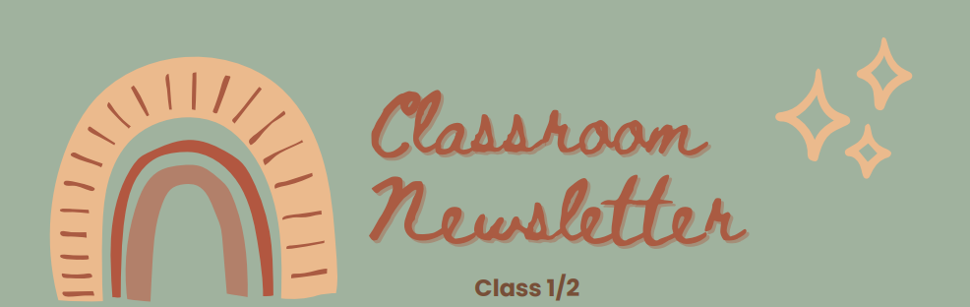
SUMMER 1 CLASSROOM NEWS
ENGLISH
We will be using the book The Three Billy Goat’s Gruff to argue who were the good and bad characters in the story.

MATHS
During the summer term we will be focusing recognising money and starting to look at fractions.

SCIENCE
We will be having an introduction to plants and growing our own bean plant.

History
We will be able learning about explorers. Including, who was the first person to fly a plane and who was the first female to fly a plane.

RELIGIOUS EDUCATION
In RE we will focusing on what it means to belong to a faith community.

Design & Technology
In design and technology, we are learning about nutrition. We will be designing our own fruit kebab and smoothies.

PE
In PE, we will be learning new skills that we can use in athletics.

COMPUTING
We will be creating our own story book using Purple Mash.

Music
Vocal and body sounds.
REMINDERS
- PE days are Mondays and Thursday, PE kits to be in school, this includes a plain white t shirt, plain black shorts and PE pumps.

- Reading books to be brought in to school daily.

- Homework and spellings in school on Thursday.
HOW TO HELP
- Read at least 3 times a week.

- Ask your child questions about their book, talking about the book helps their understanding.

- Practice 2,3, 4, 5,10 timetables.
Class 2

