 |  | Autumn 1 | Autumn 2 | Spring 1 | Spring 2 | Summer 1 | Summer 2
Dialogical Book Talk | 2-week texts | 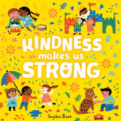  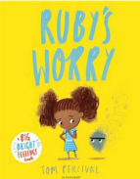  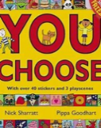 | 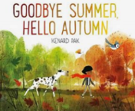  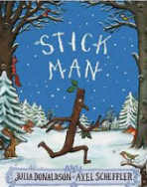  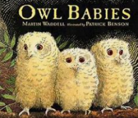 | 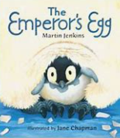  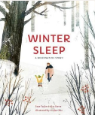  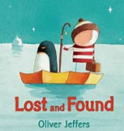 | 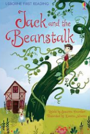  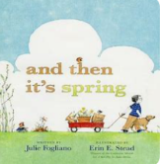  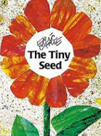 | 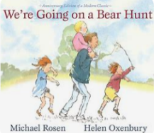  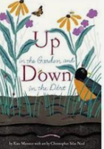  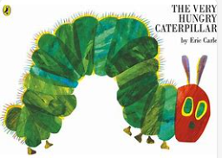 | 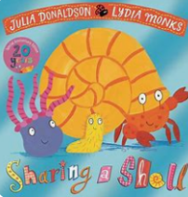  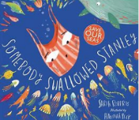  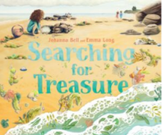
Dialogical Book Talk | 1-week texts | 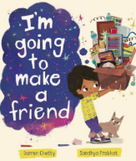  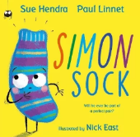 | 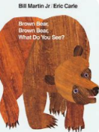  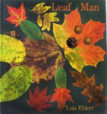 | 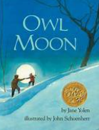  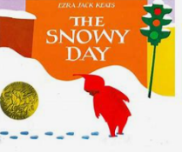 | 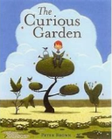  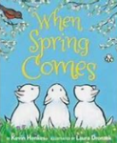 | 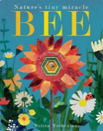  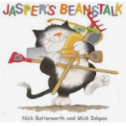 | 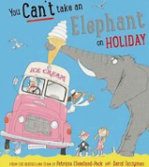  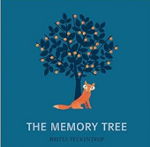
Story Time / Reading for Pleasure | Fiction | 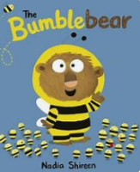  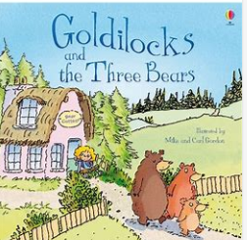    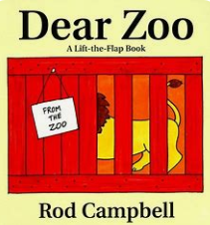 | 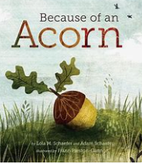  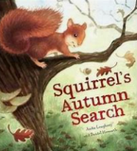  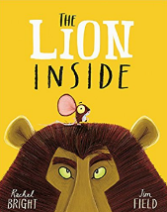  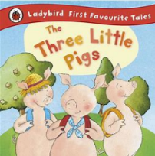 | 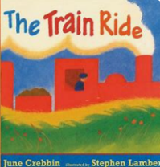  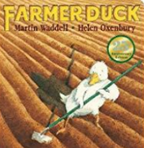  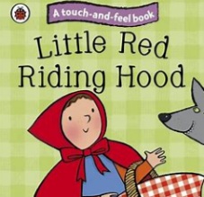  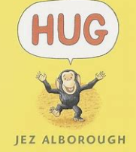 | 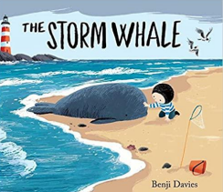  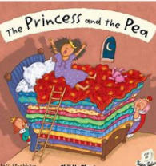  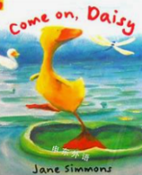  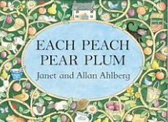 | 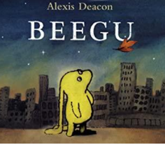  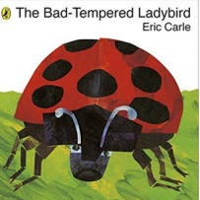  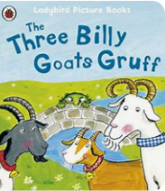  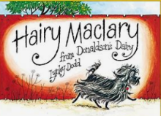 | 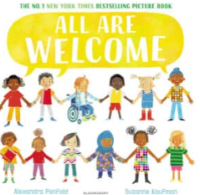  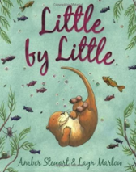  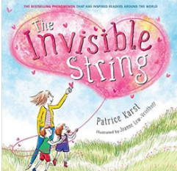  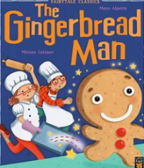
Story Time / Reading for Pleasure | Non- Fiction | 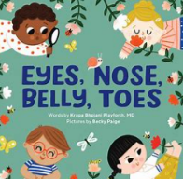  Other non- fiction texts available:  - Environmental print  - Signs around the home  - Local area maps and plans | 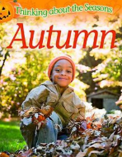  Other non- fiction texts available:  - Autumn festivals  - Autumn is here  - Seasons come, seasons go  - The Stickman Cookbook |   Other non- fiction texts available:  - First Animals  - The coldest place on earth  - Maps/plans and atlases | 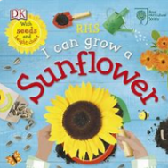  Other non- fiction texts available:  - How flowers grow  - bulb  - Flowers  - Life cycle  - Planting seeds | 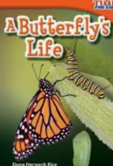  Other non- fiction texts available:  - Snail  - Tadpole and Frog  - Caterpillar to Butterfly  - Minibeast Madness  - What the Ladybird Heard Cookbook | 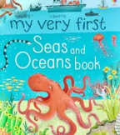  Other non- fiction texts available:  - Making and following instruction  - Postcards  - Maps and atlases
Story Time / Reading for Pleasure | Poetry and Rhyme | - I am special  - Heads, shoulders, knees and toes  - Hokey Cokey  - Makaton parts of the body | - Autumn leaves  - This little autumn leaf  - Autumn winds begin to blow… | - The penguin song  - Five Little Snowmen  - Incy Wincy Freeze  - Sing a song of sixpence. | - Spring is here  - 5 little ducks  - 5 speckled frogs  - Mary Mary  - Lavender blue | - Incy Wincy Spider  - Ladybird, ladybird fly away home…  - Herman the worm  - The Creepy Crawly song  - What the Ladybird Heard song | - Twinkle twinkle little star  - Rain rain go away  - Row row your boat  - Old mother Hubbard
Phonics |  | Strong focus on developing auditory discrimination  - Nursery songs and rhymes  - Nursery Rhyme week  Wellcomm targets focus following baseline |  | Aspect 1-4  Environmental sounds  Instrumental sounds  Body percussion  Rhyme and rhythm  Aspect 4-7  Rhyme and rhythm  Alliteration  Voice sounds  Oral blending and segmentation |  | Aspect 4-7  Rhyme and rhythm  Alliteration  Voice sounds  Oral blending and segmentation  Assessing and establishing readiness for SSP  - Introduce set 1 SS  Embedding Phase 1 with strong focus on  Aspect 7:  Oral blending and segmentation  Read Write Inc Set 1 sounds

