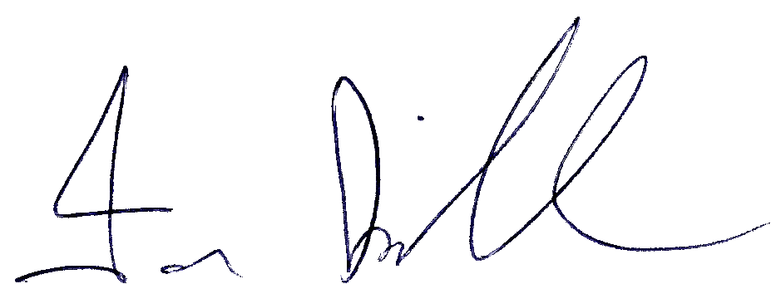

Ian Kirkham 21.10.25



Complaints Policy/Procedure 2025

Author | Cathy Liku
Approved by Governing Body | 20 October 2025
Review Date | September 2026
First Version Date | September 2021
Version | 2
Section 1 – Complaints Procedure
General principles.
At Birchfield Nursery School, we aim to maintain a caring and supportive learning environment where children benefit from the best possible start to their school journey. All staff work hard to continually improve our nursery and build strong positive relationships with parents. However, the school needs procedures in place in case there are complaints by parents or carers.
The following procedure is to help you to raise a concern or complaint relating to the school or the services that it provides.
To enable a proper investigation, concerns or complaints should be brought to the attention of the school as soon as possible. (In general, any matter raised more than 3 months after the event will not be considered).
We need to be clear about the difference between a concern and a complaint. Taking informal concerns seriously at the earliest stage will reduce the numbers that develop into formal complaints.
Aims and Objectives.
As a school we aim to be fair, open and honest when dealing with any complaint. We give careful consideration to all complaints and deal with them as swiftly as possible. We aim to resolve any complaint through dialogue and mutual understanding. We will always put the interests of the child first. We aim to provide sufficient opportunity for any complaint to be fully discussed and then resolved.
Raising a concern or complaint.
- Informal stage.
As part of our open door approach to seeing parents at the beginning and end of nursery sessions we would encourage parents/carers to communicate directly with the member of staff concerned, usually this will be the child’s key carer. It may be more convenient or appropriate to speak to the member of staff at another time when your child is not with you or over the telephone if you are unable to get into nursery. We are happy to arrange a mutually convenient time to talk through your concerns. Most concerns can be resolved by simple clarification or providing information and the majority of concerns will be resolved at this informal stage. All staff work hard to make sure that your child is happy at school, and they want to resolve any concerns that arise so we can make sure your child makes good progress. In the case of serious concerns, it may be appropriate to address them directly to the Head Teacher (or to the Chair of the Governing Body, if the complaint is about the Head teacher).
If you are uncertain about who to contact, please seek advice from the school office or the chair of the Governing Body.

- Formal stage
If your concern or complaint is not resolved at the informal stage you may choose to put the complaint in writing and address it to the Head Teacher, who will be responsible for ensuring that it is investigated appropriately. If the complaint is about the Head Teacher, your complaint should be addressed to the Chair of Governors. This can be done via the school office in an envelope marked for the attention of the Head Teacher /the Chair of Governors.
A complaint form is provided in the appendix 1 to assist you. You should include details which might assist the investigation, such as names of potential witnesses, dates and times of events and copies of relevant documents. It is very important that you include a clear statement of the actions you would like the school to take to resolve your concern. Please pass the completed form, in a sealed envelope to the school office. The envelope should be addressed to the Head Teacher, or to the Chair of Governors as appropriate.
The Head Teacher (or Chair) may invite you to a meeting to clarify your concerns and to explore the possibility of an informal resolution. If you accept that invitation, you may be accompanied by a friend, if you wish, to assist you in explaining the nature of your concerns.
It is possible that your complaint will be resolved through a meeting with the Head Teacher (or Chair). If not, arrangements will be made for the matter to be fully investigated, using the appropriate procedure. In any case you should learn in writing, usually within the 5 days of the school receiving your formal complaint, of how the school intends to proceed. This notification should include an indication of the anticipated timescales.
Any investigation will begin as soon as possible and when it has been concluded you will be informed in writing of its conclusion. If you are not satisfied with the manner in which the process has been followed, you may request that the governing body reviews the process followed by the school in handling the complaint. Any such request must be made in writing to the Chair of the Governing body within 10 school days of receiving notice of the outcome and include a statement specifying any perceived failure to follow the procedure. The procedure below will be followed. A review request form is provided in Appendix 2 for your convenience.
Review process
Any review of the processes followed by the school will be conducted by a panel of 3 members of the governing body. This will usually take place within 10 school days of receipt of your request. The review will normally be conducted through a consideration of written submissions, but reasonable request to make oral representation should be considered sympathetically.
Policy review and monitoring
The Head Teacher retains all complaints received by the school and how they were resolved in the complaint folders. The governors monitor the complaints procedure in order to ensure that all complaints are handled properly.
Governors take into account any local or national decisions that affect the complaints process and make any modifications to this policy. This policy is made available to all parents and carers, at the front of school, in the prospectus and on the website.
Section 2 -Policy for handling Unreasonably Persistent, Harassing or Abusive complainants.
Sometimes parents or carers pursuing complaints or other issues treat staff and others in a way that is unacceptable. Whilst we recognise that some complaints may relate to serious and distressing incidents, we will not accept threatening or harassing behaviour towards any members of the school community.
What is meant by “an unreasonably persistent complainant?
This is anyone who engages in unreasonable behaviour when making a complaint. This will include persons who pursue complaints in an unreasonable manner.
Unreasonable behaviour may include:
Actions which are.
- Out of proportion to the nature of the complaint or
- Persistent – even when the complaints procedure has been exhausted or
- Personally harassing or
- Unjustifiably repetitious
- An insistence on pursuing unjustified complaints and/or
- Unrealistic outcomes to justified complaints
- Pursuing justifiable complaints in an unreasonable manner (e.g. using abusive or threatening language) or
- Making complaints in public or via social networking site such as Facebook or
- Refusing to attend appointments to discuss the complaint.
What is harassment?
We regard this as the unreasonable pursuit of issues or complaints, particularly if the matter appears to be pursued in a way intended to cause personal distress rather than to seek a resolution.
Behaviour may fall within the scope of this policy if:
It appears to be deliberately targeted at one or more members of school staff or others, without good cause.
The way in which a complaint or other issues is pursued (as opposed to the complaint itself) causes undue distress to school staff or others.
It has a significant and disproportionate adverse effect on the school community.
The school expects anyone who wishes to raise concerns with the school to:
- Treat all members of the school community with courtesy and respect.
- Respect the needs of pupils and staff within the school.
- Avoid the use of violence, or threats of violence, towards people or property.
- And allow the school a reasonable time to respond to a complaint.
- Follow the school’s complaint procedure.
In cases of unreasonably persistent complaints or harassment the school may take some or all of the following steps as appropriate
- Inform the complainant informally that his/her behaviour is now considered by the school to be unreasonable or unacceptable and request a changed approach.
- Inform the complainant in writing that the school considers his/her behaviour to fall under the terms of the Unreasonably persistent complaints/Harassment Policy
- Require all future meetings with a member of staff to be conducted with a second person present. In the interests of all parties, notes of these meetings may be taken.
The governing body will not tolerate any form of physical or verbal aggression against members of the school community. If there is evidence of any such aggression the school may:
- Ban the individual from entering the school site, with immediate effect.
- Prosecute under Anti-Harassment legislation.
- Call the police to remove the individual from the premises, under powers provided by the Education Act 1996.
Legitimate new complaints will always be considered, even if the person making them is (or has been) subject to the Unreasonably Persistent Complaints/Harassment Policy. The subject nevertheless reserves the right not to respond to communications from individuals subject to the policy.
Birchfield Nursery School
Outline of Complaint procedure
Informal stage | Talk to your child’s key carer or a member of the senior leadership team, Mrs Liku about your concerns
Formal Complaint
Stage 1  Appendix 1 form | Complaint can be put in writing to the Head Teacher (using template provided in appendix 1) via the school office.  The Head teacher will contact the parent/carer within 5 school days of receiving the formal complaint stating how the school intends to proceed and anticipated timescales. (meeting/investigation)
Stage 2  Appendix 2 form | Complaint can be put in writing to the Chair of Governors via the school office using the template provided in Appendix 2 requesting a review of the process followed by the school in handling the complaint.  Complaint heard by the Governing Body’s complaint panel within 10 days of receiving the request.

Birchfield Nursery School
Complaints policy
Appendix 1- Formal Complaint Form
(Address to Head Teacher, or Chair of Governors if about the Head Teacher via the school office)
Your name:
Relationship with the school (e.g. Parent of a pupil)
Pupil’s name (if relevant to the matter to be discussed)
Your address:
Telephone numbers:
Please give concise details of your complaint (including dates, names of witnesses etc) to allow the matter to be fully investigated:

You may continue on a separate paper, or attach additional documents if you wish

What action, if any have you already taken to resolve your complaint?
(Who have you spoken with or written to and what was the outcome?)

What actions do you feel might resolve the problem at this stage?

Signed …………………………………………………………………………………………………………………………………………………
Date…………………………………………………………………………………………………………………………………………………….
School use:

Date form received:

Received by:

Date acknowledgement sent:

Acknowledgement sent by:

Complaint referred to.

Date;

Birchfield Nursery School
Complaints policy
Appendix 2- Complaint Review Request Form
(Address to Chair of Governors via the school office)
Your name:
Relationship with the school (e.g. Parent of a pupil)
Pupil’s name (if relevant to the matter to be discussed)
Your address:

Telephone numbers:
Dear Sir/Madam,
I submitted a formal complaint to the school on ………………………………………………………….. and I am dissatisfied by the procedure that has been followed. My complaint was submitted to ……………………………………………………………… and I received a response from ………………………………………………. on………………………………………………….

I have attached copies of my formal complaint and of the response(s) from the school.

I am dissatisfied with the way in which the procedure was carried out because;

You may continue on separate paper or attach additional documents if you wish.
What actions do you feel might resolve the problem at this stage?

Signed………………………………………………………………………………………………………………………
Date…………………………………………………………………………………………………………………………
School Use:
Date Form received:

Received by:

Date acknowledgement sent:

Acknowledgement sent by:

Complaint referred to:

Date:

Version Control and Change History
Version Control | Review Date | Amendment
1 | September 2021 | Document created.
2 | September 2025 | Cover sheet added.  Formatting and grammar updates.

