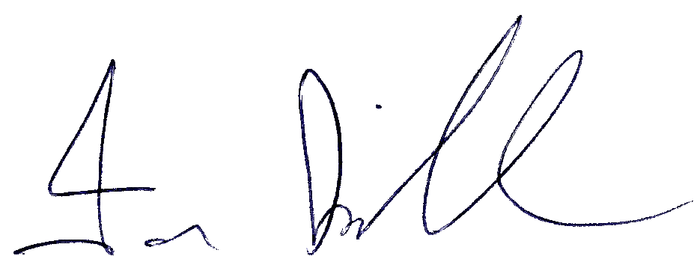

Ian Kirkham 21.10.25

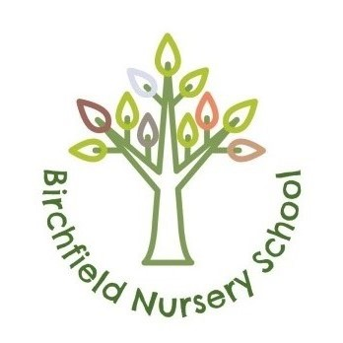

Charging Policy 2025

Author | Cathy Liku
Approved by Governing Body | 20 October 2025
Review Date | September 2026
First Version Date | September 2022
Version | 2

CONTEXT
The 1988 Education Reform Act requires that all schools should have a “charging policy” which is published and given to all parents / carers.

Funded Sessions
The Act states that education must be free from charge if it takes place in school sessions.
These are the “funded” places which we offer to all three- and four-year-olds, from the term after their 3rd birthday. Each eligible child is entitled to 15 hours of free Nursery education per week. From September 2017, this also incorporates 30 hours funded sessions for working families. Families have a choice of sessions of 15 or 30 hours between the hours of 9.00am-12.00pm and 12.45pm-3.45pm.

The Government has outlined the following:

Government funding is intended to deliver 15 or 30 hours a week of free, high quality, flexible childcare. It is not intended to cover the costs of meals, other consumables, additional hours or additional services.

As a nursery we keep costs to parents to a minimum but do require contributions to meet the rising costs. These are outlined clearly on the charges template below and are covered by the weekly payment relating to your child’s hours of attendance.

30 Hours Eligibility and Funding
It is the responsibility of parents to ensure that eligibility codes are current and up to date. Parents are directed to the government childcare funding website https://www.gov.uk/apply-free-childcare-if-youre-working at the earliest opportunity and informed of this responsibility. Where funding has not been accessed, parents can pay for the additional hours until the next funding deadline.

Paid-for Regular Sessions
Families can pay for regular sessions for their child (we do require a minimum of 2 sessions a week to help their child settle). The additional sessions can be accessed over and above their child’s 15 hours of funding if we have places available or they can be accessed from the day after a child’s 3rd birthday (subject to availability).

- Sessions must be paid for in full at the start of each week
- Please note that there will be no refunds for sessions or parts of sessions missed due to illness.

Meals
Children who attend over the lunch hour need to bring a packed lunch.

Breakfast Club/After-School Club
A maximum of 13 spaces are available for breakfast club (8.00am-9.00am) and 8 after-school club (3.45pm-4.30pm). These places are priced at £5.00 per child per session.

Breakfast club will include a selection of appropriate food and drink choices. After-school club will include a warm snack and drinks. These extended school places must be booked 2 weeks in advance and are payable at the time of booking. Payment is non-refundable.

Chargeable Extras

Description | Unit | Unit price | Line total
Free entitlement hours - 30 hours per week | Weekly | Free | Free
Free entitlement hours - 15 hours per week | Weekly | Free | Free
Additional hours - sessional 9.00am-12.00pm | Daily | £15.00 | Dependent on hours accessed
Additional hours - sessional 12.45pm-3.45pm | Daily | £15.00 | Dependent on hours accessed
Additional hours - lunch provision 12.00pm-12.45pm | Daily | £5.25 | £5.25
Additional hours - lunch provision 12.00pm-12.45pm | Weekly | £26.25 | £26.25
Snack (15/30 hours)  Access to snack including fresh fruit daily | Weekly |  | £2.50
Additional voluntary services (15/30 hours)  Dance session (Creative/Physical Development)  P.E lesson (Physical Development/PSED) | Weekly  Weekly |  | £2.00  £2.00
Consumables (30 hours only)  Sun cream/baking goods/trips/additional visitors | Weekly |  | £1.00
 |  | Total
 |  | 30 hours | £33.75
 |  | With tax free childcare | £27.00
 |  | 15 hours | £6.50
 |  | With tax free childcare | £5.20

Tax-Free Childcare Account
We urge all parents to register for a childcare account which entitles families to a rebate on any childcare related costs. This reduces costs to the family by 20%. More information can be found at https://www.gov.uk/tax-free-childcare

Special Circumstances
Where a family consider the payments unfair or beyond financial capability, we ask that you please contact the Headteacher at the earliest opportunity to discuss your situation.

This policy will be reviewed at least annually or as changes to funding occur that necessitate earlier review.

Version Control and Change History
Version Control | Review Date | Amendment
1 | September 2022 | Document created.
2 | September 2025 | Cover sheet added.  Charges updated and table added.  Formatting updated.

