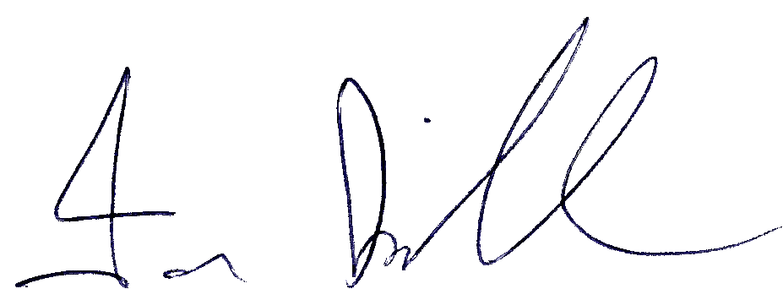
Ian Kirkham 21.10.25



Attendance Policy 2025

Author | Cathy Liku
Approved by Governing Body | 20 October 2025
Review Date | September 2026
First Version Date | September 2024
Version | 2

BACKGROUND
At Birchfield Nursery School we believe good attendance is essential if children are to be settled and take full advantage of the learning and development opportunities available to them. At a young age continuity and consistency are important contributors to a child's well-being and progress. Also we believe regular attendance at nursery can set good practice for statutory school.

EXPECTATIONS
When taking a place in Birchfield Nursery-
We expect that all children will-
- attend nursery from the allocated start date
- attend nursery punctually
- Attend nursery appropriately prepared for the day.

We expect all parents and carers to-
- encourage regular nursery attendance
- ensure that their child arrives punctually and prepared
- ensure nursery is contacted when the child is not attending
- contact the nursery on the first day of absence
- contact the nursery regarding any issue that may keep their child off school

SUPPORTING ATTENDANCE
Birchfield Nursery encourages regular attendances in the following ways-
- by providing a caring and welcoming learning environment
- by responding promptly to a child’s or parent’s concern about the school or other children
- by celebrating good and improved attendances
- by monitoring all attendances, informing and arranging meetings with the family, and if necessary, liaising with outside agencies.

LEAVE OF ABSENCE
As the nursery year is not a statutory year in education it will only be in rare occasions that requests for leave will be declined. Notification requests can be made using the School Spider App and details will be entered into the register. Unexplained absences (i.e. without notification) will be marked as unauthorised.

RESPONDING TO NON-ATTENDANCE
The school register opens at 9am and closes at 9.15am. If a child is not attending, the parent should contact the school as soon as possible.
Parents will be contacted on the first day of absence and no more than 24 hours after being absent from school.
Frequent unexplained and sustained unexplained absences will lead to the head teacher/office staff to telephone the home. This will be followed up by a formal letter. Should the absences continue, the head teacher will then liaise with the family and any other relevant agencies to support the family in improving attendance.

If attendance still continues to be unacceptably poor, without an adequate explanation and every reasonable step has been taken to ensure attendance by the school, then the head teacher will refer the matter to the School Governors.

CHANGING SCHOOLS
It is important that if a family decide to move or change schools, that the head teacher/office staff are informed in writing of the following details-
- The date the child will be leaving and starting the new school
- The address of the new school
- The new home address, if known
- Should a child be withdrawn from nursery and not attending another nursery, the Health Visitor will be informed

Version Control and Change History

Version | Review Date | Amendment
1 | September 2024 | Document created.
2 | September 2026 | Cover Sheet added.  Leave of absence – no longer use notification paper forms. Absences are recorded on School Spider app.  Office manager has been changed to office staff.

