Science Project
After half term, our first ‘mini project’ is a Science unit about the Human Skeleton. The children will learn the importance of the human skeleton as well as the roles of muscles and joints and how they help us.
To create some excitement for our new unit, we would like your child to carry out a home learning project.
- With your grown up, carry out some research about the human skeleton. You could use websites such as BBC Bitesize.
Examples of questions to search:
- Why do we have a skeleton?
- How many bones does an adult have?
- What are the longest bones in the body?
- What are the smallest bones in the body?

- Have a go at creating a human skeleton. You can do this in lots of ways. You could use arts and crafts materials e.g cotton buds, straws or pasta or you could have a go at drawing/painting a skeleton. Remember to include lots of important bones.
- Add some exciting facts around your skeleton design to show off your learning!
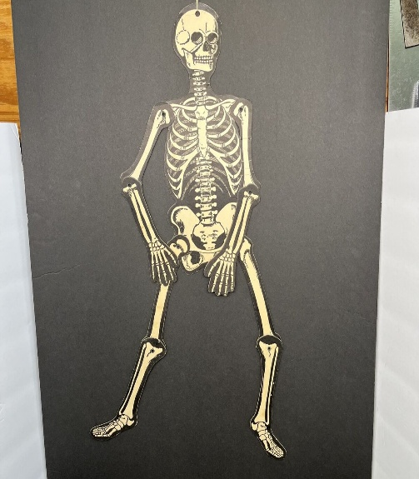
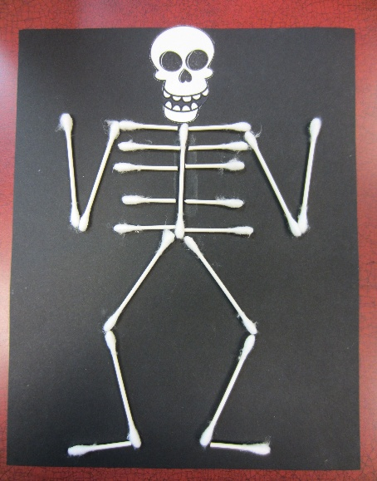
Here are some examples of how to do the craft:
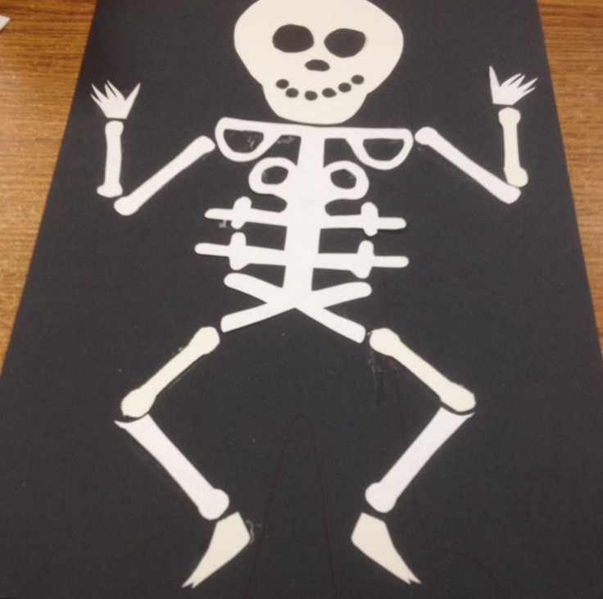
We would love to display your projects in the classroom.
Please make sure your creations are brought to school by Thursday 6th November.

Thank you for your continued support,
The Year 3 team.

