The Harmony Model Curriculum
EYFS INSPIRE Overview
Nursery | Autumn 1 | Autumn 2 | Spring 1 | Spring 2 | Summer 1 | Summer 2
Nursery | Nursery Rhymes   | Food  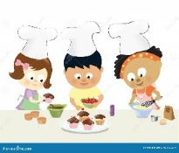 | People who help us  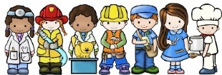 | Traditional tales  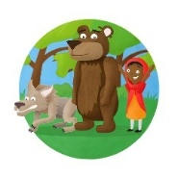 | Minibeasts  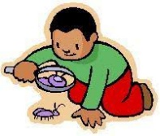 | Journeys &  Transport  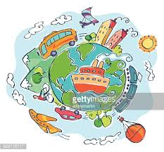
Reception | I am Special, I am ME!   | Night and day  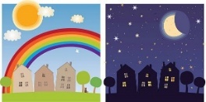 | Modern Tales –  Julia Donaldson  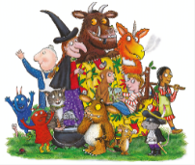 | Modern Tales – Traditional Tales with a Twist  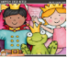 | In the Garden  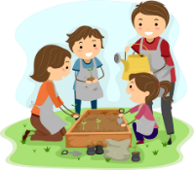 | The Farm  