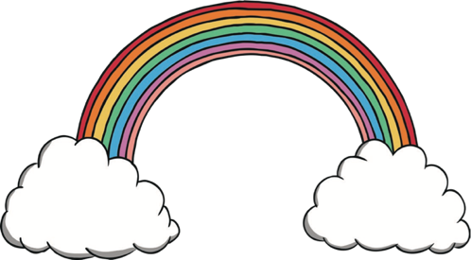
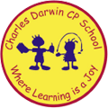

21/11/2022
Song of the week:

‘You Got a Friend in Me’ – Toy Story
https://www.youtube.com/watch?v=cNIg45GZ_ts

Theme of the week:
‘Friendship’

Quote of the week:

‘Good friends are like stars.
You don’t always see them but you know they’re always there.’

Wellbeing Wednesday:
Continue with theme and repeat song.
Input
Discuss what makes a good friend, what we want to look for in a friend and how we can be good friends.

Activity
Choose which activities will be best for your class:
- Friendship recipe
- Friend scavenger hunt
- Team building activities

Mindful Monday:

Listen to song, introduce the theme and quote.
Catch up with the children.

Friendship PowerPoint. (See attached)

Fab Friday:
Repeat song
- Discuss when the children have been good friends this week.
- Discuss who has been a good friend to the children this week.

Mindful colouring (See attached colouring sheets).

