
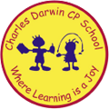

31/10/2022
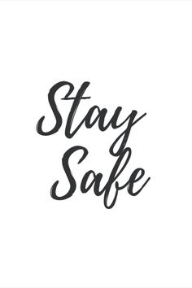
Song of the week:

‘Firework’ – Katy Perry
https://www.youtube.com/watch?v=KSbwHzlcgs8

Theme of the week:

‘Be Safe’

Quote of the week:

‘Stay Safe’

Mindful Monday:

On Tuesday:
Listen to song
Catch up with the children about half term.

Wellbeing Wednesday:

Continue with theme and repeat song.

EYFS/ KS1
Follow link for fireman Sam safety brief
https://www.youtube.com/watch?v=JTqb8JLgiew
KS2 Activity
Follow link for Twinkl firework safety brief
https://www.youtube.com/watch?v=Q-fizT5O4ik

Fab Friday:
Repeat song and invite class to dance along, remind of firework safety
- Discuss bonfire night and how exciting it is but the importance of being safe
- Remind to only attending safe bonfires and follow adults instructions with where to stand and if handling sparklers.
- Explain the difference between safe and unsafe firework displays



Be Safe around fireworks

