
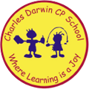

17/10/2022

Song of the week:

Count on me- Bruno Mars

https://www.youtube.com/watch?v=HSK2tDTSkWw

Theme of the week:

‘Kindness’

Quote of the week:

‘In a world where you can be anything, be kind.’

Mindful Monday:
Listen to the song.
- Try to listen to the song daily
- Discuss which emotions the song provokes

Introduce ‘Kindness’ poem.
- Explore the emotion poem.
- Discuss what kindness means.

- Remind the children to be kind to themselves and others.

Wellbeing Wednesday:

Input
- Discuss the importance of being kind to yourself and others.
- Discuss what kind things children have done for themselves, for others or someone has done for them.

Activity
- Fill a cup with kindness activity (see attached).
- There is also a kindness checklist activity, which could be used as inspiration.

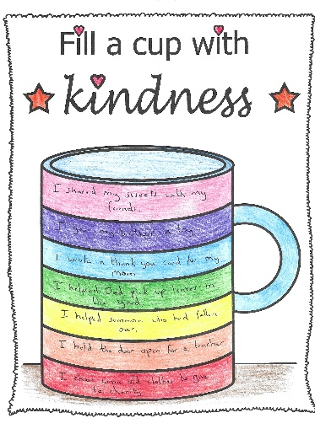

Fab Friday:
Mindful colouring
- Discuss any emotional barriers that children may have faced this week.
- Discuss how we overcame the barriers and how we became more resilient.
- Ask children to give examples of positive experiences that have happened this week or throughout the half term. Positive reflections on the half term.



