
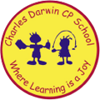

10/10/2022
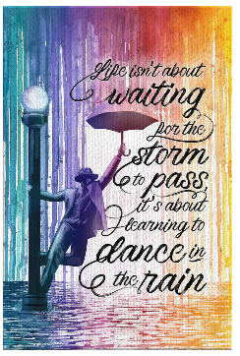
Song of the week:

‘Here comes the sun- The Beatles

https://www.youtube.com/watch?v=fKLV8GCrveQ

Theme of the week:

‘Tranquillity’ – Hello Yellow Day

Quote of the week:
‘Life isn’t about waiting for the
storm to pass, it’s about learning
to dance in the rain.’

Mindful Monday:
Listen to the song.

- Try to listen to the song daily
- Discuss which emotions the song provokes

Hello Yellow Day
- Children to wear yellow/ bright colours
- Discuss what hello yellow day is
- We will take a sunshine photo in the hall

Activity
- Hello Yellow Day challenge: for each challenge, the children get 2hps. This can be redeemed once then they can do good deeds and feel good about that!
- Challenge the children to do something nice for themselves this week. This could be the Wellbeing Bingo. This could be taken home to try at home.

Wellbeing Wednesday:
Introduce ‘Tranquillity’ poem.
- Explore the emotion poem.
- Discuss what tranquillity means.
- Talk about how we also need to look after our minds as well as our bodies
- Encourage class to think of what calms them.
Activity
- Mindful Colouring with calming music

Fab Friday:
- Discuss any emotional barriers that children may have faced this week.
- Discuss how we overcame the barriers and how we became more resilient.
- Ask children to give examples of positive experiences that have happened this week or things they have done for themselves.

