
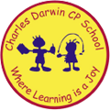

03/10/2022
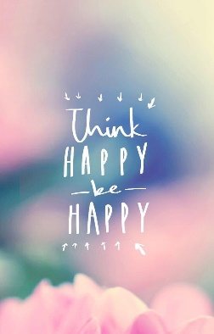
Song of the week:
‘Happy’ – Pharrell Williams
https://www.youtube.com/watch?v=7E5_TpWgXf8

‘I’m Walking on Sunshine’ – Katrina and the Waves

Katrina And The Waves - Walking On Sunshine (Lyrics) - YouTube

Theme of the week:

‘Happiness’

Quote of the week:

‘Think Happy, Be Happy’

Mindful Monday:
Listen to song and introduce ‘Happiness’ poem.
- Discuss which emotions the song provokes
- Explore the emotion poem and how happiness effects us and what things make us happy

Wellbeing Wednesday:
Continue with poem and repeat song.

- Share as a group things that make us happy.
- Discuss how happiness comes from lots of different things, exercise, hobbies or seeing other people happy.

KS1 & KS2 Activity

- Hand out post it notes or paper and ask children to make notes of 3 things in school that make them happy and 3 things outside of school.

- Share as a whole class or in small groups

Fab Friday:

Repeat song and invite class to dance along



