
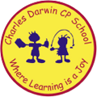

12/09/2022
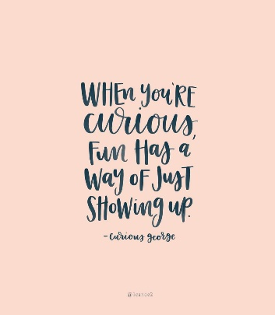
Song of the week:
‘Upside down’- Jack Johnson
https://www.youtube.com/watch?v=dqUdI4AIDF0

‘U
Theme of the week:

‘Curiosity’

Quote of the week:
‘When you’re curious, fun has a
way of just showing up’

Wellbeing Wednesday:
Continue with An Emotional Menagerie’ book and repeat song.

EYFS/ KS1 / KS2 Activity
Follow the link below for a short film about curiosity and resilience leading to wonderful things.
https://www.youtube.com/watch?v=eDkpVwrhYfo

Mindful Monday:
Introduce song

- Discuss the meaning of the word ‘Curious’
- Read the ‘curious’ poem from the ‘Emotional Menagerie’.

Fab Friday:

Continue with An Emotional Menagerie’ book and repeat song.

KS2 Activity
Ask class to name certain topics or questions in which they are curious about. As a class search these questions to find the answers.



