
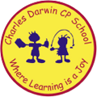

10/07/2023
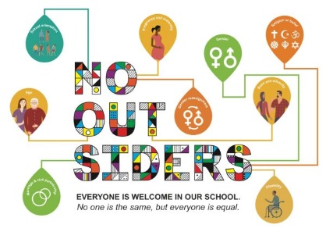
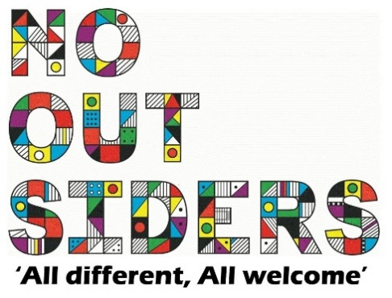
Song of the week: https://www.youtube.com/watch?v=Rr1AdioVsaw
Harry Styles- Treat People with Kindness

https://www.youtube.com/watch?v=DykVJl6wr_4
We’re all in this together- HSM

Theme of the week:

‘Togetherness’
Quote of the week:

Everyone is welcome in our school.
No one is the same,
but everyone is equal.

Wellbeing Wednesday:

Discuss how there are two weeks left as a class. Also how we all are unique but together are a masterpiece, if we work together.

Read one or more of your No Outsider’s books to your class during your end of the day read and discuss.

Mindful Monday:
.

Welcome class in with song, greet children at door using greeting options if possible.

Discuss what the quote means at an age-appropriate level for your class. Explain why there are no outsiders in our school and the importance of this. (PowerPoint attached if wanted)

Fab Friday:

Enjoy songs and have a fantastic weekend!

There is also the opportunity to do something mindful with your class, e.g. meditation or mindful colouring (see attached).

