
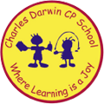

26/06/2023
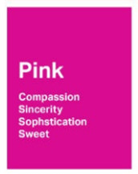
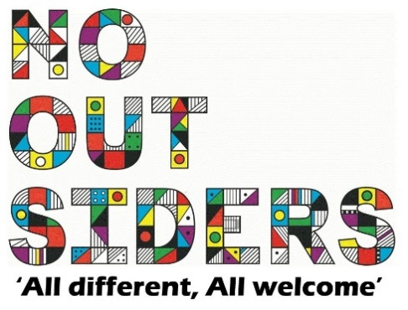
Song of the week:
Roar- one voice children’s choir

https://www.youtube.com/watch?v=GGE40abHFHw

Theme of the week:

‘I feel Purple…’
Quote of the week:
Purple
Loyalty
Spirituality
Ambition

Wellbeing Wednesday:

Whole School
Try and spend around 15 mins outside reading.
Children to lay down on the grass eyes closed and teacher to read class book to children.
This could also be done as quiet reading time after lunch.

Wellbeing Wednesday:

Positivity mirrors attached, draw self portrait, cut and stick words from the map that reflect what is on the inside.
Mindful Monday:
.

Welcome class in with song, greet children at door using greeting options if possible.

This weeks theme is pride and ambition.

Fab Friday:

Enjoy song and have a fantastic weekend!

PURPLE

Spirituality
Loyalty
Ambition
Power

