
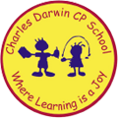

12/06/2023
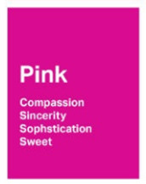
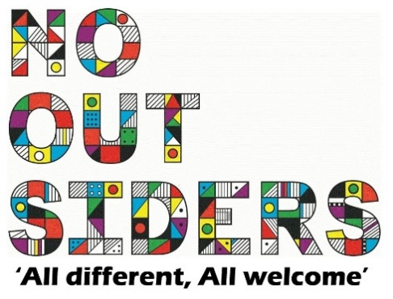
Song of the week:

Dance Monkey- Tones and I

https://www.youtube.com/watch?v=1__CAdTJ5JU

Theme of the week:

‘I feel Pink…’
Quote of the week:
PINK
Compassion
Sincerity
Sweet

Wellbeing Wednesday:

Whole School
Try and spend around 15 mins outside reading.
Children to lay down on the grass eyes closed and teacher to read class book to children.
This could also be done as quiet reading time after lunch.

Wellbeing Wednesday:

Pet Challenge
Create a pet rock, choose a stone from outside, decorate and name. Keep it safe all week.
(can also be done with boiled eggs if you would like to make the challenge harder)

Mindful Monday:
.

Welcome class in with song, greet children at door using greeting options if possible.

This weeks theme is compassion, showing compassion and how to care for things.

Fab Friday:

Enjoy song and have a fantastic weekend!

PINK

Sweet
Sincerity
Compassion
Sophistication
Bright

