
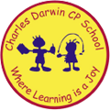

22/05/2023
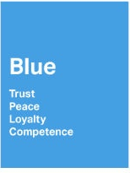
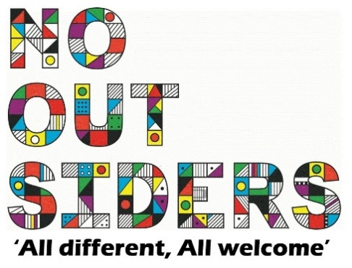
Song of the week:

Livin on a prayer- Bon Jovi
https://www.youtube.com/watch?v=ohFtQIPqGSo

Theme of the week:

‘I feel Blue…’
Quote of the week:
BLUE
Trust
Loyalty
Peace

Wellbeing Wednesday:

EYFS/KS1
Create posters to encourage your house point team on sports day

KS2
As a class play the count to 20 game. Only one person can say one number at a time, see how far you can get with 20 being the goal.
This is to encourage working as a team and celebrating each other’s success and taking failure as a team too.

Mindful Monday:
.

Welcome class in with song, greet children at door using greeting options if possible.

We are focusing on building confidence and sportsmanship in preparation for Thursdays sports day

Fab Friday:

Enjoy song and have a fantastic half term!

BLUE

Trust
Peace
Loyalty
Support

