
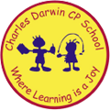

01/05/2023
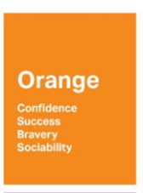
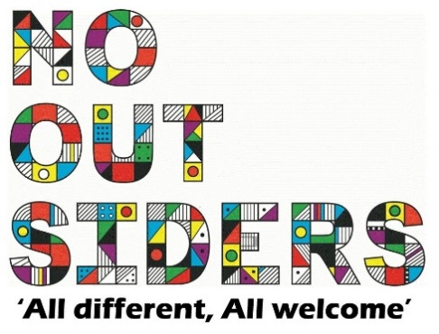
Song of the week:

Sia- Unstoppable
https://www.youtube.com/watch?v=cPZ9v8vBtRQ

Theme of the week:

‘I feel Orange…’
Quote of the week:
Orange,
Confidence,
Success,
Bravery

Wellbeing Wednesday:

EYFS/KS1
BSL greetings.
Use document attached, practice as whole class or in groups.

Upper KS1 and all of KS2
Emotions Bingo
Use the attached list of words, give children scrap paper to choose 6 of the words. Play bingo, first to have all 6 wins.

Mindful Monday:
.

Welcome class in with song, greet children at door using greeting options if possible.
Revisit previous week BSL emotion cards.

Fab Friday:

Enjoy song and have a fantastic weekend!

ORANGE

Confidence
Success
Bravery
Sociability

