
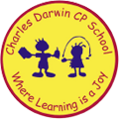

24/04/2023
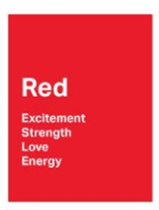
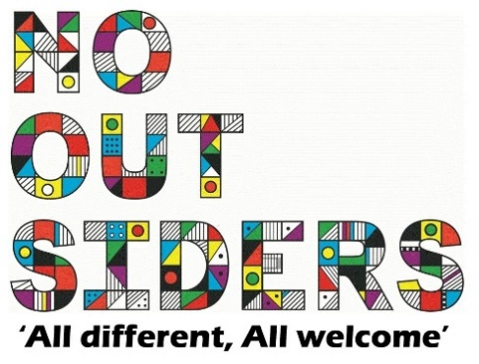
Song of the week:

Taylor Swift- Shake it off
https://www.youtube.com/watch?v=8xG7mH8i-WE

Theme of the week:

‘I feel Red…’
Quote of the week:

‘Red,
Excitement
Strength
Love, energy’

Wellbeing Wednesday:

Whole school activity-

See the sign language cards attached-
This can be done as an entire class or work in pairs.
Try and memorize the BSL for each emotion.
Mindful Monday:
.

Welcome class in with song, greet children at door using greeting options if possible.

Fab Friday:

Enjoy song and have a fantastic weekend!

RED

Excitement
Strength
Love
Energy

