
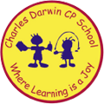

27/03/2023
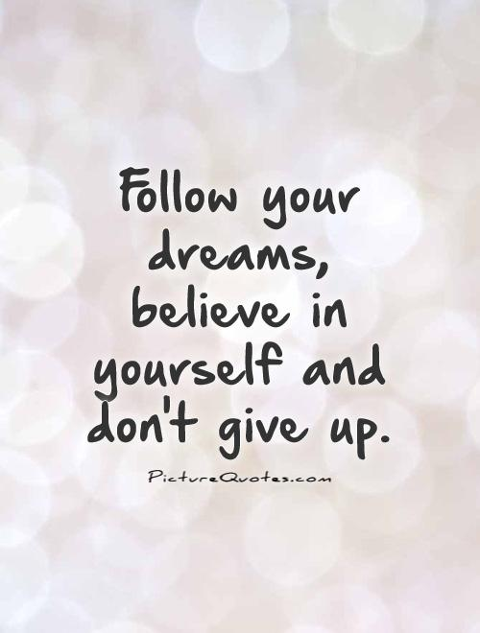
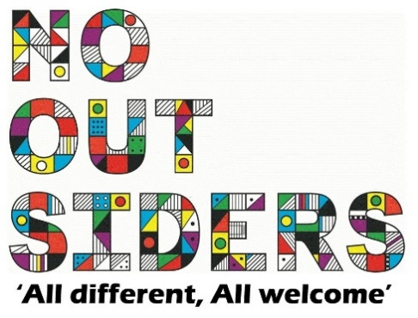
Song of the week:

Don’t’ stop believing- Glee
Don't stop believing Glee • lyrics •

Theme of the week:

‘I Believe’

Quote of the week:

‘’Follow your dreams,
Believe in yourself and don’t
Give up’’

Wellbeing Wednesday:

EYFS/KS1
Powerpoint attached

KS2
Write a letter to yourself, telling yourself your favourite things about you.
You do not have to share this letter with anybody unless you want to.
Mindful Monday:
.
EYFS/KS1- Introduce song and theme
KS2 Powerpoint attached.

Fab Friday:

Enjoy song

