


20/03/2023
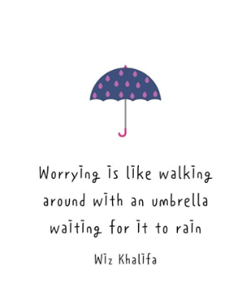

Song of the week:

‘Don’t Worry Be Happy’ by Bobby McFerrin Bobby McFerrin - Don't Worry Be Happy (Lyrics)

Theme of the week:

‘worries’

Quote of the week:
‘’Worrying is like walking around
With an umbrella waiting
For it to rain’’

Wellbeing Wednesday:

Whole School Book- ‘There’s a bully inside my brain’
Book can be found on youtube, ‘there’s a bully inside my brain’, to be played to class.
Open to questions at the end.

Class worry jar/box
Have a box/jar in classroom with postit notes and pens, children can put worries on paper and put them in the jar- a problem shared is a problem halved.

Mindful Monday:
.
Introduce song and theme to class.

Fab Friday:

Enjoy song,
If class want to share worries they added to the jar then discuss how we can work past those worries.

