
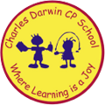

13/03/2023
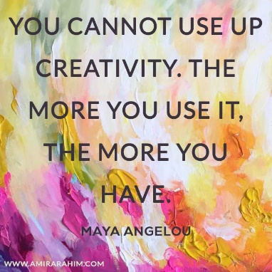
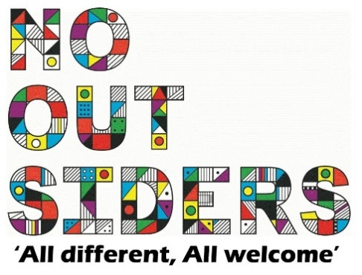
Song of the week:

Imagine Dragons - On Top Of The World
https://www.youtube.com/watch?v=g--BAaaRKLA

Theme of the week:

‘Creativity’

Quote of the week:
‘You cannot use up creativity.
The more you use it, the more
you have’

Wellbeing Wednesday:

Repeat song.

See attached activity EYFS/ KS1 document

KS2 Acitvity

DARWIN’S DRAGON DEN
See attached document,
Work in teams or individually to create something new, can be an invention to help you with life for example- a back pack that turns into a car.
Draw invention and describe how you are going to make it.
Invite to pitch to rest of class.

Mindful Monday:
.
Introduce song and theme to class.

Fab Friday:

Repeat song and invite class to dance along

