
Our focus this half term
In Reception we plan our projects according to the children’s interests. Projects can last as long or as short as the children’s interests develop. Our project for the first half term is ‘Ready, Steady, Grow; Can we do it as a team?’

We are starting the Autumn term by settling in and getting to know each other, making friends, introducing classroom rules and routines.

Then we will move onto a project about growing, where we will be finding out about how the children have grown. See separate letter for more information about this.

Focus Books
Starting School
Meesha Makes Friends
Do you Remember?
The Growing Story
As We Grow
Once There Were Giants
The Growing Story
Peepo

Welcome
We are so excited to start a fun-filled Reception year with the children.

Here is a brief overview of what is in store this half term……….
Class Newsletter
Reception
Autumn 1 2025
Essentials to bring every day
Reading folder
A coat
Water bottle
Snack

Reception Staff
Class Teachers
Mrs Power & Mrs Devenport
Class Teaching Assistants
Miss Sanderson and Miss Levine

School information
Doors open at 8.40am.

Home time is 3.15pm.

PE kits stay in school all half term

PE is on Wednesday.

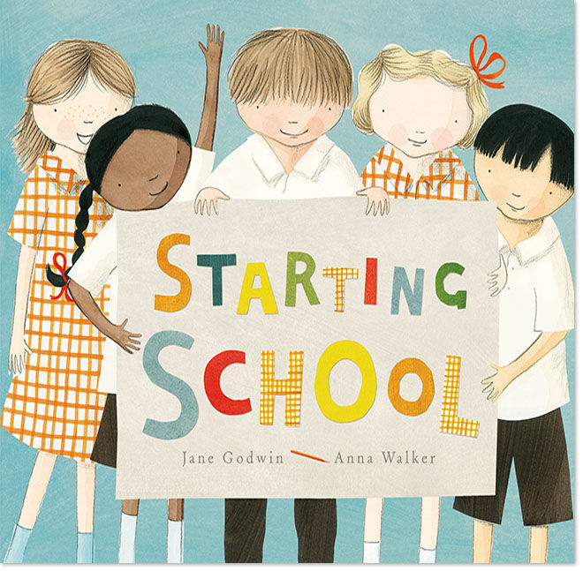
Writing
Our scheme for writing is called ‘Pathways to write’.

We will be basing a lot of our writing around the book ‘The Gingerbread Man’.

We will be using the phonics we learn in Read Write Inc phonics lessons in our writing.

We will be writing labels and simple words.

We will be retelling the story and reenacting it in sequence.

Reading
The children will bring home new Phonics RWI Speed Sound cards every Friday (beginning on the 19th September.) Please use these daily so the children become really familiar with the letter sounds. More information about this will be given at the Phonics Workshop on Wednesday 17th September at 9am.

Each Monday you will receive an email with links for videos of the sounds your child will be learning that week, for you to watch with your child at home.

Please read and share books daily with your child and record this in the planner. Reading planners are checked each Friday.

Trip to Knutsford library
We noticed that many children brought in one of their favourite books in their shoe boxes when they started school.

We will be visiting Knutsford Library on Thursday 9th October.

Vocabulary
- author, illustrator, pages, story, beginning, end
- wondered, evening, unpredictable, gasped, spoiled, comfortable
- growing, toddler, adult, elderly, birthday, changing

