Saighton Church of England Primary School & Pre-School

Saighton Lane, Saighton, Chester, CH3 6EG

‘Flourishing Together. Life in all its fullness’


Admissions Policy

Parents should be aware before applying that in this school RE, collective worship and our whole ethos are based on the teachings of the Church of England.
Applications should be made through the Cheshire West & Chester Council School Admissions website (https://www.cheshirewestandchester.gov.uk/residents/education-and-learning/school-admissions) and the deadline for applications is 15th January in the year of admission. If applying under criteria 6, 7 and 8 below, a Supplementary Information Form SIF), which can be found at the end of this policy, should also be completed and forwarded to the school.

Letters informing parents of whether or not their child has been allocated a place will be sent out by the Local Authority on 16th April or the next working day in the year of admission. Parents of children not admitted will be informed of the reason and offered an alternative place by the Authority.
The number of places available for admission to the Reception class will be a maximum of 16. This arrangement follows consultation between the governing body, the Diocesan Board of Education, Local Authorities and other admissions authorities in the area. The governing body will not place any restrictions on admissions to the reception class unless the number of children for whom admission is sought exceeds this number. By law, no infant class may contain more than thirty children.
The Governing Body operates a system of equal preferences under which they consider all preferences equally and the Local Authority allocates places according to its policy. In the event that there are more applicants than places, the governing body will allocate places using the following criteria, which are listed in order of priority below:
- Looked after children – a ‘looked after child’ is a child who is in the care of the local authority or provided with accommodation by that authority (as defined in section 22 of the Children Act 1989) or a child who was previously looked after but immediately after being looked after became subject to an adoption, residence, or special guardianship order 67.
- Children with special medical or social circumstances affecting the child where these needs can only be met at this school (see note a below).
- Children who have a sibling in school who will still be attending school the following year (see note f below).
- Children who are in attendance at Saighton Pre-School.
- Children resident in the parishes of Bruera and Aldford and part of Huntington in St. Luke’s parish. A map showing the catchment area is available at the end of this policy and on the school website.
- Children whose parents are faithful and regular worshippers in the Parishes of Bruera (St Mary the Virgin) or Aldford (St John the Baptist)
- Children whose parents are faithful and regular worshippers in the following parishes that share boundaries with Bruera and Aldford for whom this is the closest Church of England school measured using an Ordnance Survey address-point system which measures straight line distances from the address point of the school to the address point of the place of residence, with those living closer to the school receiving the higher priority.
  - Waverton
  - Handley
  - Coddington
  - Farndon
  - Christleton
  - Chester St Paul with St Luke
  - Chester St Mary Without-the-Walls (Handbridge)
  - Eccleston & Pulford [St Mary & St Mary the Virgin]
- Children whose parents are faithful and regular worshippers at another Christian church, which means any church which is designated under the Ecumenical Relations Measure nationally by the Archbishops of Canterbury and York or locally by the diocesan bishop, or is a member of Churches Together in England, or the Evangelical Alliance, or a partner church of Affinity’
- Other children who do not fit into any of the above categories.

Notes

(a) Professional supporting evidence from eg a doctor, psychologist, social worker, is essential if admission is to be made under the criterion for special medical or social circumstances, and such evidence must set out the particular reasons why the school is question is the most suitable school and the difficulties which would be caused if the child had to attend another school.

(b) By “faithful and regular” we mean attendance at a minimum of two services per month for at least six months prior to the closing date for applications. A letter from your Worship Leader will be required as proof of attendance.

(c) A map showing the boundaries is available at the end of this policy and on the school website.

(d) Where the above criteria are not adequate to distinguish between requests for admission which cannot all be accepted without exceeding the admission limit, priority will be decided on the basis of the distance from the school to home, with those living closer to the school receiving the higher priority. In the event of a tie-break on distance a random paper draw will be undertaken by an independent body.

(e) A parent is any person who has parental responsibility or care of the child. Where admission arrangements refer to ‘parent’s attendance at church’ it is sufficient for just one parent to attend.

- Siblings include step, half, foster, adopted brothers and sisters living at the same address and full brother and sister living apart.

- Where the 16th child is a sibling, as in the case of twins, then governors may admit above the infant class size limit if it is possible to do so.

Children with an Education, Health Care Plan (EHCP)
Where a child has an education, health and care plan (EHCP) which names the School, then that child will be admitted to the School and the number of available places in the PAN will reduce correspondingly. Admission of children with an EHCP is dealt with by the home Local Authority (LA) (which is where you reside).

Late applications for admission
Where there are extenuating circumstances for an application being received after the last date for applications, and it is before the governors have established their list of pupils to be admitted, then it will be considered alongside all the others.

Otherwise, applications which are received after the last date will be considered after all the others, and placed on the waiting list in order according to the criteria.

Waiting List
Where we have more applications than places, the oversubscription criteria will be used. Children who are not admitted will have their name placed on a waiting list. The names on this waiting list will be in the order resulting from the application of the oversubscription criteria. Since the date of application cannot be a criterion for the order of names on the waiting list, late applicants for the school will be slotted into the order according to the extent to which they meet the criteria. Thus it is possible that a child who moves into the area later to have a higher priority than one who has been on the waiting list for some time. If a place becomes available within the planned admission number, the child whose name is at the top of the list will be offered a place. This is not dependent on whether an appeal has been submitted.
This waiting list will operate until the 31st December of the year of admission

Address of pupil
The address used on the school’s admission form must be the current one at the time of application. If the address changes subsequently, the parents should notify the school. Where the parents live at different addresses, the current-at-the-time-of-application, normal address of the child will be the one used. This will normally be the one where the child wakes up for the majority of Monday to Friday mornings. Parents may be asked to show evidence of the claim that is being made for the address, e.g. identity cards of various sorts showing the child’s address as the one claimed. Where there is dispute about the correct address to use, the governors reserve the right to make enquiries of any relevant third parties, e.g. the child’s GP. For children of UK Service personnel and other Crown Servants returning to the area proof of the posting is all that is required.

In-Year Admissions
It sometimes happens that a child needs to change school other than at the “normal” time; such admissions are known as non-routine admissions. Parents wishing their child to attend this school are advised to arrange to visit the school. If there is a place in the appropriate class, then the governors will arrange for the admission to take place. If there is no place, then the admissions committee will consider the application and information about how to appeal against the refusal will be provided.

Appeals
Where the governors are unable to offer a place because the school is over subscribed, parents have the right to appeal to an independent admission appeal panel, set up under the School Standards and Framework Act, 1998, as amended by the Education Act, 2002. Parents should notify the clerk to the governors at the school within 14 days of receiving your offer letter. Parents will have the opportunity to submit their case to the panel in writing and also to attend in order to present their case. You will normally receive 14 days’ notice of the place and time of the hearing.

If your child does not gain a place in Reception or Key Stage 1 because of Government limits on Infant class sizes, the grounds on which your appeal could be successful are limited. You would have to show that the decision was one which in the circumstances no reasonable governing body would have made, or that your child would have been offered a place if the governors’ admissions arrangements had been properly implemented.
Please note that this right of appeal against the governors’ decision does not prevent you from making an appeal in respect of any other school.

Fraudulent applications
Where the governing body discovers that a child has been awarded a place as the result of an intentionally misleading application from a parent (for example a false claim to residence in the catchment area or of involvement in a place of worship) which effectively denies a place to a child with a stronger claim, then the governing body is required to withdraw the offer of the place. The application will be considered afresh and a right of appeal offered if a place is refused.

Deferred admission
Children are eligible for a reception place from the beginning of the school year in which they become 5 years old. However they do not become of compulsory school age until the start of the term after their fifth birthday. After a place has been allocated and accepted parents may defer the school place until later in the school year and if they do this the place will be held for the child. They cannot however defer entry beyond the beginning of the term after the child’s fifth birthday, nor beyond the summer term. Parents may also choose that their child attends on a part time basis until the child reaches compulsory school age.

Children Educated Outside of Their Normal Age Group
Parents who wish to delay entry until the following year due to specific circumstances, such as ill health, specific circumstances which mean they are not ready to start school or summer born children (those between 1st April and 31st August), must contact the school and Local Authority as soon as possible as this this would involve either an in-year application for year 1 or a new application for reception in the following year. Parents should submit the request for admittance outside of the chronological year group to the headteacher and LA as soon as possible in addition to submitting the normal application. The decision as to which year group the child will enter will be made taking into account information from the parents and headteacher and should be in the best interests of the child. Information that parents could include in their request may include details of medical conditions or reports from professionals to support their request.
Parents of summer born children should be aware that agreement by the school to allow a child to enter reception in the following year does not guarantee a place in the class. Parents must apply to the school in the normal co-ordinated round and the application will be considered in the normal manner following the oversubscription criteria. Parents may also choose to apply in-year for admittance to year 1 and the child’s normal age group.
Parents whose children have been educated outside of their normal age group because of being a summer born child will need to apply once again for an outside normal year group place alongside an application for a school place and should do so when their child’s ‘correct’ cohort are making applications for a school place. This means that for a summer born child who started in reception a year later than is usual, parents will need to apply for a secondary school place and for an out of year group place when the child is in year 5 rather than year 6.
These requests will be considered based on the best interests of the child and will take into account the fact the child has been educated in a different year group up until this point.
For many children, it will be right for them to remain with their adopted year group but it is possible that others may be better off joining their normal year group. All decisions will be made taking the circumstances of the case into account and considering all of the child’s needs, including their social and emotional needs.
Unless there are sound educational reasons to do otherwise, the assumption would be that children remain outside their normal year group (that is, in the year which they have been educated so far).
Similarly if the parents of a gifted and talented child wish to apply for a place outside of their child’s normal age group they should make a request to the school and the Local Authority. Any application will be considered to ensure any decision is in the best interests of the child and parents informed of the outcome.

Twins/ Multiple Births
Where there are twins/ children from multiple births wanting admission and there is only a single place left within the admission number, then the governing body are able to go above the infant class size limit if it is deemed possible and appropriate to do so.

.

Saighton Church of England Primary School & Pre-School

Saighton Lane, Saighton, Chester, CH3 6EG

‘Nurturing Children in a Christian Environment to Achieve Excellence’



SUPPLEMENTARY INFORMATION FORM

Name of child

Surname: First Names:

Date of Birth:

Name of Parent / Guardian

Surname: First Names:

Address:

Post Code:

Place of Worship (one of parents / guardians regularly attends)

Place of worship:

Address:

Name of Worship Leader:

Telephone:

Worship attendance

I confirm that the above parent(s) have attended at a minimum of two services per month for at least six months.

Signed:

Signature (Parent / Guardian) Date

Saighton Church of England Primary School & Pre-School Catchment Area

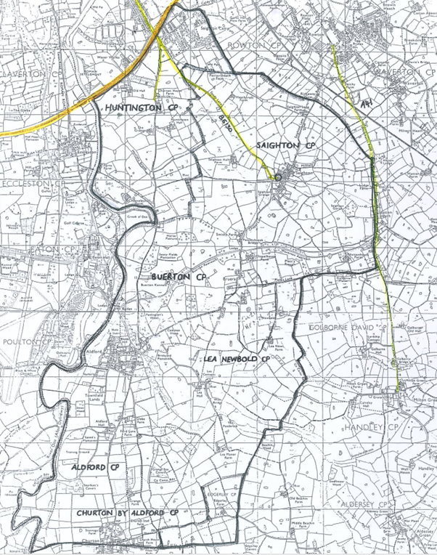

Date of Last Review: | October 2025
Next Review Due: | October 2026
Approved by Governing body:

