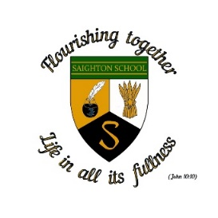
Saighton Church of England Primary School & Pre-School

School term dates 2026-2027

Autumn Term 2026

Tuesday 1st September INSET (Staff training day)
Wednesday 2nd September Pupils return to school
Friday 23rd October School closes for half term

Half term: Monday 26th October - Friday 30th October

Monday 2nd November School reopens
Friday 18th December School closes for Christmas holidays

Christmas holiday: Monday 21st December to Friday 1st January

Spring Term 2027

Monday 4th January INSET (Staff training Day)
Tuesday 5th January School reopens
Friday 12th February School closes for half term

Half term: Monday 15th to Friday 19th February

Monday 22nd February School reopens
Thursday 25th March School closes for Spring Break

Spring Break: Friday 26th March to Friday 9th April

Summer Term 2027

Monday 12th April School reopens
Monday 3rd May Bank holiday
Friday 28th May School closes for half term

Half term Monday 31st May to Friday 4th June
Monday 7th June School reopens
Friday 16th July School closes for summer holiday
Monday 19th July INSET (Staff training day)
Tuesday 20th July INSET (Staff training day)
Wednesday 21st July INSET (Staff training day)

