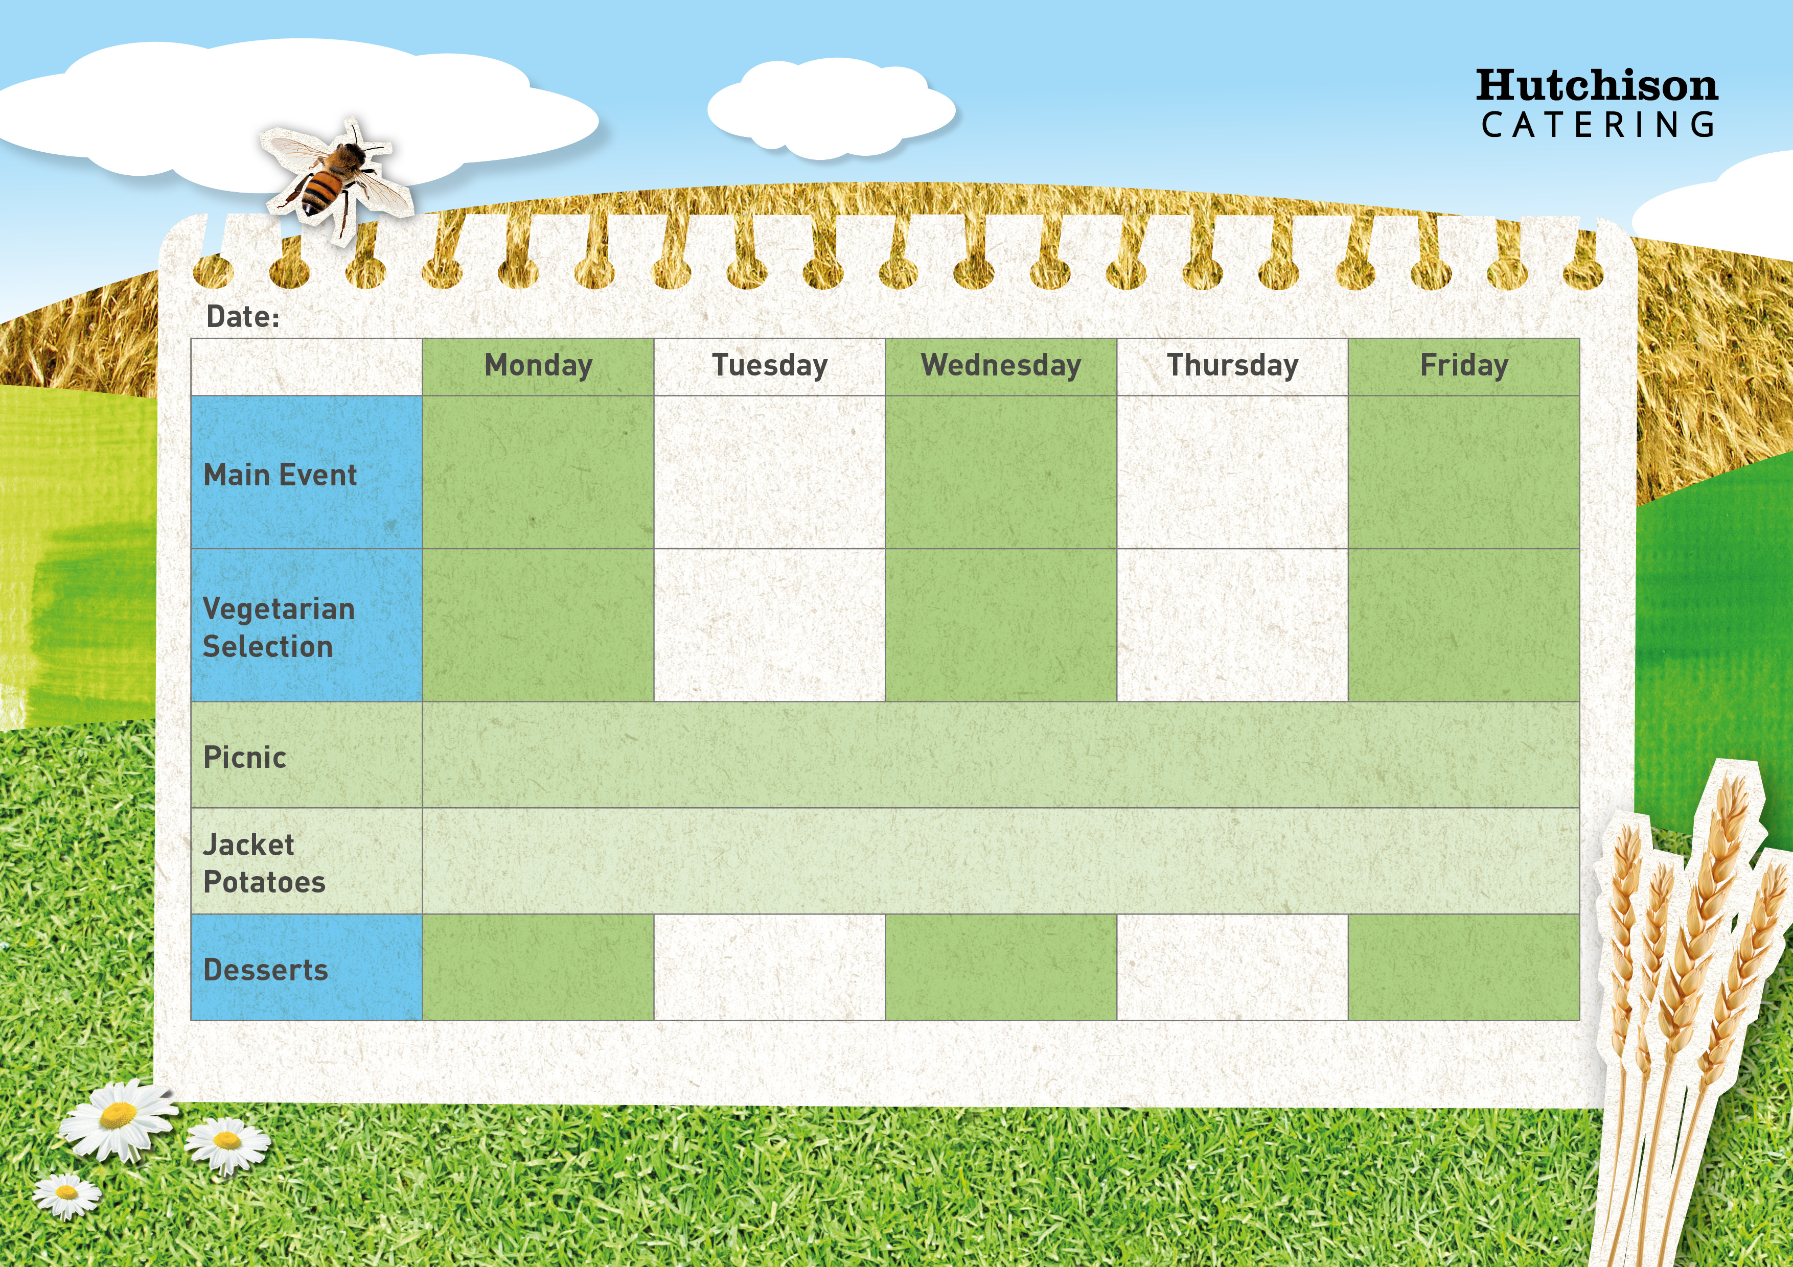
Freshly Prepared Sandwich with Mixed Salad, Healthy Snack,
Dessert of the Day or Fresh Fruit

Spring Week 3

Tomato & Basil Pasta
& with Garlic Bread

Vegetable Pasta Bake

Italian Chicken Pasta with Garlic Bread

Chicken Goujons
With Mexican Rice and Brocolli

Macaroni Cheese with Garlic Bread
Available Daily: Fresh Bread, Water, Fresh Fruit and Yoghurt

Ice cream

Sponge Muffin

Chocolate Cookies

Carrot Cake

Flapjacks
Crispy Baked Jacket Potato with a Choice of Fillings, Mixed Salad
Dessert of the Day or Fresh Fruit

Cheese Pin Wheels with Chips & Baked Beans

Veggie Burger with Potato Wedges and Beans

Fish Fingers with Chips & Baked Beans

Beef Burgers on a bun with Potato wedges and Beans
“Meat Free Mondays”

Margarita Pizza with Potato Wedges & Peas

