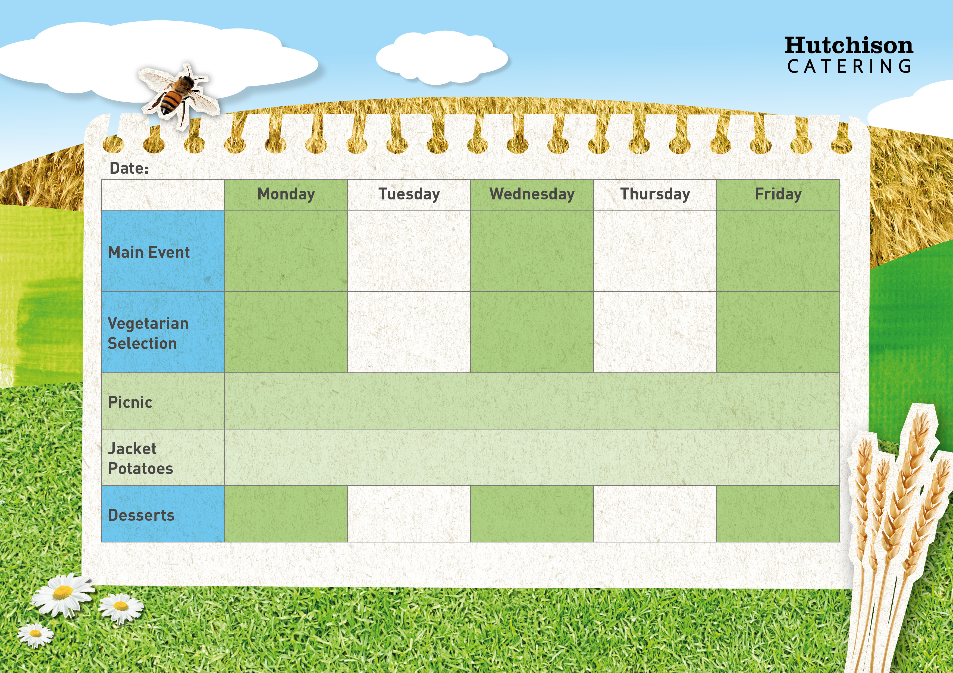
Freshly Prepared Sandwich, Mixed Salad, Healthy Snack,
Dessert of the Day or Fresh Fruit

Veggie Spaghetti
Bolognese

Spring Week 2

Chocolate Biscuit

Homemade Spaghetti Bolognaise with
Sweetcorn

Chicken Tikka Masala with Rice and Naan
Vegetarian Toad in the hole with potato and peas
Available Daily: Fresh Bread, Water, Fresh Fruit and Yoghurt

Ice Cream

Chocolate Muffin

Strawberry Jelly

Oaty Biscuits
Crispy Baked Jacket Potato with a Choice of Fillings, Mixed Salad
Dessert of the Day or Fresh Fruit

Quorn Vegan Dippers with Chips & Baked Beans or Peas

All Day Veggie Breakfast with Beans
Pizza Pin Wheel with Peas

Oven Baked Fish Fingers with Chips & Baked Beans or Peas

All Day Breakfast with Beans
“Meat Free Mondays”

Margherita Pizza with Potato Wedges & Peas

